**Practical: 15**

**Aim: Consider a simple database of books and authors:**

**author(jane, book1).**

**author(mary, book2).**

**author(john, book3).**

**author(jane, book4).**

**Write a Prolog rule to find all authors of books by a given author (including repeated results if the same author wrote multiple books). Use cut and fail to control the backtracking behaviour in a way that minimizes unnecessary computations.**

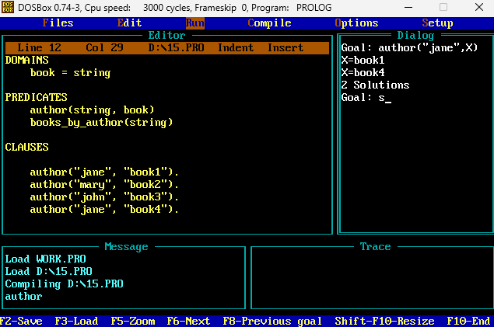

**Practical: 16**

**Aim: Experiment with different placements of cut and fail in the code generated for above practical and observe their effect on the solutions Prolog generates.**

