**Practical: 4**

**Aim: (i) Get intelligent dialog out of Eliza**

**(ii) Get intelligent dialog out of ChatGPT**

**Questions:**

1. **Describe India as a Culture**
2. **Why is AI so important nowadays?**
3. **Why is Surat's GDP so high in Gujarat?**

**Output:**

**ChatGPT:**

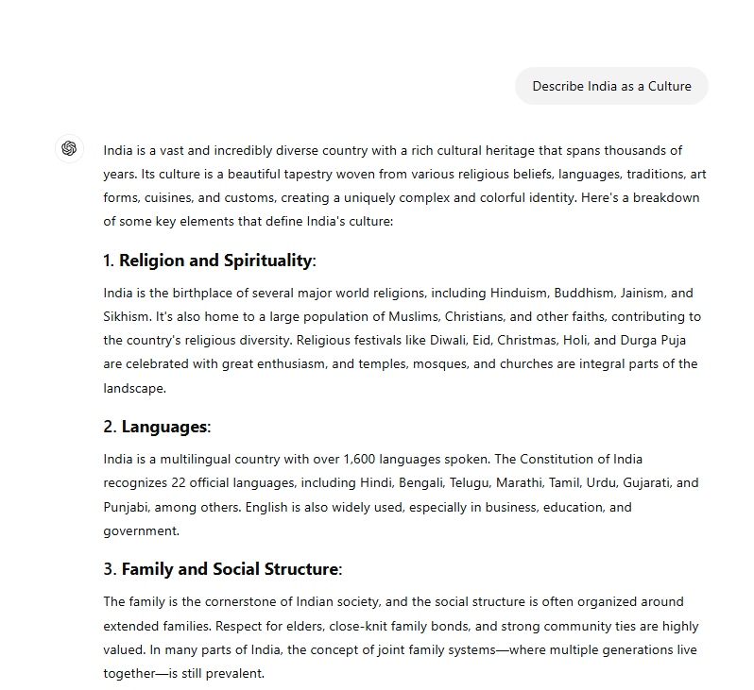

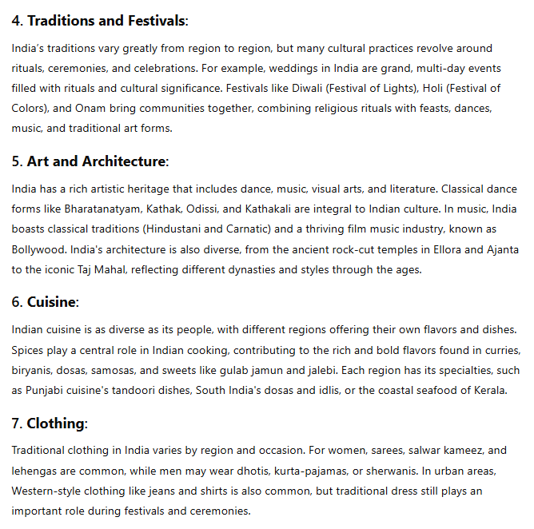

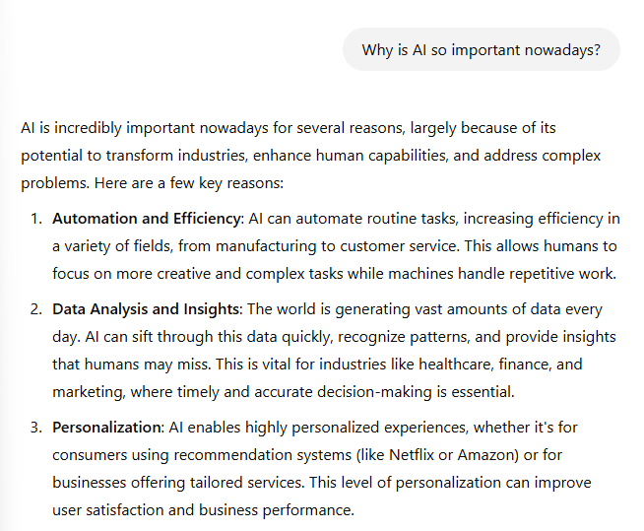

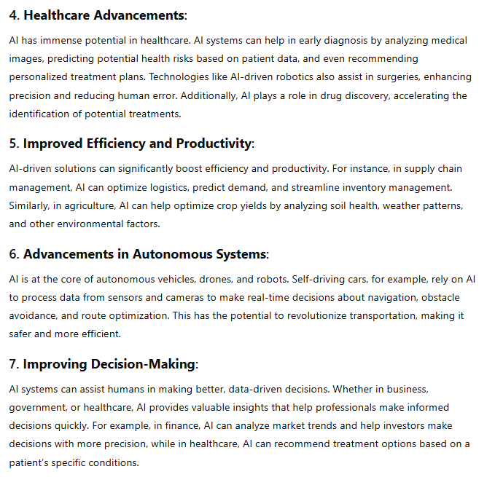

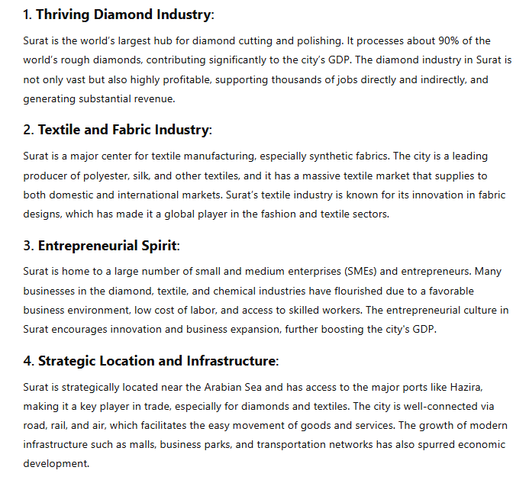

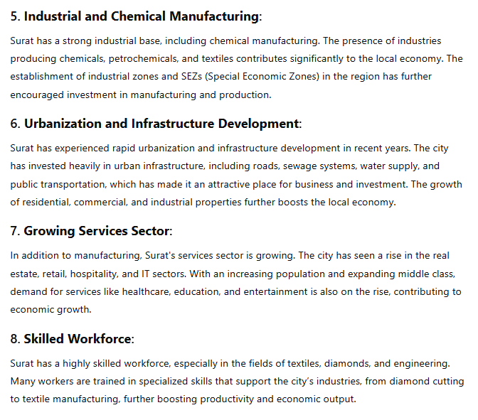

**Eliza:**

