**Practical: 5**

**Aim: Parse five English sentences using the Link Grammar Parser.**

## **I am Studying in SCET College.**

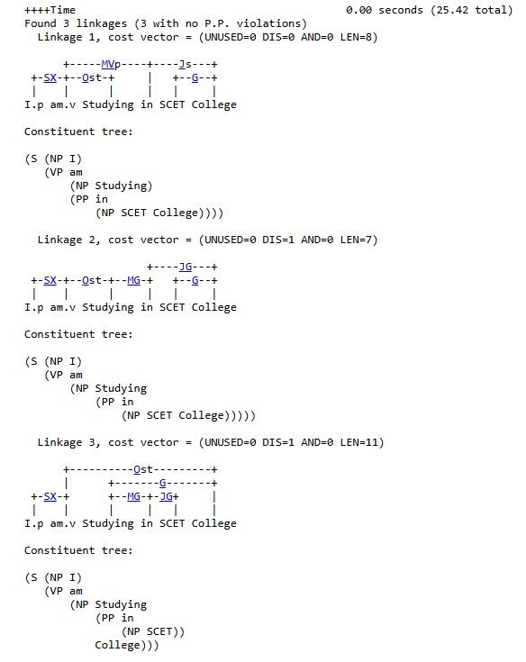

## **I will go to Singapore Tomorrow.**

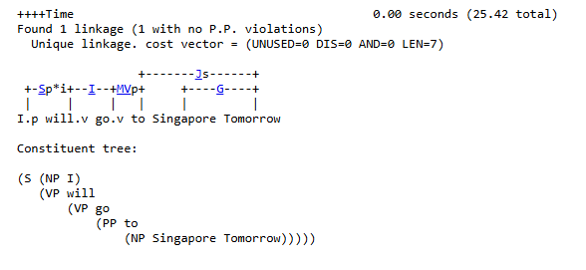

## **Utsav Vachhani and Krish Vanani are the CR of our Class.**

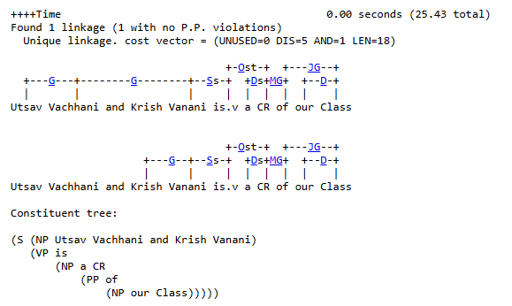

## **I am a part of The Sarkar Ganesh Utsav.**

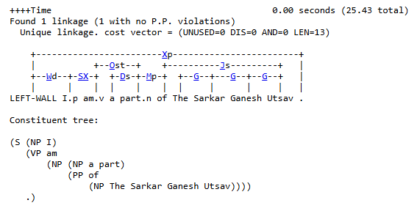

## **I have many issues in my life.**

