**Practical: 1**

**Aim: Study and make a detailed note on the following AI Projects.**

**i) Deep Blue (chess program)**

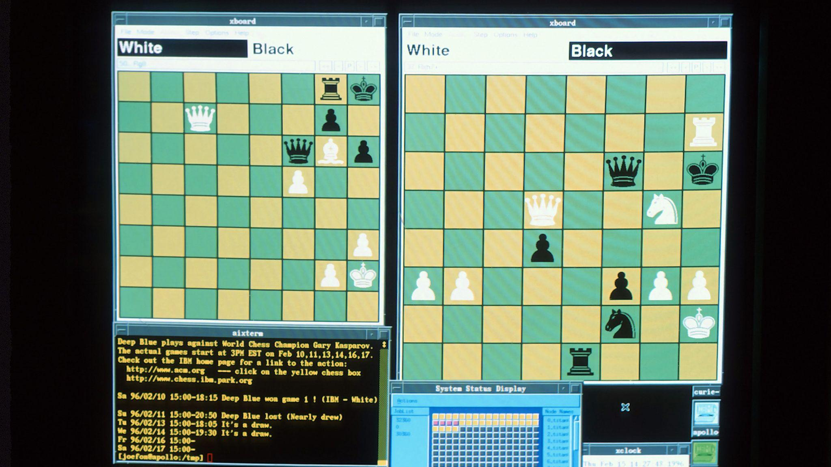

**Overview:**

* **Developer**: IBM
* **Year**: 1996 (first version), 1997 (final version)
* **Purpose**: Deep Blue was designed to play chess at a very high level, using advanced algorithms and computational power to evaluate millions of possible moves per second.

**Key Features & Technologies:**

* **Brute-Force Search**: Deep Blue used a combination of brute-force search techniques and sophisticated evaluation functions. It was able to evaluate around 200 million chess positions per second.
* **Evaluation Function**: The program used a heuristic evaluation function to assess the desirability of a board position. This function considered factors like material balance, piece positions, control of the center, pawn structure, etc.
* **Move Tree Pruning**: It employed techniques like *alpha-beta pruning* to reduce the number of nodes that needed to be explored in the search tree, thus speeding up decision-making.
* **Hardware**: Deep Blue's hardware was a supercomputer with 30 processors working in parallel, designed to maximize computational speed for chess computations.

**Key Events:**

* In **1997**, Deep Blue famously defeated the reigning World Chess Champion, Garry Kasparov, in a six-game match. This was a landmark event in AI history, highlighting the potential of AI to outperform humans in specific, highly structured domains.
* The first match in **1996** was won by Kasparov, but Deep Blue gained significant improvements before the rematch in 1997.

**Impact:**

* The victory showed that AI could reach expert-level performance in complex tasks that were previously thought to require human intuition and creativity.
* It also demonstrated the importance of both hardware and software in advancing AI capabilities.

**References**:

* [Deep Blue on Wikipedia](https://en.wikipedia.org/wiki/Deep_Blue_(chess_computer))
* [IBM Research on Deep Blue](https://research.ibm.com/deepblue/)

**ii) Chinook (checkers program)**



**Overview:**

* **Developer:** University of Alberta's Computer Science Department, led by Dr. Jonathan Schaeffer.
* **Year:** 1994 (first version), 2007 (final version)
* **Purpose:** Chinook was developed to play checkers (also known as draughts) at a high level, ultimately achieving the status of the first program to *solve* the game of checkers.

**Key Features & Technologies:**

* **Endgame Database:** Chinook used a vast endgame database containing all possible positions that could occur in a game, which allowed it to make perfect moves in the final stages of a game.
* **Search Algorithm:** It used a combination of *minimax* search and *alpha-beta pruning* to evaluate possible moves and outcomes. This algorithm, when coupled with efficient search techniques, enabled Chinook to evaluate millions of positions.
* **Solved Game:** By 2007, Chinook had effectively solved checkers, meaning it could play a perfect game and never lose. This was a significant milestone in AI, as checkers was the first game to be solved using AI techniques.

**Key Events:**

* **1994:** Chinook became the first computer to win the World Checkers Championship, defeating the human world champion, Marion Tinsley.
* **2007:** Dr. Jonathan Schaeffer and his team announced that Chinook had solved checkers. It was proven that, assuming perfect play from both sides, the game would end in a draw.

**Impact:**

* Chinook’s ability to solve checkers inspired future efforts to solve other games, like chess (with Deep Blue) and Go (which has yet to be solved).
* It provided important insights into how AI can handle highly structured, deterministic environments and solve complex problems.

**References**:

* [Chinook on Wikipedia](https://en.wikipedia.org/wiki/Chinook_(draughts_player))
* [Chinook Project Overview](https://webdocs.cs.ualberta.ca/~chinook/)

**iii) ALVINN (autonomous driving)**

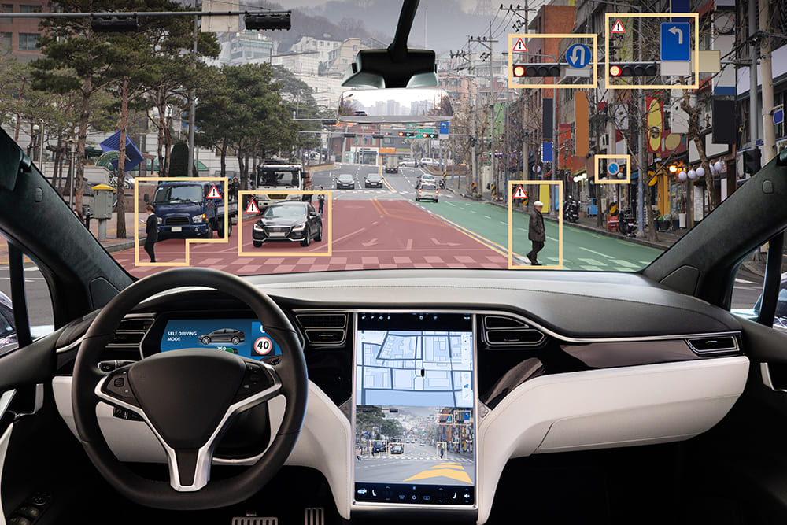

**Overview:**

* **Developer:** Carnegie Mellon University
* **Year:** 1989
* **Purpose:** ALVINN (Autonomous Land Vehicle in a Neural Network) was an early attempt at developing an autonomous vehicle that could drive itself using neural networks and computer vision.

**Key Features & Technologies:**

* **Neural Networks:** ALVINN used a neural network to drive a car by learning from real-world driving data. The network was trained using camera images to predict steering angles, making it possible for the vehicle to autonomously steer based on visual input.
* **Vision and Sensor Integration:** ALVINN’s main sensory input was a video camera mounted on the vehicle, which provided images of the road. This was paired with other sensors like odometry data to track the vehicle’s position.
* **Real-Time Processing:** The neural network ran in real time to adjust the vehicle’s steering, making it possible for the car to react to its environment while driving.

**Key Events:**

* In **1989**, ALVINN completed several successful test drives, including driving autonomously along highways and streets.
* ALVINN demonstrated that neural networks could be used for dynamic decision-making in real-world conditions.

**Impact:**

* ALVINN was one of the earliest prototypes for autonomous driving systems and laid the groundwork for future research in self-driving cars.
* It demonstrated the potential of machine learning (specifically neural networks) to solve complex tasks in dynamic and uncertain environments.

**References**:

* [ALVINN Research Paper](https://www.cs.cmu.edu/afs/cs/project/alvinn/www/)
* [History of Autonomous Vehicles](https://www.historyofselfdrivingcars.com/)

**iv) Eliza, ChatGPT (chatbots)**

#### **ELIZA (1966)**

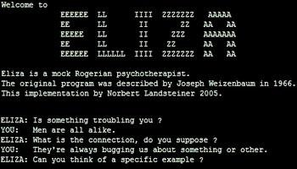

**Overview:**

* **Developer:** Joseph Weizenbaum, MIT
* **Purpose:** ELIZA was one of the first computer programs that attempted to simulate conversation. It was designed to imitate a Rogerian psychotherapist, a form of talk therapy.

**Key Features & Technologies:**

* **Pattern Matching:** ELIZA used pattern matching and substitution rules to simulate conversation. It was a rule-based system with no understanding of the conversation's content but used predefined patterns to generate responses.
* **DOCTOR Script:** The most famous script was *DOCTOR*, where ELIZA acted as a psychotherapist. The program would rephrase a user's statement as a question, prompting further conversation.

**Impact:**

* ELIZA was one of the first examples of conversational AI and inspired future developments in natural language processing.
* Although rudimentary, ELIZA highlighted the potential of computers to engage in human-like dialogue.

**References**:

* [Eliza on Wikipedia](https://en.wikipedia.org/wiki/ELIZA)

#### **ChatGPT (2022)**



**Overview:**

* **Developer:** OpenAI
* **Year:** 2022 (launch of ChatGPT)
* **Purpose:** ChatGPT is a state-of-the-art conversational AI model that is based on the GPT (Generative Pretrained Transformer) architecture. It was designed to engage in human-like dialogue, answer questions, and assist with a wide range of tasks.

**Key Features & Technologies:**

* **Transformer Architecture:** ChatGPT is based on the GPT-3 and GPT-4 models, which use the transformer architecture to process and generate human-like text.
* **Large-Scale Pretraining:** ChatGPT was trained on massive datasets of text from the internet, books, and other sources to learn the structure and nuances of natural language.
* **Contextual Understanding:** Unlike ELIZA, ChatGPT can maintain context over long conversations, understanding nuanced language and generating coherent, contextually appropriate responses.
* **Fine-tuning:** ChatGPT has undergone reinforcement learning from human feedback (RLHF) to improve response quality and safety, aiming to provide useful, respectful, and non-harmful interactions.

**Impact:**

* ChatGPT revolutionized the field of conversational AI with its ability to generate text that is fluent, context-aware, and human-like.
* It has had wide applications across industries, including customer service, education, content generation, and more.

**References**:

* [ChatGPT by OpenAI](https://openai.com/chatgpt)
* [Understanding GPT Models](https://arxiv.org/abs/2005.14165)

**v) Google Translate (machine translation)**



**Overview:**

* **Developer:** Google
* **Year:** 2006 (initial launch)
* **Purpose:** Google Translate is a machine translation service that helps users translate text, speech, and images between multiple languages using AI.

**Key Features & Technologies:**

* **Neural Machine Translation (NMT):** Initially based on phrase-based translation, Google Translate shifted to using NMT around 2016, which treats entire sentences as units for translation, providing more accurate and contextually relevant translations.
* **Deep Learning:** The NMT system uses deep learning models to learn from vast amounts of bilingual text data, improving over time as it processes more content.
* **Multilingual Support:** Google Translate supports over 100 languages, providing text translation, real-time conversation translation, and even image-based translations via smartphone cameras.

**Impact:**

* Google Translate has revolutionized language accessibility, enabling real-time communication across language barriers.
* It has improved the global accessibility of information, business, and cross-cultural communication.

**References**:

* [Google Translate Overview](https://translate.google.com/about/)

**vi) FaceNet (face recognition)**

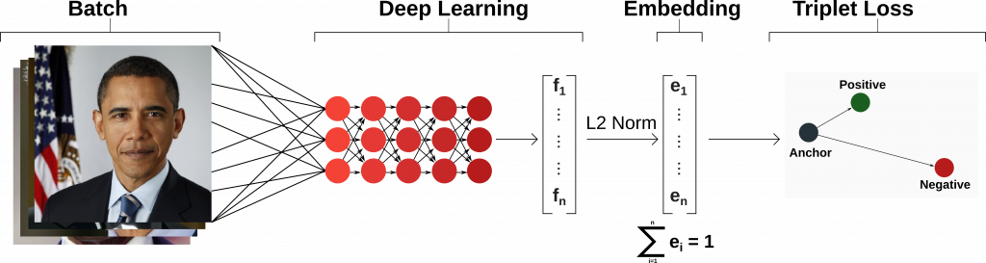

**Overview:**

* **Developer:** Google Research
* **Year:** 2015
* **Purpose:** FaceNet is a deep learning model used for face recognition and verification. It maps facial images to a Euclidean space, where similar faces are closer together.

**Key Features & Technologies:**

* **Deep Convolutional Neural Networks:** FaceNet uses a deep convolutional neural network (CNN) to extract facial features and map them into a compact vector space.
* **Face Embeddings:** The model generates *face embeddings*, numerical representations of faces, which can then be compared to determine similarity or match a known identity.
* **Applications:** FaceNet is used for identity verification (such as in mobile phone authentication), security surveillance, and even in Google's Photos app for organizing and searching images.

**Impact:**

* FaceNet has had a major impact on the accuracy and efficiency of facial recognition systems.
* It has been widely adopted for use in various industries, including security, social media, and mobile devices. However, its use has also raised concerns about privacy and surveillance.

**References**:

* [FaceNet Research Paper](https://arxiv.org/abs/1503.03832)