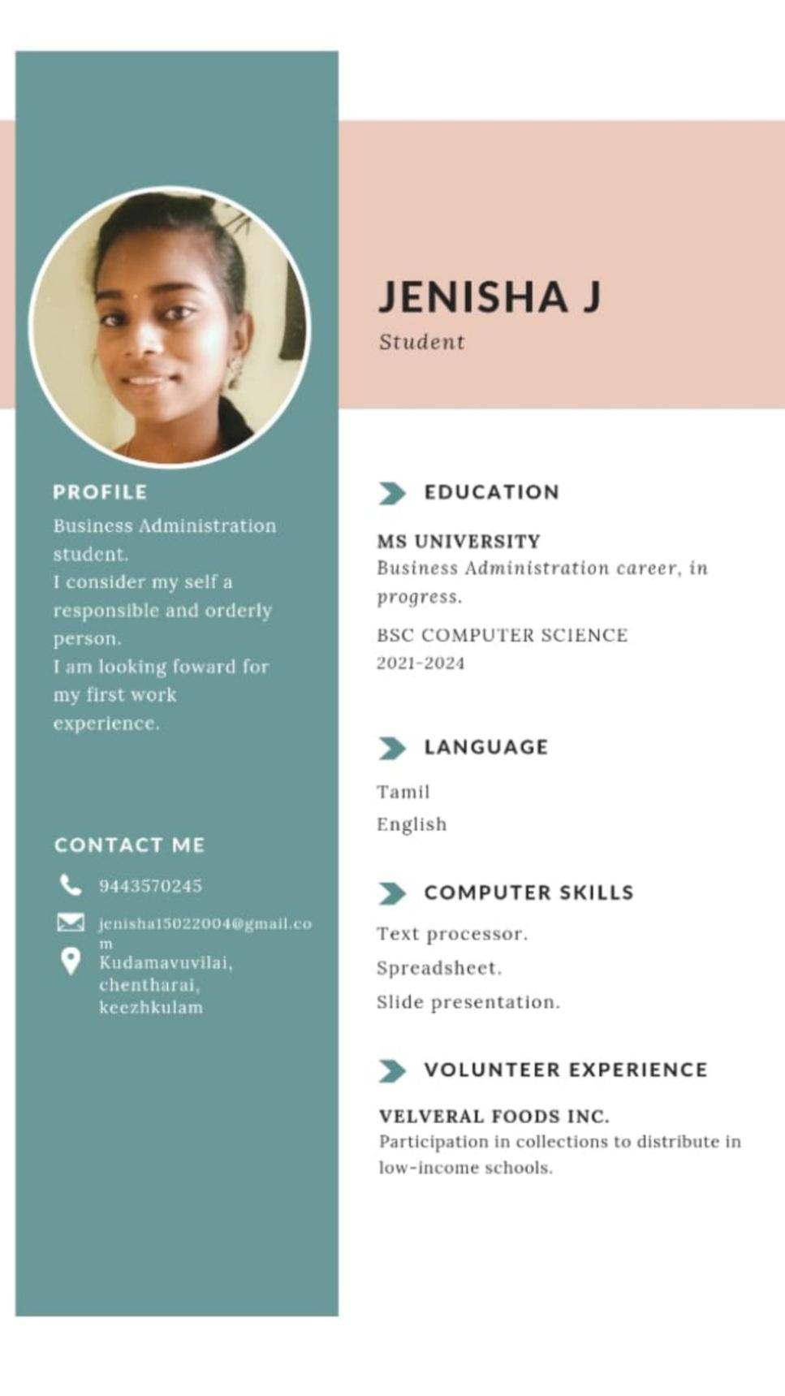

**JENISHA J**

Student

**PROFILE**

Business Administration student.

I consider my self a responsible and orderly person.

**I am looking foward for my first work experience.**

**EDUCATION**

**MS UNIVERSITY**

Business Administration career, in progress.

BSC COMPUTER SCIENCE 2021-2024

**CONTACT ME**

9443570245

jenisha15022004@gmail.co

m

Kudamavuvilai,

chentharai,

keezhkulam

LANGUAGE

Tamil English

COMPUTER SKILLS

Text processor.

Spreadsheet.

Slide presentation.

VOLUNTEER EXPERIENCE

**VELVERAL FOODS INC.**

Participation in collections to distribute in

low-income schools.