Task 2: Basic Wireshark Traffic Capture & Analysis
Capturing and looking at my own network traffic with Wireshark

1. Overview
For this task I installed Wireshark 4.4.18 on my Windows laptop and captured live traffic on my Wi-Fi connection while I browsed a few websites. I left my normal apps running in the background, so the capture has a mix of different protocols instead of just one.
The capture had tens of thousands of packets. Figure 1 shows a small part of the unfiltered packet list. You can already see TCP, TLSv1.2, ICMPv6, ARP and MDNS in it.
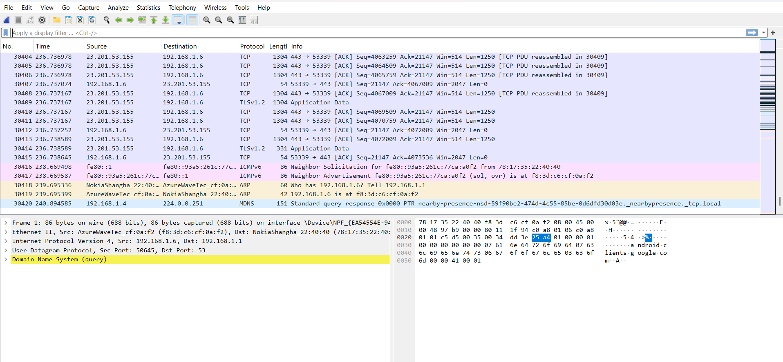
Figure 1: Unfiltered packet list with TCP, TLSv1.2, ICMPv6, ARP and MDNS traffic.

2. Protocol Breakdown
I used the display filter bar to look at each protocol one at a time. The table below lists the protocols I found. I found seven, which is more than the four required.
Protocol | What it does | What I saw
DNS | Turns website names into IP addresses | Queries and replies for android.clients.google.com, b1.nel.goog and audio-ak.spotifycdn.com
ARP | Matches IP addresses to MAC addresses on my network | My router asking "Who has 192.168.1.6?" and my laptop replying with its MAC address
TCP | Sends data reliably between two devices | Data going to 23.201.53.155 on port 443 (HTTPS)
TLS 1.2 / 1.3 | Encrypts HTTPS traffic | Application Data packets and Client Hello packets showing the site name (SNI)
HTTP | Normal web requests with no encryption | A GET request for /r/gsr1.crl to c.pki.goog
ICMPv6 | IPv6 neighbor discovery (like ARP for IPv6) | Neighbor Solicitation and Neighbor Advertisement messages
MDNS | Finds devices on the local network without a DNS server | A response for a _nearbypresence._tcp.local service

2.1 DNS
I filtered with dns to see the name lookups. Every time my laptop asked for a domain (like android.clients.google.com or b1.nel.goog), my router at 192.168.1.1 answered almost right away with CNAME records and IP addresses.
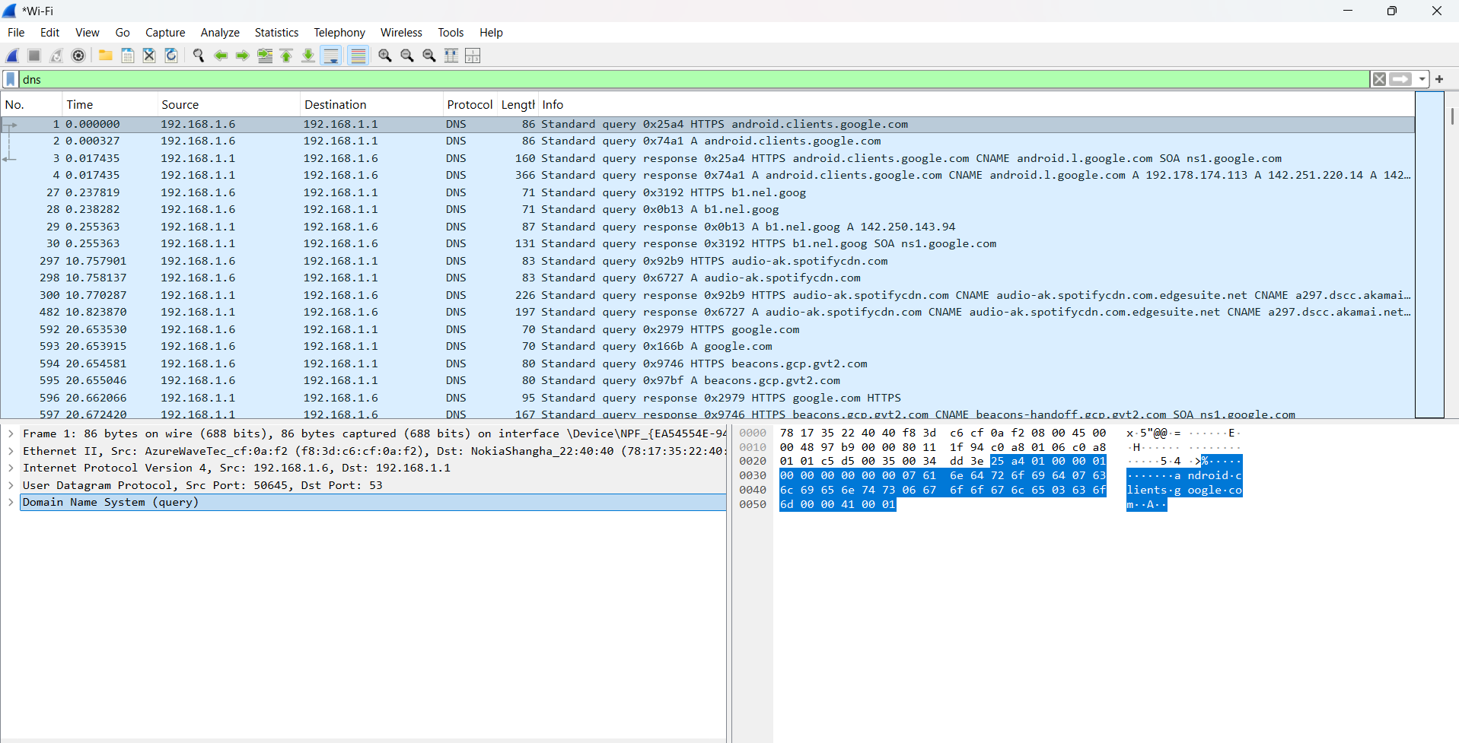
Figure 2: DNS queries and their responses for different domains.

2.2 ARP
I filtered with arp. My router kept sending "Who has 192.168.1.6? Tell 192.168.1.1" and my laptop kept answering with its MAC address. This repeats every so often so the router keeps its ARP table up to date.
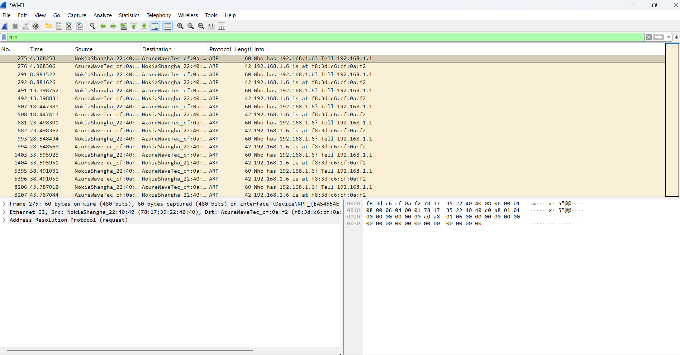
Figure 3: ARP requests and replies between my laptop and the router.

2.3 TLS (HTTPS)
I filtered with tls.handshake.type == 1 to find the Client Hello packets. These are the first step of a TLS handshake. The data in an HTTPS session is encrypted, but the Client Hello is not. It shows the Server Name Indication (SNI), which is the name of the site being connected to (for example b1.nel.goog, e2c46.gcp.gvt2.com and data.iana.org).
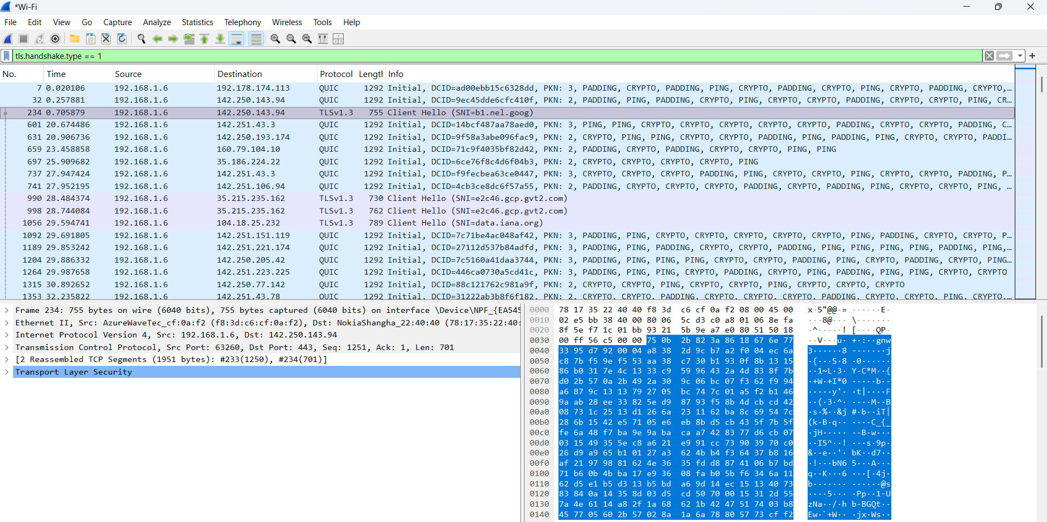
Figure 4: TLS Client Hello packets. The site name is visible in the SNI field even though the session is encrypted.

2.4 HTTP (unencrypted)
I filtered with http and found one example of plain, unencrypted traffic. It was a GET request to c.pki.goog for /r/gsr1.crl. This is a certificate revocation list check, where the computer checks if a certificate has been revoked. It was interesting that this happens over normal HTTP and not HTTPS. In the packet details I could read the Host header and the request line without decrypting anything.
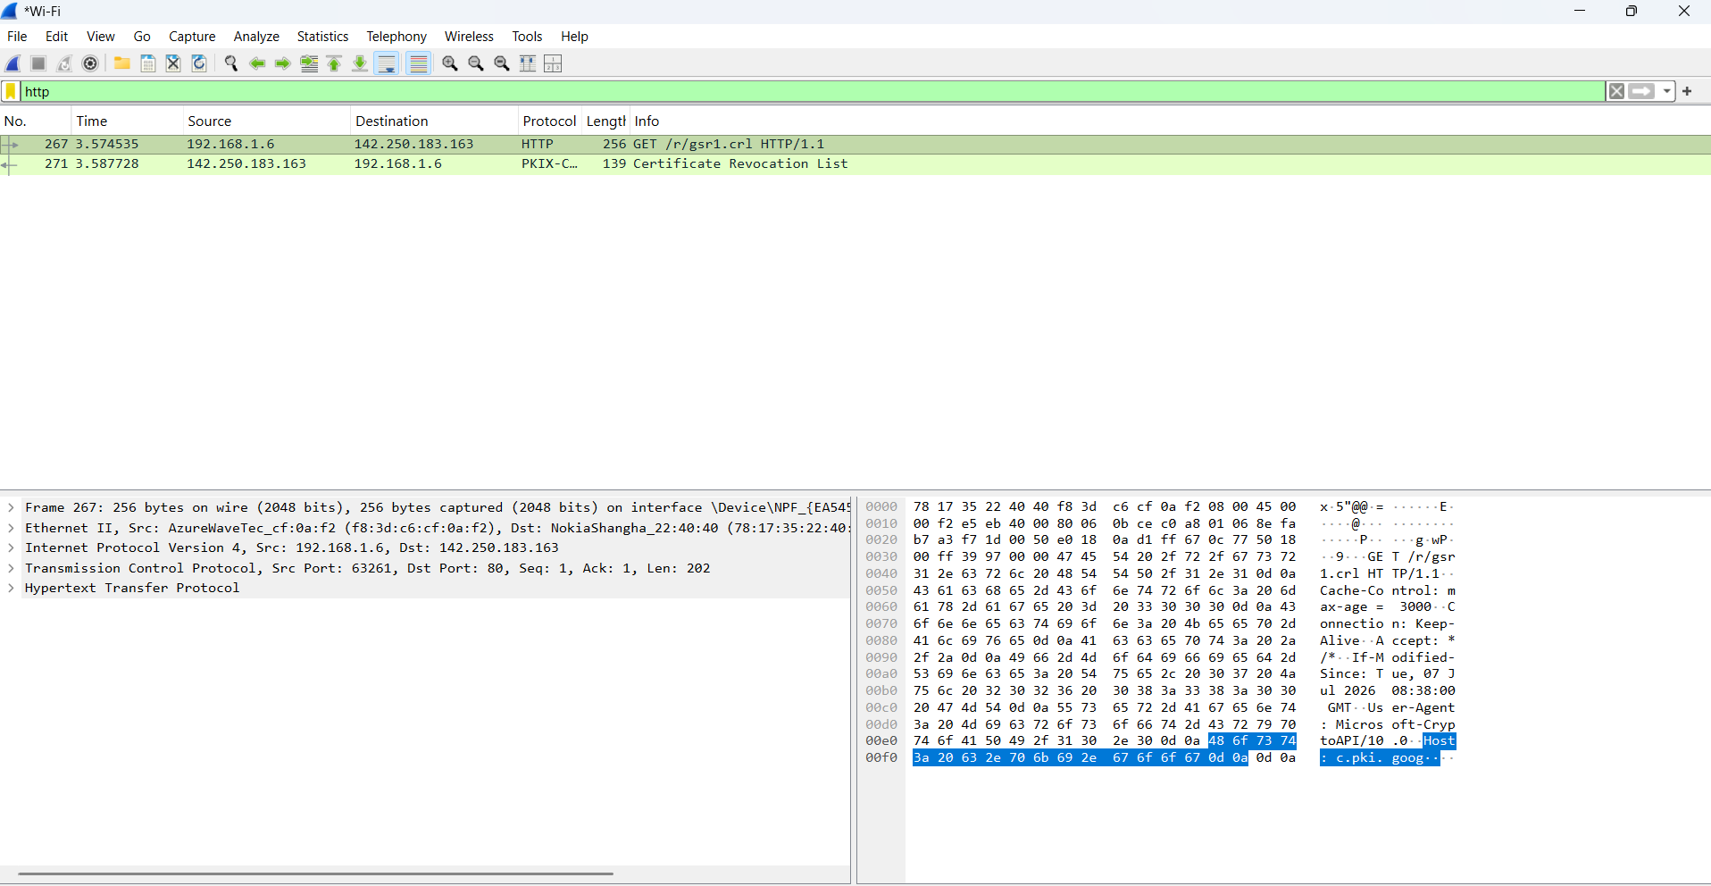
Figure 5: Plain HTTP GET request and Host header, readable without decryption.

3. Packet Walkthrough: A DNS Lookup
I picked a DNS query and response to walk through because it is short and shows the request and response pattern used by most of the other traffic in my capture.

Packet 1: the query
My laptop (192.168.1.6) sends a UDP packet to my router (192.168.1.1) on port 53, which is the standard DNS port. The Info column says:
Standard query 0x25a4 HTTPS android.clients.google.com
- Source is 192.168.1.6 and destination is 192.168.1.1, so my laptop is asking the router.
- Protocol stack: Ethernet, IPv4, UDP, DNS.
- The query type is HTTPS, a newer record type, for the domain android.clients.google.com.
- The transaction ID is 0x25a4. It lets the response be matched to this query.

Packet 3: the response
A few milliseconds later the router replies from 192.168.1.1 to 192.168.1.6, still over UDP port 53. The Info column says:
Standard query response 0x25a4 HTTPS android.clients.google.com CNAME android.l.google.com SOA ns1.google.com
- It has the same transaction ID (0x25a4), so it is the answer to my query.
- The name android.clients.google.com points to a CNAME alias, android.l.google.com.
- There is also an SOA record showing that ns1.google.com is the authoritative server for the zone.
- All of this is sent in plaintext, so anyone else on the same network could see which domains I looked up.
Every DNS lookup in my capture follows this same pattern of one query and one matching response, even for different record types.

4. Summary: What I Learned
- Even a short browsing session uses a lot of protocols at once. DNS finds names, ARP and ICMPv6 find devices on the local network, TCP moves the data, and TLS encrypts it.
- DNS and ARP are not encrypted, so someone on the same network could see the domains I looked up and the devices on the network.
- TLS hides the content of my traffic, but the SNI in the handshake still shows which site I connected to.
- I found one unencrypted HTTP request, the certificate check to c.pki.goog. It is not sensitive, but it shows that not every connection is HTTPS.
- The biggest thing I learned is how much information is visible even when the data is encrypted, like IP addresses, MAC addresses and domain names.
Note: I captured this traffic on my own laptop and home network, as the assignment requires.

