**Assignment for Block Chain Technology Step**

1: Go to Chrome and open remix platform

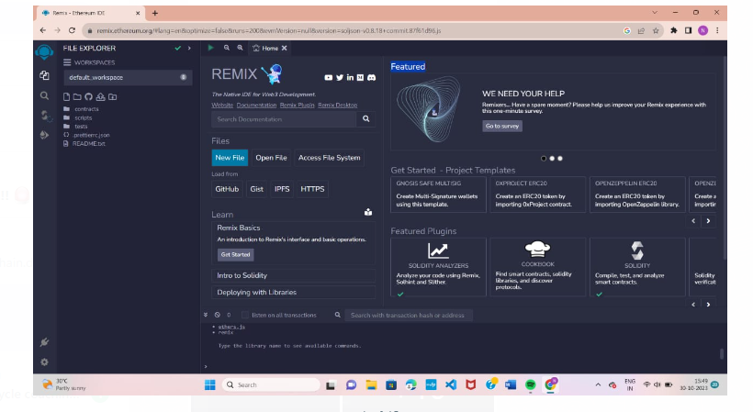

Step 2: Open the remix page and create new file

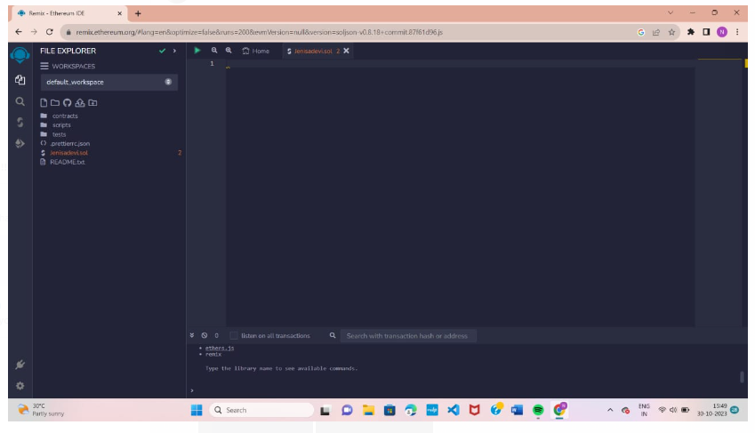

Step 3: Write the program to get the string “Zone name” in the newly created file

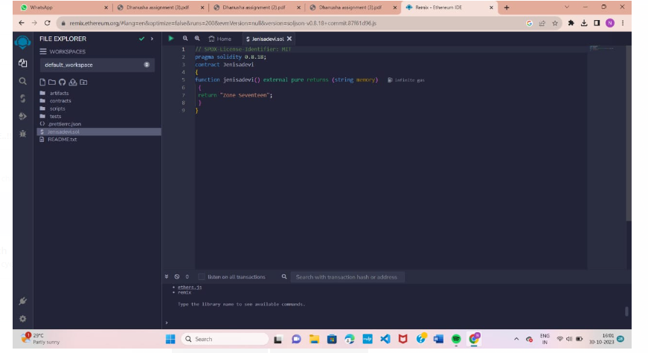

Code:

// SPDX-License-Identifier:

MIT pragma solidity 0.8.18;

contract Jenisadevi

{

function jenisadevi() external pure returns (string memory)

{ return "Zone Seventeen";

}

}

Step 4: Save the program and compile it to get the ABI and Byte code.

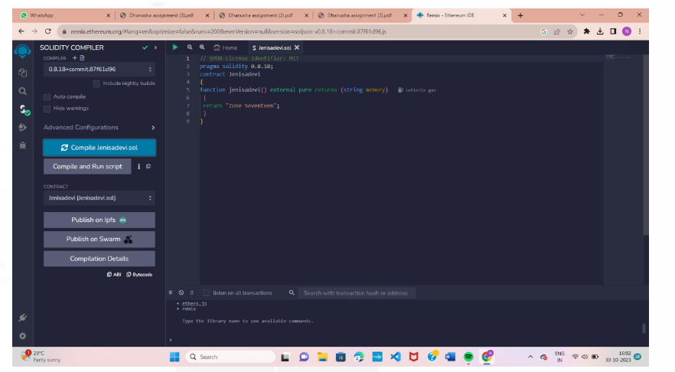

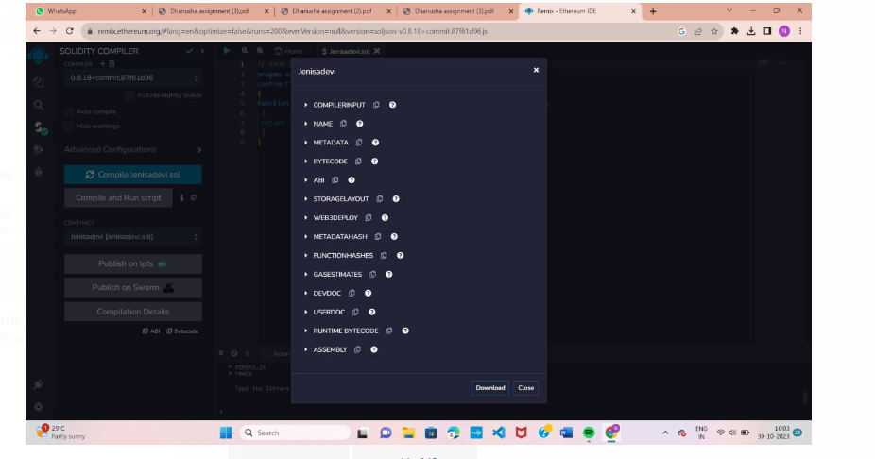

ABI code:

[

{

"inputs": [],

"name": "jenisadevi",

"outputs":

[

{

"internalType": "string",

"name": "",

"type": "string"

}

],

"stateMutability": "pure",

"type": "function"

}

]

Byte code:

{

"functionDebugData": {},

"generatedSources": [],

"linkReferences": {},

"object": "608060405234801561001057600080fd5b50610173806100206000396000f3fe60806040523480 1561001057600080fd5b506004361061002b5760003560e01c8063e2dcdd6e14610030575b6000 80fd5b61003861004e565b604051610045919061011b565b60405180910390f35b606060405180 60400160405280600e81526020017f5a6f6e6520536576656e7465656e000000000000000000000 000000000000000815250905090565b600081519050919050565b6000828252602082019050929 15050565b60005b838110156100c55780820151818401526020810190506100aa565b600084840 15250505050565b6000601f19601f8301169050919050565b60006100ed8261008b565b6100f781 85610096565b93506101078185602086016100a7565b610110816100d1565b8401915050929150 50565b6000602082019050818103600083015261013581846100e2565b90509291505056fea264 697066735822122006e45fb25e880ec209575b613d69953c69fde100dedebe3a414872402e57fd8e 64736f6c63430008120033", "opcodes": "PUSH1 0x80 PUSH1 0x40 MSTORE CALLVALUE DUP1 ISZERO PUSH2 0x10 JUMPI PUSH1 0x0 DUP1 REVERT JUMPDEST POP PUSH2 0x173 DUP1 PUSH2 0x20 PUSH1 0x0 CODECOPY PUSH1 0x0 RETURN INVALID PUSH1 0x80 PUSH1 0x40 MSTORE CALLVALUE DUP1 ISZERO PUSH2 0x10 JUMPI PUSH1 0x0 DUP1 REVERT JUMPDEST POP PUSH1 0x4 CALLDATASIZE LT PUSH2 0x2B JUMPI PUSH1 0x0 CALLDATALOAD PUSH1 0xE0 SHR DUP1 PUSH4 0xE2DCDD6E EQ PUSH2 0x30 JUMPI JUMPDEST PUSH1 0x0 DUP1 REVERT JUMPDEST PUSH2 0x38 PUSH2 0x4E JUMP JUMPDEST PUSH1 0x40 MLOAD PUSH2 0x45 SWAP2 SWAP1 PUSH2 0x11B JUMP JUMPDEST PUSH1 0x40 MLOAD DUP1 SWAP2 SUB SWAP1 RETURN JUMPDEST PUSH1 0x60 PUSH1 0x40 MLOAD DUP1 PUSH1 0x40 ADD PUSH1 0x40 MSTORE DUP1 PUSH1 0xE DUP2 MSTORE PUSH1 0x20 ADD PUSH32 0x5A6F6E6520536576656E7465656E000000000000000000000000000000000000 DUP2 MSTORE POP SWAP1 POP SWAP1 JUMP JUMPDEST PUSH1 0x0 DUP2 MLOAD SWAP1 POP SWAP2 SWAP1 POP JUMP JUMPDEST PUSH1 0x0 DUP3 DUP3 MSTORE PUSH1 0x20 DUP3 ADD SWAP1 POP SWAP3 SWAP2 POP POP JUMP JUMPDEST PUSH1 0x0 JUMPDEST DUP4 DUP2 LT ISZERO PUSH2 0xC5 JUMPI DUP1 DUP3 ADD MLOAD DUP2 DUP5 ADD MSTORE PUSH1 0x20 DUP2 ADD SWAP1 POP PUSH2 0xAA JUMP JUMPDEST PUSH1 0x0 DUP5 DUP5 ADD MSTORE POP POP POP POP JUMP JUMPDEST PUSH1 0x0 PUSH1 0x1F NOT PUSH1 0x1F DUP4 ADD AND SWAP1 POP SWAP2 SWAP1 POP JUMP JUMPDEST PUSH1 0x0 PUSH2 0xED DUP3 PUSH2 0x8B JUMP JUMPDEST PUSH2 0xF7 DUP2 DUP6 PUSH2 0x96 JUMP JUMPDEST SWAP4 POP PUSH2 0x107 DUP2 DUP6 PUSH1 0x20 DUP7 ADD PUSH2 0xA7 JUMP JUMPDEST PUSH2 0x110 DUP2 PUSH2 0xD1 JUMP JUMPDEST DUP5 ADD SWAP2 POP POP SWAP3 SWAP2 POP POP JUMP JUMPDEST PUSH1 0x0 PUSH1 0x20 DUP3 ADD SWAP1 POP DUP2 DUP2 SUB PUSH1 0x0 DUP4 ADD MSTORE PUSH2 0x135 DUP2 DUP5 PUSH2 0xE2 JUMP JUMPDEST SWAP1 POP SWAP3 SWAP2 POP POP JUMP INVALID LOG2 PUSH5 0x6970667358 0x22 SLT KECCAK256 MOD 0xE4 0x5F 0xB2 0x5E DUP9 0xE 0xC2 MULMOD JUMPI JUMPDEST PUSH2 0x3D69 SWAP6 EXTCODECOPY PUSH10 0xFDE100DEDEBE3A414872 BLOCKHASH 0x2E JUMPI REVERT DUP15 PUSH5 0x736F6C6343 STOP ADDMOD SLT STOP CALLER ", "sourceMap": "58:114:0:-:0;;;;;;;;;;;;;;;;;;;"

}

Step5: Deploy it to display the output

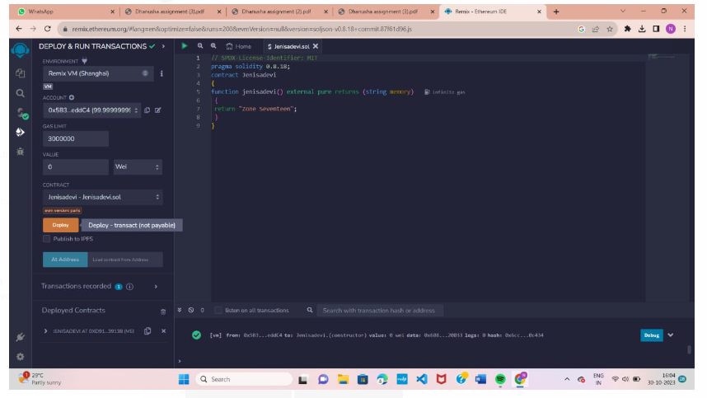

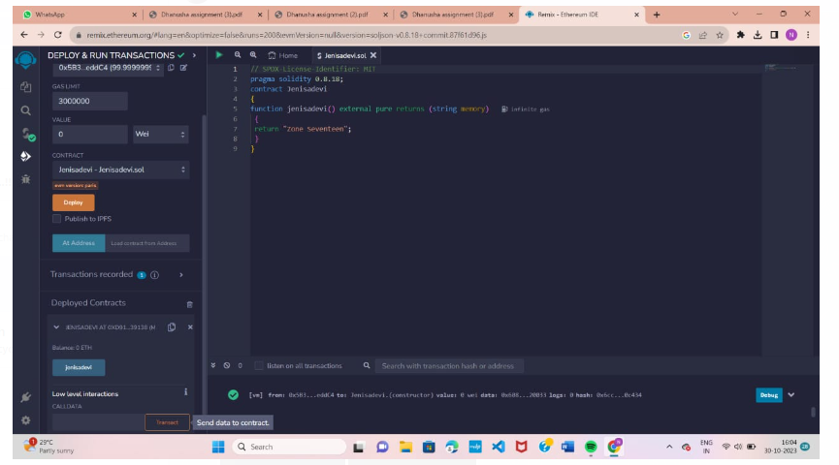

Submitted by,

Jenisadevi .U,

963520106024.