**Module: - 3 Context Based Testing**

__________________________________________________________________________________

1. What is load testing?

Load Testing is a type of [Performance Testing](https://www.geeksforgeeks.org/performance-testing-software-testing/) that determines the performance of a system, software product, or software application under real-life based load conditions. Basically, load testing determines the behaviour of the application when multiple users use it at the same time. It is the response of the system measured under varying load conditions. The load testing is carried out for normal and extreme load conditions.

Objectives of Load Testing: The objective of load testing is:

* To maximize the operating capacity of a software application.
* To determine whether the latest infrastructure is capable to run the software application or not.
* To determine the sustainability of application with respect to extreme user load.
* To find out the total count of users that can access the application at the same time.
* To determine scalability of the application.
* To allow more users to access the application.

Load Testing Process:   
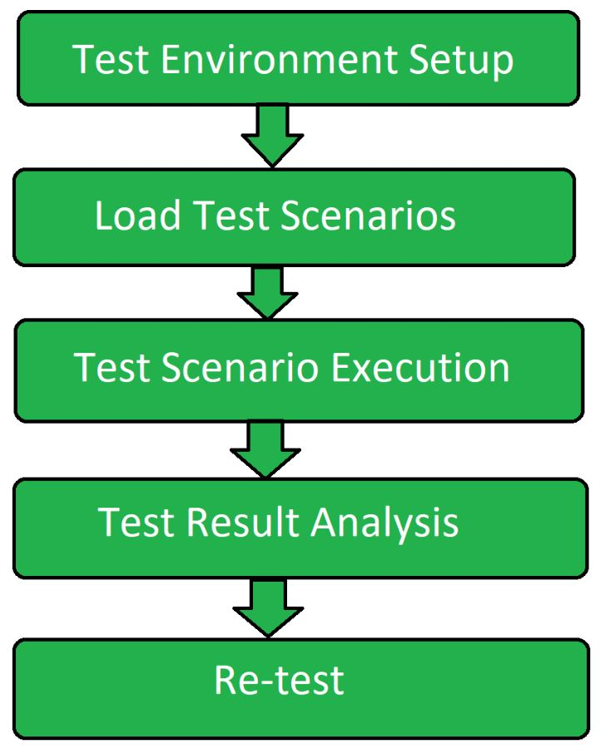 

1. Test Environment Setup: Firstly create a dedicated test environment setup for performing the load testing. It ensures that testing would be done in a proper way.
2. Load Test Scenario**:** In second step load test scenarios are created. Then load testing transactions are determined for an application and data is prepared for each transaction.
3. Test Scenario Execution**:** Load test scenarios that were created in previous step are known executed. Different measurements and metrics are gathered to collect the information.
4. Test Result Analysis**:** Results of the testing performed is analysed and various recommendations are made.
5. Re-test**:** If the test is failed then the test is performed again in order to get the result in correct way.

Metrics of Load Testing:

Metrics are used in knowing the performance of load testing under different circumstances. It tells how accurately the load testing is working under different test cases. It is usually carried out after the preparation of load test scripts/cases. There are many metrics to evaluate the load testing. Some of them are listed below.

1. Average Response Time:It tells the average time taken to respond to the request generated by the clients or customers or users. It also shows the speed of the application depending upon the time taken to respond to the all requests generated.

2. Error Rate: The Error Rate is mentioned in terms of percentage denotes the number of errors occurred during the requests to the total number of requests. These errors are usually raised when the application is no longer handling the request at the given time or for some other technical problems. It makes the application less efficient when the error rate keeps on increasing.

3. Throughput:This metric is used in knowing the range of bandwidth consumed during the load scripts or tests and it is also used in knowing the amount of data which is being used for checking the request that flows between the user server and application main server. It is measured in kilobytes per second.

4. Requests per Second:It tells that how many requests are being generated to the application server per second. The requests could be anything like requesting of images, documents, web pages, articles or any other resources.

5. Concurrent Users:This metric is used to take the count of the users who are actively present at the particular time or at any time. It just keeps track of count those who are visiting the application at any time without raising any request in the application. From this, we can easily know that at which time the high number of users are visiting the application or website.

6. Peak Response Time:Peak Response Time measures the time taken to handle the request. It also helps in finding the duration of the peak time (longest time) at which the request and response cycle is handled and finding that which resource is taking longer time to respond the request.

**Load Testing Tools:**

1**.** Apache Jmeter

2**.** Web Load

3**.** NeoLoad

4**.** Load Ninja

5. HP Performance Tester

6**.** LoadUI Pro

7. Load View

1. What is stress testing?

Stress Testing is a software testing technique that determines the robustness of software by testing beyond the limits of normal operation. Stress testing is particularly important for critical software but is used for all types of software. Stress testing emphasizes robustness, availability, and error handling under a heavy load rather than what is correct behaviour under normal situations. Stress testing is defined as a type of software testing that verifies the stability and reliability of the system. This test particularly determines the system on its robustness and error handling under extremely heavy load conditions. It even tests beyond the normal operating point and analyses how the system works under extreme conditions. Stress testing is performed to ensure that the system would not crash under crunch situations. Stress testing is also known as Endurance Testing or Torture Testing.

Characteristics of Stress Testing:

1. Stress testing analyses the behaviour of the system after a failure.
2. Stress testing makes sure that the system recovers after failure.
3. It checks whether the system works under abnormal conditions.
4. It ensures to display of appropriate error messages when the system is under stress.
5. It verifies that unexpected failures do not cause security issues.
6. It verifies whether the system has saved the data before crashing or not.

Stress TestingProcess: 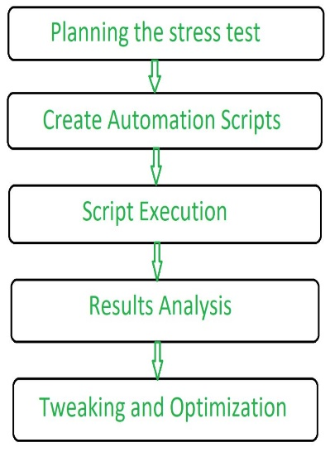 Types of Stress Testing:

1. Server-client Stress Testing: In this stress testing, testing is carried out across all clients from the server.
2. Product Stress Testing: Product stress testing concentrates on discovering defects related to data locking and blocking, network issues, and performance congestion in a software product.
3. Transaction Stress Testing: Transaction stress testing is performed on one or more transactions between two or more applications. It is carried out for fine-tuning and optimizing the system.
4. Systematic Stress Testing: Systematic stress testing is integrated testing that is used to perform tests across multiple systems running on the same server. It is used to discover defects where one application data blocks another application.
5. Analytical Stress Testing: Analytical stress testing is performed to test the system with abnormal parameters or conditions that are unlikely to happen in a real scenario. It is carried out to find defects in unusual scenarios like a large number of users logged at the same time or a database going offline when it is accessed from a website.

**Stress Testing Tools:**

1. [Jmeter](http://jmeter.apache.org/)
2. [Load Runner](http://www.hp.com/)
3. Stress Tester
4. Neo load

Metrics of StressTesting**:s**

Metrics are used to evaluate the performance of the stress and it is usually carried out at the end of the stress scripts or tests. Some of the metrics are given below.

1. Pages per Second:Number of pages requested per second and number of pages loaded per second.
2. Pages Retrieved:Average time taken to retrieve all information from the particular page.
3. Byte Retrieved:Average time is taken to retrieve the first byte of information from the page.
4. Transaction Response Time:Average time is taken to load or perform transactions between the applications.
5. Transactions per Second**:**It takes count of the number of transactions loaded per second successfully and it also counts the number of failures that occurred.
6. Failure of Connection:It takes count of the number of times that the client faced the connection failure in their system.
7. Failure of System attempts:It takes count of the number of failed attempts in the system.
8. Rounds:It takes count of the number of test or script conditions executed by the clients successfully and it keeps track of the number of rounds failed.
9. Write a scenario of only whatsapp chat messages?

**Test Scenarios For Whatsapp Individual Chats**

* Check the Chat window that contains the entire chat list.
* Check the Chat window displays the contact numbers whose numbers are not saved on mobile.
* Check the Chat window displayed with all contacts with DP or without DP
* Check the Chat window is displayed on the group chat list.
* Check the Chat window displays the last updated chatting time.
* Check the Chat window displays the name of all contacts on the chat window.
* Check the clicking on one Chat contact then a new window should open with history.
* Check the user can see all delivered and received messages.
* Check the user can see the read or send time of messages.
* Check the user can send and receive text messages in the individual chat box.
* Check the user can send and receive documents in the individual chat box.
* Check the user can send and receive photos in an individual chat box.
* Check the user can send and receive videos in an individual chat box.
* Check the user can send and receive audio in an individual chat box.
* Check the user can send and receive emotions icons in the individual chat boxes.
* Check the user can send and receive Contacts in the individual chat boxes.
* Check the user can send and receive Location in the individual chat box.
* Check the user can send and receive GIFs in the individual chat boxes.
* Check the user can send and receive Stickers in the individual chat boxes.
* Check the user can delete text, video, audio, locations, and documents in the individual chat boxes.
* Check the user can send recorded voice mail in an individual chat box.
* Check the user can delete the entire chat history in the individual chat box.
* Check the user is able to see contact details in the individual chat box.
* Check the user is able to share images, links, and documents from media in the individual chat boxes.
* Check the user is able to search specific chat history using the search option in the individual chat box.
* Check the user is able to video call in the individual chat box.
* Check the user is able to voice call in the individual chat box.
* Check the user is able to mute the individuals in the individual chat boxes.
* Check the user is able to change the wallpaper.
* Check the users have options like Report, Block, Clear Chat, Export Chat, and Add Shortcut.

**Test Scenarios for Whatsapp Group Chats**

* Check whether the user is able to create a new one or not.
* Check the user is able to add multiple contacts from the contact list.
* Check the user is able to insert the group name and select an image for DP.
* Check the user is able to add and remove contacts from the group.
* Check the user is able to delete a group.
* Check the user can send and receive text messages in the group.
* Check the user can send and receive documents in the group chat box.
* Check the user can send and receive photos in the group chat box.
* Check the user can send and receive videos in the group chat box.
* Check the user can send and receive audio in the group chat box.
* Check the user can send and receive emotions icons in the group chat box.
* Check the user can send and receive Contacts in the group chat box.
* Check the user can send and receive Location in the group chat box.
* Check the user can send and receive GIFs in the group chat box.
* Check the user can send and receive Stickers in the group chat box.
* Check the user can delete text, video, audio, locations, and documents in the group chat box.
* Check the user can send recorded voice mail in the group chat box.
* Check the user is able to make multiple video call in the group chat box.
* Check the user is able to see the group contact information from Group Info in the group chat box.
* Check the user is able to share images, links, and documents from Group Media in the group chat box.
* Check the user is able to search specific chat history using the search option in the group chat box.
* Check the user is able to mute the group in the group chat box.
* Check the users have options like Report, Block, Clear Chat, Export Chat, and Add Shortcut.

1. Write a scenario of pen?
2. Verify that the length and the diameter of the pen are as per the specifications.
3. Verify the outer body material of the pen. Check if it is metallic, plastic, or any other material specified in the requirement specifications.
4. Check the colour of the outer body of the pen. It should be as per the specifications.
5. Verify that the brand name and/or logo of the company creating the pen should be clearly visible.
6. Verify that any information displayed on the pen should be legible and clearly visible.
7. Verify the type of pen, whether it is a ballpoint pen, ink pen, or gel pen.
8. Verify that the user is able to write clearly over different types of papers.
9. Check the weight of the pen. It should be as per the specifications. In case not mentioned in the specifications, the weight should not be too heavy to impact its smooth operation.
10. Verify if the pen is with a cap or without a cap.
11. Verify the colour of the ink of the pen.
12. Check the odor of the pen’s ink on writing over a surface.
13. Verify the surfaces over which pen is able to write smoothly apart from paper e.g. cardboard, rubber surface, etc.
14. Verify that the text written by the pen should have consistent ink flow without leaving any blob.
15. Check that the pen’s ink should not leak in case it is tilted upside down.
16. Verify if the pen’s ink should not leak at higher altitudes.
17. Verify if the text written by the pen is erasable or not.
18. Check the functioning of the pen on applying normal pressure during writing.
19. Verify the strength of the pen’s outer body. It should not be easily breakable.
20. Verify that text written by pen should not get faded before a certain time as mentioned in the specification.
21. Check if the text written by the pen is waterproof or not.
22. Verify that the user is able to write normally on tilting the pen at a certain angle instead of keeping it straight while writing.
23. Check the grip of the pen, whether it provides adequate friction for the user to comfortably grip the pen.
24. Verify if the pen can support multiple refills or not.
25. In the case of an ink pen, verify that the user is able to refill the pen with all the supported ink types.
26. For ink pens, verify that the mechanism to refill the pen is easy to operate.
27. In the case of a ballpoint pen, verify the size of the tip.
28. In the case of a ball and gel pen, verify that the user can change the refill of the pen easily.
29. Check how fast the user can write with the pen over supported surfaces.
30. Verify the performance or the functioning of a pen when used continuously without stopping (Endurance Testing).
31. Verify the number of characters a user can write with the single refill in case of ballpoint & gel pen and with full ink, in case of ink or fountain pens.
32. Write scenario of door?
33. Verify if the door is single door or bi-folded door
34. Check if the door opens inwards or outwards
35. Verify that the dimension of the doors are as per the specifications
36. Verify that the material used in the door body and its parts is as per the specifications
37. Verify that colour of the door is as specified
38. Verify if the door is sliding door or rotating door
39. Check the position, quality and strength of hinges
40. Check the type of locks in the door
41. Check the number of locks in the door interior side or exterior side
42. Verify if the door is having peek-hole or not
43. Verify if the door is having stopper or not
44. Verify if the door closes automatically or not – spring mechanism
45. Verify if the door makes noise when opened or closed
46. Check the door condition when used extensively with water
47. Check the door condition in different climatic conditions- temperature, humidity etc.
48. Check the amount of force- pull or push required to open or close the door
49. Write scenario of ATM?
50. Verify that all the labels and controls including text-boxes, buttons, images, and links are present on the screen.
51. Check the informative text written displayed on the screen is clearly visible and legible.
52. Verify that the size, colour, and UI of the different objects are as per the specifications.
53. Verify that the application’s UI is responsive i.e. it should adjust to different screen resolutions of ATM machines.
54. Verify that the user’s session timeout is maintained.
55. Check that the user is not allowed to exceed one transaction limit amount.
56. Verify that the user is not allowed to exceed the one-day transaction limit amount.
57. Verify that the user is allowed to do only one transaction per pin request.
58. Check that in case the ATM machine runs out of money, a proper message is displayed to the user.
59. Verify that the applicable fee gets deducted along with the withdrawn amount in case the user exceeds the limit of the number of free transactions in a month.
60. Verify that the applicable fee gets deducted along with the withdrawn amount in case the user uses the card of a bank other than that of an ATM.
61. Check that the user is not allowed to proceed with the expired ATM card and a proper error message gets displayed.
62. Verify that in case of sudden electricity loss before withdrawing cash, the transaction is marked as null and the amount is not withdrawn from the user’s account.
63. When to used usability testing?

When software is made-ready, it is important to make sure that the user experience with the product should be seamless. It should be easy to navigate and all the functions would be working properly, else the competitor’s website will win the race. Therefore, usability testing is performed. The objective of usability testing is to understand customers’ needs and requirements and also how users interact with the product (software). With the test, all the features, functions, and purposes of the software are checked.

The primary goals of usability testing are – discovering problems (hidden issues) and opportunities, comparing benchmarks, and comparison against other websites***.*** The parameters tested during usability testing areefficiency, effectiveness, and satisfaction. It should be performed before any new design is made. This test should be iterated unless all the necessary changes have been made. Improving the site consistently by performing usability testing enhances its performance which in return makes it the best website.

* Usability testing provides some benefits and the main benefit and purpose of usability testing are to identify usability problems with a design as early as possible, so they can be fixed before the design is implemented or mass produced and then such, usability testing is often conducted on prototypes rather than finished products, with different levels of fidelity depending on the development phase.

1. What is the procedure for GUI testing?

**GUI Testing Approaches**

1. Manual Testing. This approach involves human tester, where each screen is manually checked to validate each functionality by creating and executing test cases. ...
2. Record and Replay Testing. GUI record and replay tools are used to test applications for their user interface. ...
3. Model-based testing.
4. Write a scenario of microwave Owen?
5. Verify that the dimensions of the oven are as per the specification provided.
6. Verify that the oven’s material is optimal for its use as an oven and as per the specification.
7. Verify that the oven heats the food at the desired temperature properly.
8. Verify that oven heats food at the desired temperature within a specified time duration.
9. Verify the ovens functioning with maximum attainable temperature.
10. Verify the ovens functioning with minimum attainable temperature.
11. Verify that the oven’s plate rotation is speed is optimal and not too high to spill the food kept over it.
12. Verify that the oven’s door gets closed properly.
13. Verify that the oven’s door opens smoothly.
14. Verify the battery requirement of the microwave oven and check that it function’s smoothly at that power.
15. Verify that the text written over the oven’s body is clearly readable.
16. Verify that the digital display is clearly visible and functions correctly.
17. Verify that the temperature regulator is smooth to operate.
18. Verify that the temperature regulator works correctly.
19. Check the maximum capacity of the oven and test its functioning with that volume of food.
20. Check oven’s functionality with different kinds of food – solid, liquid.
21. Check the oven’s functionality with different food at different temperatures.
22. Verify the oven’s functionality with different kinds of container material.
23. Verify that the power cord of the oven is long enough.
24. Verify that the usage instruction or user manuals have clear instructions.
25. Write a scenario of coffee vending machine?
26. UI scenario – Verify that the dimension of the coffee machine is as per the specification
27. Verify that outer body, as well as inner part’s material, is as per the specification
28. Verify that the machine’s body colour as well brand is correctly visible and as per specification
29. Verify the input mechanism for coffee ingredients-milk, water, coffee beans/powder, etc.
30. Verify that the quantity of hot water, milk, coffee powder per serving is correct
31. Verify the power/voltage requirements of the machine
32. Verify the effect of suddenly switching off the machine or cutting the power. The machine should stop in that situation and in power resumption, the remaining coffee should not get come out of the nozzle.
33. Verify that coffee should not leak when not in operation
34. Verify the amount of coffee served in single-serving is as per specification
35. Verify that the digital display displays correct information
36. Check if the machine can be switched on and off using the power buttons
37. Check for the indicator lights when the machine is switched on-off
38. Verify that the functioning of all the buttons work properly when pressed
39. Verify that each button has an image/text with it, indicating the task it performs
40. Verify that complete quantity of coffee should get poured in a single operation, no residual coffee should be present in the nozzle
41. Verify the mechanism to clean the system work correctly- foamer
42. Verify that the coffee served has the same and correct temperature each time it is served by the machine
43. Verify that system should display an error when it runs out of ingredients
44. Verify that pressing the coffee button multiple times leads to multiple serving of coffee
45. Verify that there is the passage for residual/extra coffee in the machine
46. Verify that machine should work correctly in different climatic, moistures and temperature conditions
47. Verify that machine should not make too much sound when in operation
48. Write a scenario of chair?

Facebook Twitter WhatsApp LinkedIn

1. Verify that the chair is stable enough to take an average human load
2. Check the material used in making the chair-wood, plastic etc
3. Check if the chair’s leg are level to the floor
4. Check the usability of the chair as an office chair, normal household chair
5. Check if there is back support in the chair
6. Check if there is support for hands in the chair
7. Verify the paint’s type and colour
8. Verify if the chair’s material is brittle or not
9. Check if cushion is provided with chair or not
10. Check the condition when washed with water or effect of water on chair
11. Verify that the dimension of chair is as per the specifications
12. Verify that the weight of the chair is as per the specifications
13. Check the height of the chair’s seat from floor
14. To create scenario (positive & negative) 1. Facebook chat on mobile 2.Gmail (receiving mail) 3.Online shopping to buy product (flipkart)

### Test scenario on Facebook Messages

* Check if the user is able to send messages to friends.
* Check if the user is able to send message requests to people who are not friends.
* Check if the user is able to receive messages from friends.
* Check if the user is able to send photos/videos/audio to friends in messages.
* Check if the user is able to block friends.
* Check if the user is able to unblock friends.
* Check if the user is able to delete sent messages.
* Check if the user is able to see all the messages in the messages tab.

1. Gmail

* Verify that all the read and unread emails are displayed in the inbox
* Verify that the recently received email or unread emails are highlighted in bold in the Inbox section.
* Verify that the recently received email has correct sender‘s name or email id, subject of the email, its preview and date or time.
* Verify that the recently received email’s sender’s name or email id, subject of the email, and date or time should be in bold and preivew text shouldn’t be in bold.
* Verify that the attachment icon is displayed next to the preview text of the email, if the email has any attachment.
* Verify that the Archive, Delete, Mark as read, Snooze options are displaying on hovering the unread email.
* Verify that the Archive, Delete, Mark as unread, Snooze options are displaying on hovering the read email.
* Verify that the Email id, Add to contacts, Open detailed view, Send email, Send message, Start video call, Schedule event options are displaying when we hover on the name/email of the read/unread email.
* Verify that the user is navigated to the email content when clicking on the email in the inbox.
* Verify that the content of the email is displayed correctly without any formatting issues.
* Verify that the attachment in the email is downloadable or not.
* Verify that the attachments can be downloaded as a single zip file.
* Verify that the attachments can be downloaded individually.
* Verify that the attachments can be viewable in the browser itself without downloading.
* Verify that the attachment is downloading in zip format, if the attachment size is more than 1 MB.
* Verify that the attachments are scanned for viruses once we try to download the file.
* Verify that the Reply and Forward buttons are displaying in the bottom of the email content.
* Verify that all the read emails are not highlighted.
* Verify that unread emails count is displayed beside ‘Inbox’ text in the left sidebar of Gmail.
* Verify that unread emails count is increased as per the number of new emails we received.
* Verify that the unread emails count is increased when we mark an email as unread.
* Verify that the unread emails count is decreased when we mark an email as read or opened.
* Verify that email recipients in CC are visible to all the users whose emails are present.
* Verify that email recipients in BCC are not visible to other users in the TO, CC or BCC section.
* Verify that email can be received from other domains like Hotmail, Outlook, Yahoo mail or any other company domains.

1. Write a scenario of wrist watch?
2. Verify the type of watch – analog or digital.
3. In the case of an analog watch, check the correctness time displayed by the second, minute, and hour hand of the watch.
4. In the case of a digital watch, check the digital display for hours, minutes, and seconds is correctly displayed.
5. Verify the material of the watch and its strap.
6. Check if the shape of the dial is as per specification.
7. Verify the dimension of the watch is as per the specification.
8. Verify the weight of the watch.
9. Check if the watch is waterproof or not.
10. Verify that the numbers in the dial are clearly visible or not.
11. Check if the watch is having a date and day display or not.
12. Verify the colour of the text displayed in the watch – time, day, date, and other information.
13. Verify that clock’s time can be corrected using the key in case of an analog clock and buttons in case of a digital clock.
14. Check if the second hand of the watch makes ticking sound or not.
15. Verify if the brand of the watch and check if its visible in the dial.
16. Check if the clock is having stopwatch, timers, and alarm functionality or not.
17. In the case of a digital watch, verify the format of the watch 12 hours or 24 hours.
18. Verify if the watch comes with any guarantee or warranty.
19. Verify if the dial has glass covering or plastic, check if the material is breakable or not.
20. Verify if the dial’s glass/plastic is resistant to minor scratches or not.
21. Check the battery requirement of the watch.
22. Write a scenario of lift (elevator)?
23. Verify the dimensions of the lift
24. Verify the type of door of the lift is as per the specification
25. Verify the type of metal used in the lift interior and exterior
26. Verify the capacity of the lift in terms of the total weight
27. Verify the buttons in the lift to close and open the door and numbers as per the number of floors
28. Verify that lift moves to the particular floor as the button of the floor is clicked
29. Verify that lift stops when up/down buttons at particular floor are pressed
30. Verify if there is an emergency button to contact officials in case of any mishap
31. Verify the performance of the floor – the time is taken to go to a floor
32. Verify that in case of power failure, lift doesn’t free-fall and get halted in the particular floor
33. Verify lifts working in case button to open the door is pressed before reaching the destination floor
34. Verify that in case door is about to close and an object is placed between the doors if the doors sense the object and again open or not
35. Verify the time duration for which door remain open by default
36. Verify if lift interior is having proper air ventilation
37. Verify lighting in the lift
38. Verify that at no point lifts door should open while in motion
39. Verify that in case of power loss, there should be a backup mechanism to safely get into a floor or a backup power supply
40. Verify that in case multiple floor number button is clicked, lift should stop at each floor
41. Verify that in case of capacity limit is reached users are prompted with warning alert- audio/visual
42. Verify that inside lift user are prompted with current floor and direction information the lift is moving towards- audio/visual prompt
43. Write a scenario of whatsapp Group (generate group)?

**Test Scenarios for Whatsapp Group Chats**

* Check whether the user is able to create a new one or not.
* Check the user is able to add multiple contacts from the contact list.
* Check the user is able to insert the group name and select an image for DP.
* Check the user is able to add and remove contacts from the group.
* Check the user is able to delete a group.
* Check the user can send and receive text messages in the group.
* Check the user can send and receive documents in the group chat box.
* Check the user can send and receive photos in the group chat box.
* Check the user can send and receive videos in the group chat box.
* Check the user can send and receive audio in the group chat box.
* Check the user can send and receive emotions icons in the group chat box.
* Check the user can send and receive Contacts in the group chat box.
* Check the user can send and receive Location in the group chat box.
* Check the user can send and receive GIFs in the group chat box.
* Check the user can send and receive Stickers in the group chat box.
* Check the user can delete text, video, audio, locations, and documents in the group chat box.
* Check the user can send recorded voice mail in the group chat box.
* Check the user is able to make multiple video call in the group chat box.
* Check the user is able to see the group contact information from Group Info in the group chat box.
* Check the user is able to share images, links, and documents from Group Media in the group chat box.
* Check the user is able to search specific chat history using the search option in the group chat box.
* Check the user is able to mute the group in the group chat box.
* Check the users have options like Report, Block, Clear Chat, Export Chat, and Add Shortcut.