**Report**

1. **Task Description**

Task 3 involves implementing a basic React Router setup in a web application. It focuses on creating navigation links that allow users to switch between different views or pages without reloading the page. This enhances the user experience by enabling smooth, client-side routing in React.

1. **Task Output Screenshot**

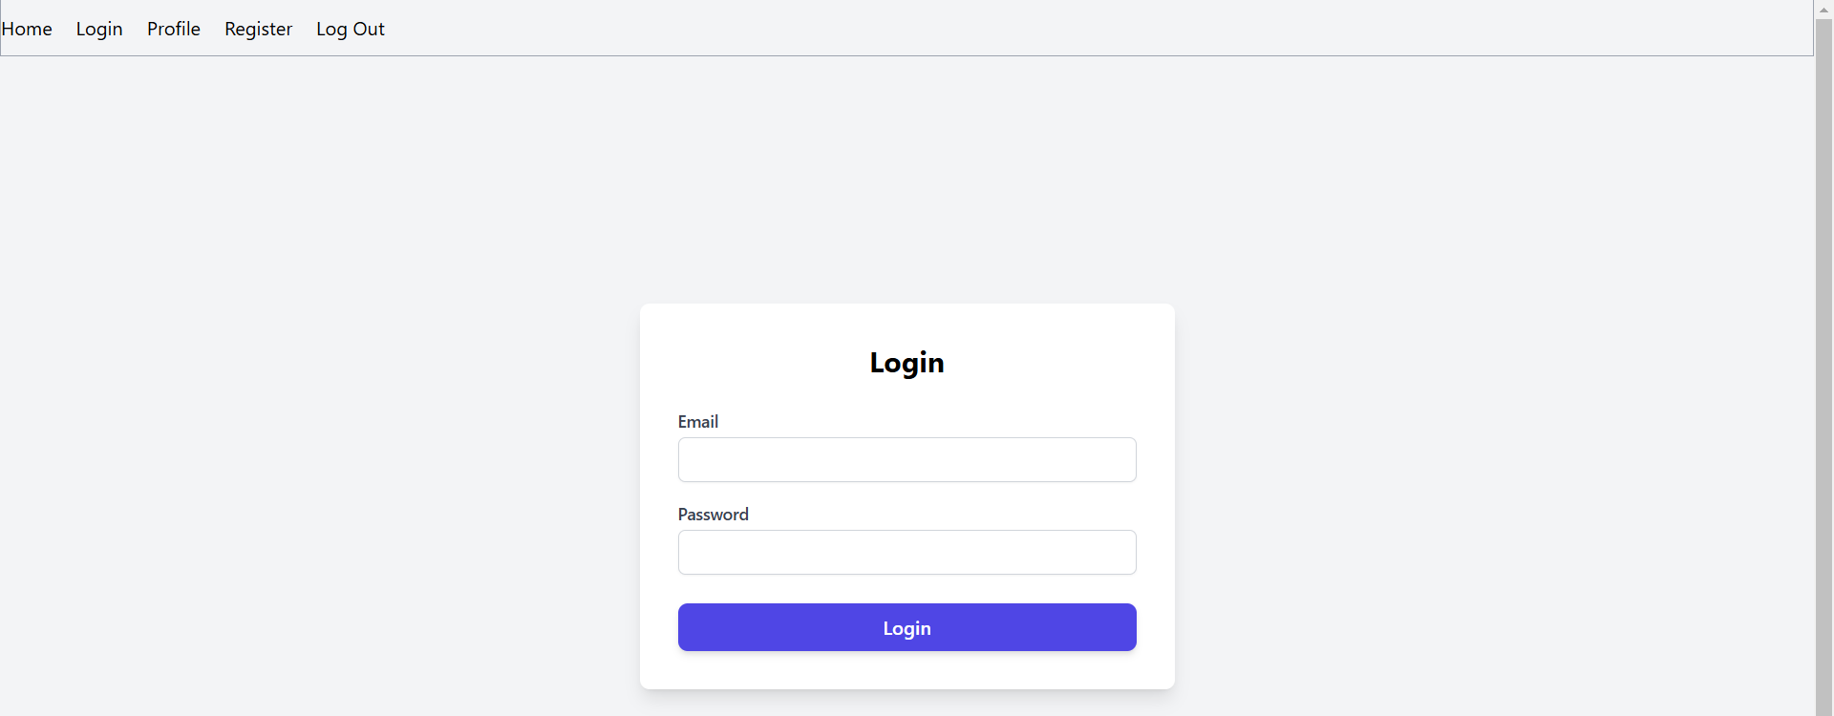

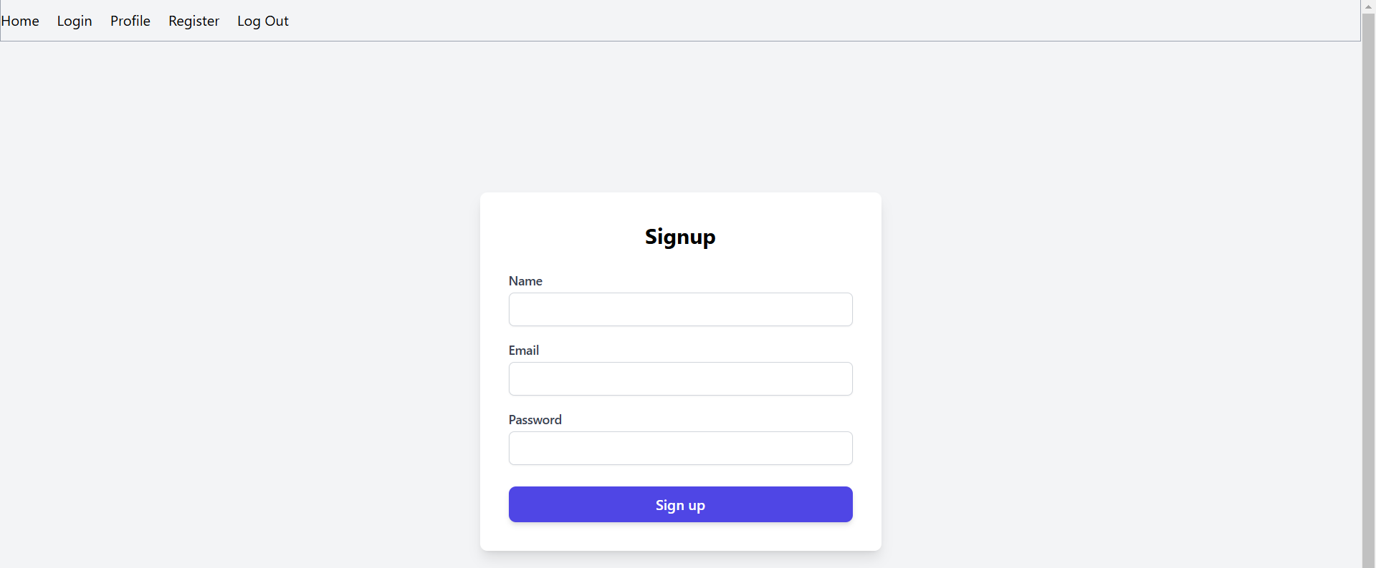

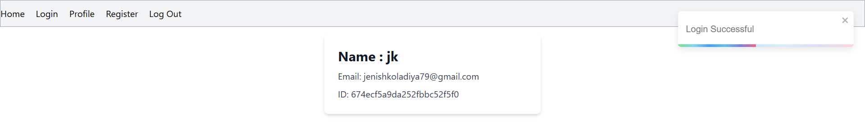

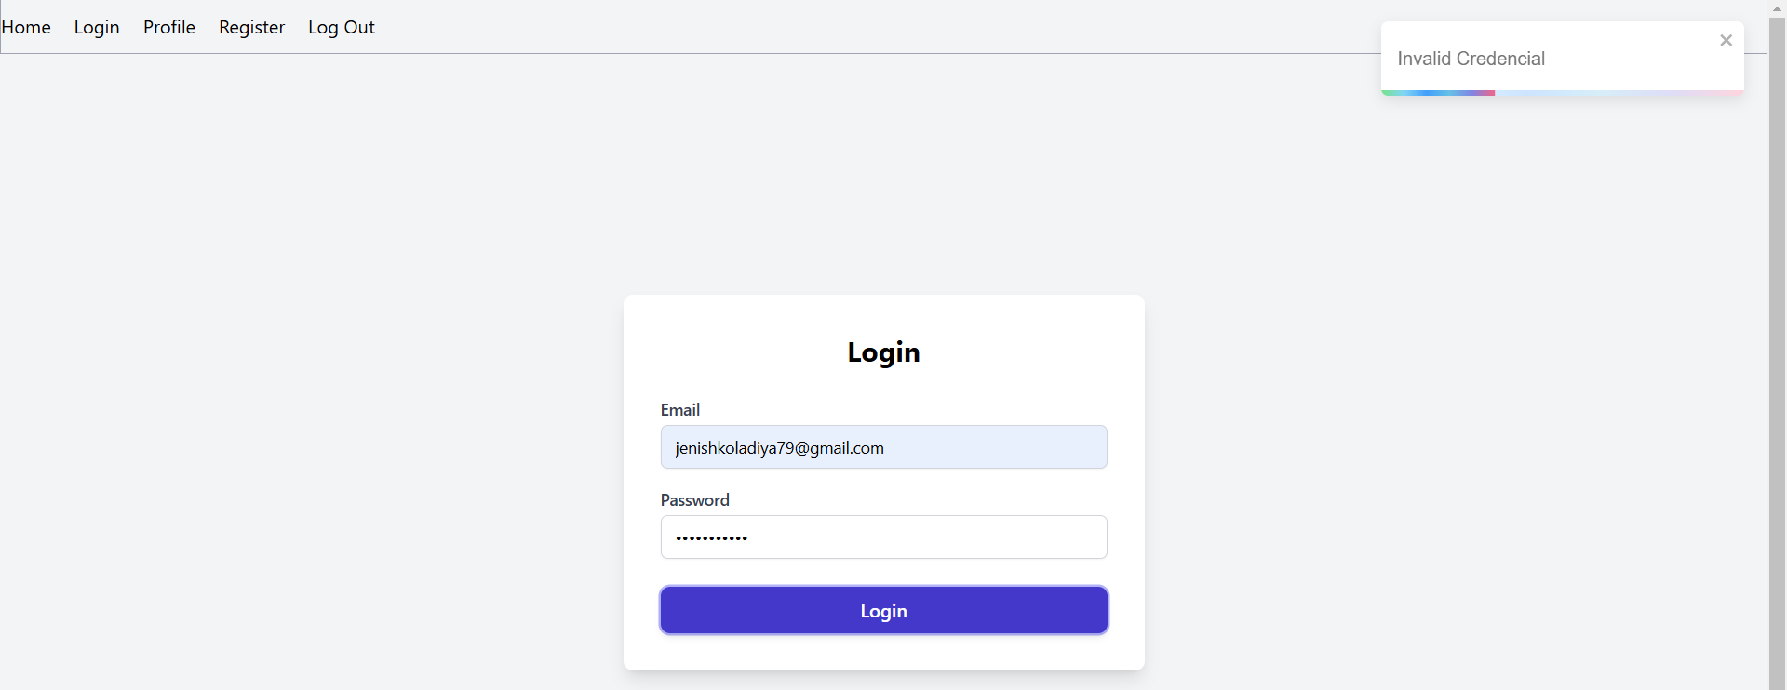

1. **Widget/Algorithm Used In Task**

* **React Router:** Used for setting up routes and navigation in React. It allows you to create protected routes that require authentication.
* **Private Route (Higher-Order Component):** A custom component that wraps around the protected routes and checks if the user is authenticated. If not, the user is redirected to the login page.
* **JWT (JSON Web Token):** A common authentication strategy used to verify and manage user sessions.