**Report**

1. **Task Description**

Create a dynamic table that automatically generates rows and columns based on an array of objects. The table should dynamically display data, allow for sorting by column, and handle empty datasets gracefully.

1. **Task Output Screenshot**

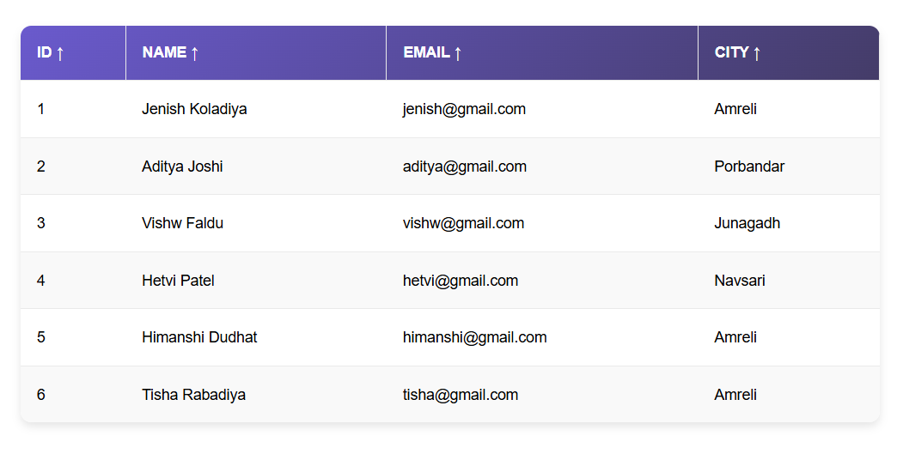

1. **Widget/Algorithm Used In Task**

* The table is generated dynamically by extracting column headers from the data using Object.keys() and rendering rows and cells with the help of the map() function. This ensures the table adapts automatically to any changes in the dataset.
* A sorting mechanism is implemented to sort the table data by clicking on column headers. It uses the JavaScript sort() method and toggles between ascending and descending orders based on the current state.
* To handle scenarios with no data, a conditional check displays a user-friendly "No data available" message instead of rendering an empty table.
* The state management for sorting and data display is handled using React's useState hook, making the table interactive and dynamic.
* The code is modular and reusable, leveraging React components to ensure scalability and ease of maintenance.