**Report**

1. **Task Description**

Create a dynamic form where users can add or remove rows with input fields for "Name," "Email," and "Password." Each row should allow real-time editing, with the form data updating automatically as users make changes. The form should be easy to use, visually clean, and include a submit button that gathers and displays the data entered by the user.

1. **Task Output Screenshot**

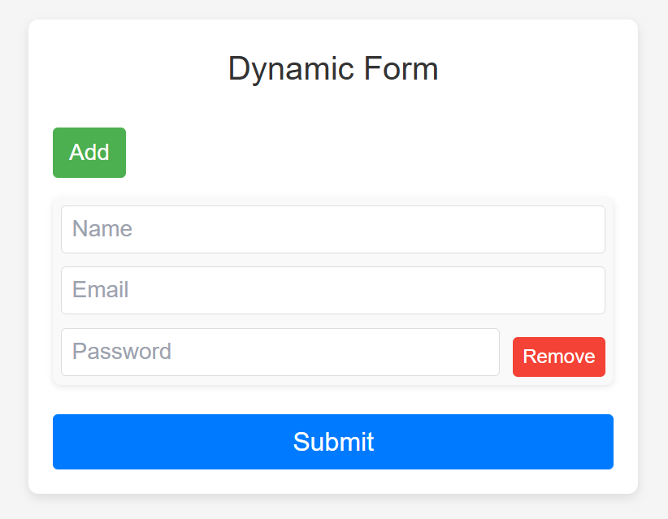

1. **Widget/Algorithm Used In Task**

* **Dynamic Form Widget**: The form utilizes a dynamic input field generation technique, allowing users to add or remove rows of "Name," "Email," and "Password" fields. This is handled through React’s state management and component re-rendering based on user actions.
* **Event Handling**: The form includes event handlers for adding rows, removing rows, and capturing user input. These handlers dynamically update the form data and manage the addition/removal of rows without reloading the page.
* **State Management**: React’s useState hook is used to manage and track the state of rows and form data, ensuring that all updates are reflected in the UI in real-time. This provides an efficient and responsive user experience.