**Report**

1. **Task Description**

This task is about setting up nested routes using React Router. It focuses on creating a multi-level navigation structure where users can access different views within a parent component, such as a dashboard with multiple sub-pages. This provides a more organized and scalable routing solution.

1. **Task Output Screenshot**

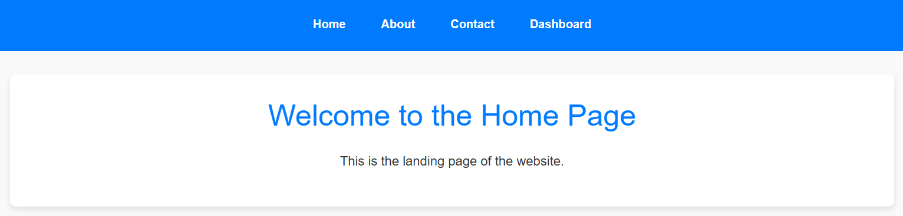

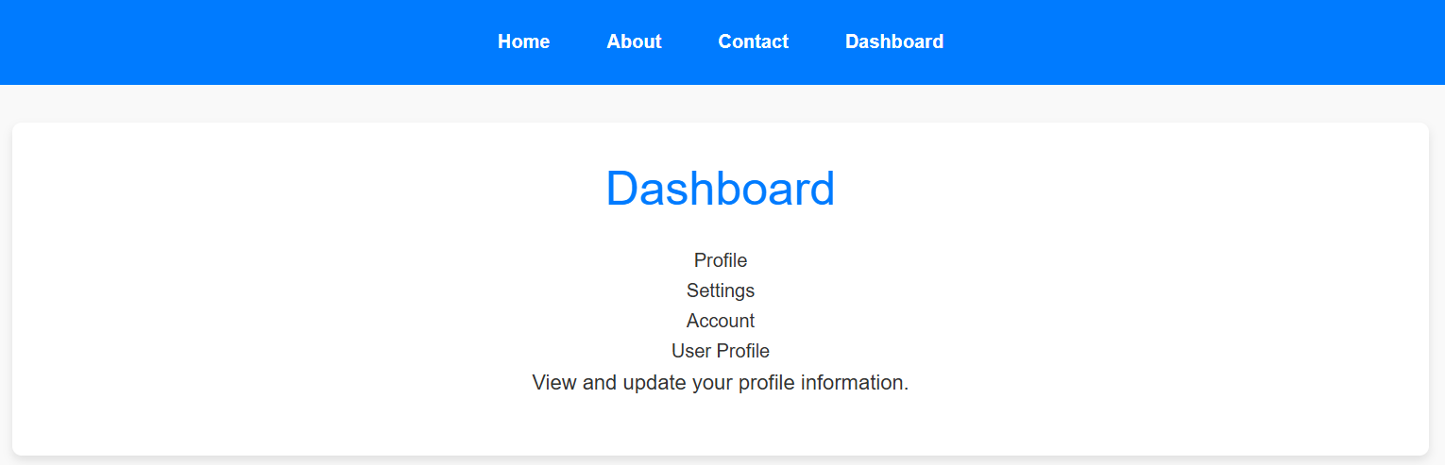

1. **Widget/Algorithm Used In Task**

* **React Router:** Used to handle both parent and child routes for nested routing.
* **Route Component:** Used to define both parent and child routes in a nested structure.
* **Outlet (React Router v6):** A special component used to render the matched child route within a parent route.