**Report**

1. **Task Description**

In this task, you will create a custom form component using React Hooks. The form should handle user inputs with validation using a specified library, ensuring the form data is managed efficiently. The validation ensures that all input fields are properly filled before submission.

1. **Task Output Screenshot**

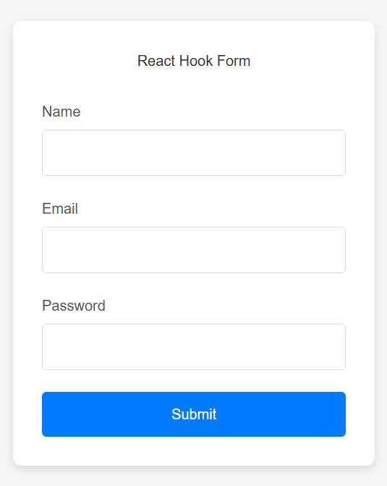

1. **Widget/Algorithm Used In Task**

* **React Hook Form:** A popular library used for building forms in React. It integrates well with React Hooks and provides validation capabilities.
* **Controlled Components:** Form elements (input fields, checkboxes, etc.) are controlled by React state to manage form data.
* A schema-based validation library that can be used alongside React Hook Form to validate form inputs.