## Edit Campaign – Bug

1. Click on Edit Icon

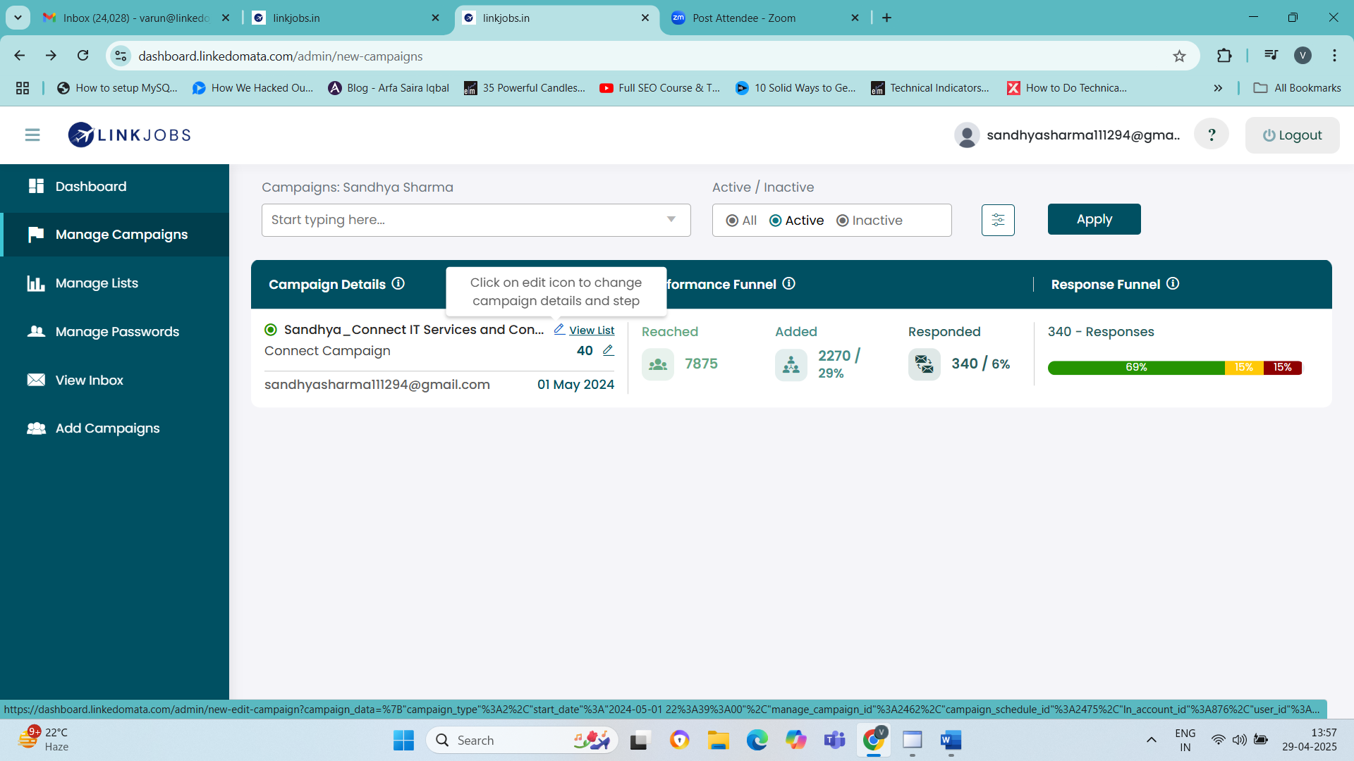

1. It gives the following error – Please fix this.

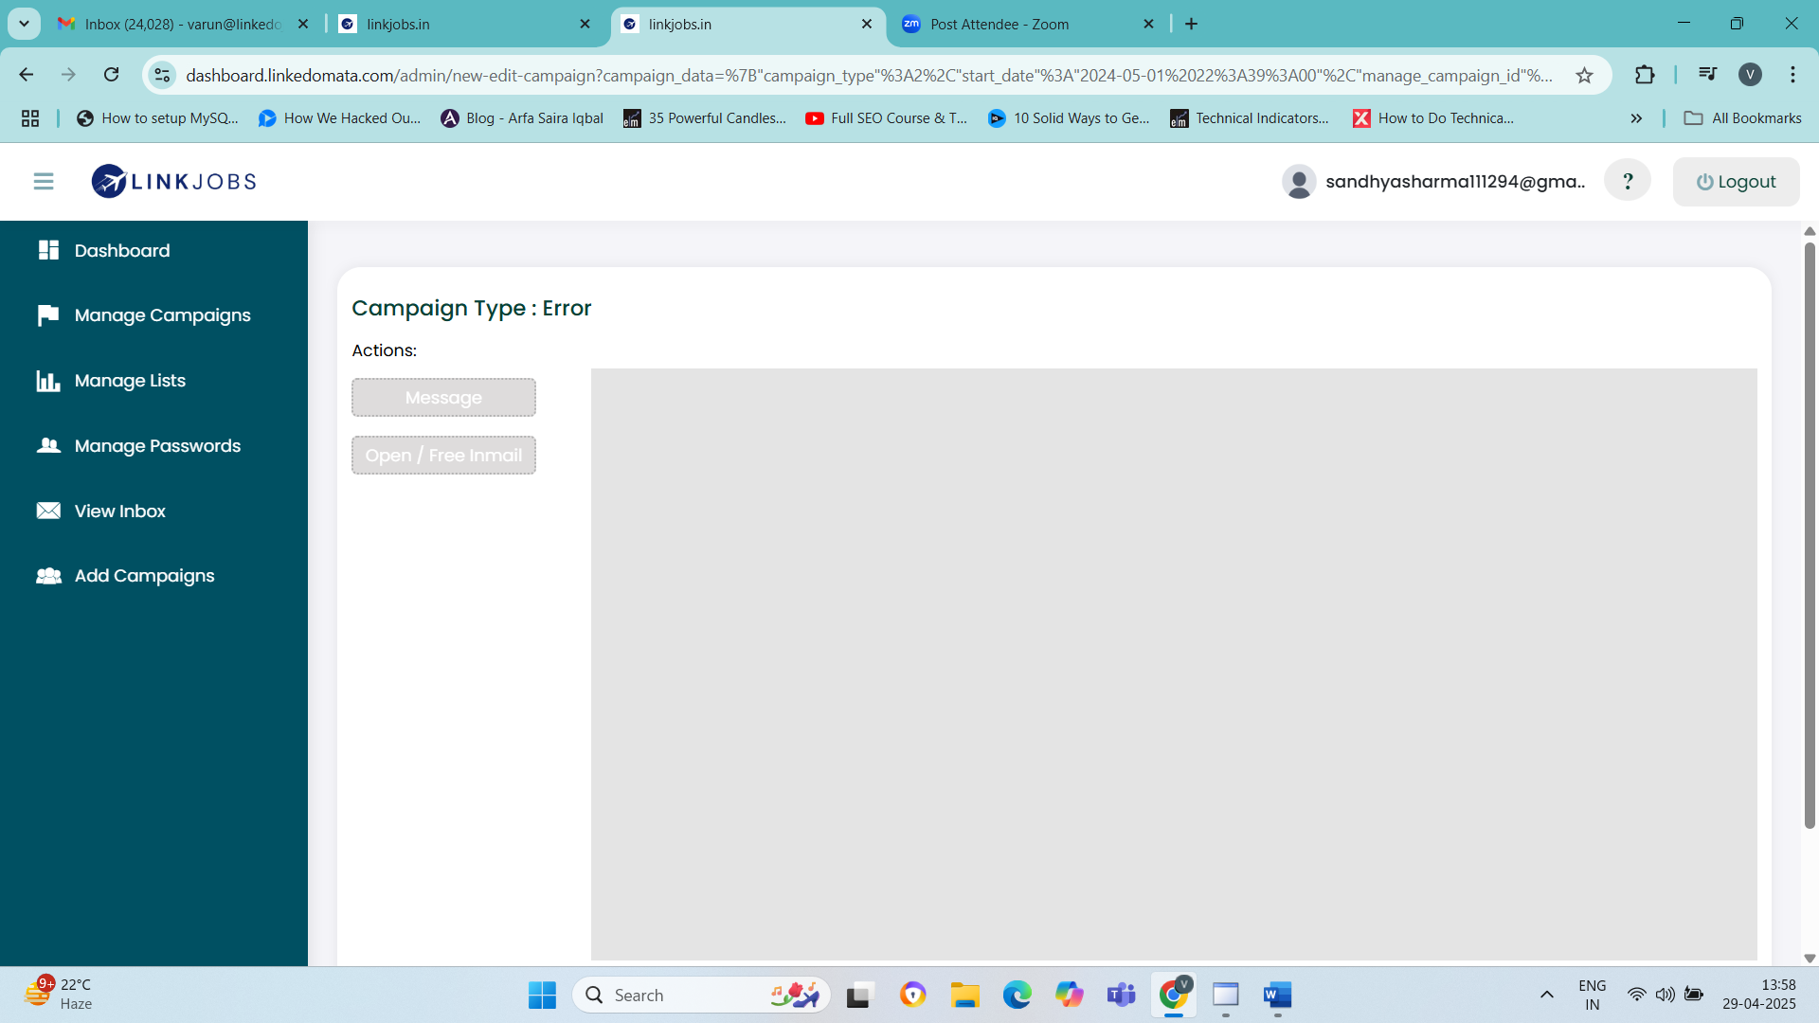

## Main Dashboard – Funnel Section – Mobile Version

Select a campaign and allow its Funnel View Load in Mobile.

Issue 1 **- Once the funnel is loaded – you will notice that there is no option to go Back to the previous page in the mobile version. The navigation Arrow is missing.**

Issue 2 **– No data is loaded in the replies section for the selected campaign.**

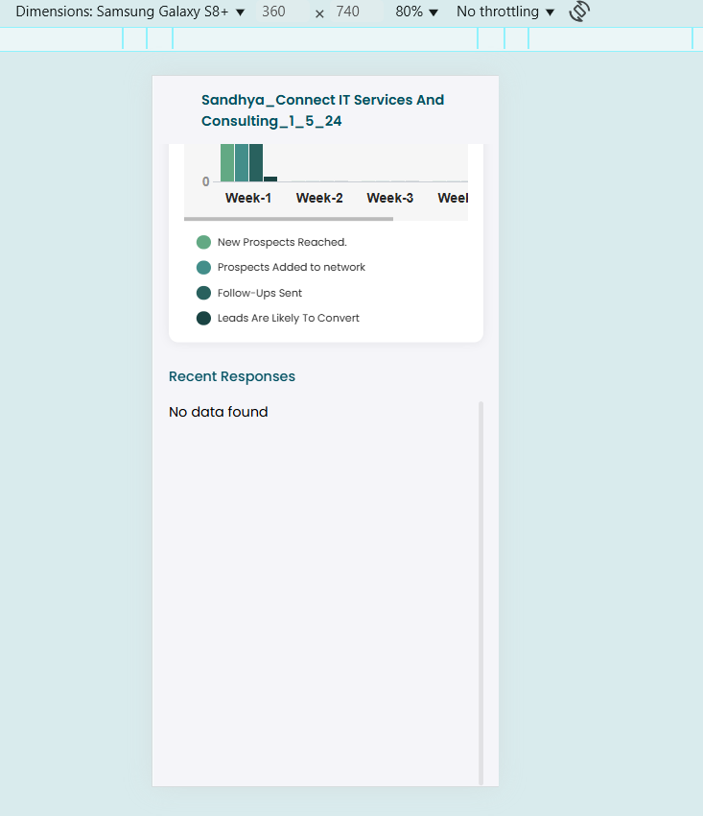

## View More Details

In this section, it doesn’t make sense to show the message “Please select a LinkedIn Account to see its daily results “since there is only one single account that is already pre-selected for the White label version.

Instead, I would **request that for White label allow data to be pre-loaded** for the selected period for **White labeled Version**

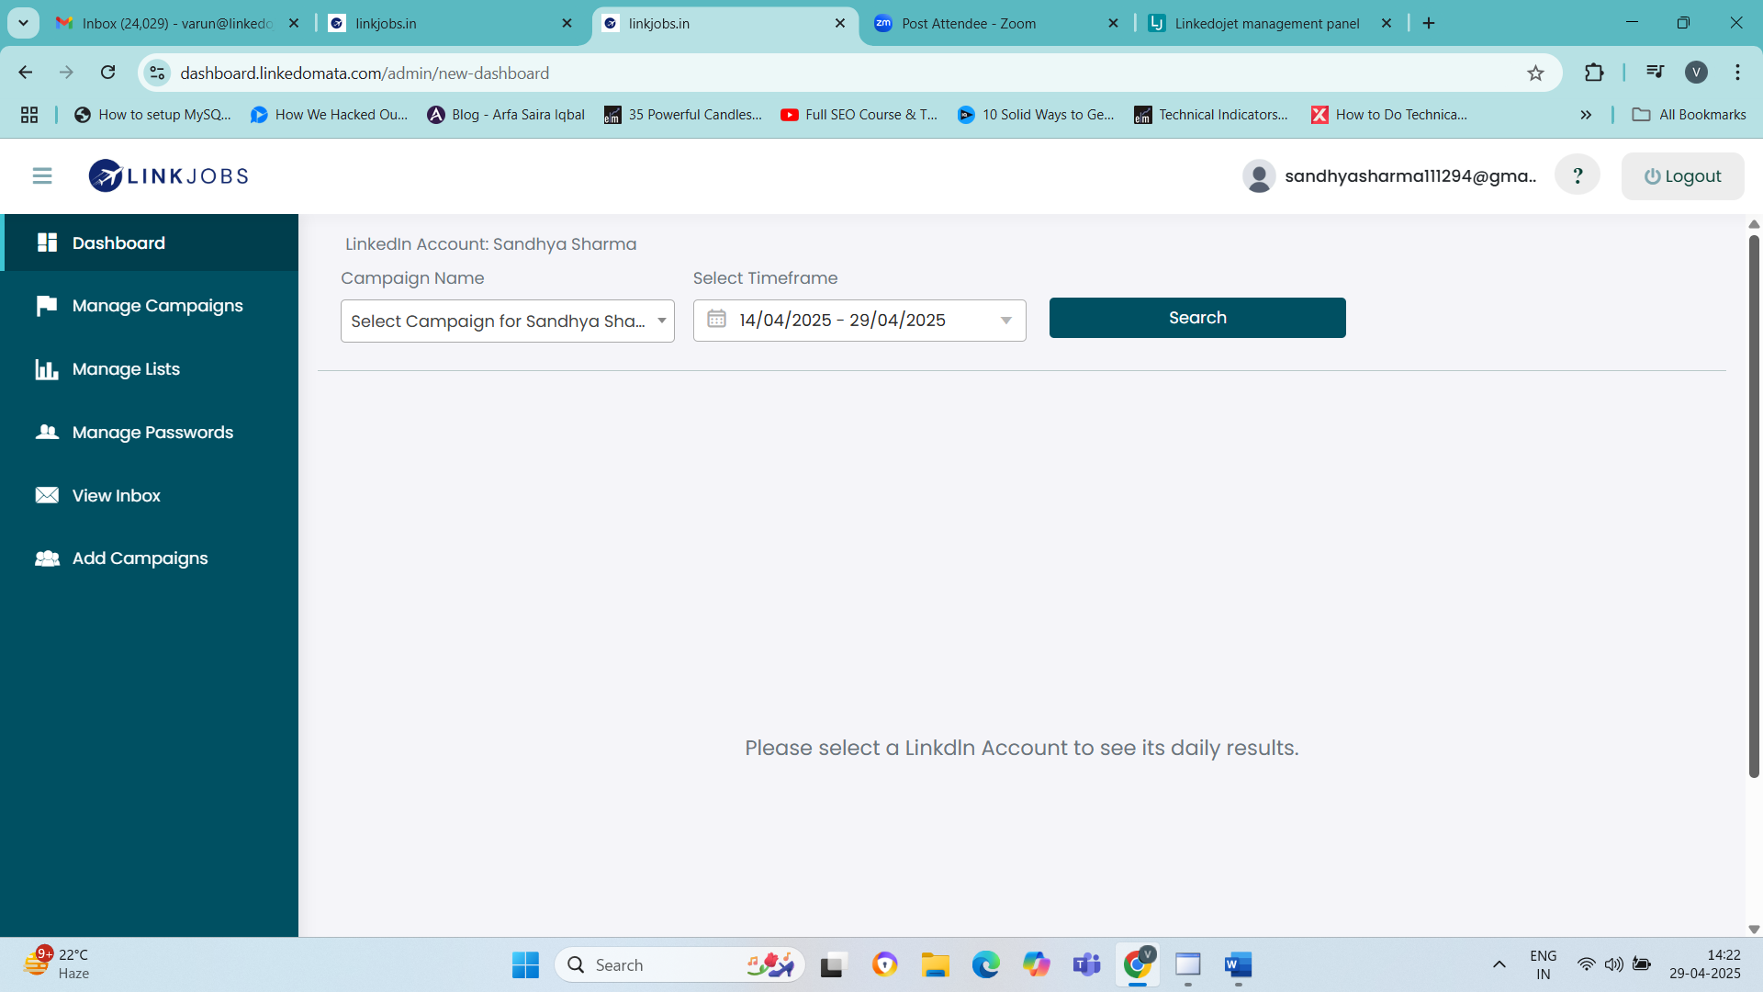

## Add Campaign

After setting up Sequence , List - the option to Summarize and Launch Campaign is not visible.

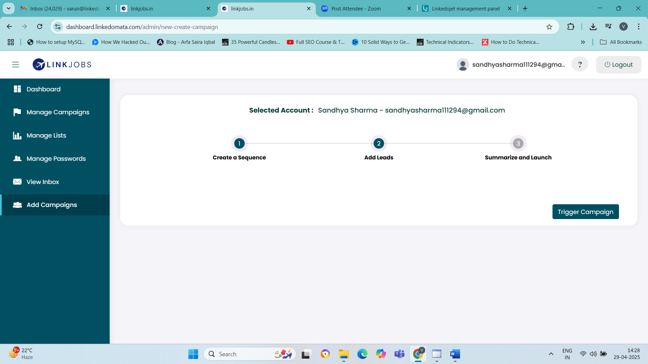

## Manage Passwords

Need to make a small update to its UI

Instead of 2 buttons , I would recommend using 2 Radio buttons with title

1. Update Dashboard Password.
2. Update LinkedIn Account Password.

