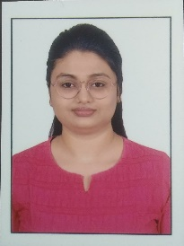
Resume
Name : Richa Naik
Mobile no: 9879074653
Email id: richanaik302@gmail.com
Languages known: English, Hindi and Gujarati
Date of birth:29/09/2000
Objective
Seeking the position of a teacher in your reputed school that will allow me to utilize my strong passion of teaching students which will enhance their academic and mental growth which can enlighten the young minds.

Professional efficiencies
- A passion about the teaching field with a great teaching aptitude .
- Thorough knowledge of the subject to be taught and background
- Great fluency in English and command over comprehension.
- Effective classroom management.

Educational qualification
- Pursuing B. SC. In Biotechnology from Veer Narmad South Gujarat University (2021-2024)
- 12th passed from CBSE Board with 99.97 percentile in 2020
- 10th passes from GSEB Board with 94.43 percentile in 2018
- Will be pursuing B.ED from April 2024 (From Gujarat University 2024-25)

Working Experience
Worked as tutor in Balaji tuition classes. Having an experience of teaching Biology and Science.

Extracurricular activities
- Participated in inter-college elocution competition
- Participated in essay writing competition by G20 Innovative india.
- Participated in “Vishva matru bhasha divas” speech giving competition.
- Participated in cultural programme in VNSGU.
- Participated in English, Science and mathematics olympaid .
- Awarded as student of the year for 5 times

Hobbies
- Reading
- Writing
- Acting
- Anchoring
- Working out
- Management
- Counselling

Declaration
- I hereby declare that all the details furnished above are true to the best of my knowledge.

Subject details
Dedicated Biology/Science educator with a strong academic background in Biology/Science and a passion for fostering student understanding. Seeking a Biology/Science teacher position to inspire and educate students in the wonders of the natural world.

Place : Surat,Gujarat
Date : 13/03/2024

