32) <!DOCTYPE html>

<html lang="en">

<head>

<meta charset="UTF-8">

<meta name="viewport" content="width=device-width, initial-scale=1.0">

<title>Document</title>

</head>

<body>

<script>

let a=0

let b=false;

let ans1=(a==b)

let ans2=(a===b)

console.log(ans1)

console.log(ans2)

</script>

</body>

</html>

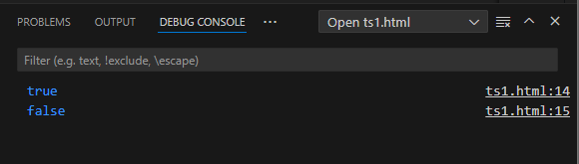

33)<!DOCTYPE html>

<html lang="en">

<head>

<meta charset="UTF-8">

<meta name="viewport" content="width=device-width, initial-scale=1.0">

<title>Document</title>

</head>

<body>

<script>

let a="jacky"

let b="jenishta"

let ans2=(a===b)

console.log(ans2)

</script>

</body>

</html>

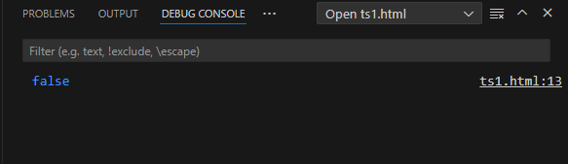

34)

<!DOCTYPE html>

<html lang="en">

<head>

<meta charset="UTF-8">

<meta name="viewport" content="width=device-width, initial-scale=1.0">

<title>Document</title>

</head>

<body>

<script>

let a=100

let b=150

let ans1=(a!=b)

let ans2=(a!==b)

console.log(ans1)

console.log(ans1)

</script>

</body>

</html>

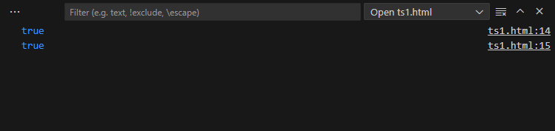

35)

<!DOCTYPE html>

<html lang="en">

<head>

<meta charset="UTF-8">

<meta name="viewport" content="width=device-width, initial-scale=1.0">

<title>Document</title>

</head>

<body>

<script>

let a=null

let b;

let ans1=(a==b)

let ans2=(a===b)

console.log(ans1)

console.log(ans1)

</script>

</body>

</html>

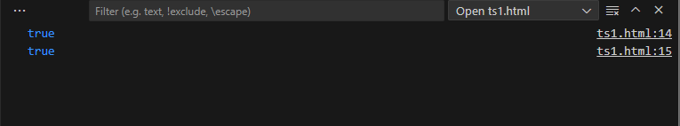

36)

<!DOCTYPE html>

<html lang="en">

<head>

<meta charset="UTF-8">

<meta name="viewport" content="width=device-width, initial-scale=1.0">

<title>Document</title>

</head>

<body>

<script>

let a=7

if(a%2==0)

console.log("EVEN")

else

console.log("ODD")

</script>

</body>

</html>

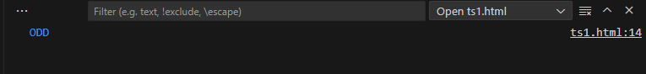

37)

<!DOCTYPE html>

<html lang="en">

<head>

<meta charset="UTF-8">

<meta name="viewport" content="width=device-width, initial-scale=1.0">

<title>Document</title>

</head>

<body>

<script>

let a=7

if(a==0){

console.log("ZERO")

}

else{

if(a<0){

console.log("NEGATIVE")

}

else{

console.log("POSITIVE")

}

}

</script>

</body>

</html>

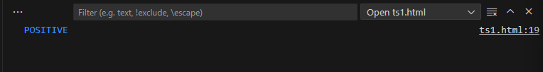

38)

<script>

let a=7

let b=10

let ans=(a>b)?true:false;

console.log(ans)

</script>

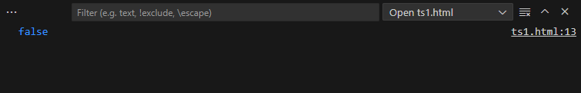

39)

<script>

let user = {

name: 'jeni',

address: {

city: 'cbe'

}

};

let city = user.address?.city;

console.log(city);

let country = user.address?.country;

console.log(country);

</script>

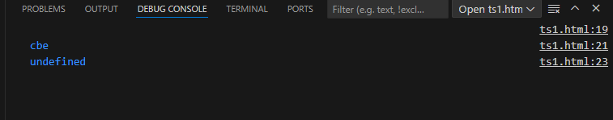

40) <script>

let a=-10;

let ans=(a<0)?a=10:a;

console.log(ans)

</script>

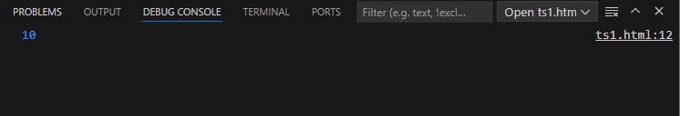

41)

<script>

let a=10;

let b=5

console.log(a&&b)

console.log(a||b)

console.log(!b)

</script>

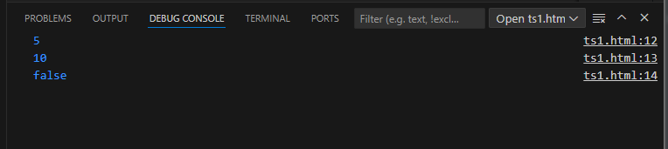

42)

<script>

let a=45

if(a>=0 && a<=100){

console.log("YES")

}

else{

console.log("NO")

}

</script>

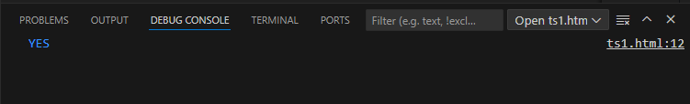

43)

<script>

let a=45

console.log(!a)

</script>

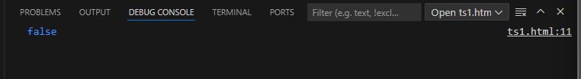

45)

<script>

let a=10

let b="hello"

console.log(a&&b)

</script>

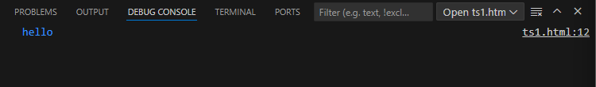

46) <script>

function sum(a,b){

return a+b;

}

console.log(sum(10,10))

</script>

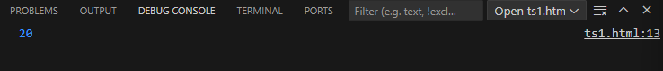

47)

<script>

function area(l,b){

return l\*b;

}

console.log”area of rectangle is”,+(area(5,10))

</script>

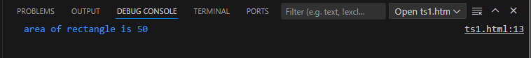

48)

<script>

function func(){

console.log("hello guys");

}

func();

</script>

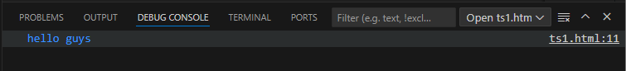

49)

<script>

function func(){

return;

}

console.log(func())

</script>

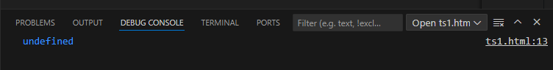

50) <script>

function func(n1=10,n2=20){

console.log(n1+n2)

}

func();

func(5,4)

func("hello","hai")

func(true,false)

</script>

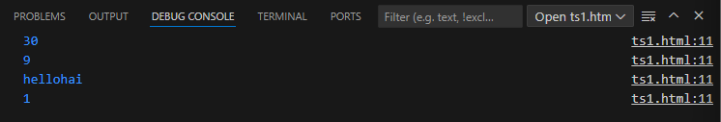

51)

<script>

let greets=(name)=>console.log(`hello,${name}!`);

greets("jacky")

</script>

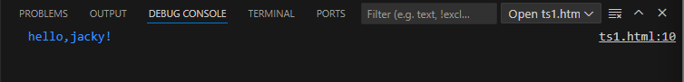

52)

<script>

let add=(n1,n2)=>console.log(n1+n2);

add(5,4)

add(2,9)

add(78,4)

add(5,15)

</script>

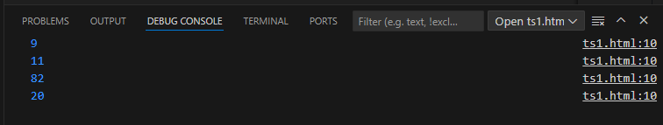

53)

<script>

let isEven=(n)=>(n%2==0)?true:false;

console.log(isEven(5))

console.log(isEven(6))

</script>

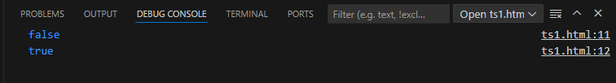

54)

<script>

let max=(n1,n2)=>{

return n1>n2?n1:n2;

}

console.log(max(5,3))

</script>

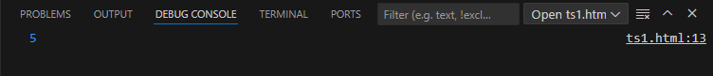

55)

<script>

let obj={

value:10,

traditional:function(n){

return this.value\*n;

},

arrowfun:(n)=>{

return this.value\*n;

}

}

console.log(obj.traditional(5))

console.log(obj.arrowfun(5))

</script>

