1) <script>

let book={

title:"ahaa",

author:"jacky",

year:2024,

getsummary(){

return "summarizing the book";

}

}

console.log(book.getsummary());

</script>

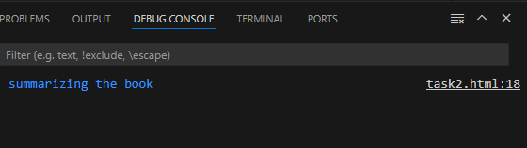

2) <script>

let book={

title:"ahaa",

author:"jacky",

year:2000,

getsummary(){

return "summarizing the book";

},

age(){

return 2024-this.year;

}

}

console.log(book.age());

</script>

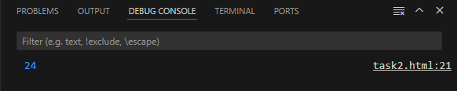

3) <script>

let calculator={

n:5,

m:3,

add(){

return this.n+this.m;

},

sub(){

return this.n-this.m;

},

mul(){

return this.n\*this.m;

},

div(){

return this.n/this.m;

}

}

console.log(calculator.add())

console.log(calculator.sub())

console.log(calculator.mul())

console.log(calculator.div())

</script>

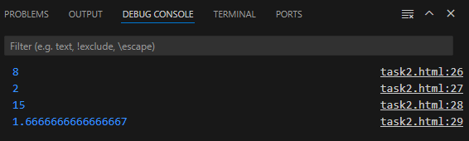

4)

<script>

let calculator={

n:5,

m:3,

history:[],

add(){

this.history.push(this.n+this.m)

},

sub(){

this.history.push(this.n-this.m)

},

mul(){

this. history.push(this.n\*this.m)

},

div(){

this.history.push(this.n/this.m)

},

gethistory:function(){

return this.history;

}

}

calculator.add()

calculator.sub()

calculator.mul()

calculator.div()

console.log(calculator.gethistory())

</script>

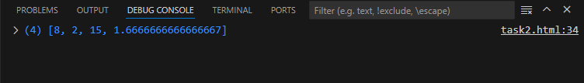

5)

<script>

let person={

age:25,

inc(n){

this.age+=n

},

dec(n){

this.age-=n;

if(this.age<0)

this.age=0;

}

}

person.inc(5);

person.dec(10)

person.dec(25)

console.log(person.age)

</script>

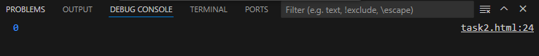

6) <script>

let person={

name:"jeni",

greet(){

console.log(`hello my name is,${this.name}`);

}

}

person.greet()

</script>

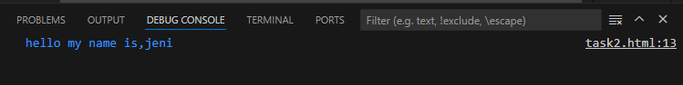

7)

<script>

let circle={

radius:5,

calculate(){

return 3.14\*this.radius\*this.radius;

}

}

console.log(“radius is”,+circle.calculate())

</script>



8)

<script>

let circle={

radius:5,

calculate(){

return 3.14\*this.radius\*this.radius;

},

diameter(){

return 2\*this.radius;

},

circumference(){

return 2\*3.14\*this.radius;

}

}

console.log("radius is",+circle.calculate())

console.log("diameter is",+circle.diameter())

console.log("circumference is",+circle.circumference())

</script>

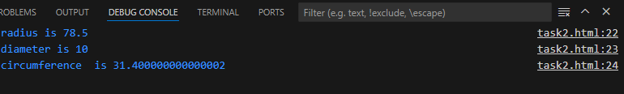

9) <script>

let account={

name:"jeni",

bal:2000,

deposit(n){

return this.bal+=n;

},

withdraw(n){

return this.bal-=n;

}

}

console.log("balance amount after deposit",+account.deposit(500))

console.log("balance amount after withdraw",+account.withdraw(1000))

</script>

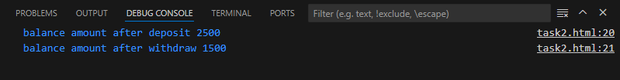

10)

<script>

let account={

name:"jeni",

bal:2000,

deposit(n){

return this.bal+=n;

},

withdraw(n){

this.bal-=n;

if(this.bal<0){

return this.bal=0;

}

else

return this.bal;

}

}

console.log("balance amount after deposit",+account.deposit(500))

console.log("balance amount after withdraw",+account.withdraw(3000))

</script>

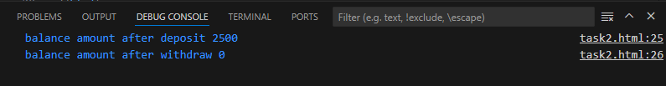

11) <script>

let fruits=["apple","orange","pineapple"]

fruits.push("mango")

console.log(fruits)

</script>



12) <script>

let fruits=["apple","orange","pineapple"]

fruits.pop()

console.log(fruits)

</script>



13) <script>

let fruits=["apple","orange","pineapple"]

fruits.unshift("straberry")

console.log(fruits)

</script>



14)

<script>

let fruits=["apple","orange","pineapple"]

fruits.shift()

console.log(fruits)

</script>

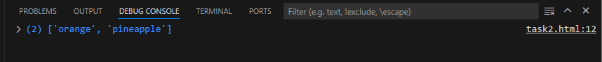

15) <script>

function arr(a){

a.push(7);

}

let a=[1,2,4,5,3]

arr(a)

console.log(a);

</script>

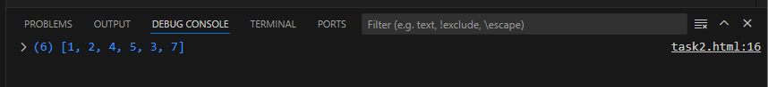

16) <script>

function str(s){

let arr=s.split(" ") ;

arr.pop()

console.log(arr)

}

let s="hello i am jenishta cse"

str(s)

</script>



17)

<script>

let weeks=["sun","mon","tue","wed","thu","fri","sat"];

let s=weeks.shift();

weeks.push(s)

console.log(weeks)

</script>



18) <script>

function add(letters){

letters.unshift('z')

letters.push('z')

}

let letters=['a','b','c','d','e'];

add(letters)

console.log(letters)

</script>



19)

<script>

let movie=["dada","joe","rayan","visvasam","gilli"];

let str=prompt("enter movie name?")

movie.push(str)

console.log(movie)

</script>



20)

<script>

let movie=["dada","joe","rayan","visvasam","gilli"];

let n=3-1

movie.splice(2,1)

console.log(movie)

</script>



21)

<script>

let num=[1,2,3,4,5]

let tosquare=t=>t\*t;

let square=num.map(tosquare)

console.log(square)

</script>



22)

<script>

let num=[1,2,3,4,5]

let ans=num.filter(num=>num%2==0)

console.log(ans)

</script>

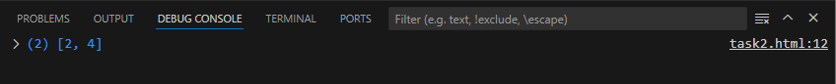

23)

<script>

let prices=[50,20,90,100]

let ans=prices.reduce((sum,i)=>sum+i,0)

console.log(ans)

</script>

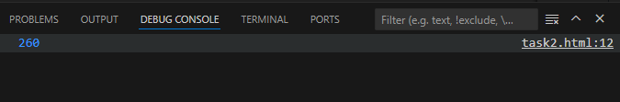

24)

<script>

let str=["jeni","hello","jackyjenish","javascript"]

let tolength=n=>n.length;

let length=str.map(tolength)

console.log(length)

</script>

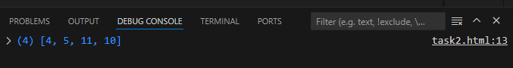

25)

<script>

let str=["hello","hai","js","html","css"]

str.splice(2,1,"replaces!")

console.log(str)

</script>

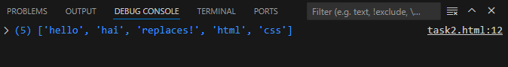

26)

<script>

let arr=[1,2,3,4,5,6,7]

let newarr=arr.slice(1,4)

console.log(newarr)

</script>

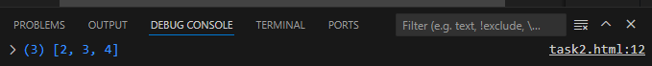

27) <script>

let names=["jeni","sheela","Agalya","ram","Angel"]

let char=names.filter(n=>n.startsWith('A'))

console.log(char)

</script>

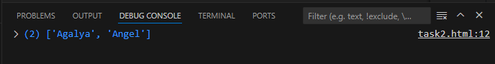

28)

<script>

let scores=[90,86,56,99,100,75,80,60]

let grade=scores.map(n=>{

if(n>=90)

return 'A';

else if(n<90 && n>=80)

return 'B';

else if(n<80 && n>=70)

return 'C';

else if(n<70 && n>=60)

return 'D'

else

return 'E'

})

console.log(grade)

</script>

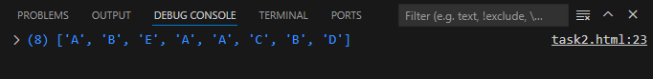

29)

<script>

let scores=[25,40,36,19,28,29]

let avgsc=scores.reduce((sum,i)=>sum+i,0)

let avg=avgsc/scores.length;

console.log(avg)

</script>

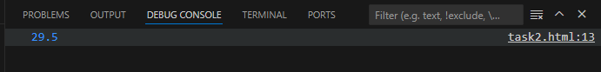

30)

<script>

let fruits=["mango","jerry","apple"]

fruits.splice(2,0,"pineapple","strawberry")

console.log(fruits)

</script>

