EXPERIMENT 5
SELECT with Various Clauses – WHERE, Pattern Matching

AIM
To study and execute the SELECT statement using WHERE clause and pattern matching in MySQL.
THEORY
The SELECT statement is used to retrieve records from a table. It can be used with different clauses such as WHERE, LIKE, and DISTINCT to filter and display data based on specific conditions.
PROCEDURE
1. Select the required database.
2. Display the table.
3. Execute different SELECT statements.
4. Apply WHERE clause for conditional retrieval.
5. Use LIKE for pattern matching.
6. Verify the output after each query.
QUERIES AND OUTPUTS
1. Select the database
USE PetAdoptionDB;


2. Display available tables
SHOW TABLES;

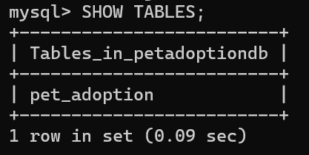
3. Display all records
SELECT * FROM Pet_Adoption;

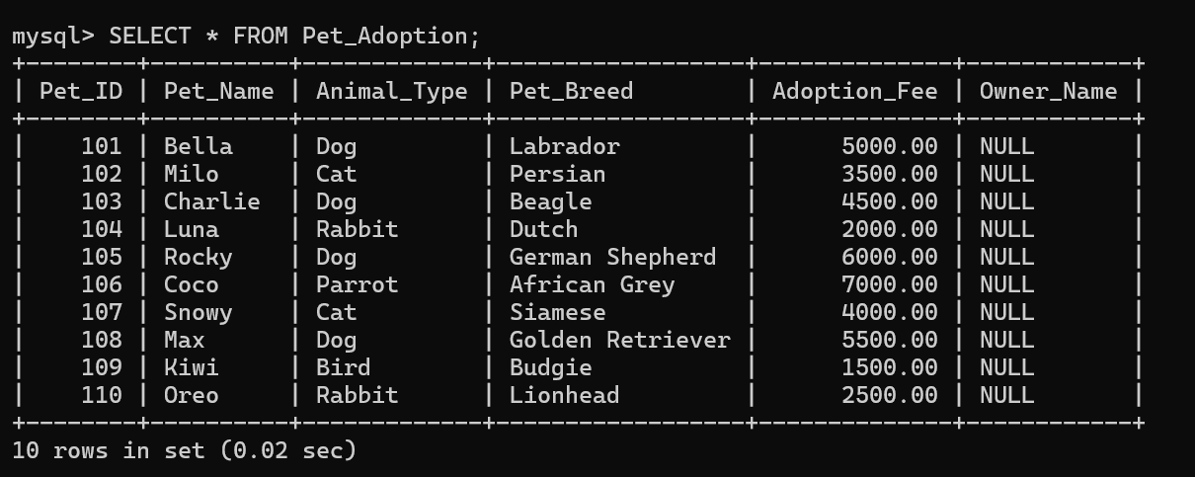
4. Display selected columns
SELECT Pet_Name, Animal_Type FROM Pet_Adoption;

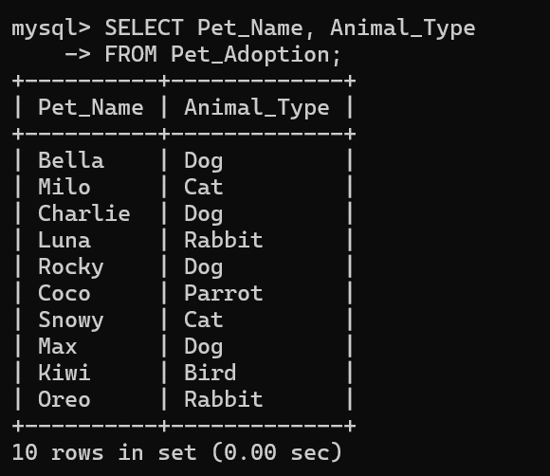
5. Display three columns
SELECT Pet_ID, Pet_Name, Adoption_Fee FROM Pet_Adoption;

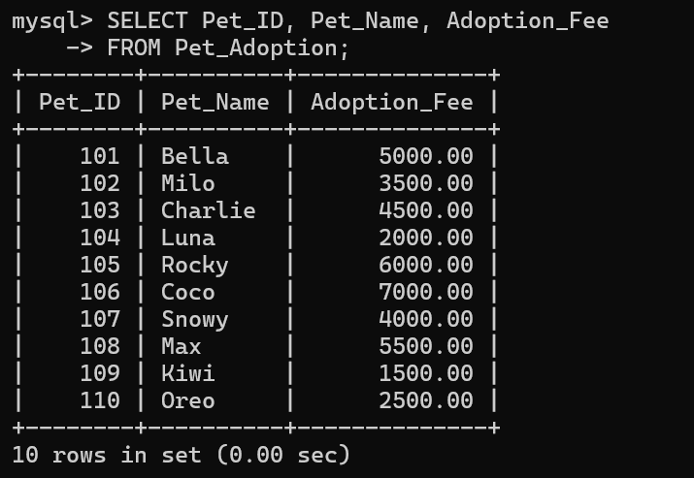
6. Display distinct animal types
SELECT DISTINCT Animal_Type FROM Pet_Adoption;

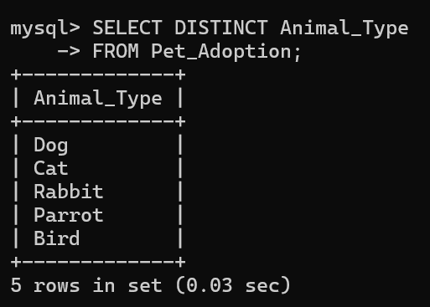
7. Display pets whose animal type is Dog
SELECT * FROM Pet_Adoption WHERE Animal_Type='Dog';

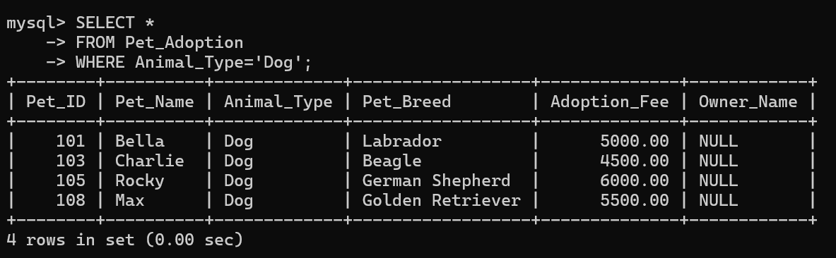
8. Display pets whose adoption fee is greater than 4000
SELECT * FROM Pet_Adoption WHERE Adoption_Fee>4000;

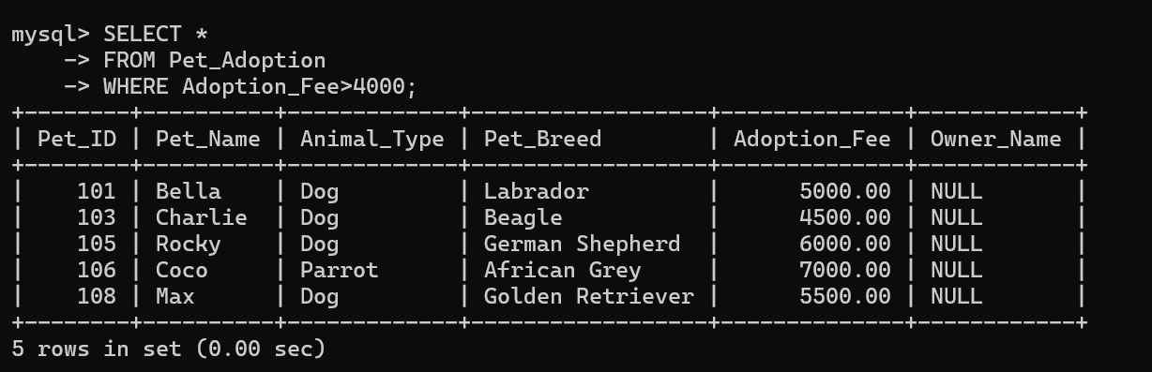
9. Display pets whose adoption fee is less than 3000
SELECT * FROM Pet_Adoption WHERE Adoption_Fee<3000;

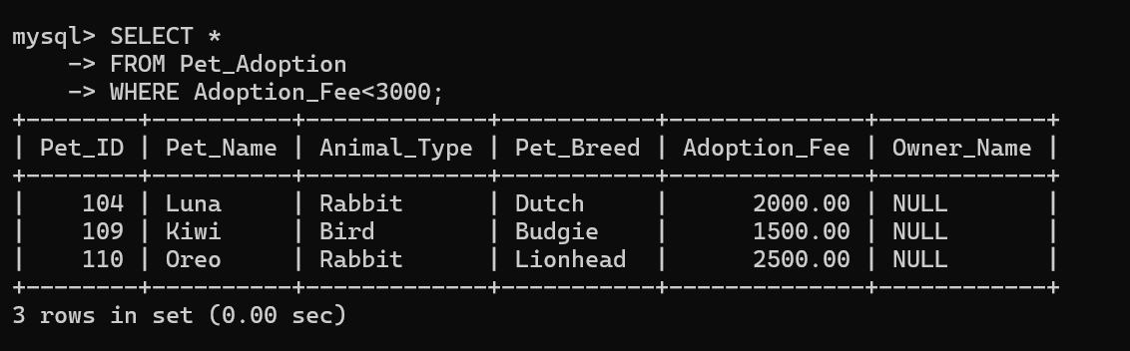
10. Display pets whose name starts with 'B'
SELECT * FROM Pet_Adoption WHERE Pet_Name LIKE 'B%';

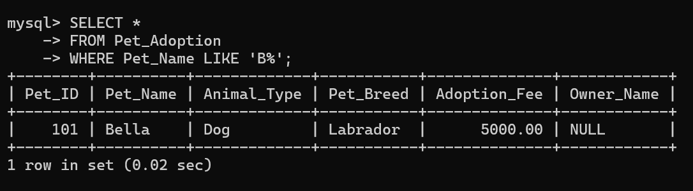
11. Display pets whose name ends with 'a'
SELECT * FROM Pet_Adoption WHERE Pet_Name LIKE '%a';

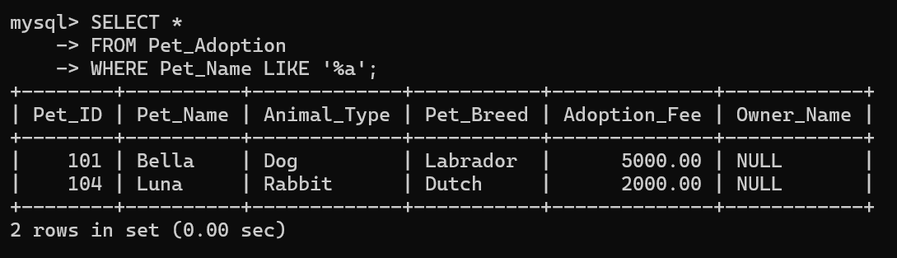
12. Display pets whose second letter is 'e'
SELECT * FROM Pet_Adoption WHERE Pet_Name LIKE '_e%';

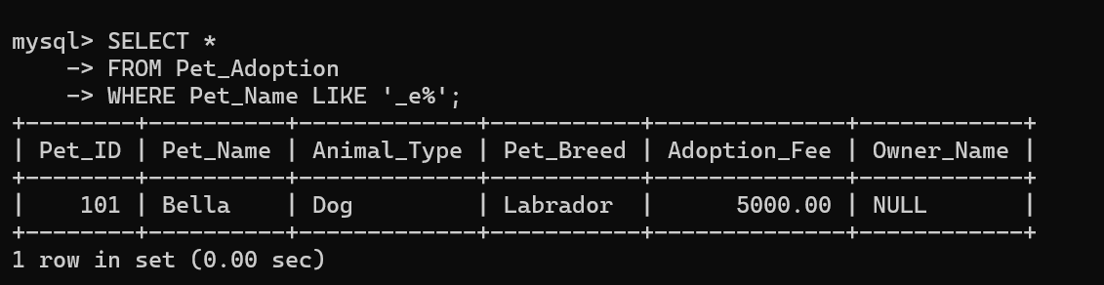
13. Display pets containing the letter 'o'
SELECT * FROM Pet_Adoption WHERE Pet_Name LIKE '%o%';

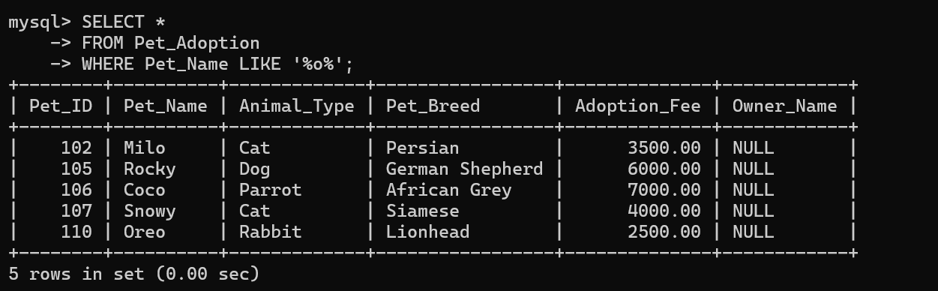
RESULT
Thus, the SELECT statement was executed successfully using WHERE, DISTINCT, and LIKE clauses to retrieve records based on different conditions.

