EXPERIMENT 6
SELECT with Various Clauses – BETWEEN, IN, Aggregate Functions

AIM
To study and execute the SELECT statement using BETWEEN, IN, and Aggregate Functions in MySQL.
THEORY
The BETWEEN clause retrieves records within a specified range. The IN clause retrieves records matching multiple values. Aggregate functions perform calculations on groups of records and return a single value.
PROCEDURE
1. Select the required database.
2. Display the table.
3. Execute SELECT statements using BETWEEN.
4. Execute SELECT statements using IN.
5. Apply aggregate functions.
6. Verify the output after each query.
QUERIES AND OUTPUTS
1. Display pets with adoption fee between 3000 and 6000
SELECT * FROM Pet_Adoption WHERE Adoption_Fee BETWEEN 3000 AND 6000;

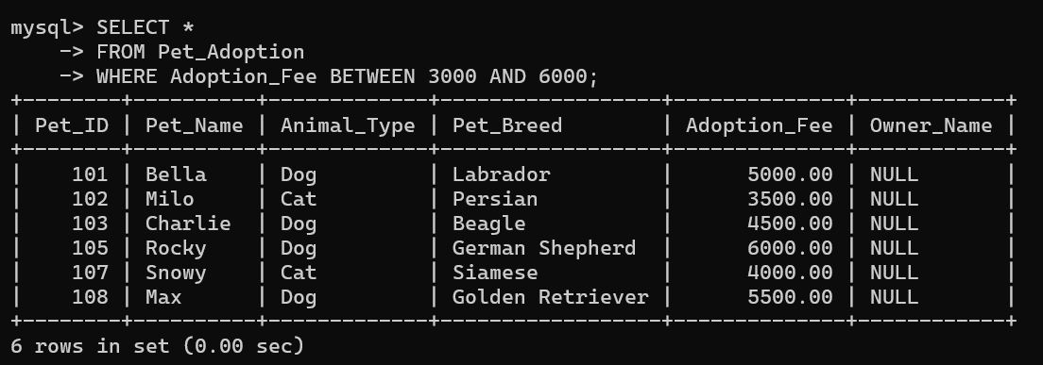
2. Display pets with Pet_ID between 103 and 108
SELECT * FROM Pet_Adoption WHERE Pet_ID BETWEEN 103 AND 108;

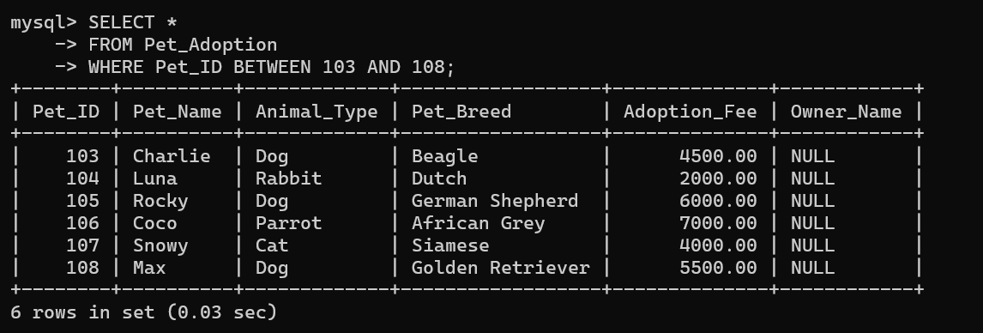
3. Display Dogs and Cats only
SELECT * FROM Pet_Adoption WHERE Animal_Type IN ('Dog', 'Cat');

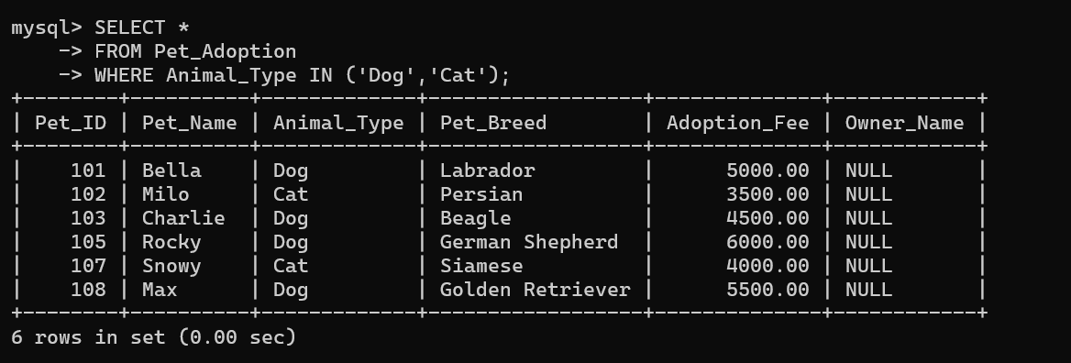
4. Display selected pet names
SELECT * FROM Pet_Adoption WHERE Pet_Name IN ('Bella', 'Milo', 'Max');

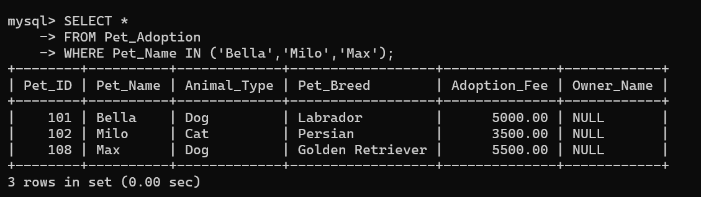
5. Count the total number of pets
SELECT COUNT(*) AS Total_Pets FROM Pet_Adoption;

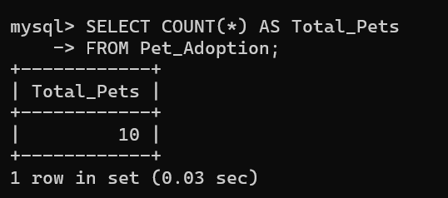
6. Display the highest adoption fee
SELECT MAX(Adoption_Fee) AS Highest_Fee FROM Pet_Adoption;

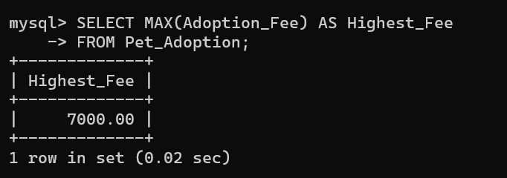
7. Display the lowest adoption fee
SELECT MIN(Adoption_Fee) AS Lowest_Fee FROM Pet_Adoption;

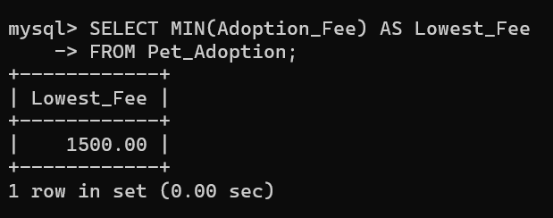
8. Display the average adoption fee
SELECT AVG(Adoption_Fee) AS Average_Fee FROM Pet_Adoption;

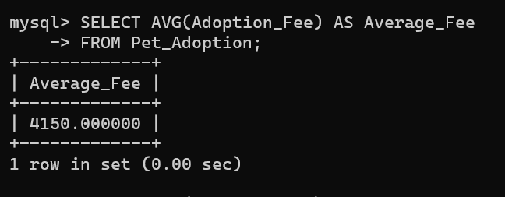
9. Display the total adoption fee
SELECT SUM(Adoption_Fee) AS Total_Fee FROM Pet_Adoption;

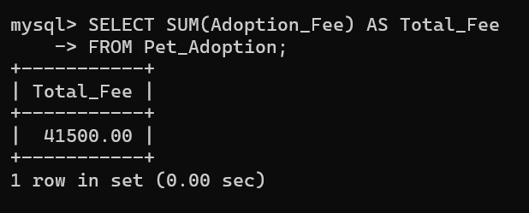
RESULT
Thus, the SELECT statement was executed successfully using BETWEEN, IN, and aggregate functions to retrieve and summarize data from the table.

