Experiment: 10
Database with VIEW and INDEX

AIM
To create VIEW and INDEX on the given relation.
DESCRIPTION
VIEW
A View is a virtual table created from one or more existing tables. It stores the query instead of storing data.
INDEX
An Index improves the speed of retrieving records from a table by creating a faster lookup mechanism.
SYNTAX
VIEW
CREATE VIEW view_name AS
SELECT column_name
FROM table_name;

INDEX
CREATE INDEX index_name
ON table_name(column_name);

QUERIES AND OUTPUTS
Use the database
USE PetAdoptionDB;
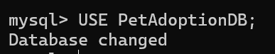

VIEW
1. Create a view named v1 containing Pet_ID and Pet_Name.
CREATE VIEW v1 AS
SELECT Pet_ID, Pet_Name
FROM Pet_Adoption;
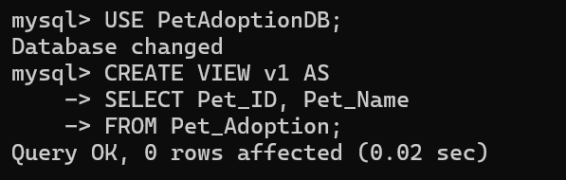

2. Display the view.
SELECT * FROM v1;

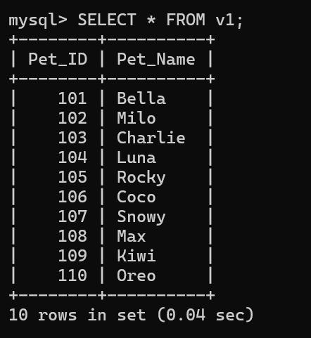
INDEX
1. Create an index on Adoption_Fee and display pets having adoption fee greater than 5000.
CREATE INDEX index1
ON Pet_Adoption(Adoption_Fee);
SELECT Pet_Name
FROM Pet_Adoption
WHERE Adoption_Fee > 5000;
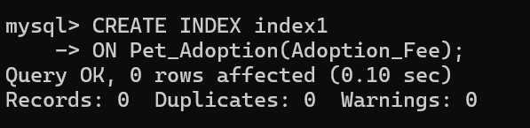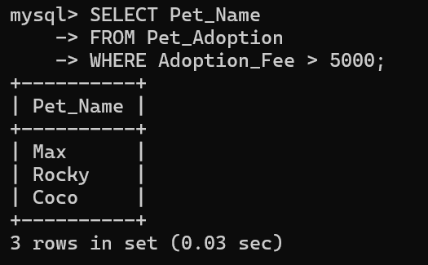

2. Drop the index.
DROP INDEX index1
ON Pet_Adoption;
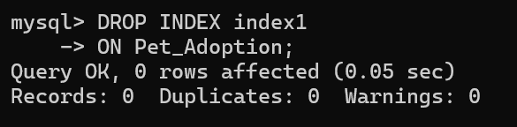

RESULT
Thus, the VIEW and INDEX were created successfully, and the records were retrieved efficiently from the Pet_Adoption table.

