Experiment: 11
DATABASE WITH AUTO_INCREMENT SEQUENCES

AIM
To create an AUTO_INCREMENT sequence on the given relation.
DESCRIPTION
AUTO_INCREMENT
The AUTO_INCREMENT attribute in MySQL is used to generate unique numbers automatically whenever a new record is inserted into a table.
• It is generally applied to the PRIMARY KEY column.
• MySQL automatically assigns the next available number whenever a new row is inserted.
• AUTO_INCREMENT helps maintain unique identification values without manual entry.
SYNTAX
CREATE TABLE table_name(
column_name INT AUTO_INCREMENT PRIMARY KEY,
column_name datatype,
...
);

QUERIES AND OUTPUTS
Use the database
USE PetAdoptionDB;


1. Create a table with AUTO_INCREMENT for Pet_ID.
CREATE TABLE Pet_Record(
Pet_ID INT AUTO_INCREMENT PRIMARY KEY,
Pet_Name VARCHAR(30),
Animal_Type VARCHAR(20),
Adoption_Fee DECIMAL(8,2)
);
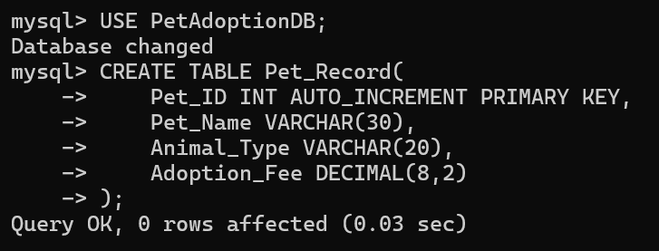

2. Insert records without specifying Pet_ID.
INSERT INTO Pet_Record(Pet_Name, Animal_Type, Adoption_Fee) VALUES
('Bruno', 'Dog', 4500),
('Lily', 'Cat', 3500),
('Tom', 'Rabbit', 2500);
SELECT * FROM Pet_Record;
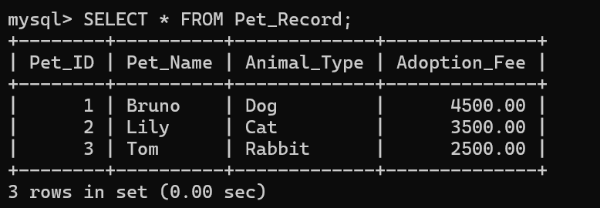

3. Create another table and manually populate Pet_ID.
CREATE TABLE Pet_Record_Manual(
Pet_ID INT PRIMARY KEY,
Pet_Name VARCHAR(30),
Animal_Type VARCHAR(20),
Adoption_Fee DECIMAL(8,2)
);
INSERT INTO Pet_Record_Manual VALUES
(101, 'Bruno', 'Dog', 4500),
(102, 'Lily', 'Cat', 3500),
(103, 'Tom', 'Rabbit', 2500);
SELECT * FROM Pet_Record_Manual;

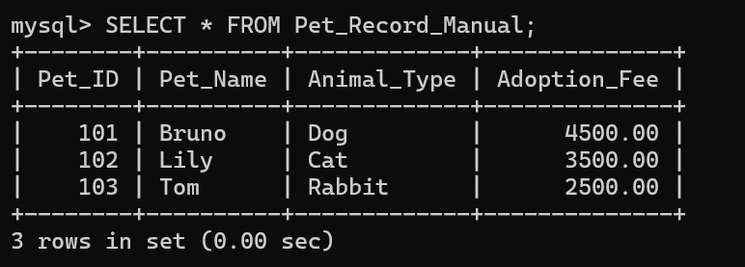
4. Drop the AUTO_INCREMENT table.
DROP TABLE Pet_Record;


RESULT
Thus, the AUTO_INCREMENT sequence was created successfully and the records were inserted automatically as well as manually.

