Experiment.: 7
SELECT with Various Clauses – GROUP BY, HAVING, ORDER BY

AIM
To view the records from the table using SELECT commands with GROUP BY, HAVING, and ORDER BY.
DESCRIPTION
GROUP BY – HAVING
• The GROUP BY clause groups a set of rows into summary rows based on the values of one or more columns. It returns one row for each group, thereby reducing the number of rows in the result set.
• The GROUP BY clause is used with aggregate functions such as SUM(), AVG(), MAX(), MIN(), and COUNT(). These functions provide summarized information for each group.
• The GROUP BY clause is an optional clause of the SELECT statement.
• To filter the grouped records, the HAVING clause is used after the GROUP BY clause.
ORDER BY
• When the SELECT statement retrieves records from a table, the result set is not sorted by default.
• The ORDER BY clause is used to sort the result set.
• It allows sorting based on one or more columns.
• The records can be arranged in ascending (ASC) or descending (DESC) order.
SYNTAX
GROUP BY – HAVING
SELECT column1, aggregate_function(column2)
FROM table_name
WHERE condition
GROUP BY column1
HAVING condition;

ORDER BY
SELECT column1, column2, ...
FROM table_name
ORDER BY column1 [ASC|DESC], column2 [ASC|DESC];

ASC stands for Ascending and DESC stands for Descending. By default, the ORDER BY clause sorts the records in ascending order.
QUERIES AND OUTPUTS
Use the database
USE PetAdoptionDB;


GROUP BY – HAVING
1. Display the number of pets available in each animal type.
SELECT Animal_Type, COUNT(Pet_ID) AS Total_Pets
FROM Pet_Adoption
GROUP BY Animal_Type;
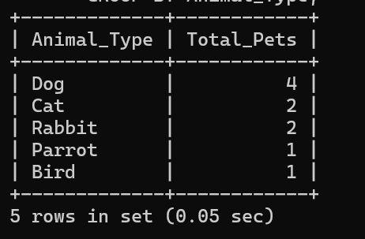

2. Display only those animal types having more than one pet.
SELECT Animal_Type, COUNT(Pet_ID) AS Total_Pets
FROM Pet_Adoption
GROUP BY Animal_Type
HAVING COUNT(Pet_ID) > 1;
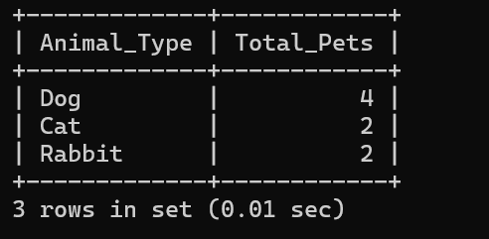

ORDER BY
3. Retrieve Pet Name, Animal Type and Adoption Fee in ascending order of Pet ID.
SELECT Pet_Name, Animal_Type, Adoption_Fee
FROM Pet_Adoption
ORDER BY Pet_ID ASC;
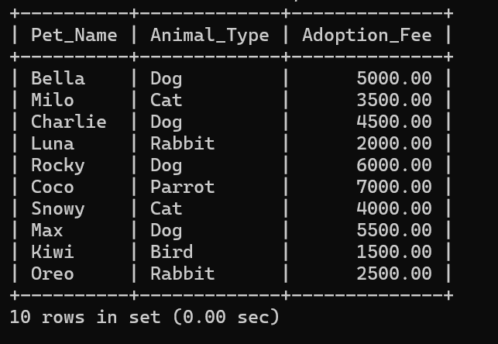

4. Display pet details in the order of highest adoption fee first.
SELECT Pet_Name, Animal_Type, Adoption_Fee
FROM Pet_Adoption
ORDER BY Adoption_Fee DESC;
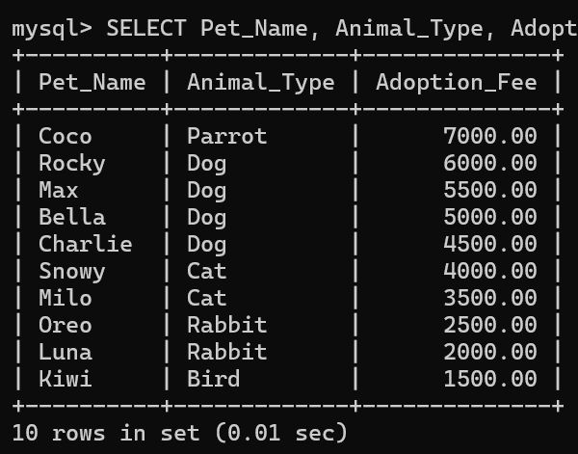

RESULT
Thus, the records from the table were displayed successfully using SELECT commands with GROUP BY, HAVING, and ORDER BY clauses.

