Experiment.: 8
Query with Sub Query & Correlated Query

AIM
To perform Sub Query and Correlated Query on the given table.
DESCRIPTION
SUBQUERY
A Sub Query is a query nested inside another SQL query such as SELECT, INSERT, UPDATE, or DELETE.
• A subquery is also known as an Inner Query, while the main query is called the Outer Query.
• A subquery is enclosed within parentheses.
• It is commonly used with operators such as IN, EXISTS, ANY, ALL, and comparison operators.
CORRELATED QUERY
• A Correlated Query is a subquery that depends on the outer query.
• The inner query is executed once for every row processed by the outer query.
• Correlated queries commonly use the EXISTS operator.
SYNTAX
SUBQUERY
SELECT column_name
FROM table_name
WHERE column_name IN
(
SELECT column_name
FROM table_name
WHERE condition
);

CORRELATED QUERY
SELECT *
FROM table_name t1
WHERE EXISTS
(
SELECT *
FROM table_name t2
WHERE t1.column_name = t2.column_name
);

QUERIES AND OUTPUTS
Use the database
USE PetAdoptionDB;

1. Display pets whose adoption fee is greater than the average adoption fee.
SELECT * FROM Pet_Adoption
WHERE Adoption_Fee > (SELECT AVG(Adoption_Fee) FROM Pet_Adoption);


2. Display pets belonging to animal types having more than one pet.
SELECT * FROM Pet_Adoption
WHERE Animal_Type IN
(SELECT Animal_Type FROM Pet_Adoption GROUP BY Animal_Type HAVING COUNT(*) > 1);
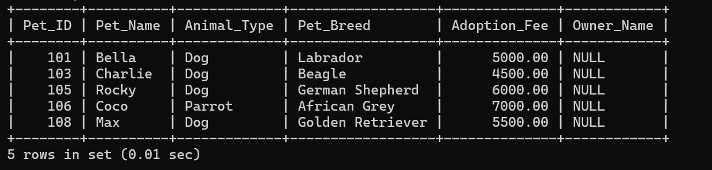

3. Display the pet having the highest adoption fee.
SELECT * FROM Pet_Adoption
WHERE Adoption_Fee = (SELECT MAX(Adoption_Fee) FROM Pet_Adoption);
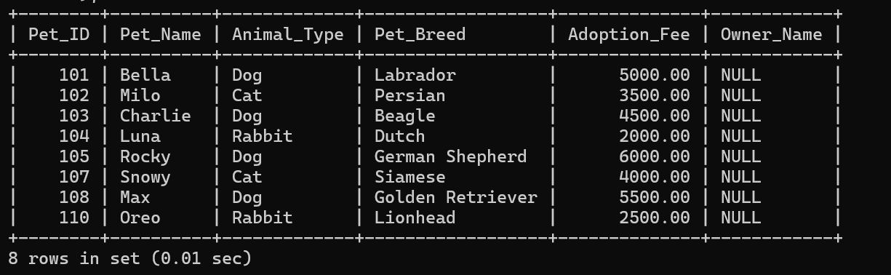

4. Display the pets whose adoption fee is greater than the average fee of their own animal type.
SELECT * FROM Pet_Adoption p1
WHERE Adoption_Fee >
(SELECT AVG(Adoption_Fee) FROM Pet_Adoption p2 WHERE p1.Animal_Type = p2.Animal_Type);
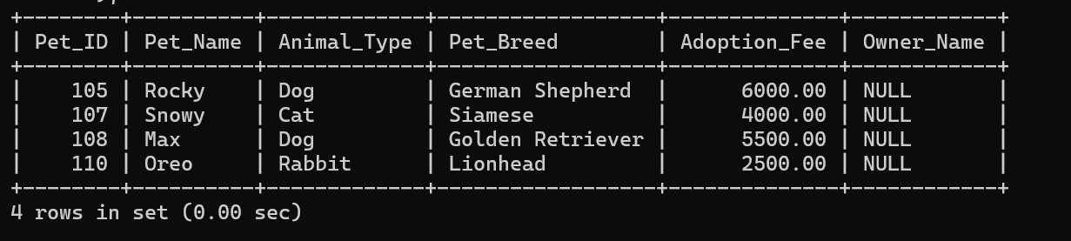

RESULT
Thus, the records from the table were displayed successfully using Sub Query and Correlated Query.

