Experiment: 9
Query with Joins – Equi Join, Inner Join, Outer Join

AIM
To perform JOIN operations using Equi Join, Inner Join, Left Join and Right Join on the given tables.
DESCRIPTION
JOIN
A JOIN is used to retrieve data from two or more tables based on a common column.
MySQL supports the following joins:
• Cross Join
• Inner Join
• Left Join
• Right Join
INNER JOIN
Returns only the matching rows from both tables.
LEFT JOIN
Returns all rows from the left table and matching rows from the right table. If there is no match, NULL values are returned.
RIGHT JOIN
Returns all rows from the right table and matching rows from the left table. If there is no match, NULL values are returned.
SYNTAX
INNER JOIN
SELECT columns
FROM table1
INNER JOIN table2
ON table1.column = table2.column;

LEFT JOIN
SELECT columns
FROM table1
LEFT JOIN table2
ON table1.column = table2.column;

RIGHT JOIN
SELECT columns
FROM table1
RIGHT JOIN table2
ON table1.column = table2.column;

QUERIES AND OUTPUTS
Use the database
USE PetAdoptionDB;


1. Display the pet names along with their owner names. (Inner Join)
SELECT p.Pet_Name, o.Owner_Name
FROM Pet_Adoption p
INNER JOIN Pet_Owner o ON p.Pet_ID = o.Pet_ID;
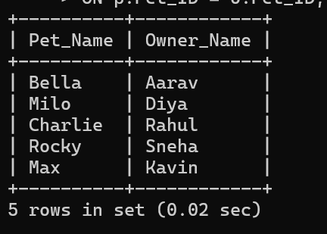

2. Display all pets including those without owners. (Left Join)
SELECT p.Pet_Name, o.Owner_Name
FROM Pet_Adoption p
LEFT JOIN Pet_Owner o ON p.Pet_ID = o.Pet_ID;
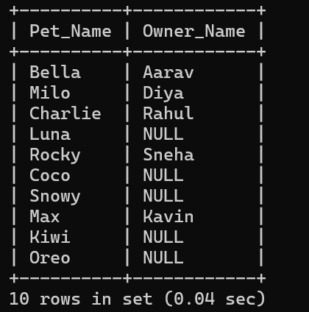

3. Display all owners along with their adopted pets. (Right Join)
SELECT p.Pet_Name, o.Owner_Name, o.City
FROM Pet_Adoption p
RIGHT JOIN Pet_Owner o ON p.Pet_ID = o.Pet_ID;
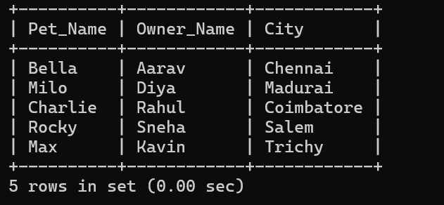

RESULT
Thus, the records from the tables were displayed successfully using INNER JOIN, LEFT JOIN and RIGHT JOIN.

