Experiment: 12
Simple Programming using WHILE, REPEAT

AIM
To learn how to use WHILE and REPEAT loop statements in MySQL.
DESCRIPTION
WHILE LOOP
The WHILE loop executes a block of statements repeatedly as long as the specified condition is true.
• It checks the condition before executing the statements.
• It is called a pre-test loop.
REPEAT LOOP
The REPEAT loop executes the statements first and then checks the condition.
• It repeats until the specified condition becomes true.
• It is called a post-test loop.
SYNTAX
WHILE
WHILE condition DO
statements;
END WHILE;

REPEAT
REPEAT
statements;
UNTIL condition
END REPEAT;

PROGRAMS AND OUTPUTS
Program – 1
Write a procedure using WHILE loop to display numbers from 1 to 5.
DELIMITER //
CREATE PROCEDURE DisplayNumbers()
BEGIN
DECLARE i INT DEFAULT 1;
WHILE i <= 5 DO
SELECT i;
SET i = i + 1;
END WHILE;
END//
DELIMITER ;
CALL DisplayNumbers();
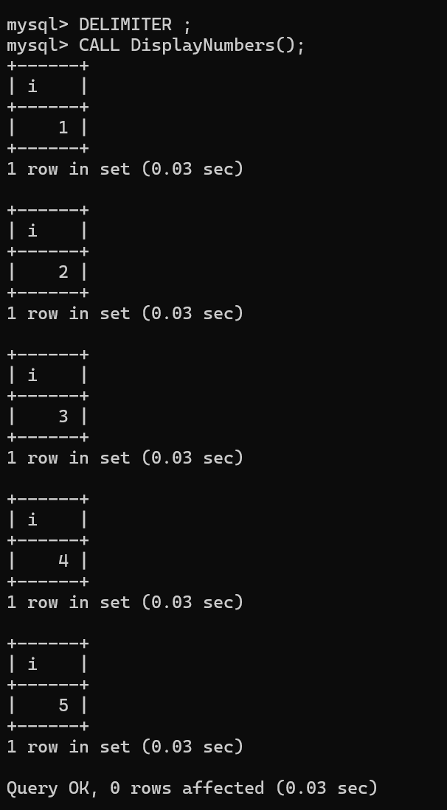

Program – 2
Write a procedure using REPEAT loop to display numbers from 1 to 5.
DELIMITER //
CREATE PROCEDURE RepeatNumbers()
BEGIN
DECLARE i INT DEFAULT 1;
REPEAT
SELECT i;
SET i = i + 1;
UNTIL i > 5
END REPEAT;
END//
DELIMITER ;
CALL RepeatNumbers();
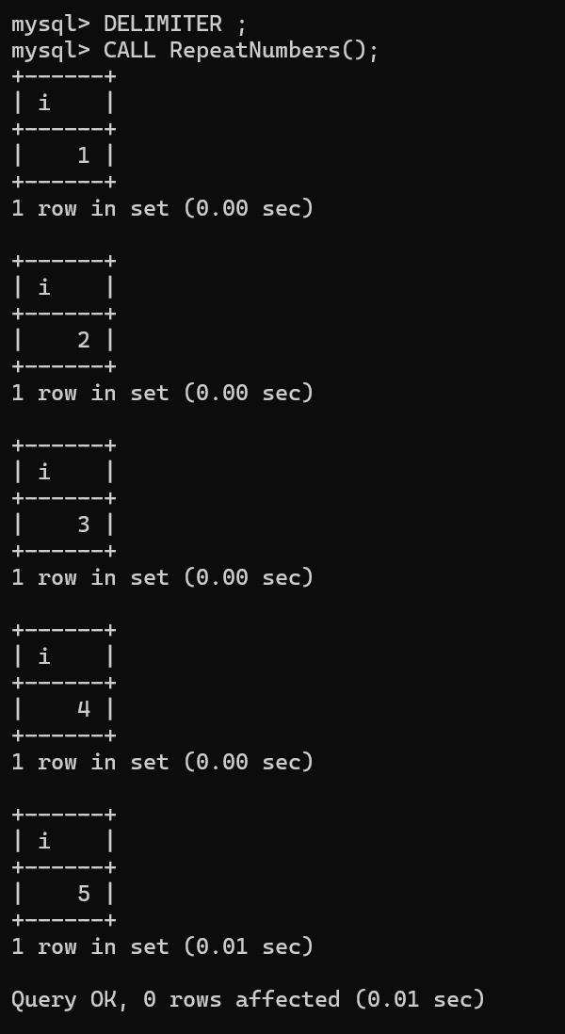

RESULT
Thus, the simple programming exercise using WHILE and REPEAT loops was executed successfully.

