Experiment.: 13
Simple Programming using CASE and LOOP

AIM
To learn how to use various MySQL programming statements including CASE and LOOP.
DESCRIPTION
CASE
The CASE statement is used to perform conditional processing in MySQL. It works like an IF-THEN-ELSE statement and executes different statements depending on the specified condition.
LOOP
The LOOP statement repeatedly executes a block of SQL statements until it is terminated using a LEAVE statement.
• LOOP provides an unconditional looping mechanism.
• It continues execution until an exit condition is met.
SYNTAX
CASE
CASE expression
WHEN value1 THEN statement1
WHEN value2 THEN statement2
ELSE statement3
END CASE;

LOOP
label: LOOP
statement_list;
IF condition THEN
LEAVE label;
END IF;
END LOOP label;

PROGRAMS AND OUTPUTS
Program – 1
Write a procedure using CASE statement to display the adoption category based on Adoption Fee.
DELIMITER //
CREATE PROCEDURE AdoptionCategory(IN fee DECIMAL(8,2))
BEGIN
CASE
WHEN fee <= 3000 THEN
SELECT 'Low Adoption Fee' AS Category;
WHEN fee <= 5000 THEN
SELECT 'Medium Adoption Fee' AS Category;
ELSE
SELECT 'High Adoption Fee' AS Category;
END CASE;
END//
DELIMITER ;
CALL AdoptionCategory(4500);
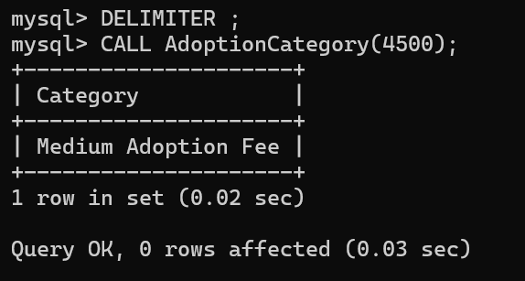

Program – 2
Write a procedure using LOOP statement to display numbers from 1 to 5.
DELIMITER //
CREATE PROCEDURE LoopNumbers()
BEGIN
DECLARE i INT DEFAULT 1;
myloop: LOOP
SELECT i;
SET i = i + 1;
IF i > 5 THEN
LEAVE myloop;
END IF;
END LOOP myloop;
END//
DELIMITER ;
CALL LoopNumbers();

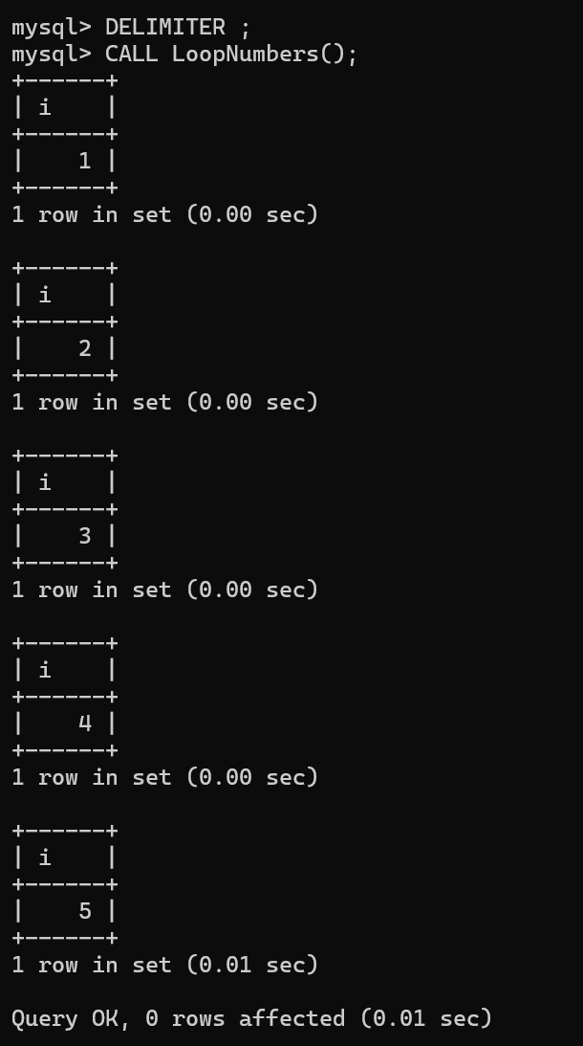
RESULT
Thus, the simple programming exercise using CASE and LOOP was executed successfully.

