Experiment: 15
DCL Commands – GRANT, REVOKE

AIM
To learn how to use various DCL commands such as GRANT and REVOKE.
DESCRIPTION
Data Control Language (DCL)
Data Control Language (DCL) is used to control user access and privileges in a database. It determines what actions a user can perform on database objects.
Privileges are of two types:
• System Privileges: Allow users to perform system-level operations such as creating sessions and tables.
• Object Privileges: Allow users to perform operations such as SELECT, INSERT, UPDATE, and DELETE on database tables.
The two main DCL commands are:
GRANT
• Used to provide privileges to a user.
• Allows users to perform specific operations on the database.
REVOKE
• Used to remove previously granted privileges from a user.
SYNTAX
GRANT
GRANT privilege_name
ON table_name
TO username;

REVOKE
REVOKE privilege_name
ON table_name
FROM username;

QUERIES AND OUTPUTS
Use the database
USE PetAdoptionDB;


1. Grant SELECT privilege on the Pet_Adoption table.
GRANT SELECT
ON PetAdoptionDB.Pet_Adoption
TO 'petuser'@'localhost';
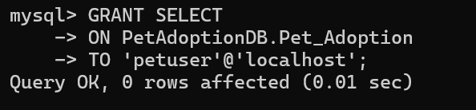

2. Grant INSERT privilege on the Pet_Adoption table.
GRANT INSERT
ON PetAdoptionDB.Pet_Adoption
TO 'petuser'@'localhost';
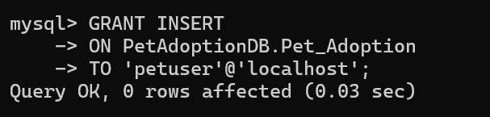

3. Grant ALL privileges on the Pet_Adoption table.
GRANT ALL PRIVILEGES
ON PetAdoptionDB.Pet_Adoption
TO 'petuser'@'localhost';
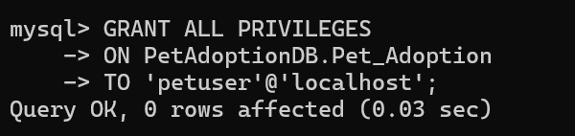

4. Revoke INSERT privilege from the user.
REVOKE INSERT
ON PetAdoptionDB.Pet_Adoption
FROM 'petuser'@'localhost';
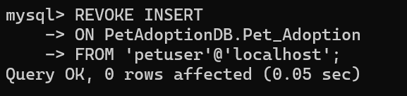

5. Revoke ALL privileges from the user.
REVOKE ALL PRIVILEGES
ON PetAdoptionDB.Pet_Adoption
FROM 'petuser'@'localhost';
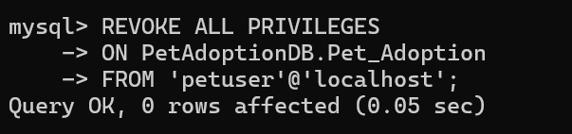

RESULT
Thus, the DCL commands GRANT and REVOKE were executed successfully, and the user privileges were granted and revoked as required.

