Experiment: 16
High Level Programming Extensions – Procedures

AIM
To implement stored procedures using MySQL.
DESCRIPTION
Stored Procedure
A stored procedure is a collection of SQL statements stored in the database that performs a specific task.
Advantages
• Reduces code duplication.
• Improves code reusability.
• Enhances performance.
• Provides better security.
The CREATE PROCEDURE statement is used to create a stored procedure, and the CALL statement is used to execute it.
SYNTAX
Create Procedure
CREATE PROCEDURE procedure_name()
BEGIN
statements;
END;

Call Procedure
CALL procedure_name();

PROGRAMS AND OUTPUTS
Program – 1
Create a procedure to display all records from the Pet_Adoption table.
DELIMITER //
CREATE PROCEDURE DisplayPets()
BEGIN
SELECT * FROM Pet_Adoption;
END //
DELIMITER ;
CALL DisplayPets();
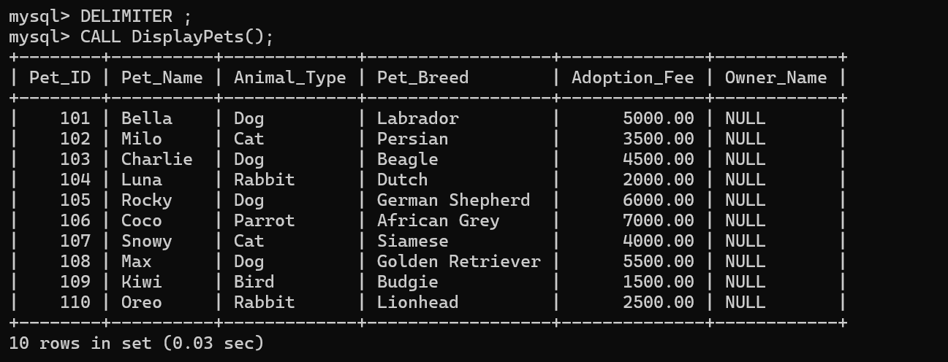

Program – 2
Create a procedure to display pets based on the animal type.
DELIMITER //
CREATE PROCEDURE GetPetsByType(IN p_type VARCHAR(20))
BEGIN
SELECT *
FROM Pet_Adoption
WHERE Animal_Type = p_type;
END //
DELIMITER ;
CALL GetPetsByType('Dog');
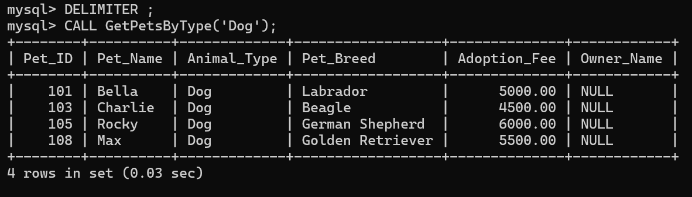

RESULT
Thus, the stored procedures were created and executed successfully using MySQL.

