08/07/26
EXPERIMENT 1
DDL COMMANDS( create,alter,truncate,drop)
AIM:
Data Definition Language (DDL) is a subset of SQL used to define, create, modify, and delete the structure of database objects such as databases and tables. DDL commands affect the schema of the database rather than the data stored in it.
DDL Commands
- CREATE – Used to create a new database or table.
- ALTER – Used to modify the structure of an existing table by adding, changing, or deleting columns.
- TRUNCATE – Removes all records from a table while keeping the table structure intact.
- DROP – Permanently deletes a table or database from the system.
- RENAME– Used to rename an existing table.
PROCEDURE:
- Open MySQL Command Line Client or MySQL Workbench.
- Create a new database.
- Select the database using the USE command.
- Create a table with the required fields.
- Insert sample records into the table for verification.
- Execute different DDL commands such as ALTER, TRUNCATE, RENAME, and DROP.
- Display the table after each modification using the SELECT statement.
- Observe the changes after every DDL operation.
- Verify the deletion of the table and database using SHOW TABLES and SHOW DATABASES.

QUERIES:

1. CREATE DATABASE
CREATE DATABASE PetAdoptionDB;

OUTPUT:
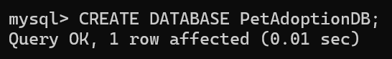
USE PetAdoptionDB;

OUTPUT:
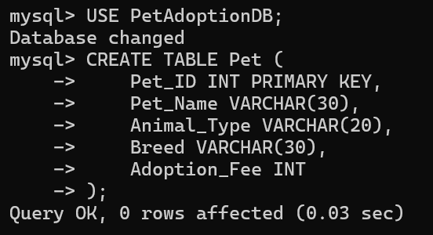

2. CREATE TABLE
CREATE TABLE Pet (
Pet_ID INT PRIMARY KEY,
Pet_Name VARCHAR(30),
Animal_Type VARCHAR(20),
Breed VARCHAR(30),
Adoption_Fee INT
);

OUTPUT:


3. DESCRIBE TABLE
DESC Pet;

OUTPUT:
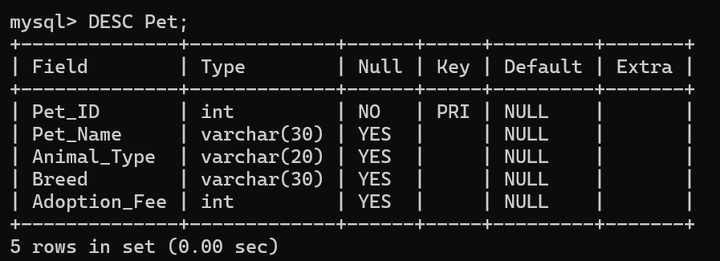

4. INSERT INTO
INSERT INTO Pet VALUES
(101, 'Bella', 'Dog', 'Labrador', 5000),
(102, 'Milo', 'Cat', 'Persian', 3500),
(103, 'Charlie', 'Dog', 'Beagle', 4500),
(104, 'Luna', 'Rabbit', 'Dutch', 2000),
(105, 'Rocky', 'Dog', 'German Shepherd', 6000),
(106, 'Coco', 'Parrot', 'African Grey', 7000),
(107, 'Snowy', 'Cat', 'Siamese', 4000),
(108, 'Max', 'Dog', 'Golden Retriever', 5500),
(109, 'Kiwi', 'Bird', 'Budgie', 1500),
(110, 'Oreo', 'Rabbit', 'Lionhead', 2500):

OUTPUT:
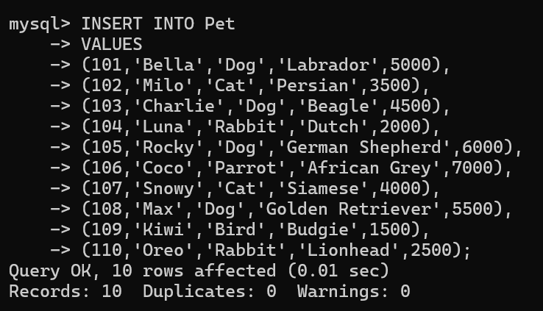

5. SELECT
SELECT * FROM Pet;

OUTPUT:
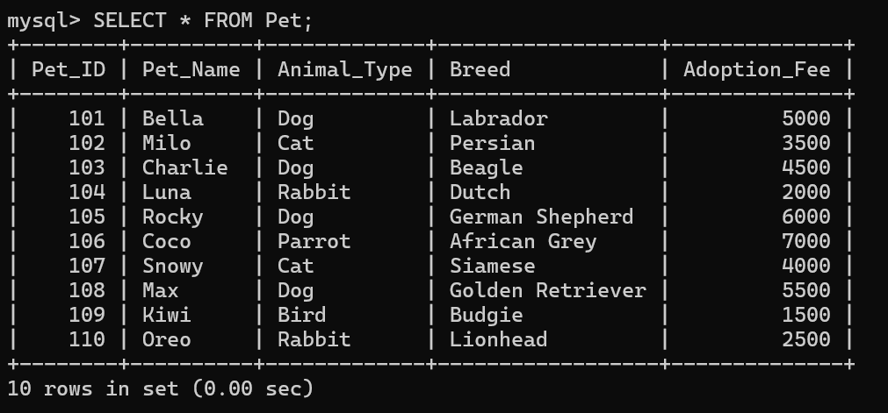

6. ALTER TABLE ADD COLUMN Owner_Name
OUTPUT:
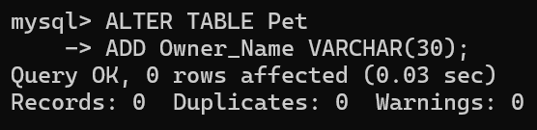

SELECT * FROM Pet;

OUTPUT:
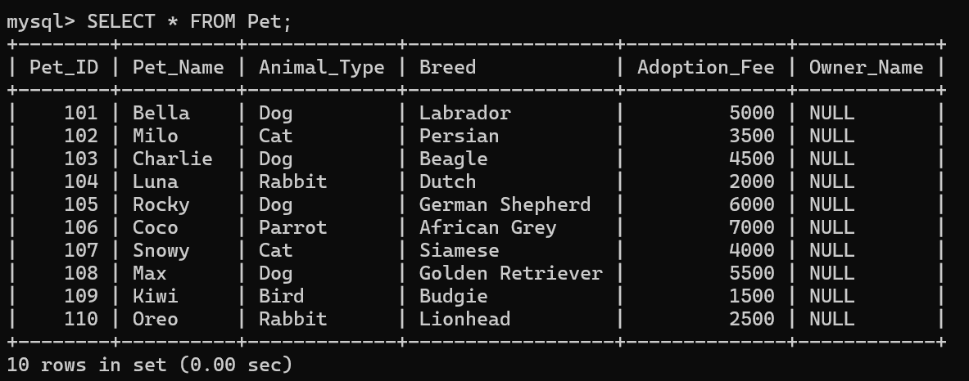

7. ALTER TABLE ADD COLUMN Contact_No

ALTER TABLE Pet ADD Contact_No BIGINT;

OUTPUT:
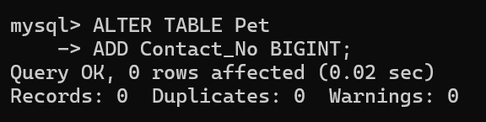

SELECT * FROM Pet;

OUTPUT:
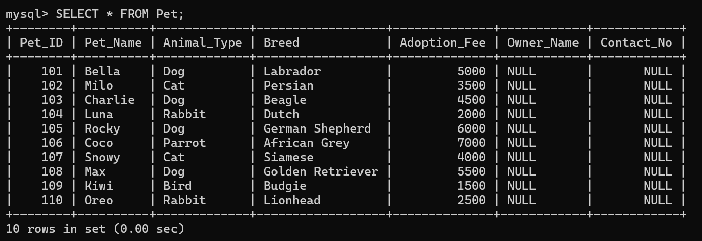

8. ALTER TABLE MODIFY COLUMN
ALTER TABLE Pet MODIFY Adoption_Fee DECIMAL(8,2);

OUTPUT:
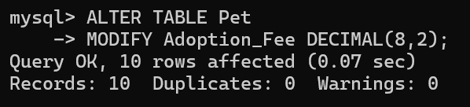

SELECT * FROM Pet;

OUTPUT:
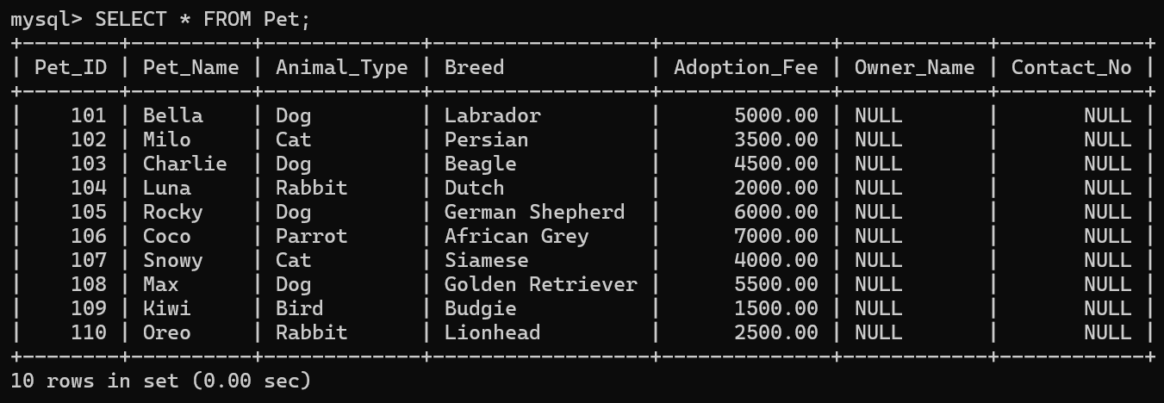

9. ALTER TABLE CHANGE COLUMN
ALTER TABLE Pet CHANGE Breed Pet_Breed VARCHAR(40);

OUTPUT:
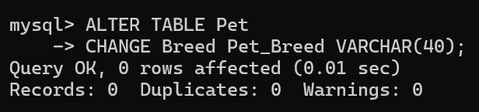

SELECT * FROM Pet;

OUTPUT:
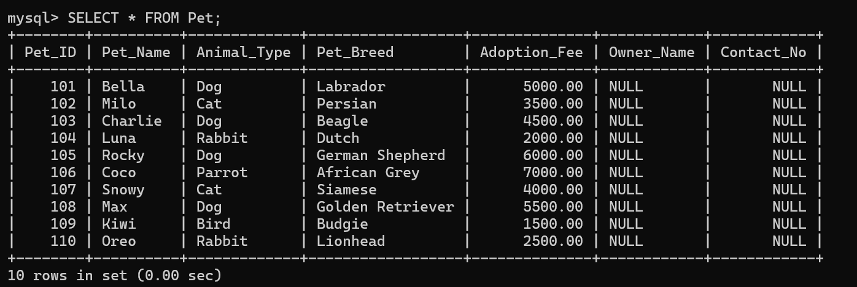

10. ALTER TABLE DROP COLUMN
ALTER TABLE Pet DROP COLUMN Contact_No;

OUTPUT:
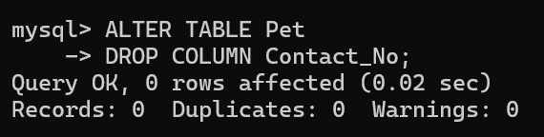

SELECT * FROM Pet;

OUTPUT:
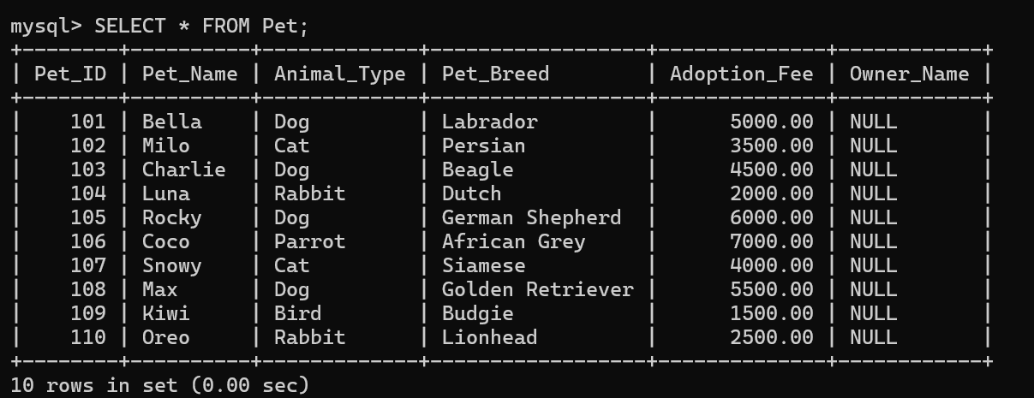

11. ALTER TABLE RENAME
ALTER TABLE Pet RENAME TO Pet_Adoption;

OUTPUT:
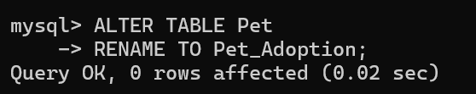

SELECT * FROM Pet;

OUTPUT:
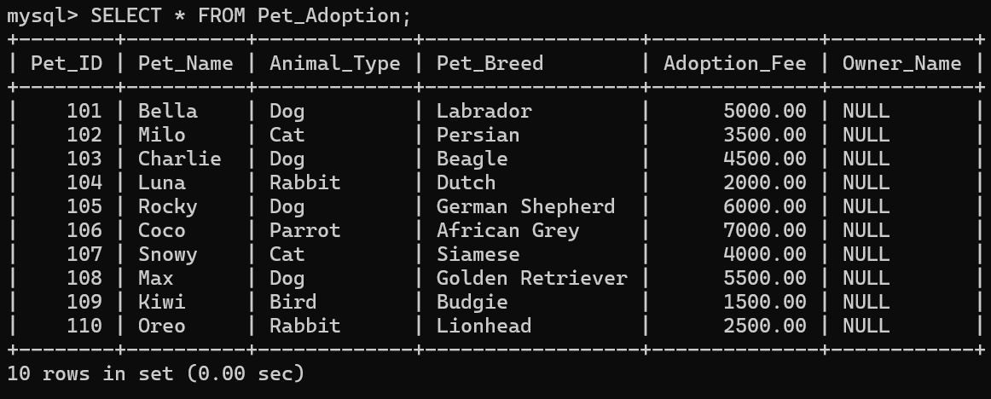

12.TRUNCATE – Removes all records from a table but keeps the table structure.
TRUNCATE TABLE Pet_Adoption;

13.DROP – Permanently deletes a table or database.
DROP TABLE Pet_Adoption;

DROP DATABASE PetAdoptionDB;

RESULT:
Thus, the DDL (Data Definition Language) commands were executed successfully. The database and table were created, the table structure was modified by adding, modifying, renaming, and deleting columns, the table was renamed successfully, and finally the table and database were removed

