10/07/26
EXPERIMENT 2
DML COMMANDS( insert,select,update,delete)
AIM:
Data Manipulation Language (DML) is a subset of SQL used to insert, retrieve, modify, and delete data stored within database objects. DML commands affect the actual records contained in database tables rather than modifying the structure of the database itself.
DML Commands
- INSERT – Used to insert new records into a table.
- SELECT – Used to retrieve and display data stored in a table.
- UPDATE – Used to modify existing data in a table based on specific conditions.
- DELETE – Used to remove specific records or rows from a table based on conditions.
PROCEDURE:
- Open MySQL Command Line Client or MySQL Workbench.
- Select the database using the USE command.
- Create a table with required fields.
- Insert sample records into the table using INSERT statement.
- Display the contents of the table using SELECT statement.
- Execute UPDATE statements to modify existing data in the table.
- Execute DELETE statements to remove specific records.
- Display the table after each modification using the SELECT statement.
- Observe the changes after every DML operation.
QUERIES:
1. Insert a new record into the Pet_Adoption table.
INSERT INTO Pet_Adoption VALUES
(111, 'Buddy', 'Dog', 'Pug', 4500.00, NULL);
OUTPUT:
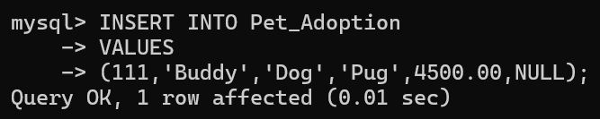
SELECT * FROM Pet_Adoption;
OUTPUT:
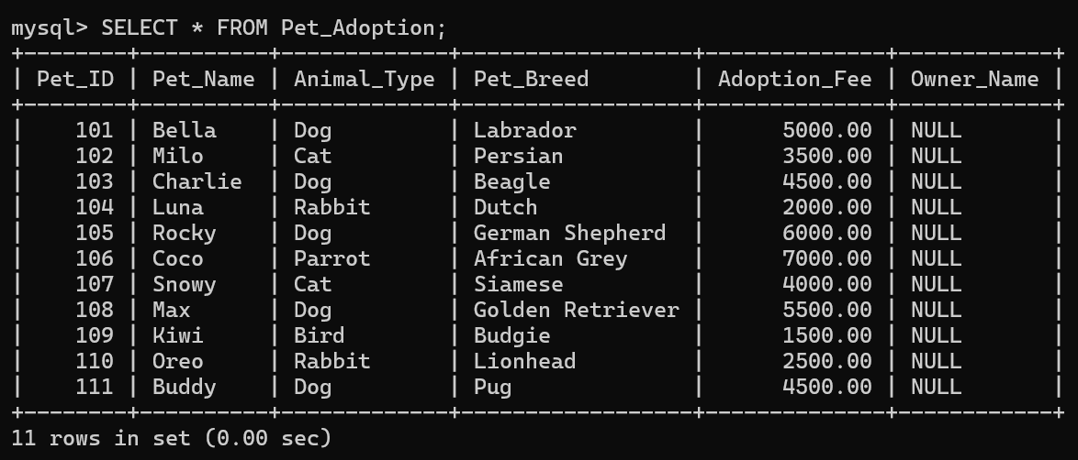
2. Update the adoption fee of Pet_ID 111.
UPDATE Pet_Adoption
SET Adoption_Fee = 5000.00
WHERE Pet_ID = 111;
OUTPUT:
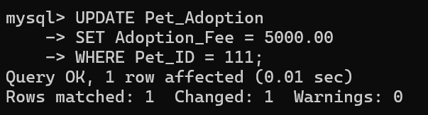
SELECT * FROM Pet_Adoption;
OUTPUT:
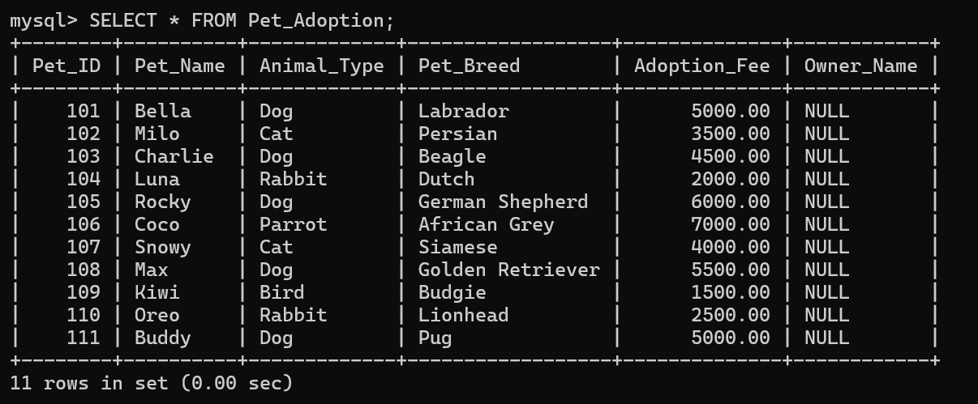
3. Update the owner name of Pet_ID 111.
UPDATE Pet_Adoption
SET Owner_Name = 'Aarav'
WHERE Pet_ID = 111;
OUTPUT:
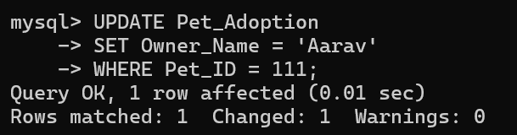
SELECT * FROM Pet_Adoption;
OUTPUT:
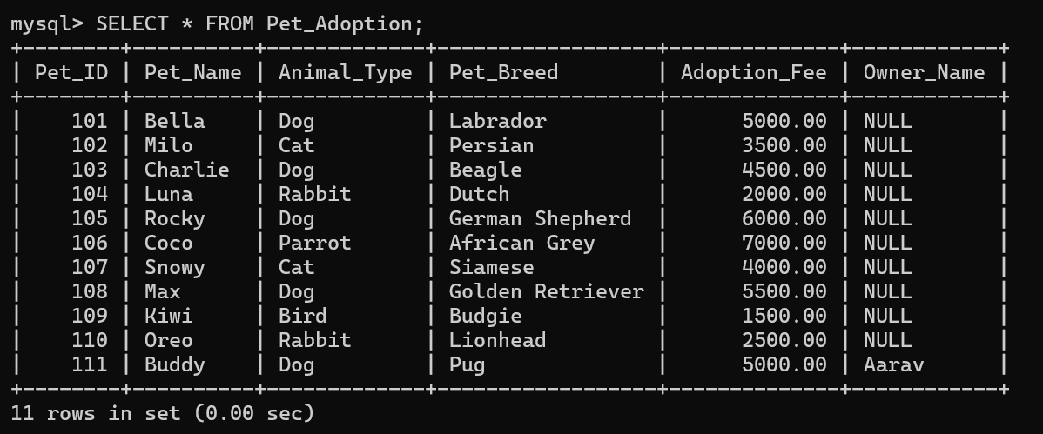
4. Delete the record with Pet_ID 111.
DELETE FROM Pet_Adoption
WHERE Pet_ID = 111;
OUTPUT:
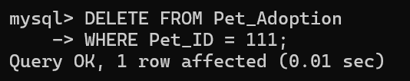
SELECT * FROM Pet_Adoption;

OUTPUT:
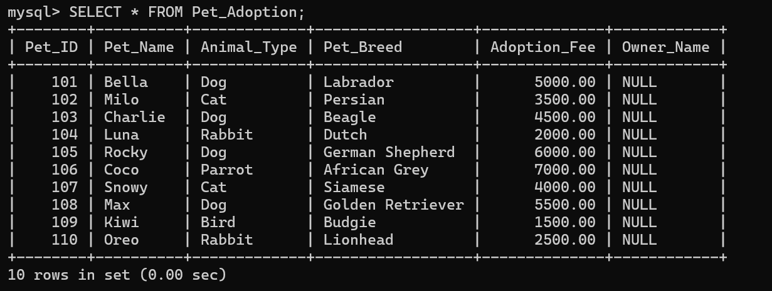
RESULT:
Thus, the DML (Data Manipulation Language) commands were executed successfully. The database and table were selected, records were inserted, queried using various SELECT conditions, modified using UPDATE statements, and deleted using DELETE statements based on specified criteria.

