LINE WATCH
Real-Time Betting-Line Divergence Detection
Big Data Course Project: Final Report
CSE412 Big Data & Large-Scale Computing
Applied Project, Track D (Kafka → Spark Streaming → Hive/HDFS)
Submitted by
Name | Roll Number
Jen Jose Jeeson | 2023BCS0017
Rupsika Thipparthi | 2023BCS0197
Praneetha Pillai | 2023BCS0207

Project repository: github.com/jenjose72/betting-line-divergence
September 2026

ABSTRACT
Betting odds for a football match should mainly change when public information changes, for example after a goal or a red card. Odds that move sharply without anything on the pitch to explain them may point to leaked information or an inefficient market, and are therefore of interest in sports-integrity monitoring. In this project, Line Watch, we built a real-time pipeline that compares betting-line movement with the match events that should explain it. Opening and closing Bet365 odds from football-data.co.uk are interpolated into minute-level ticks, and real event timelines are taken from API-Football. Both are replayed through two Apache Kafka topics, processed by a Spark Structured Streaming job, stored as Parquet on HDFS, exposed as Hive external tables and shown on a Streamlit dashboard. For every five-minute window the job converts odds into normalised implied probabilities and computes divergence_score = actual_move - expected_move, where expected movement comes from fixed, rule-based event priors; no machine learning is used. Two real Premier League matches produced no flagged windows, while a clearly labelled synthetic leak case was flagged in exactly one window (divergence +0.184). The main limitation is that the odds are interpolated, not real tick-level market data.

1. Introduction
Bookmakers publish decimal odds for home win, draw and away win. The inverse of a decimal odd is an implied probability, so odds of 2.0 mean roughly a 50% chance once the bookmaker's margin is removed. During a match a goal changes these probabilities a lot, a red card moderately, and a yellow card or substitution only slightly.
Since odds are supposed to react to public information, a line that moves before any visible event, or moves much more than the event justifies, deserves a closer look. Integrity analysts look for exactly this kind of unexplained movement. Line Watch tries to answer one question: at this point in the match, does the market's behaviour match what is happening on the pitch, and if not, how large is the gap? We call this gap the betting-line divergence. In streaming/divergence_job.py it is defined for each match and five-minute window as:
divergence_score = actual_move - expected_move
actual_move is how much the implied probabilities really moved in the window and expected_move is how much they should have moved given its events. A value near zero or below means the events explain the movement; above 0.05 the window is flagged. The system follows Track D of the course guidelines (Kafka, Spark Streaming, Hive/HDFS) with a Streamlit dashboard on top.

2. Problem Statement
Existing problem. Betting markets produce continuously changing odds, while match events provide the information that should explain many of those changes; the two arrive as separate, unaligned streams. The challenge is to find windows where odds changed significantly but the events do not adequately explain it.
Proposed problem. Build a big data pipeline that replays odds and event streams, compares actual and expected movement in time windows, and flags potentially suspicious unexplained movement. The system is a screening tool only: a flagged window means the odds moved more than our rule-based model expects, not that match fixing or insider activity took place.

3. Objectives
- Collect real betting odds (football-data.co.uk, Premier League 2023/24) and real event timelines (API-Football).
- Generate minute-level odds ticks (minutes 0 to 90) from opening and closing odds using an event-weighted interpolation model.
- Stream odds and events through two Kafka topics, odds-ticks and match-events, keyed by a shared match_id.
- Process both streams with Spark Structured Streaming in five-minute windows: convert odds to normalised implied probabilities, compute actual and expected movement, the divergence score and a flag.
- Store raw and scored data as Parquet on HDFS and expose them through Hive external tables.
- Visualise odds, events and divergence with Streamlit and Plotly.
- Validate the detector with unit tests and a clearly labelled synthetic leak scenario.

4. Dataset and Data Sources

4.1 Betting odds (real data)
fetch_odds_data.py downloads the free CSV football-data.co.uk/mmz4281/2324/E0.csv (Premier League 2023/24, one row per match) to data/raw/E0_2324.csv; odds_producer.py uses the Bet365 columns in Table 1. Only pre-match and closing lines are available, so the odds in between are modelled (Section 8), a stated assumption of the project.
Table 1. Input data fields used by the project
Source | Field(s) | Use in the project
E0_2324.csv | HomeTeam, AwayTeam, Date | Select the match row; fallback match_id
E0_2324.csv | B365H, B365D, B365A | Bet365 opening odds (home, draw, away)
E0_2324.csv | B365CH, B365CD, B365CA | Bet365 closing odds (home, draw, away)
API-Football | time.elapsed, time.extra | Event minute = elapsed + extra, clipped to 90
API-Football | type, detail | Mapped to Goal, Penalty Missed, Red/Yellow Card, Substitution
API-Football | team.name, player.name | Shown on the dashboard

4.2 Match events (real data)
events_producer.py calls API-Football v3 GET /fixtures/events?fixture=<id> (free tier, ~100 requests/day). Raw types are normalised: goal becomes Goal, or Penalty Missed if the detail says "missed"; card becomes Red Card (including a second yellow) or Yellow Card; subst becomes Substitution; anything else, such as VAR entries, is dropped because it duplicates an event already recorded. Stoppage-time events are clipped to minute 90, and results are cached locally. For Burnley 0-3 Manchester City (fixture 1035037, 11 August 2023) the API returns 15 raw events, which normalise to 14: 3 goals, 1 red card and 10 substitutions.

4.3 Synthetic validation data
producers/synthetic_leak_demo.py publishes one hand-built case with match_id = "SYNTH-LEAK-DEMO", a non-numeric id so it cannot be confused with a real fixture. We added it because a detector that never fires looks the same as a broken one. Home odds stay at 3.0 until minute 34 and crash to 1.8 in minutes 35 to 39 with no event nearby; the goal that would explain this comes only at minute 50, deliberately late, as if the market already knew. Window 35 should be flagged and window 50 should not. In summary, the odds CSV and API events are real data, the minute-level odds of real matches are modelled from real values, and SYNTH-LEAK-DEMO (plus the default sample_match_events.json) is synthetic and used only for validation.

5. Tools and Technologies
Table 2. Technologies used (versions from docker-compose.yml and requirements.txt)
Tool / technology | Version | Role in project
Python | 3.12 (referenced in requirements.txt) | Producers, API access, odds model, dashboard
Apache Kafka, ZooKeeper; kafka-python-ng | Confluent cp-kafka / cp-zookeeper 7.6.1; client 2.2.2 | Two-topic streaming ingestion
Apache Spark (PySpark) | 3.1.1 cluster (bde2020), spark-sql-kafka-0-10_2.12:3.1.1; PySpark 3.5.1 for local tests | Structured Streaming job
Hadoop HDFS | 3.2.1 (bde2020 namenode / datanode) | Parquet storage
Apache Hive | 2.3.2 (bde2020/hive postgresql-metastore) | SQL layer (external tables)
PostgreSQL | bde2020/hive-metastore-postgresql:2.3.0 | Hive metastore database
pandas, requests, python-dotenv, pytest | 2.2.2, 2.32.3, 1.0.1, 8.3.2 | CSV, HTTP, .env config, unit tests
Streamlit, Plotly | 1.38.0, 5.24.1 | Dashboard and charts
Docker Compose | Not specified in repository | Runs the 9-container stack

6. Tool-by-Tool Justification
Python handles everything before and after the big data stack: downloading odds, calling API-Football, normalising events, the interpolation model, the producers and the dashboard's HDFS reader.
Kafka decouples the two independently timed feeds from the consumer: odds arrive every match-minute, events only when something happens, and the Spark job can start before or after the producers and still read everything from the earliest offset. Keying every message by match_id lets Spark join the two topics per match.
Spark Structured Streaming does what no other tool in the stack can: reading two Kafka topics, windowing, aggregating, joining and scoring them.
HDFS is the persistent layer between processing and serving. The job writes Parquet under hdfs://namenode:8020/data/line_watch/, a columnar format that both Hive and pandas read directly. Hive gives SQL access through three external tables created by streaming/hive_tables.sql (metadata only; data is never copied). PostgreSQL is used only as the Hive metastore database (configured in hadoop-hive.env), not for application data.
Streamlit gave us a web dashboard in one Python file (dashboard/app.py), and Plotly draws the odds lines, event markers and divergence bars. Docker Compose starts all nine services (Kafka, ZooKeeper, HDFS, Hive, its PostgreSQL metastore and Spark) with one command.

7. System Architecture
Figure 1 shows the architecture as implemented. The Spark job runs three queries: two copy parsed Kafka rows into raw Parquet tables, and a heartbeat-driven third one recomputes the scores from them (dotted arrows).
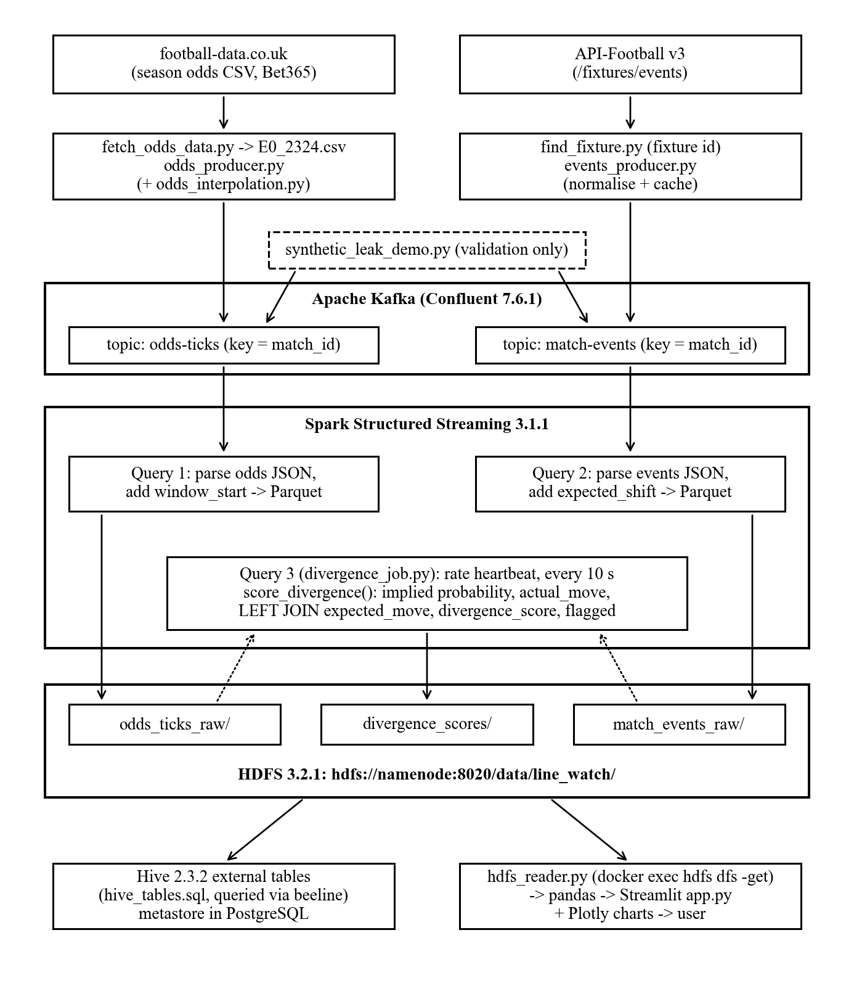
Figure 1. Overall architecture of the Line Watch system

8. Project Workflow and Data Flow
Stage 1: Data acquisition. Running fetch_odds_data.py for division E0 and season 2324 saves the season CSV as data/raw/E0_2324.csv.
Stage 2: Fixture identification. find_fixture.py --team Burnley --date 2023-08-11 returns the API-Football fixture id (1035037). A canonical match_id is needed because the sources spell team names differently ("Man City" and "Manchester City"). Otherwise the topics would carry different keys and the join would silently match nothing, so both producers get the same --match-id.
Stage 3: Odds interpolation. interpolate_odds() turns the opening odds, closing odds and events into 91 ticks. It works in de-vigged probability space, since probability is what events change. A weight w(m) between 0 and 1 says how much of the open-to-close move has happened by minute m:
w(m) = 0.3 * (m / 90) + 0.7 * E(m) / E(90)
E(m) = sum_e[ weight_e * sigmoid(1.5 * (m - minute_e)) ] / sum_e weight_e
p(m) = (1 - w) * p_open + w * p_close, odds(m) = 1 / (overround(m) * p(m))
The 0.3 term is background drift; the sigmoids create steps at event minutes, weighted by EVENT_WEIGHTS (Table 3). The first and last ticks equal the real opening and closing odds.
Stages 4 and 5: Event normalisation and Kafka ingestion. Events are normalised as in Section 4.2. Both producers send JSON keyed by match_id: odds-ticks carries {match_id, minute, home_odds, draw_odds, away_odds, produced_at} and match-events carries {match_id, minute, type, team, player, produced_at}.
Stage 6: Spark processing. The job reads both topics from the earliest offset, parses them with from_json, and adds window_start (and expected_shift for events). Every 10 seconds a rate-source heartbeat re-reads the raw tables and runs score_divergence() (Section 9).
Stages 7 to 9: Storage, Hive and dashboard. Raw rows are appended to odds_ticks_raw and match_events_raw and scores overwrite divergence_scores under /data/line_watch/; hive_tables.sql creates the external tables; hdfs_reader.py copies tables out with hdfs dfs -get and docker cp for app.py to plot.

9. Analytical Methodology
The scoring logic is score_divergence() in divergence_job.py, kept apart from the Kafka and HDFS code so it can be unit tested (Figure 2).
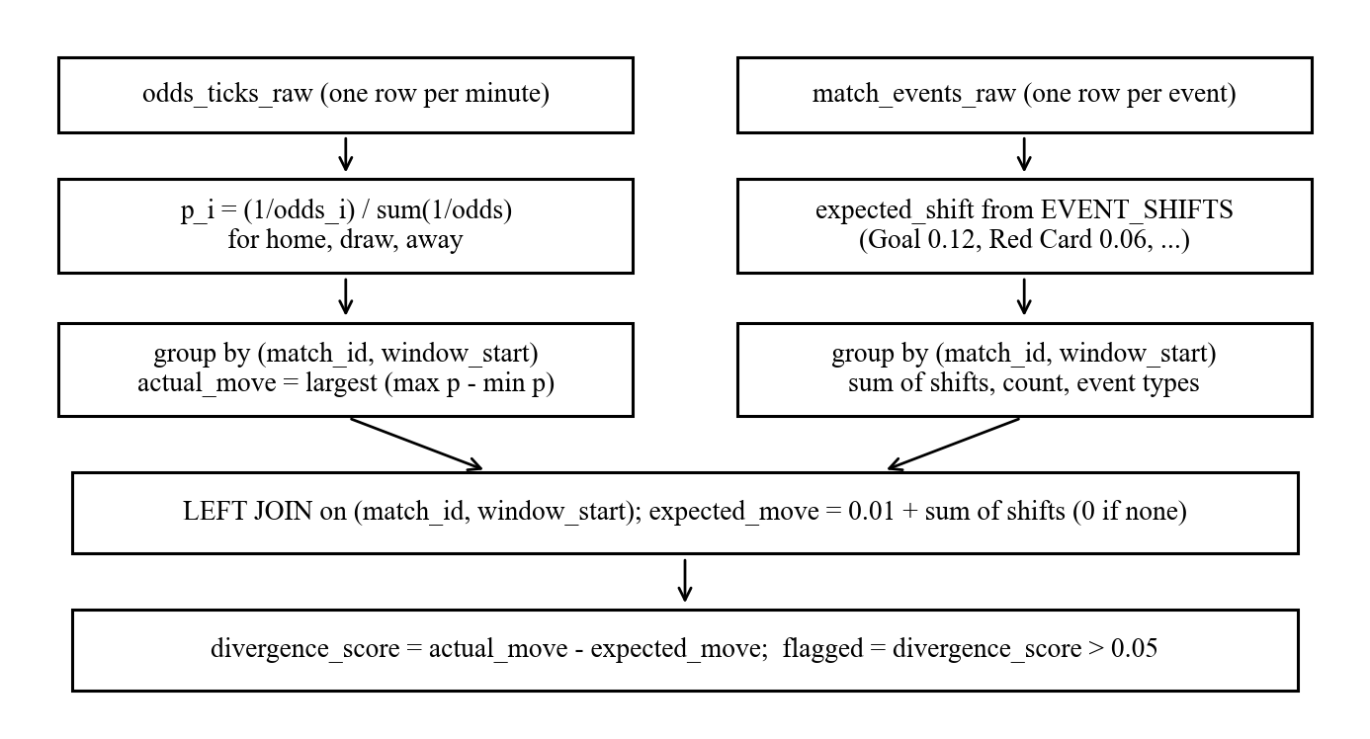
Figure 2. Divergence calculation workflow inside score_divergence()
9.1 Implied probability. Dividing each inverse odd by their sum removes the bookmaker's margin, so a change in margin alone is not mistaken for market movement:
p_home = (1/home_odds) / (1/home_odds + 1/draw_odds + 1/away_odds) (same for draw, away)
9.2 Five-minute window. window_start = floor(minute / 5) * 5, so minutes 35 to 39 form window 35. A match gives 19 windows (0 to 90).
9.3 Actual movement is the largest probability range among the three outcomes in the window:
actual_move = max( range(p_home), range(p_draw), range(p_away) ), range = max - min
9.4 Expected movement is expected_move = 0.01 + sum of expected_shift over the window's events. The 0.01 allows for a market that is never perfectly still. The priors (Table 3) are deliberately not the producer's EVENT_WEIGHTS; reusing the table that generated the odds would make divergence near zero by construction.
Table 3. Event weights used to shape the odds vs. event shifts used as expected movement
Event type | EVENT_WEIGHTS (odds_interpolation.py, relative) | EVENT_SHIFTS (divergence_job.py, probability)
Goal | 1.0 | 0.12
Red Card | 0.5 | 0.06
Penalty Missed | 0.3 | 0.04
Yellow Card | 0.15 | 0.02
Substitution | 0.05 | 0.01
Any other type | 0.1 | 0.01

9.5 Divergence and 9.6 flagging. divergence_score = actual_move - expected_move, and flagged is true when the score is above 0.05 (DIVERGENCE_THRESHOLD), false otherwise. Actual and expected movement are combined with a left join on (match_id, window_start), so a window where odds moved with no event is kept (expected 0.01); an inner join would silently drop this key case. The detector is entirely rule-based, with fixed formulas, priors and threshold; no model is trained and no machine learning is used.

10. Results
Synthetic leak case. Table 4 shows the scores for SYNTH-LEAK-DEMO. Windows 35 and 50 match streaming/README.md (cluster run); we recomputed all 19 windows offline with the same formulas and got the same values.
Table 4. Divergence results for the synthetic leak case (19 windows, 1 flagged)
Window | Events | Actual move | Expected move | Divergence | Flagged
0 to 30 | None | 0.000 | 0.010 | -0.010 | No
35 | None | 0.194 | 0.010 | +0.184 | Yes
40, 45 | None | 0.000 | 0.010 | -0.010 | No
50 | Goal | 0.003 | 0.130 | -0.127 | No
55 to 85 | None | 0.003 | 0.010 | -0.007 | No
90 | None | 0.000 | 0.010 | -0.010 | No

In window 35 the home probability rises from 0.324 (odds 3.0/3.4/2.5) to 0.519 (1.8/3.6/4.2) with nothing to explain it, so it is flagged. Window 50 has a Goal (expected 0.13), but the market barely moves because it was already priced in, so it is correctly not flagged. The tool scores moves against the information public at the time, not just their size (Figure 3).
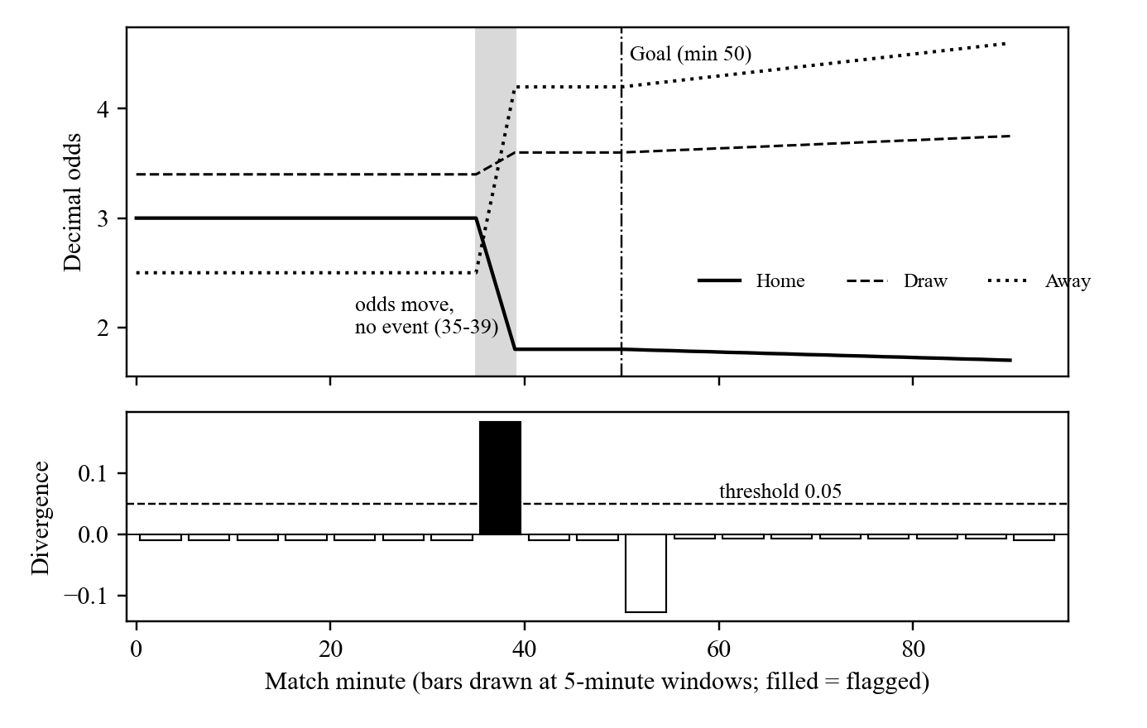
Figure 3. Synthetic leak case: odds and goal marker (top), divergence per window (bottom); recomputed from build_ticks() with the project's scoring formulas
Real matches. For Burnley 0-3 Manchester City (fixture 1035037) the producers published 91 odds ticks and 14 events, with the first and last ticks equal to the real lines. The job produced 19 scored windows, checked through Parquet and Hive. None of the 19 windows were flagged. Burnley's win probability moved only from about 11.8% (odds 8.0) to 10.6% over the whole match. Tottenham 2-0 Manchester United, with closer odds, also produced zero flagged windows. The main reason is that real-match odds are interpolated between two lines and are far smoother than a real in-play feed.

11. Analytical Validity
The real matches show the detector does not raise false alarms; the synthetic case shows that an unexplained move is flagged while a move with an appropriate event is not.
A flagged window indicates unexplained statistical movement according to the project's rule-based model; it is not evidence by itself of match fixing or insider activity. Our results show that the pipeline and scoring behave as designed, not that the system detects real-world fixing (Table 5).
Table 5. Scope summary
Category | Items
Implemented | Data download, event normalisation, odds interpolation, three Kafka producers, Spark streaming job, Parquet on HDFS, Hive external tables, Streamlit dashboard
Tested | Interpolation, event normalisation on a real API response, synthetic ticks, divergence scoring including the left-join case (17 automated tests)
Demonstrated | End-to-end runs (two real matches, synthetic case) checked via HDFS, Hive and the dashboard, per the READMEs
Assumed / modelled | Minute-level odds for real matches, event priors, 0.01 drift, 0.05 threshold
Future work only | Real tick-level odds, several bookmakers, statistical or ML models, dynamic thresholds, cloud deployment

12. Implementation and Integration
The tools are connected by real data hand-offs (Table 6). Spark writes plain Parquet to fixed paths instead of using Hive's catalog, avoiding a Spark/Hive 2.3.2 client version clash, and each trigger recomputes the windowed join from the raw tables, which is cheap at 100 to 200 rows per match.
Table 6. Data entering and leaving each stage
Stage | Data in | Data out
Sources to Python | E0.csv over HTTP; API-Football JSON | E0_2324.csv; cached event JSON
Python to Kafka | 91 interpolated ticks; normalised events | JSON messages keyed by match_id on two topics
Kafka to Spark | Topic records (binary key/value) | Typed DataFrames with window_start, expected_shift
Spark to HDFS | Parsed streams; scored batch result | Parquet: odds_ticks_raw, match_events_raw, divergence_scores
HDFS to Hive | Parquet at fixed paths | SQL tables queried through beeline
HDFS to Streamlit | Parquet via hdfs dfs -get and docker cp | pandas DataFrames, Plotly charts, tables

13. Progress Check-ins
Check-in 1: Working ingestion. The producer commits (9247200, 66e4060) are dated 14 September 2026. producers/README.md records 14 real events and 91 odds ticks for fixture 1035037, with both topics carrying key 1035037 (checked with kafka-console-consumer). The repository does not contain a dated progress-check-in record for this stage; the implementation itself demonstrates the completed ingestion stage.
Check-in 2: Draft analytical results. The streaming job (commit 93d53b0) and the synthetic case (commit 8675da6) are dated 21 September 2026. streaming/README.md records 19 unflagged windows for fixture 1035037 and the window-35 flag (+0.184) for the synthetic case. The repository does not contain a dated progress-check-in record for this stage; the implementation itself demonstrates the completed analysis stage.

14. Demo Workflow
A ten-minute demo focused on evidence of real execution:
- 0:00 to 2:00 Problem statement, architecture (Figure 1) and the divergence formula. 2:00 to 4:00 docker compose up -d; containers, HDFS UI, Spark UI.
- 4:00 to 5:30 Run the three producers; show messages with kafka-console-consumer. 5:30 to 7:00 spark-submit the job; show "scored N windows, M flagged".
- 7:00 to 8:00 HDFS folders and a beeline query on divergence_scores. 8:00 to 9:30 Streamlit dashboard: real matches and SYNTH-LEAK-DEMO.
- 9:30 to 10:00 The flagged window, the unflagged goal window, and the interpolation limitation.

15. Challenges Encountered
Table 7 lists challenges recorded in the code comments, READMEs and commit messages.
Table 7. Challenges: problem, impact and solution
Problem | Impact | Solution / workaround
No free tick-level odds | Nothing realistic to stream in-play | Event-weighted interpolation in probability space
Team names differ between sources | Different keys; Spark join finds nothing | Explicit shared --match-id (API-Football fixture id)
API limit of ~100 requests/day | Re-runs would exhaust the quota | Cache events in data/interim/events/
Version problems: Kafka image, kafka-python and Spark 3.1.1 with Python 3.12 | Ingestion and local tests broke | Confluent 7.6.1 images, kafka-python-ng; PySpark 3.5.1 for local tests only
Stream-stream outer joins in Spark 3.1 | Event-less windows at risk | Recompute a batch left join on every trigger
ProcessingTime trigger fires only on new offsets; early triggers before tables exist | Score table froze after a replay; early failures | rate-source heartbeat every 10 s; skip the batch if tables are not ready
HiveServer2 2.3.2 SASL vs. Python clients; WebHDFS redirect to unpublished datanode | Dashboard could not read via Hive or WebHDFS | hdfs dfs -get in the namenode container, docker cp, pandas

16. Limitations
- Interpolated odds. Real in-play volatility is not captured, the main reason real matches show no flags. Improvement: in-play odds snapshots (the plan names the Apify football-odds-historical actor).
- Rule-based detector with hand-set priors. EVENT_SHIFTS ignores score and minute. Improvement: priors conditioned on game state or learned from history.
- Fixed 0.05 threshold for all matches. Improvement: volatility-scaled thresholds.
- Window boundaries. A jump between minutes 34 and 35 falls between windows and is not counted. Found in our code review; not handled. Improvement: sliding windows.
- Default event file. Without --events, odds_producer.py shapes the curve with the synthetic sample_match_events.json, and the README command does not pass it. For real matches --events data/interim/events/<id>.json should be given.

17. Future Work
Proposed, not implemented: a real in-play odds API and several bookmakers; expected movement learned from historical matches, statistical anomaly detection (for example per-window z-scores) or machine-learning models; dynamic thresholds; incremental stateful Spark processing with watermarks; cloud deployment instead of the current single-host Docker setup; and a proper query service instead of the docker exec/docker cp dashboard workaround.

18. Individual Contribution Breakdown
The team members are Jen Jose Jeeson (2023BCS0017), Rupsika Thipparthi (2023BCS0197) and Praneetha Pillai (2023BCS0207). Development was collaborative, and the Git history records all 14 commits (8 content commits and the merges of PR #1 to #6) under the GitHub account jenjose72, so it does not by itself distinguish which member built which module. Table 8 reflects the team's agreed division of ownership by tool: each member is responsible for their assigned area going forward, including its share of testing, review and this report.
Table 8. Role-based contribution breakdown, by tool
Role | Files / modules | Contribution | Team member
A: Ingestion | fetch_odds_data.py, find_fixture.py, odds_interpolation.py, odds_producer.py, events_producer.py, synthetic_leak_demo.py | Data pulls, interpolation model, Kafka producers, validation case | Jen Jose Jeeson
B: Analytics | divergence_job.py, hive_tables.sql | Streaming job, windowed join, scoring, HDFS/Hive output | Praneetha Pillai
C: Serving and reporting | hdfs_reader.py, app.py, READMEs | Dashboard, HDFS access, documentation, demo and report | Rupsika Thipparthi

19. Reproducibility and Setup
Requirements are Docker with Compose, Python with requirements.txt, and an API-Football key. The commands are taken from the repository READMEs:
git clone https://github.com/jenjose72/betting-line-divergence.git
cd betting-line-divergence && cp .env.example .env # set API_FOOTBALL_KEY
docker compose up -d
python -m venv .venv && source .venv/bin/activate && pip install -r requirements.txt
python -m producers.fetch_odds_data --division E0 --season 2324
python -m producers.find_fixture --team Burnley --date 2023-08-11
python -m producers.events_producer --fixture-id 1035037 \
--match-id 1035037 --speed 0
python -m producers.odds_producer --home Burnley --away "Man City" \
--match-id 1035037 --speed 0
python -m producers.synthetic_leak_demo --speed 0
docker exec linewatch-spark-master /spark/bin/spark-submit \
--master spark://spark-master:7077 \
--packages org.apache.spark:spark-sql-kafka-0-10_2.12:3.1.1 \
/workspace/streaming/divergence_job.py --bootstrap-servers kafka:29092
cat streaming/hive_tables.sql | docker exec -i linewatch-hive-server \
beeline -u jdbc:hive2://localhost:10000
streamlit run dashboard/app.py
python -m pytest

20. Testing
The repository has 17 unit tests in four files (Table 9). We ran the suite on 28 September 2026 on Windows 11 and all 17 passed. The 15 producer tests needed PYTHONUTF8=1 on Python 3.13, because the API fixture (containing "Kovačić") is opened without an explicit encoding and Windows defaults to cp1252. The two Spark tests needed Python 3.11 with JDK 21 (they failed on JDK 25 / Python 3.13).
Table 9. Automated test cases and results
Test file | Tests | What is validated | Result
producers/tests/ test_odds_interpolation.py | 5 | 91 ticks; first = opening and last = closing odds; works with no events; bigger move around a goal than in a quiet period | 5 passed
producers/tests/ test_events_normalization.py | 5 | Real response for 1035037: 3 goals, 1 red, 10 subs; VAR dropped; 90+4 clipped to 90; sorted; first goal Haaland, minute 4 | 5 passed
producers/tests/ test_synthetic_leak_demo.py | 5 | 91 ticks; flat before the leak; drop above 1.0 in minutes 35 to 39; holds; ends at final close | 5 passed
streaming/tests/ test_divergence_scoring.py | 2 | Same move flagged without an event, not flagged with a Goal; event-less window kept (left join) | 2 passed

21. Evaluation Rubric Mapping
Table 10. Course evaluation criteria and evidence in the project
Evaluation criterion | Evidence in project
Proposal & Planning | PROJECT_PLAN.md: problem, data, Track D tools, schedule, risks, outcome
Implementation & Integration | Python, Kafka (2 topics), Spark Streaming, HDFS, Hive, Streamlit on real data (Sections 8, 12)
Analytical Quality | Actual vs. expected movement, independent priors, left join, synthetic true positive, real true negatives (Sections 9 to 11)
Demo | Ten-minute live run of the full pipeline (Section 14)
Documentation & Report | READMEs, Figure 1, setup commands (Section 19), 17 tests
Presentation & Q&A | Documented design decisions and stated limitations (Sections 12, 15, 16)

22. Conclusion
Line Watch compares football betting-line movement with the events that should explain it, using a Kafka, Spark Structured Streaming, HDFS/Hive and Streamlit pipeline. The analysis is rule-based, comparing actual movement in implied probability with expected movement from independent event priors. The synthetic leak was flagged in the expected window and its late goal left unflagged, while two real matches produced no false alarms. The main limitation is interpolated real-match odds; real in-play data and a data-driven expected model are the next steps.

23. References
[1] football-data.co.uk, football results and betting odds data (Premier League 2023/24, mmz4281/2324/E0.csv). https://www.football-data.co.uk/
[2] API-SPORTS, API-Football v3 (endpoints /fixtures/events, /fixtures, /teams). https://api-sports.io
[3] Apache Software Foundation, Apache Kafka. https://kafka.apache.org/
[4] Confluent, Docker images confluentinc/cp-kafka and cp-zookeeper 7.6.1. https://hub.docker.com/u/confluentinc
[5] Apache Software Foundation, Apache Spark 3.1.1 Structured Streaming Programming Guide. https://spark.apache.org/docs/3.1.1/structured-streaming-programming-guide.html
[6] Apache Software Foundation, Apache Hadoop. https://hadoop.apache.org/
[7] Apache Software Foundation, Apache Hive. https://hive.apache.org/
[8] Big Data Europe, Docker images for Hadoop, Hive and Spark (bde2020). https://github.com/big-data-europe
[9] Streamlit. https://streamlit.io/
[10] Plotly, Plotly Python graphing library. https://plotly.com/python/
[11] kafka-python-ng, Python client for Apache Kafka. https://pypi.org/project/kafka-python-ng/
[12] CSE412 Big Data & Large-Scale Computing, Applied Project Guidelines (course document).
[13] J. J. Jeeson, R. Thipparthi and P. Pillai, Line Watch project repository. https://github.com/jenjose72/betting-line-divergence

