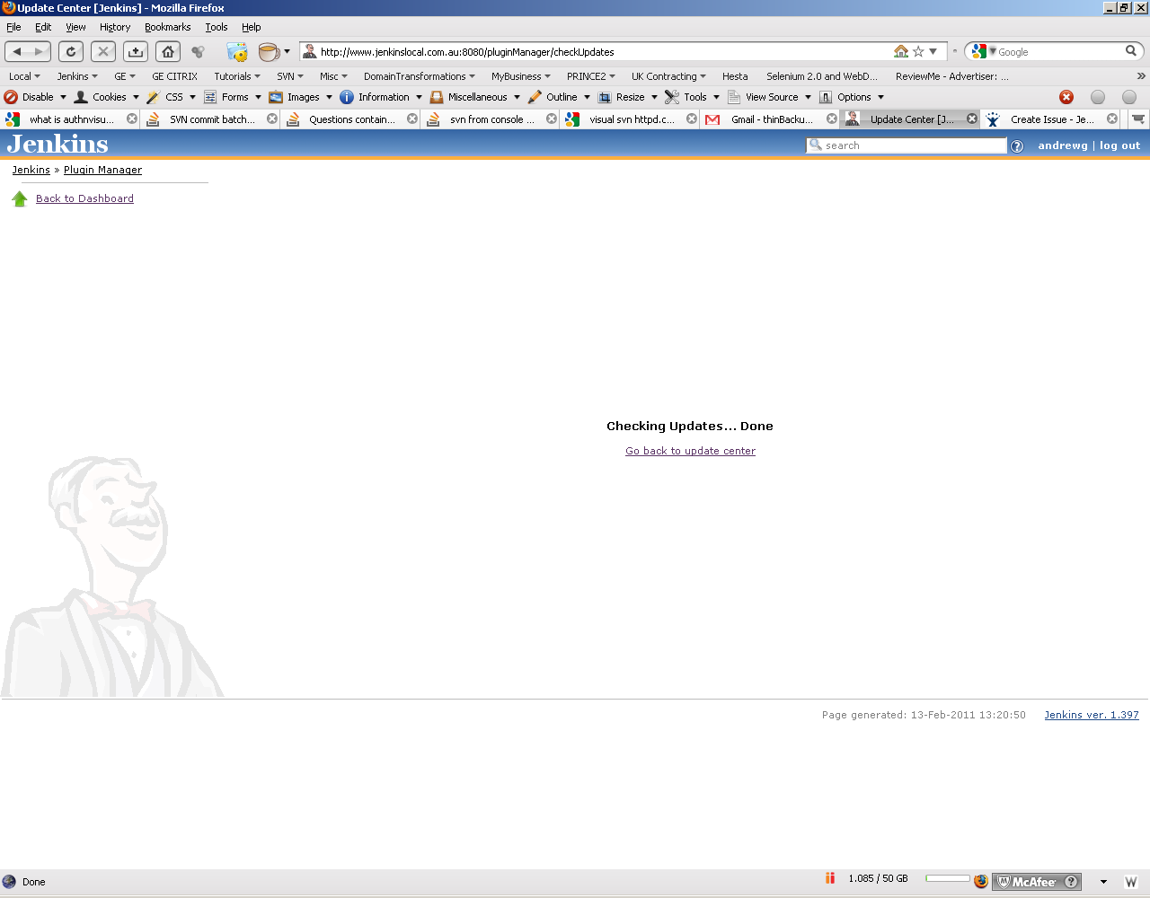
Would be great if there was another link under this one to go back to:
http://www.jenkinslocal.com.au:8080/manage

