Our core job has a post build step to trigger several projects

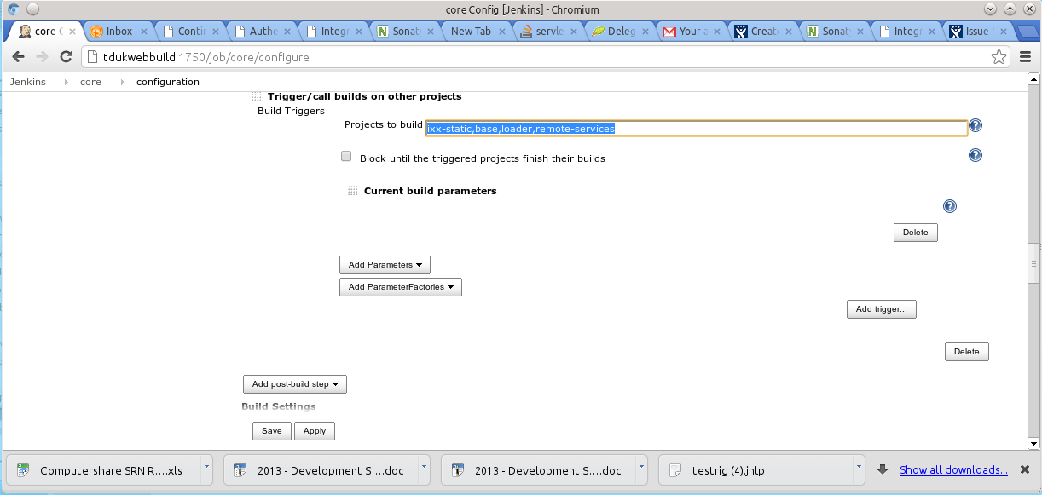
However if you look at the top level project view it does not mention any Downstream jobs

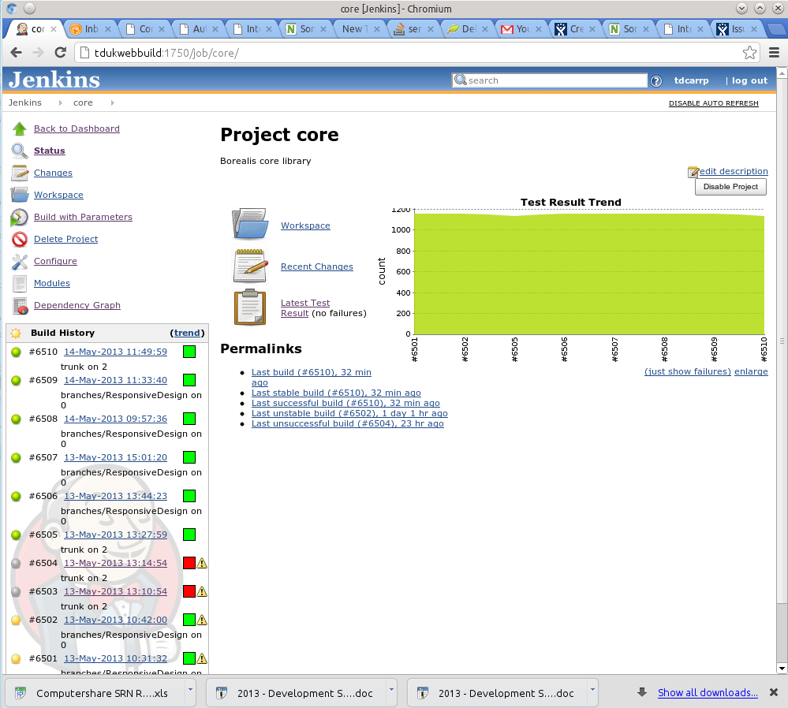

The Dependency Graph Plugin is now useless :-

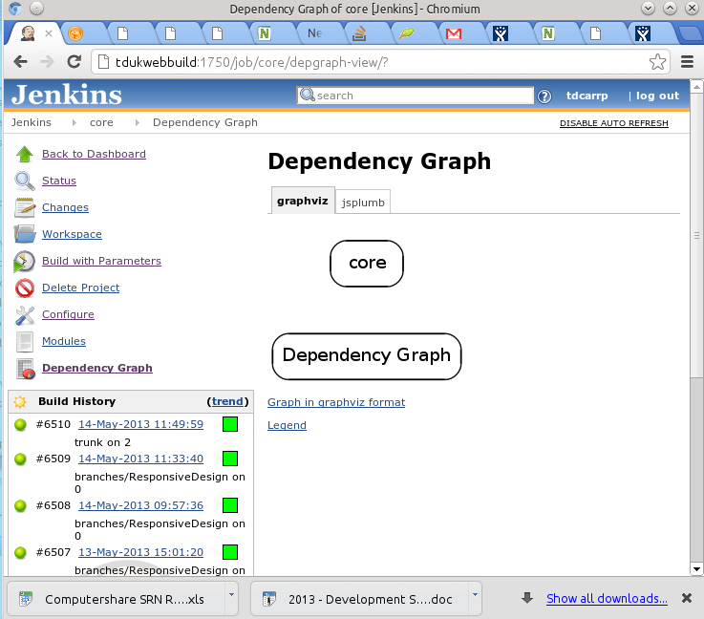

As is the build pipeline :-

