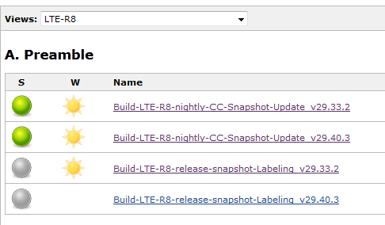
Extract from D:\Jenkins\config.xml on Jenkins master
...
<hudson.plugins.sectioned__view.SectionedView plugin="sectioned-view@1.18">
<owner class="hudson" reference="../../.."/>
<name>LTE-R8</name>
<filterExecutors>false</filterExecutors>
<filterQueue>false</filterQueue>
<properties class="hudson.model.View$PropertyList"/>
<sections>
<hudson.plugins.sectioned__view.ListViewSection>
<jobNames>
<comparator class="hudson.util.CaseInsensitiveComparator" reference="../../../../../hudson.plugins.sectioned__view.SectionedView/sections/hudson.plugins.sectioned__view.ListViewSection/jobNames/comparator"/>
<string>Build-LTE-R8-nightly-CC-Snapshot-Update_v29.32.2</string>
<string>Build-LTE-R8-nightly-CC-Snapshot-Update_v29.33.2</string>
<string>Build-LTE-R8-nightly-CC-Snapshot-Update_v29.40.2</string>
<string>Build-LTE-R8-release-snapshot-Labeling_v29.32.2</string>
<string>Build-LTE-R8-release-snapshot-Labeling_v29.33.2</string>
</jobNames>

- new build jobs *v.29.40.3* are missing, old build jobs *v29.32.2* are yet to be seen
The config.xml has the following date:
D:\Jenkins>dir config*
Volume in drive D is Hudson
Volume Serial Number is 98C6-D3C0

Directory of D:\Jenkins

21.11.2012 12:30 <DIR> config-history
31.07.2013 09:33 305.434 config.xml
27.06.2012 11:29 132.339 config.xml.bak
31.07.2013 09:33 305.434 config.xml.bak1

The changes in view LTE-R8 were made onn 12.08.2013

