Build Section
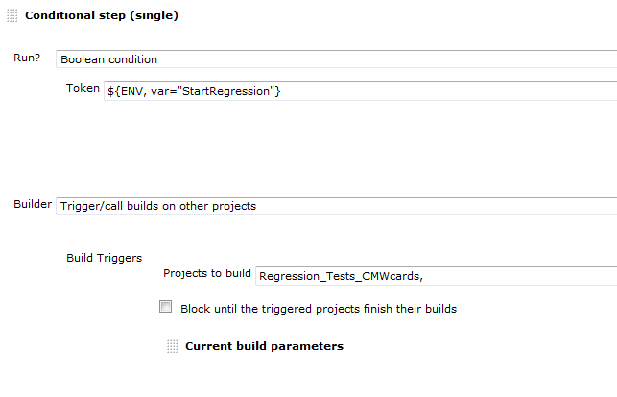

did work with Jenkins 1522, but no longer with 1527.
The following is reported:
09:56:33 Started by user Bauer,Angela,91005207
09:56:33 [EnvInject] - Loading node environment variables.
09:56:33 [EnvInject] - Preparing an environment for the build.
09:56:33 [EnvInject] - Keeping Jenkins system variables.
09:56:33 [EnvInject] - Keeping Jenkins build variables.
09:56:33 [EnvInject] - Injecting contributions.
09:56:33 Building remotely on MU719161 in workspace D:\Snapshots\MU719161-cmwcards-nightly
09:56:33 Run condition [Boolean condition] enabling prebuild for step [Trigger/call builds on other projects]
09:56:33 [MU719161-cmwcards-nightly] $ cmd /c call c:\temp\hudson3059501791918155930.bat
09:56:33 ">>>>>>>>>>>>>> Show Current Parameters"
09:56:33 MajorVersion
09:56:33 MinorVersion
09:56:33 BuildVersion
09:56:33 PackageVersion
09:56:33 TestPlan CMWcards
09:56:33 StartRegression true
09:56:33 LabelBuildNumber 0
09:56:33 BuildType
09:56:33 WorkspaceToUse D:\Snapshots\MU719161-cmwcards-nightly
09:56:33 LatestLabel
09:56:33 ReleaseLabel
09:56:33
09:56:33 D:\Snapshots\MU719161-cmwcards-nightly>exit 0

...
09:56:34 Run condition [Boolean condition] enabling perform for step [Trigger/call builds on other projects]
09:56:34 ERROR: Build aborted. Can't trigger undefined projects. 1 of the below project(s) can't be resolved:
09:56:34 >
09:56:34 Check your configuration!
09:56:34 Notifying upstream projects of job completion
09:56:34 Finished: FAILURE

The job fails, although the next project Regression_Tests_CMWcards is started:
09:56:39 Started by upstream project "Regression_Preparation_CMWcards" build number 15
09:56:39 originally caused by:
09:56:39 Started by user Bauer,Angela,91005207
09:56:40 [EnvInject] - Loading node environment variables.
09:56:40 [EnvInject] - Preparing an environment for the build.
09:56:40 [EnvInject] - Keeping Jenkins system variables.
09:56:40 [EnvInject] - Keeping Jenkins build variables.
...

Remarks:
Same problem occurs with no condition at all, just having "trigger build on other project":
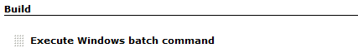
...
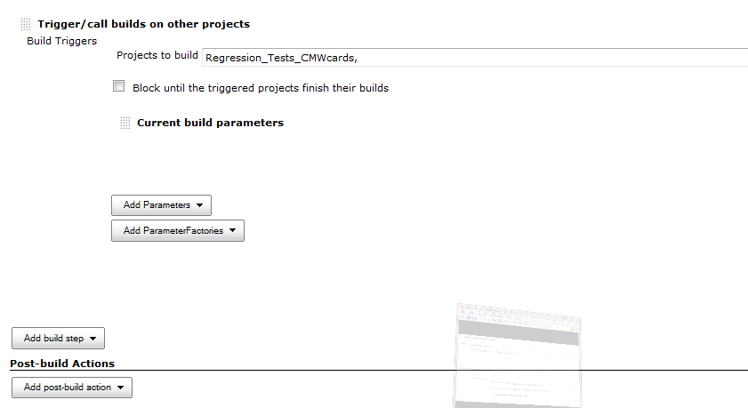
10:36:52 D:\Snapshots\MU719161-cmwcards-nightly>exit 0
10:36:52 ERROR: Build aborted. Can't trigger undefined projects. 1 of the below project(s) can't be resolved:
10:36:52 >
10:36:52 Check your configuration!
10:36:52 Notifying upstream projects of job completion
10:36:52 Finished: FAILURE

The problem does not occur, when the next project is started within the Post-build Action section, however, here I cannot use conditional steps, therefore, this is no option for me:
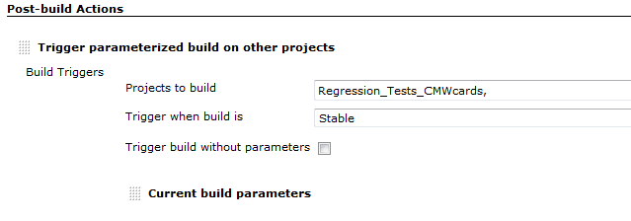

...
11:35:27 Triggering a new build of Regression_Tests_CMWcards #17
11:35:27 Notifying upstream projects of job completion
11:35:27 Finished: SUCCESS

