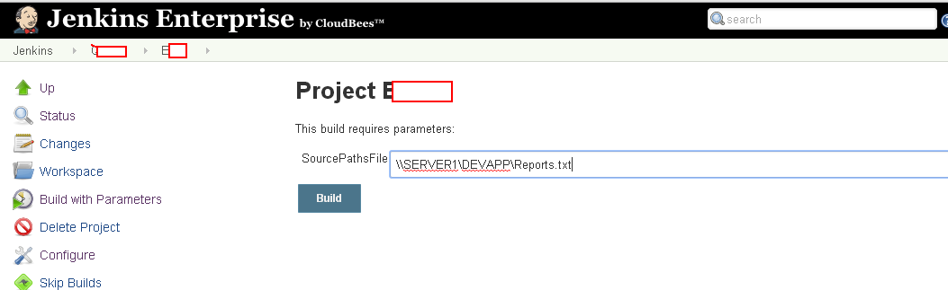
For testing purpose, I am sending mail from Nolio to validate as what parameter value it receives from Jenkins. See below subject of email

