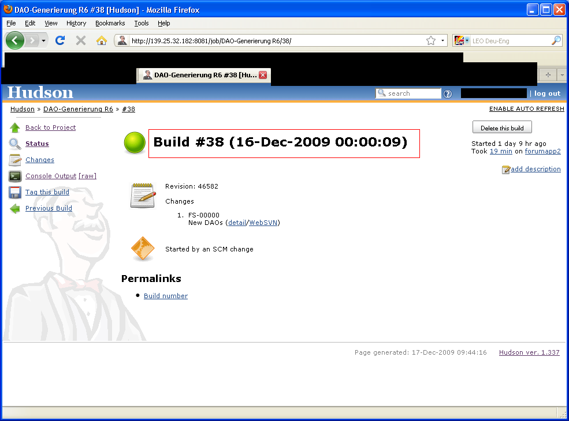

The Build time here noticed is 16.12.2009 but in real it was 17.12.2009

The console log also tells so:
SQL*Plus: Release 10.2.0.1.0 - Production on Do Dez 17 00:01:41 2009

As a result of this the project which is executed after that build had no chance to fetch date from scm:
