I defined a "conditional step (single)" within Build paragraph. I used condition "always" just for simplicity:
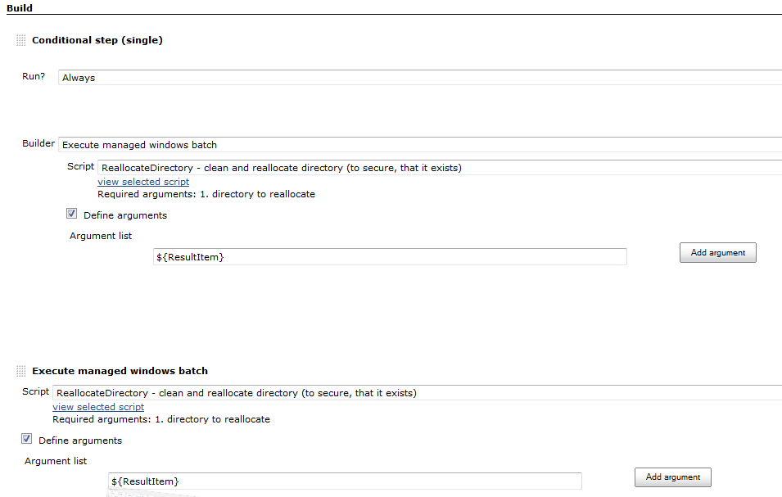

For comparison, I defined the same "Execute managed windows" batch afterwards, without the "Conditional step" around.

After saving these changes in my Jenkins build job, I opened the Jenkins build job again (with configure), and found, that the argument for the script in the "conditional step" is lost (whereas the argument in the script afterwards is yet there):
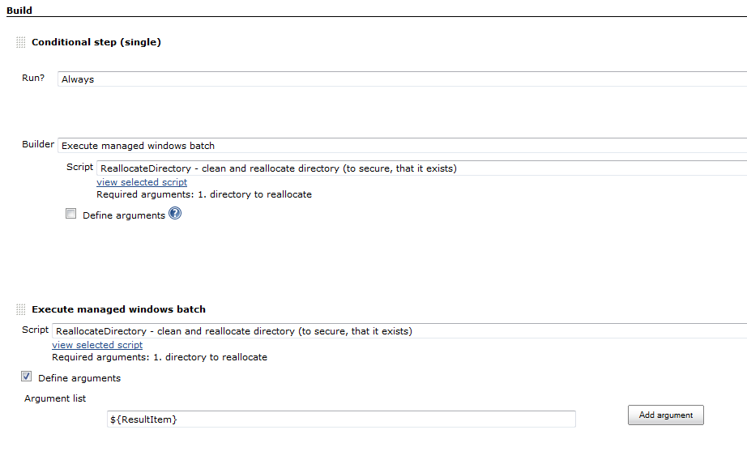
The same happens with "conditional step (multiple).
The workaround for this erroneous situation is to use global variables instead of arguments. But this is not always possible.

