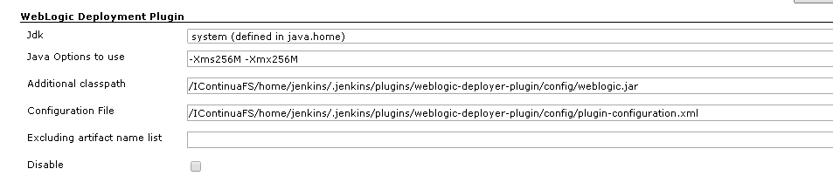

I have configured the weblogic deployment plugin with this options.
Additional classpath I cath the file from the weblogic server and I put in the directory that appears in the image
Configuration file :
<?xml version="1.0" encoding="UTF-8"?>
<config xmlns="http://org.jenkinsci.plugins/WeblogicDeploymentPlugin"
xmlns:xsi="http://www.w3.org/2001/XMLSchema-instance"
xsi:schemaLocation="http://org.jenkinsci.plugins/WeblogicDeploymentPlugin plugin-configuration.xsd">
<weblogic-targets>
<weblogic-target>
<name>weblogic_des</name>
<host>192.168.121.3</host>
<port>7002</port>
<login>weblogic</login>
<password>BSA_forms01</password>
<authMode>BY_LOGIN</authMode>
</weblogic-target>
<weblogic-target>

The configuration of job freestyle is the next

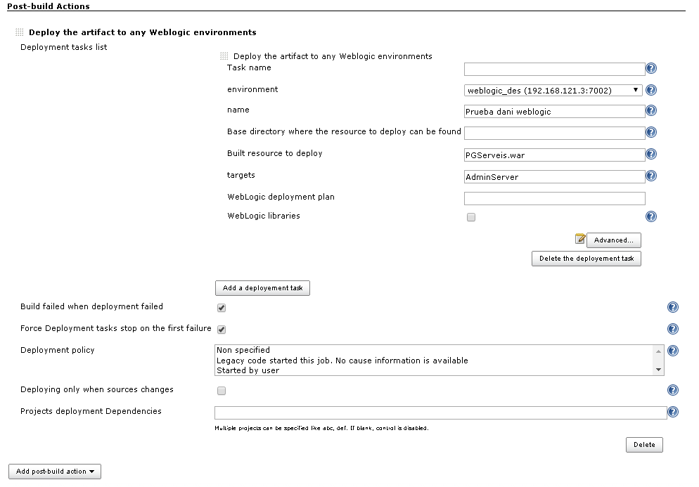
I have a subversion with the .war when I try to execute the job the output give me the next error

Started by user User sistemes
Building in workspace /IContinuaFS/home/jenkins/.jenkins/jobs/Weblogic_job/workspace
Updating https://bsarepo.bsa.net/icbsa at revision '2015-03-24T12:14:30.038 +0100'
At revision 55
no change for https://bsarepo.bsa.net/icbsa since the previous build
[WeblogicDeploymentPlugin] - The JDK /usr/java7/jre will be used.
[WeblogicDeploymentPlugin] - ArtifactSelector used : org.jenkinsci.plugins.deploy.weblogic.FreeStyleJobArtifactSelectorImpl@10341034
[WeblogicDeploymentPlugin] - Retrieving artifacts recorded [filtered resources on PGServeis.war]...
[WeblogicDeploymentPlugin] - 11 files found under workspace
[WeblogicDeploymentPlugin] - the following resource .adf doesn't match PGServeis.war
[WeblogicDeploymentPlugin] - the following resource .data doesn't match PGServeis.war
[WeblogicDeploymentPlugin] - the following resource .svn doesn't match PGServeis.war
[WeblogicDeploymentPlugin] - the following resource AppDir doesn't match PGServeis.war
[WeblogicDeploymentPlugin] - the following resource AppDir.rar doesn't match PGServeis.war
[WeblogicDeploymentPlugin] - the following resource PGClient doesn't match PGServeis.war
[WeblogicDeploymentPlugin] - the following resource PGServeis doesn't match PGServeis.war
[WeblogicDeploymentPlugin] - the following resource PGServeis.jws doesn't match PGServeis.war
[WeblogicDeploymentPlugin] - the following resource recorded PGServeis.war is eligible.
[WeblogicDeploymentPlugin] - the following resource pom.xml doesn't match PGServeis.war
[WeblogicDeploymentPlugin] - the following resource wsUtils doesn't match PGServeis.war
[WeblogicDeploymentPlugin] - Deploying the artifact on the following target : (name=weblogic_des) (host=192.168.121.3) (port=7002)
[WeblogicDeploymentPlugin] - UNDEPLOYING ARTIFACT...
$ /usr/java7/jre/bin/java -Xms256M -Xmx256M -cp /IContinuaFS/home/jenkins/.jenkins/plugins/weblogic-deployer-plugin/config/weblogic.jar weblogic.Deployer -debug -remote -verbose -noexit -name "Prueba dani weblogic" -targets AdminServer -adminurl t3://192.168.121.3:7002 -user weblogic -password Weblogic_PRE -undeploy
[WeblogicDeploymentPlugin] - ARTIFACT UNDEPLOYED SUCCESSFULLY.
[WeblogicDeploymentPlugin] - DEPLOYING ARTIFACT...
$ /usr/java7/jre/bin/java -Xms256M -Xmx256M -cp /IContinuaFS/home/jenkins/.jenkins/plugins/weblogic-deployer-plugin/config/weblogic.jar weblogic.Deployer -debug -stage -remote -verbose -upload -name "Prueba dani weblogic" -source /IContinuaFS/home/jenkins/.jenkins/jobs/Weblogic_job/workspace/PGServeis.war -targets AdminServer -adminurl t3://192.168.121.3:7002 -user weblogic -password Weblogic_PRE -deploy
java.lang.RuntimeException: task completed abnormally (exit code = 1)
at org.jenkinsci.plugins.deploy.weblogic.task.DeploymentTaskServiceImpl.deploy(DeploymentTaskServiceImpl.java:263)
at org.jenkinsci.plugins.deploy.weblogic.task.DeploymentTaskServiceImpl.perform(DeploymentTaskServiceImpl.java:192)
at org.jenkinsci.plugins.deploy.weblogic.WeblogicDeploymentPlugin.perform(WeblogicDeploymentPlugin.java:236)
at hudson.tasks.BuildStepMonitor$1.perform(BuildStepMonitor.java:20)
at hudson.model.AbstractBuild$AbstractBuildExecution.perform(AbstractBuild.java:745)
at hudson.model.AbstractBuild$AbstractBuildExecution.performAllBuildSteps(AbstractBuild.java:709)
at hudson.model.Build$BuildExecution.post2(Build.java:182)
at hudson.model.AbstractBuild$AbstractBuildExecution.post(AbstractBuild.java:658)
at hudson.model.Run.execute(Run.java:1735)
at hudson.model.FreeStyleBuild.run(FreeStyleBuild.java:43)
at hudson.model.ResourceController.execute(ResourceController.java:88)
at hudson.model.Executor.run(Executor.java:231)
ERROR: [WeblogicDeploymentPlugin] - Failed to deploy.
[INFO] ------------------------------------------------------------------------
[INFO] DEPLOYMENT FAILURE
[INFO] ------------------------------------------------------------------------
Build step 'Deploy the artifact to any Weblogic environments' changed build result to FAILURE
Finished: FAILURE

