Here is the workflow connected to the Jenkins job, run manually in workflow designer with success:
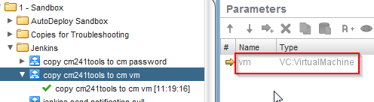
Notice there is only a single input parameter of type VC:VirtualMachine (all other input required by the workflow is hard-coded via attributes).

Here is the Variables tab (so I can show you the value of the input during the successful manual run):
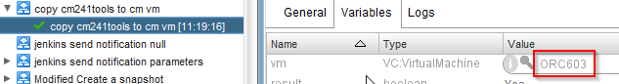

Here is the parameter configuration in the Jenkins job:
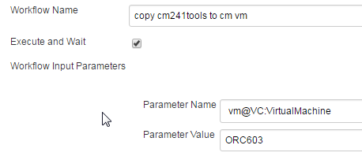

Here is the result as seen in workflow designer, after running the Jenkins job:
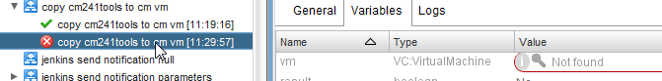

Here is the output sent to the Jenkins console (names have been sanitized):
11:29:55 Started by user anonymous
11:29:55 [EnvInject] - Loading node environment variables.
11:29:55 Building remotely on anonymous in workspace F:\jenkins\workspace\bk_orchestrator_copy-cm241tools-to-cm_vm
11:29:56 Starting Orchestrator workflow execution : dfd361ec-f0d0-4ff5-b105-aade124c9aee
11:30:07 FATAL: Workflow execution failed.
11:30:07 java.io.IOException: Workflow execution failed.
11:30:07 at com.vmware.vro.jenkins.plugin.OrchestratorCallable.call(OrchestratorCallable.java:66)
11:30:07 at com.vmware.vro.jenkins.plugin.OrchestratorCallable.call(OrchestratorCallable.java:17)
11:30:07 at hudson.remoting.UserRequest.perform(UserRequest.java:121)
11:30:07 at hudson.remoting.UserRequest.perform(UserRequest.java:49)
11:30:07 at hudson.remoting.Request$2.run(Request.java:325)
11:30:07 at hudson.remoting.InterceptingExecutorService$1.call(InterceptingExecutorService.java:68)
11:30:07 at java.util.concurrent.FutureTask.run(Unknown Source)
11:30:07 at java.util.concurrent.ThreadPoolExecutor.runWorker(Unknown Source)
11:30:07 at java.util.concurrent.ThreadPoolExecutor$Worker.run(Unknown Source)
11:30:07 at hudson.remoting.Engine$1$1.run(Engine.java:69)
11:30:07 at java.lang.Thread.run(Unknown Source)
11:30:07 at ......remote call to anonymous(Native Method)
11:30:07 at hudson.remoting.Channel.attachCallSiteStackTrace(Channel.java:1416)
11:30:07 at hudson.remoting.UserResponse.retrieve(UserRequest.java:220)
11:30:07 at hudson.remoting.Channel.call(Channel.java:781)
11:30:07 at com.vmware.vro.jenkins.plugin.OrchestratorBuilder.perform(OrchestratorBuilder.java:113)
11:30:07 at hudson.tasks.BuildStepMonitor$1.perform(BuildStepMonitor.java:20)
11:30:07 at hudson.model.AbstractBuild$AbstractBuildExecution.perform(AbstractBuild.java:782)
11:30:07 at hudson.model.Build$BuildExecution.build(Build.java:205)
11:30:07 at hudson.model.Build$BuildExecution.doRun(Build.java:162)
11:30:07 at hudson.model.AbstractBuild$AbstractBuildExecution.run(AbstractBuild.java:534)
11:30:07 at hudson.model.Run.execute(Run.java:1738)
11:30:07 at hudson.model.FreeStyleBuild.run(FreeStyleBuild.java:43)
11:30:07 at hudson.model.ResourceController.execute(ResourceController.java:98)
11:30:07 at hudson.model.Executor.run(Executor.java:410)
11:30:07 Caused by: java.io.IOException: Workflow execution failed.
11:30:07 at com.vmware.vro.jenkins.plugin.OrchestratorCallable.call(OrchestratorCallable.java:52)
11:30:07 at com.vmware.vro.jenkins.plugin.OrchestratorCallable.call(OrchestratorCallable.java:17)
11:30:07 at hudson.remoting.UserRequest.perform(UserRequest.java:121)
11:30:07 at hudson.remoting.UserRequest.perform(UserRequest.java:49)
11:30:07 at hudson.remoting.Request$2.run(Request.java:325)
11:30:07 at hudson.remoting.InterceptingExecutorService$1.call(InterceptingExecutorService.java:68)
11:30:07 at java.util.concurrent.FutureTask.run(Unknown Source)
11:30:07 at java.util.concurrent.ThreadPoolExecutor.runWorker(Unknown Source)
11:30:07 at java.util.concurrent.ThreadPoolExecutor$Worker.run(Unknown Source)
11:30:07 at hudson.remoting.Engine$1$1.run(Engine.java:69)
11:30:07 at java.lang.Thread.run(Unknown Source)
11:30:07 [BFA] Scanning build for known causes...
11:30:07 [BFA] No failure causes found
11:30:07 [BFA] Done. 0s
11:30:07 Started calculate disk usage of build
11:30:07 Finished Calculation of disk usage of build in 0 seconds
11:30:07 Started calculate disk usage of workspace
11:30:07 Finished Calculation of disk usage of workspace in 0 seconds
11:30:07 Finished: FAILURE

