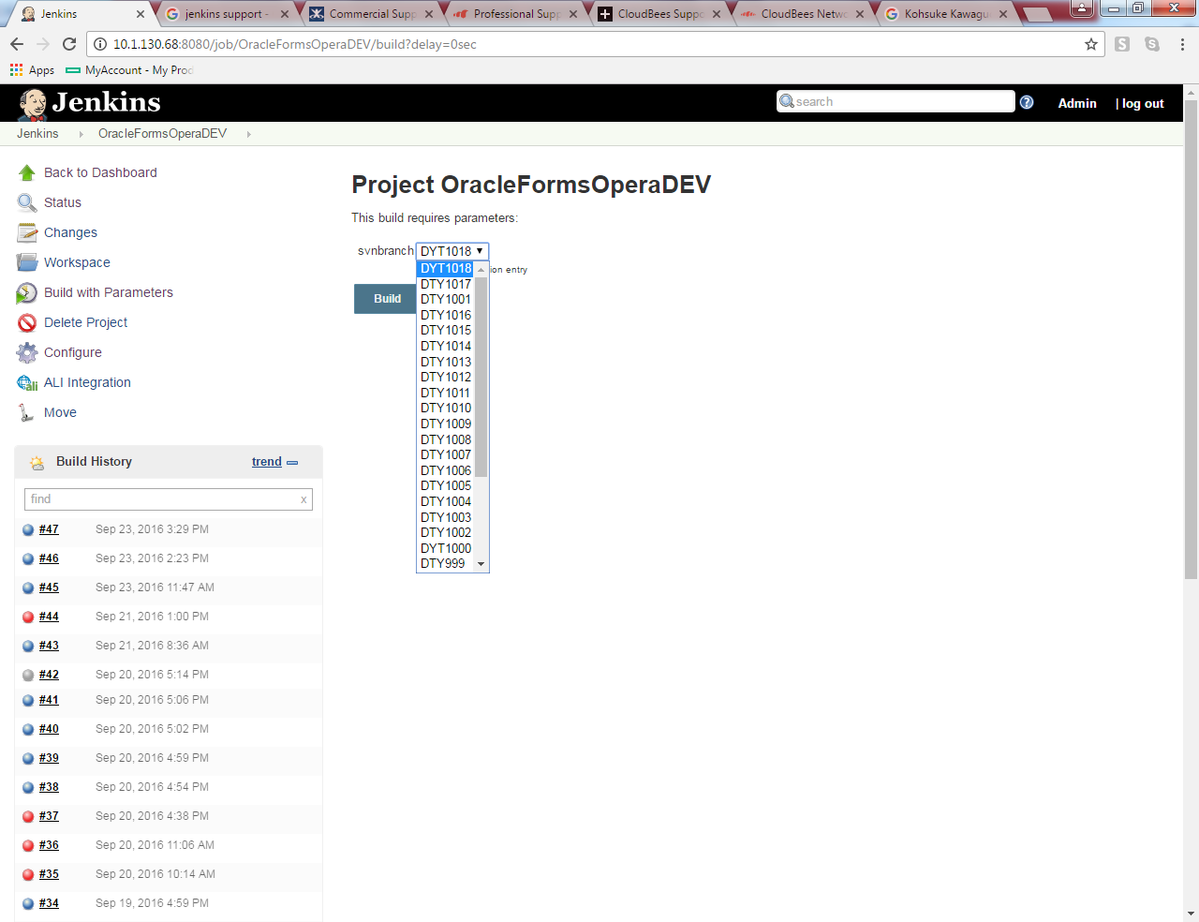

I try to run http://10.1.130.68:8080/job/OracleFormsOperaDEV/buildWithParameters?PARAMETER=DYT1017

But jenkins runs always DYT1018. Do you know any idea?

