Jenkins Issue Details

Which Jenkins Version?
2.181
Which plugins are you using? & What versions?
Git and Bitbucket related plugins screenshot is below:
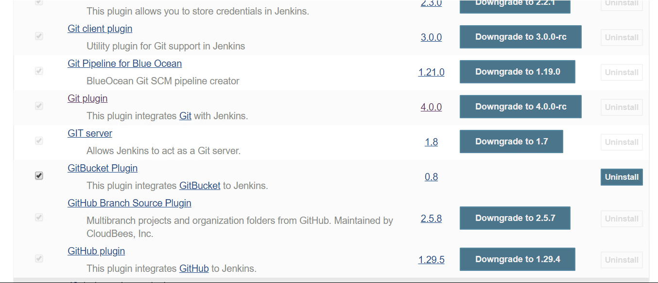
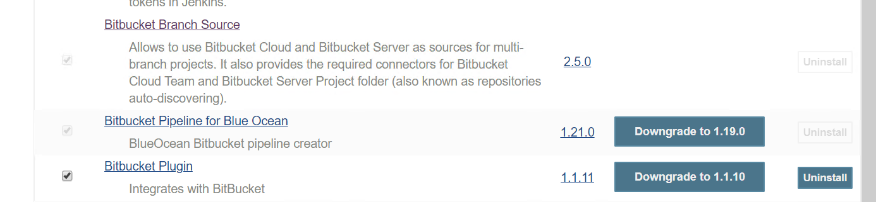
Please let me know if you need information for any other plugins

What is the detailed job configuration of the job that is showing the problem?
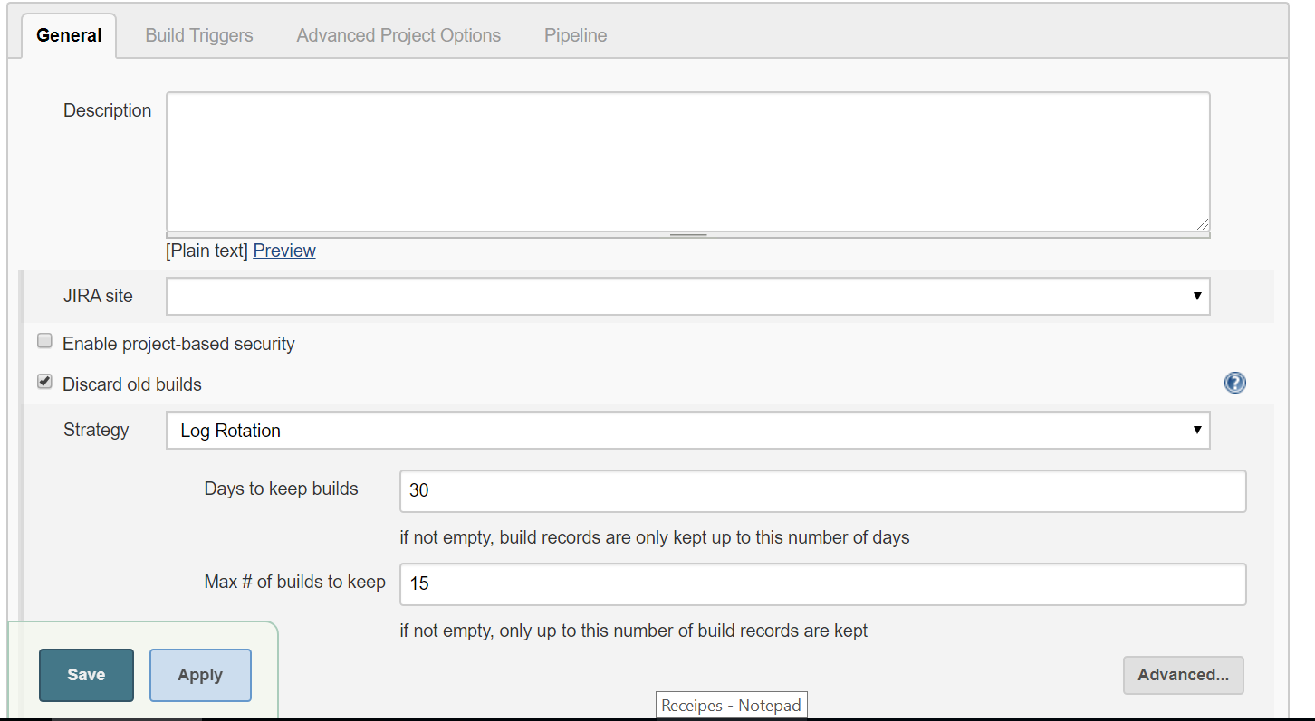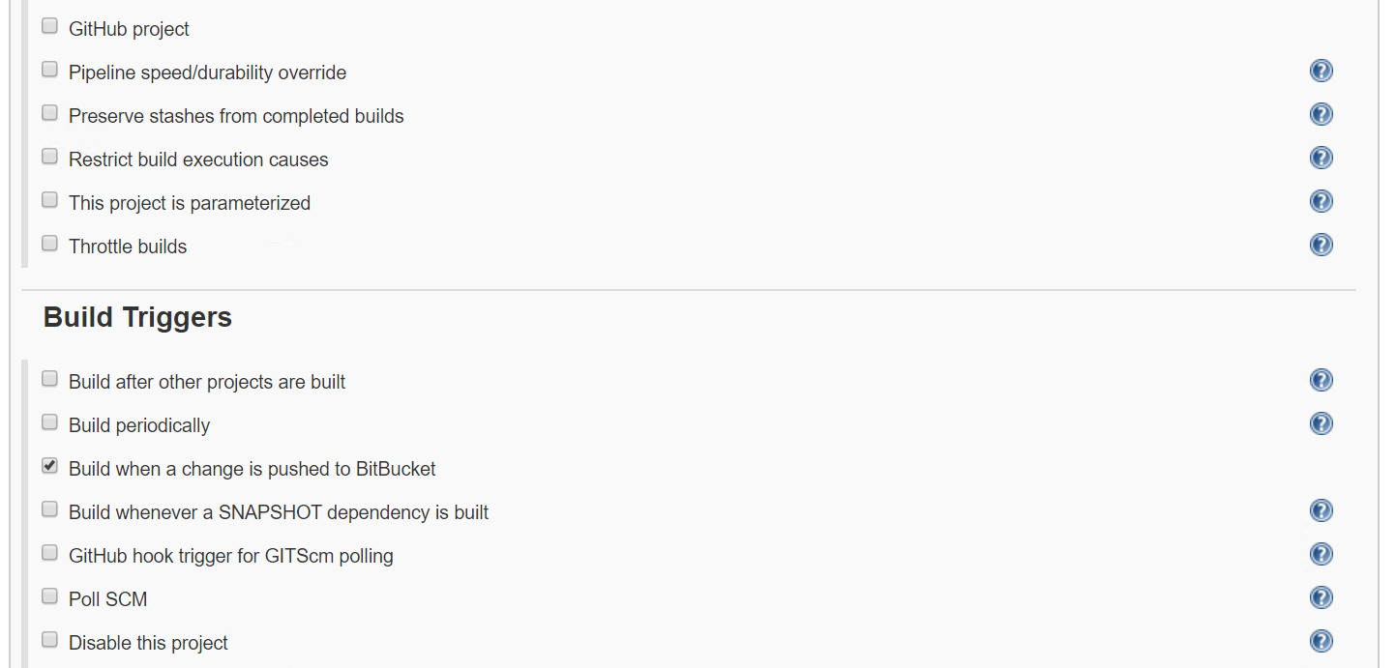

After this it is followed by the pipeline script as below, please note few details are masked for security reasons:
pipeline{
agent{label 'node1'}
stages{
stage('Code Checkout') { // for display purposes
steps{
checkout poll: true, scm: [$class: 'GitSCM', branches: [[name: 'refs/heads/develop']], doGenerateSubmoduleConfigurations: true, extensions: [], submoduleCfg: [], userRemoteConfigs: [[credentialsId: 'XXXXXX', url: 'git@bitbucket.org:XXXXXXX/MyRepo.git']]]
}
}
stage ('Update DB Credentials'){
steps{
withCredentials([usernamePassword(credentialsId: 'XXXXXX', passwordVariable: 'PWD', usernameVariable: 'UNAME')]) {
dir('myfolder/dev'){
sh 'sed -i "s/USERNAME/$UNAME/g" abc-secret.yaml'
sh 'sed -i "s/PASSWORD/$PWD/g" abc-secret.yaml'
}
}
}
}
stage('Build code'){
steps{
dir('myfolder') {
withEnv(['JAVA_HOME=/root/jdk1.8.0_201']) {
sh 'pwd'
sh 'ls -lart'
sh 'chmod 755 mvnw'
sh 'ls -lart'
sh './mvnw clean package'
}
}
}
}
stage("SonarQube analysis") {
steps {
dir('myfolder') {
withEnv(['JAVA_HOME=/root/jdk1.8.0_201/']) {
withSonarQubeEnv('Sonarqube web server') {
sh './mvnw sonar:sonar'
}
}
}
}
}
stage('Build Docker image'){
steps{
dir('myfolder') {
script {
TAG_VERSION = readMavenPom().getVersion()
}
echo("TAG_VERSION_BUILD=${TAG_VERSION}")
sh "docker build --file=docker/Dockerfile.remote -t MyApplication_img:${TAG_VERSION} ."
}
}
}
stage('Tag the image'){
steps{
echo("In Tag image=${TAG_VERSION}")

sh "docker tag MyApplication_img:'${TAG_VERSION}' XXXX/XXXXX/msp/dev/MyApplication_img:'${TAG_VERSION}'"
sh "docker tag MyApplication_img:'${TAG_VERSION}' XXXX/XXXXX/msp/dev/MyApplication_img:latest"
}
}
stage('push image to OCIR'){
steps{
echo("TAG_VERSION_PUSH=${TAG_VERSION}")

withDockerRegistry(credentialsId: 'XXXXX', url: 'XXXXXXX'){
sh "docker push XXXX/XXXXXX/msp/dev/MyApplication_img:latest"
sh "docker push XXXX/XXXXX/msp/dev/MyApplication_img:'${TAG_VERSION}'"
sh 'docker image ls --all XXXX/XXXXXXX/msp/dev/MyApplication_img'
}
}
}
stage('Deploy app on Kubernetes container'){
steps{
sh 'sudo su - myuser -c "kubectl --namespace=parent-namespace delete deployment MyApplication-deployment --ignore-not-found=true"'
sh 'sudo su - myuser -c "kubectl --namespace=my-namespace apply -f MyApplication-configmap.yaml"'
sh 'sudo su - myuser -c "kubectl --namespace=my-namespace apply -f MyApplication-secret.yaml"'
sh 'sudo su - myuser -c "kubectl --namespace=my-namespace apply -f MyApplication-app.yaml"'
sh 'sudo su - myuser -c "kubectl --namespace=my-namespace apply -f MyApplication-ingress.yaml"'

}
}

}
post{
failure{
emailext attachLog: true,
body: "<br>Project: '${env.JOB_NAME}' <br>Build Number: '${env.BUILD_NUMBER}' <br> URL of build: '${env.BUILD_URL}'",
compressLog: true,
mimeType: 'text/html',
subject: "'${currentBuild.currentResult}': Project name -> '${env.JOB_NAME}'",
to: 'XXXXXXX',
from: 'JENKINS-MS@XXXXXX'
}
}
}

How are the webhooks configured on Bitbucket? & What arguments are included in the Bitbucket webhook call to Jenkins?
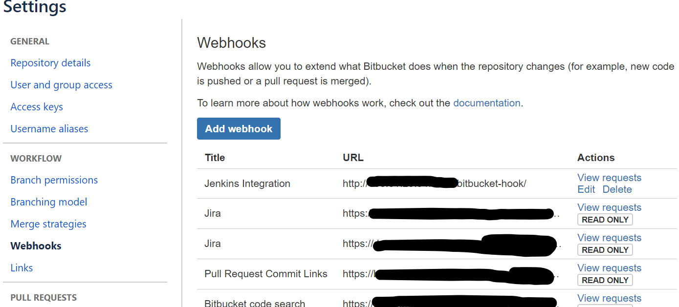
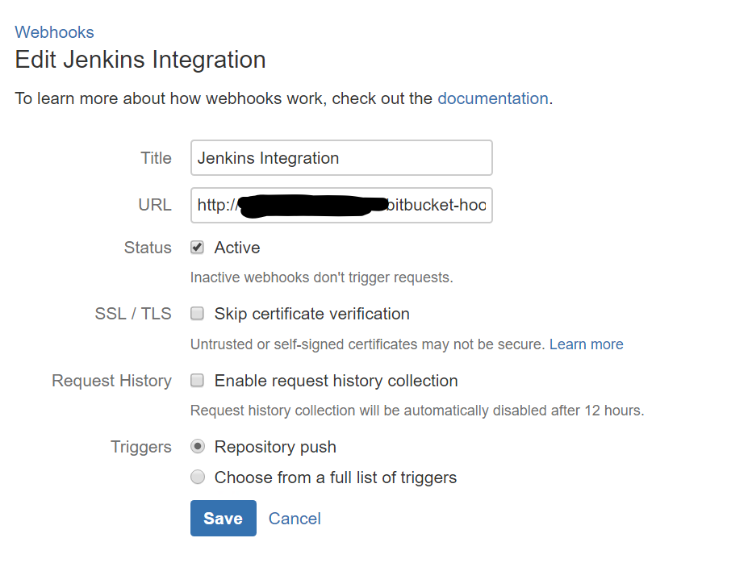
Which type of Bitbucket are you running, cloud or server?
Cloud Licensed Premium
Are there cases where the system behaves the way you want in this use case, or do you always have the poor behavior? Are you using webhooks to notify Jenkins?
The system behaves fine if it is newly created pipeline. I can replicate this problem only for pipelines which haven’t been trigger from a month or more. Newer pipelines aren’t exhibiting this behavior. Also note that once the old pipeline is triggered, then the next subsequent runs also do not show this problem and trigger only the pipeline for which the code is committed.
So for me to try any solution also has limitations as once the old pipeline is triggered, I cannot re use it to replicate the issue.
If you poll for changes, does it behave the same way, or does it only build on the branch that changed?
Yes, it is same.

