## Issue:

When running Datical DB over Windows would receive the following error message when executing a Job step calling the Datical DB Plugin.

## 'C:\Program' is not recognized as an internal or external command,

We then modified the Datical Install Parameter by quoting the Path provided. E.g,

“C:\Program Files\DaticalDB”

However this resulted in the following error:

'"C:\Program Files\DaticalDB\hammer.bat"' is not recognized as an internal or external command,

To work around the issues above we ended up appending repl and quoting the path (Figure 2).

Figure 2

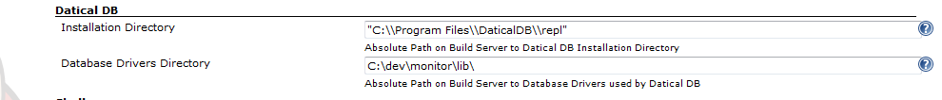

## Debugging:

1. Download and extract Maven.

2. Append System Path with “C:\<Maven Install> \bin “

3. Download and extract Datical-DB plugin for Jenkins from GIT (<https://github.com/jenkinsci/datical-db-plugin>)

4. Open a command prompt and cd into the directory where you extracted the Datical-DB plugin.

5. From a command prompt issue the following Maven Command: mvn package

The rest of the instructions are largely taken from the following link.

<https://wiki.jenkins-ci.org/display/JENKINS/Plugin+tutorial>

1. Under C:\Users\<profile>\.m2 add to or create settings.xml and add the following.

<settings>

<pluginGroups>

<pluginGroup>org.jenkins-ci.tools</pluginGroup>

</pluginGroups>

<profiles>

<!-- Give access to Jenkins plugins -->

<profile>

<id>jenkins</id>

<activation>

<activeByDefault>true</activeByDefault> <!-- change this to false, if you don't like to have it on per default -->

</activation>

<repositories>

<repository>

<id>repo.jenkins-ci.org</id>

<url>http://repo.jenkins-ci.org/public/</url>

</repository>

</repositories>

<pluginRepositories>

<pluginRepository>

<id>repo.jenkins-ci.org</id>

<url>http://repo.jenkins-ci.org/public/</url>

</pluginRepository>

</pluginRepositories>

</profile>

</profiles>

<mirrors>

<mirror>

<id>repo.jenkins-ci.org</id>

<url>http://repo.jenkins-ci.org/public/</url>

<mirrorOf>m.g.o-public</mirrorOf>

</mirror>

</mirrors>

</settings>

The following sequence of steps require you to be in a command window and in the directory where you extracted the Datical-DB Plugin. DO NOT CLOSE THIS WINDOW.

1. Run the following Maven command.

mvn -DdownloadSources=true -DdownloadJavadocs=true -DoutputDirectory=target/eclipse-classes eclipse:eclipse

1. Run the following Maven command.

set MAVEN_OPTS=-Xdebug -Xrunjdwp:transport=dt_socket,server=y,address=8000,suspend=n

Open Eclipse and Select File -> Import -> Existing Projects into Workspace (Figure 3). Select the directory where you extracted the Datical-DB Plugin.

Figure 3

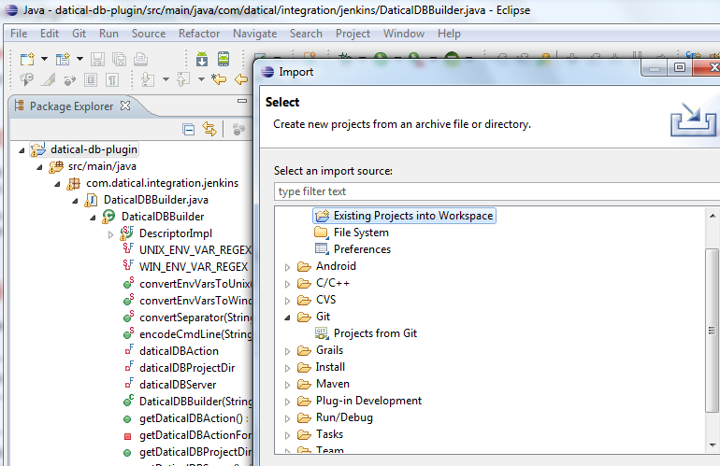

Next, Select Run -> Debug Configurations (Figure 4). Note on the right side pane select “Remote Java Application”

Figure 4

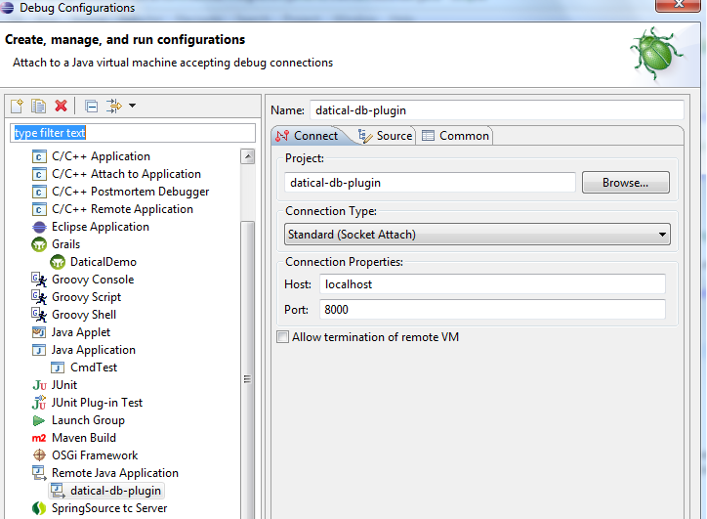

If you have multiple Consoles ensure that you are in the correct console from within the Debug Perspective (Figure 5).

Figure 5

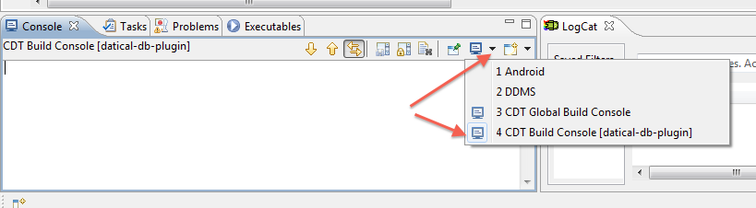

Go back to the Command Prompt Window where you have the Datical-DB Plugin installed and execute the following Maven Command.

mvn hpi:run

Next go back into Eclipse and Launch the projects Debugger (Figure 6).

Figure 6

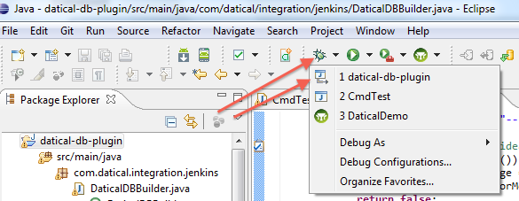

If the Debug Perspective does not launch then you will need to select Window -> Preferences (Figure 7).

Figure 7

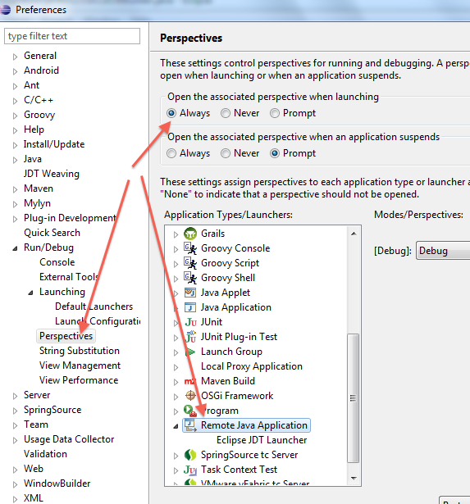

If you experienced errors then you may need to restart Eclipse or re-launch the sequence of Maven Commands previously listed.

Assuming no issues then open a browser and navigate to the following url (<http://localhost:8080>) DO NOT navigate to (<http://localhost:8080/jenkins>)

Jenkins Console should display.

Select “Manage Jenkins” -> “Configure System”

Scroll down and set the Global Datical DB properties (Figure 8).

Figure 8.

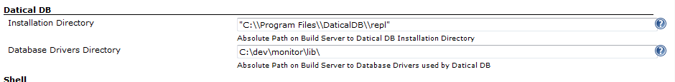

Next Create a New Job (Figure 9).

Figure 9

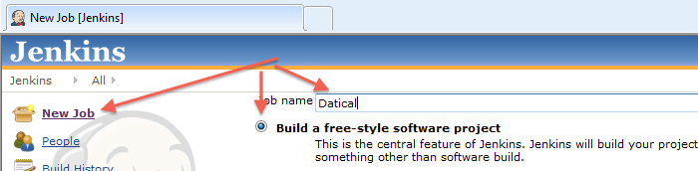

“Configure” the Datical DB Job Properties (Figure 10).

Figure 10.

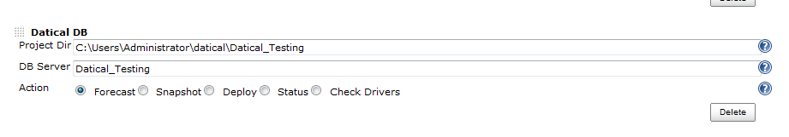

Next Select “Build Now” and you should then be able to step through and debug the Datical DB Plugin code from within Eclipse.

If at any time you run into issues then close everything out and restart.

## Problem Identification

Enclosing the Datical Installation Directory path in Double Quotes resolved the issue of executing the command however it failed to detect the existence of the Datical DB Command (hammer.bat).

“C:\Program Files\DaticalDB”\repl\hammer.bat

Because of this the code assumed a CLI installation and truncated the command to

“C:\Program Files\DaticalDB”\hammer.bat

What appears to be happening is that the tag library for textbox.jelly is JSON encoding the value entered via (<?jelly escape-by-default='true'?> thereby resulting in an actual value of “C:\Program Files\DaticalDB”. The value passed is not interpreted by Java as an escaped quote.

## Solution

Therefore to eliminate any ambiguities the following changes were made to DaticalDBBuilder.java

Added a static method called encodeCmdLine.

public static String encodeCmdLine(String cmdLine)

{

String REGEX = "\\s+";

Pattern p = Pattern.compile(REGEX);

String[] s = p.split(cmdLine);

if (s.length == 1) {

return cmdLine;

}

StringBuffer sb = new StringBuffer();

for(int x = 0; x < s.length; x++){

if (x == 0){ sb.append("\"").append(s[x]).append(" "); }else{

if (x == (s.length -1)){ sb.append(s[x]).append("\"");

}else{

sb.append(s[x]).append(" ");

}

}

return sb.toString();

}

Next I added the snippet offset in red font below to call the encodeCmdLine.

// TODO: more of the same, need to get FormValidation doing this daticalDBServer check

// forecast, snapshot, deploy need the DB Server set

if (daticalDBAction.equals("forecast") || daticalDBAction.equals("snapshot") || daticalDBAction.equals("deploy")) {

if (daticalDBServer.isEmpty()) {

final String errorMessage = "Datical DB Server must be set if the Datical DB Action is \"" + daticalDBAction + "\". Please update Datical DB build step in the project's configuration.";

listener.fatalError(errorMessage)

return false;

}

}

if (!launcher.isUnix()) {

daticalCmd = encodeCmdLine(daticalCmd);

}

Once completed then it is not necessary to escape the Datical Installation Directory Path or add any additional characters. It can be provided as follows:

C:\Program Files\DaticalDB