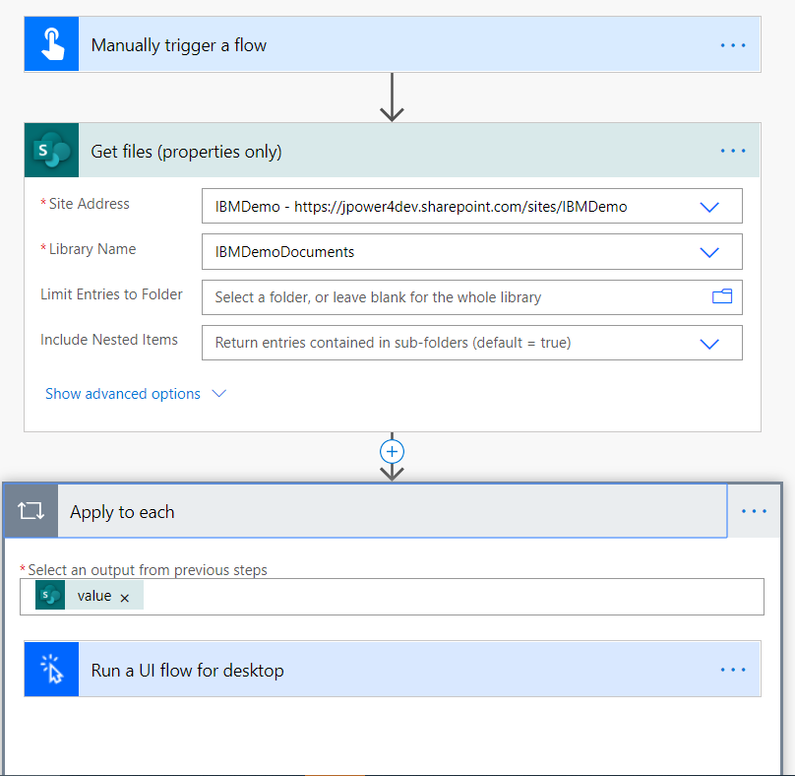

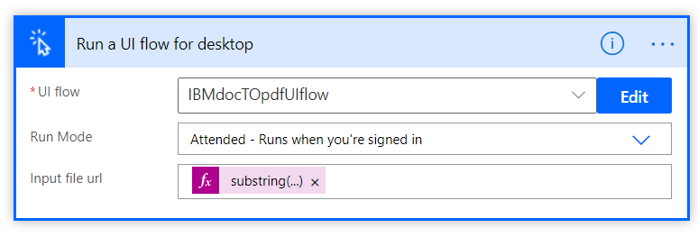

substring(item()?['{Link}'],0,indexOf(item()?['{Link}'],'?d'))

[https://jpower4dev.sharepoint.com/sites/IBMDemo/Testing/Lab 1-Setting Up you Environment.docx](https://jpower4dev.sharepoint.com/sites/IBMDemo/Testing/Lab%201-Setting%20Up%20you%20Environment.docx)

