# Five Colleges MARC Record Loading

# JSTOR

## Files

Files come through OCLC Files download. There are three different sets: Books at JSTOR Purchased, Books at JSTOR Demand Driven Acquisition, Books at JSTOR Open Access. The knowledge base in Collection Manager has been set up so that these collections are delivered in one file with the code fcjst.

CHANGED TO 3 FILES DELIVERED on 4/19/19 for WEEKLY Delivery:

JSTOR Demand Driven Acquisition: fcjstdd

Books at JSOR Open Access: fcjstoa

Books at JSTOR Purchased: fcjstp

The collections have been set up to delivery only updates after the initial delivery. This is through the UMass OCLC WorldShare account and not the FC one.

The original setup in OCLC included information to construct a full 949 _1 field including sublibrary, collection, item material type, and EDS type (subfield k). This was later changed so that the files only include the 949_1$kE-Book. It is necessary to check files to ensure that all unnecessary information is removed before loading.

## Preprep Files

These are only ebooks. There is no initial prep as there is a fix routine as well as a map that creates the sublibrary/collection/item material type in Aleph.

## Outline

1. Convert the file (step 1 and 2)
2. Run a fix DPJST
3. Check the database
4. Troubleshoot any multimatches
5. Load new and updated bibliographic records and then inventory
6. Remove 856 from bibliographic records

## Process

### Retrieve MARC file(s)

1. Go to OCLC File Downloads. Search and download file(s).
2. Change the name of the file to be more manageable.

### Load Records into Aleph

1. FTP the file to the /exlibris/aleph/u21_1/fcl01/scratch directory.
2. (Step 1) Services/Load Catalog Records and Convert step 1 (file-01)
   1. Input file: name of the marc file
   2. Output file: any name
   3. MARC Record Format: ‘1D’ separator
   4. Library: FCL01

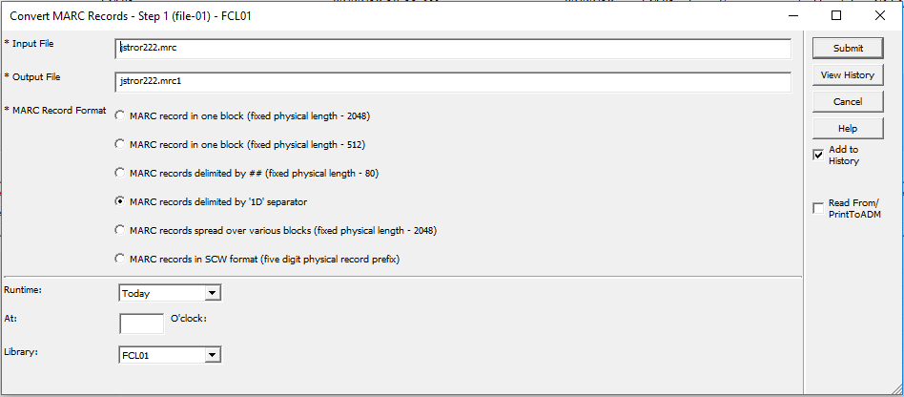

1. (Step 2) Click on Services/Load Catalog Records and Convert step 2 (file -02)
   1. Input file: name of output file from step 1
   2. Output file: new name
   3. MARC Record Form: Marc Record
   4. Library: FCL01

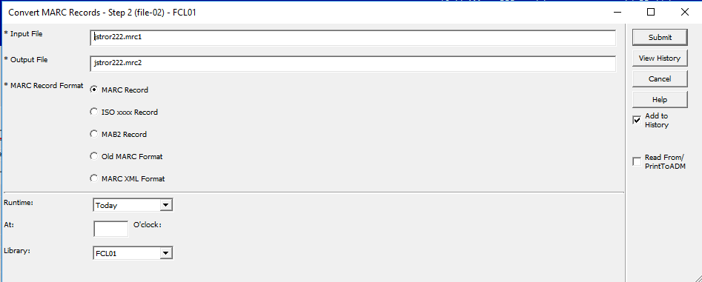

1. (FIX) Services/Load Catalog Records and select Fix Catalog Records (manage-37)
   1. Input File: Name of output file from step 2
   2. Output file: New name
   3. Input File Type: ALEPH Sequential
   4. Fix Routine: DPJST
   5. Update Database: No

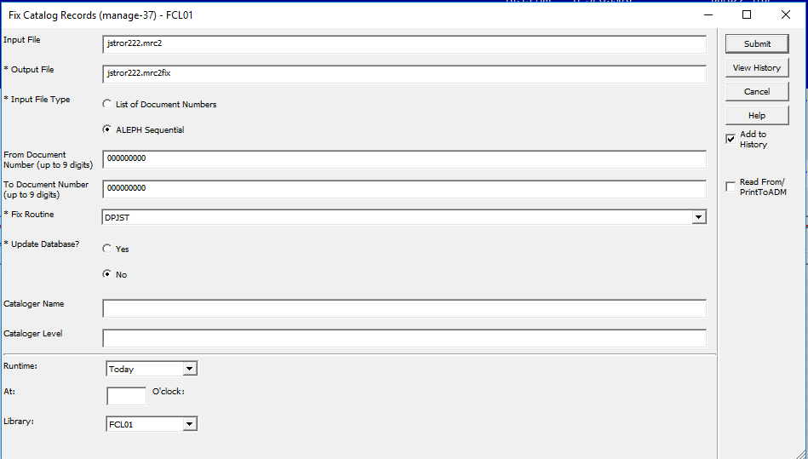

1. (Check Database) Services/Load Catalog Records and select Check Input File Against Database (manage-36)
   1. Input file: Name of output file from manage-37
   2. Output file 1, 2 & 3: give numbers 0 (new or no matches), 1 (update or single match), 2 (multimatches)
   3. Match Selection: 0359A
   4. Tag for Multiple Record Numbers: 989 or some other field never used
   5. Library: FCL01

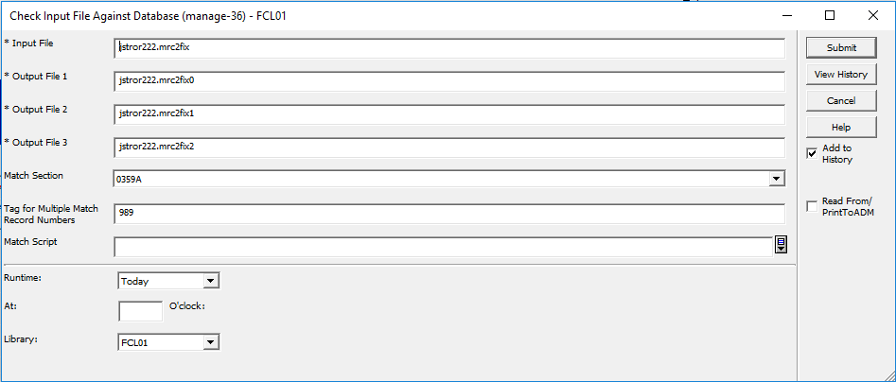

1. (**NEW & Updated RECORDS LOAD**): There is data in the file with the 0 at the end. Load that file under Services/Load Catalog Records and select Load Catalog Records (manage-18)
   1. Input file: File name with 0 at the end from manage-36
   2. Output file for Rejected Records: Add new file name
   3. Output file for Logging System Numbers: Add new file name
   4. Procedure to Rune: Add new records to the database
   5. If Updating Current Records: Replace fields within a record
   6. Indexing: Full
   7. Fix Routine: None
   8. Merge/Preferred Routine: None
   9. Character Conversion: OCLC_UTF_TO_UTF
   10. No. of Catalogers Currently Working: Multi-users
   11. Library: FCL01

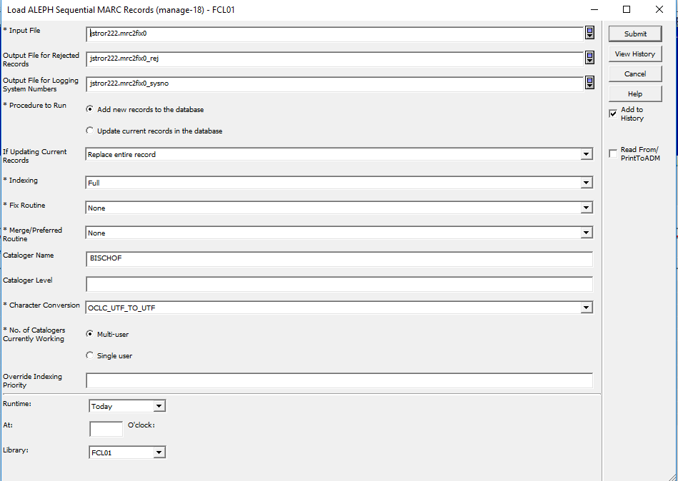

1. **(Add Inventory for Records)** Add Items/Holdings for New Records Loaded. Go to Serves/Load Catalog Records and select Create Holdings and Item records based on Bibliographic Data (manage-50)
   1. Input file: File name for the list of bib sys numbers created in last step manage-18
   2. ADM Library: DEP50
   3. HOL Library: FCL60
   4. Expand Procedure: None
   5. Main Field: 949#1
   6. Item/Holdings Creation Table: tab_hol_item_create_fcjstor
   7. Mapping table: tab_hol_item_map_fc_jstor
   8. Holdings Record Creation Mode: Replace existing holdings records
   9. Item Record Creation Mode: Replace existing item records
   10. Holdings/Item Creation Interaction: Create holdings records based only on new items
   11. ADM Cataloger: Your login username to Aleph
   12. ADM Cataloging Level: 20
   13. HOL Cataloger: Your login username to Aleph
   14. HOL Cataloging Level: 20
   15. Update Database: Yes
   16. Check Item records: Yes
   17. Library: FCL01

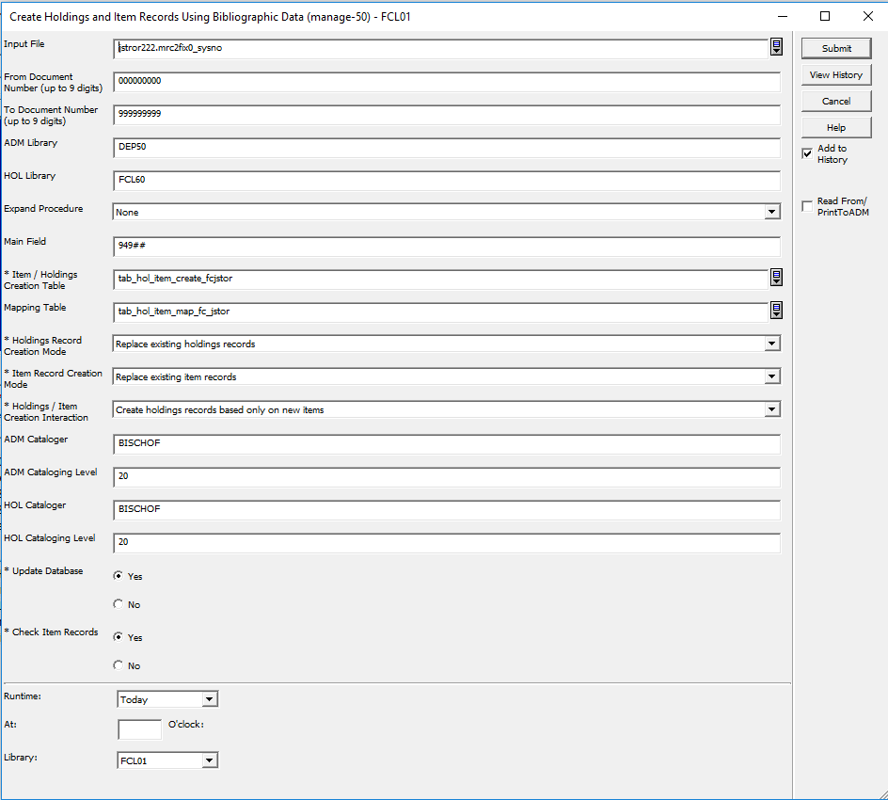

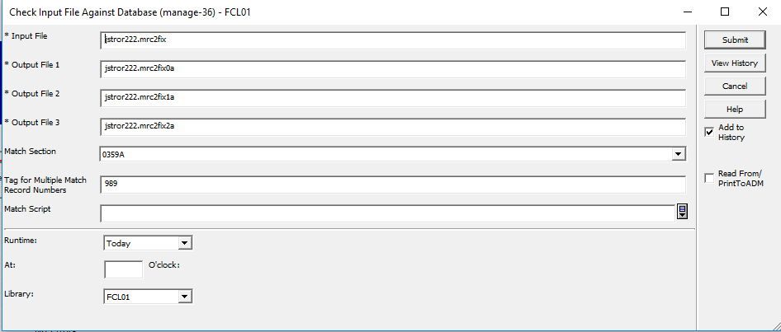

1. **(Remove URLs from New Record Bibs)** Remove URLs from Bib records: Go to Services/Catalog Maintenance Procedures and select Global Changes (manage-21)
   1. Input File: File name with the Bib sys numbers from manage-18
   2. Output file: File name for log
   3. Update database: Yes
   4. Line in Record
      1. Tag: 856
      2. First Indicator: #
      3. Second Indicator: #
   5. Delete Field: Yes

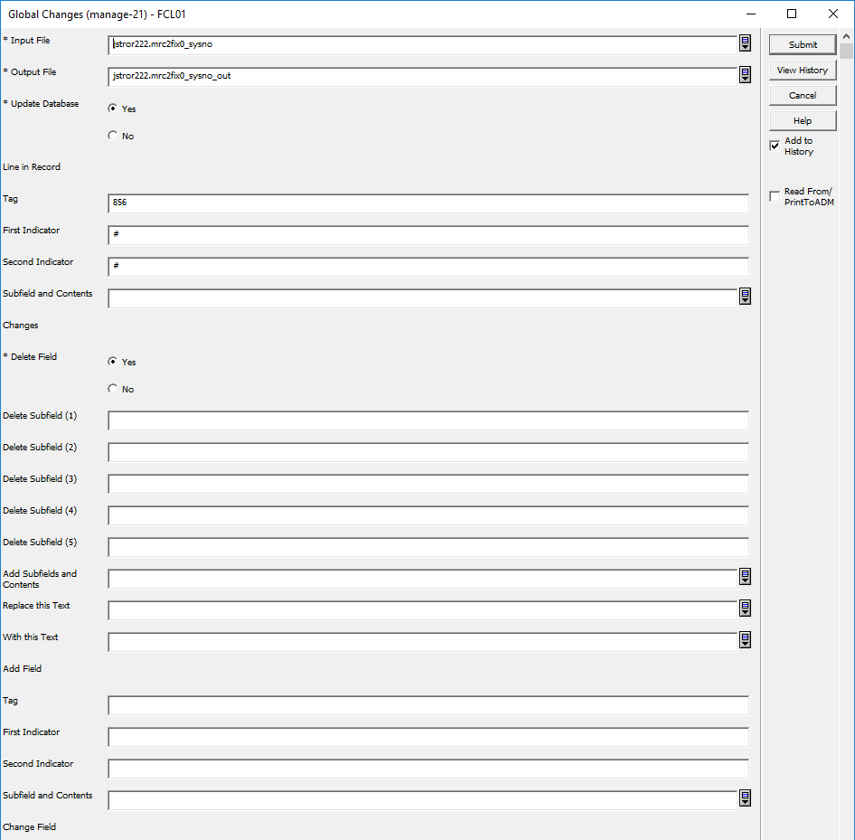

Instructions When No Delete File is Delivered

This will create a list of records that need to be deleted.

