# Five Colleges MARC Record Loading

# Knowledge Unlatched

Collection Code: FCKNU

## Files

Files can be found on the vendor website at <http://knowledgeunlatched.org/ku-marc-records/>. Records were loaded from an OCLC KB. However, there are multiple collections and it is easier to retrieve the one file from the vendor site. Updates occur infrequently from the vendor. Loads occur twice a year or when there’s notification of significant changes.

## Outline

1. Prepare file in MarcEdit
2. Convert the file (step 1 and 2)
3. Run a fix DPKNU
4. Check the database
5. Troubleshoot any multimatches
6. Load new and updated bibliographic records and then inventory
   1. tab_hol_item_create_fcku
   2. tab_hol_item_map_fc_ku
7. Remove 856 from bibliographic records

## Process

### Retrieve MARC file(s)

1. Go to vendor site and get latest records.

### Prepare MARC file(s) in MarcEdit

Note: The urls in the file are inconsistent. The task is unable to account for the multiple variations and tries to deal with the majority. There will be some manual cleanup.

1. Check the field count
2. Review the 856 fields
3. Run the FCKNU task
   1. Removes tabs
   2. Deletes bad data in 856 and unnecessary 856
   3. Removes subfields 3,a,x,z
   4. Adds prefix to OCLC number
   5. Ensures as many as possible of the urls have the same prefixes
   6. Removes duplicate 856s
   7. Adds 949\1$kE-Book
   8. Adds 655\4$aElectronic Books
   9. Adds z Five colleges: Link to resource to 856s
4. Check the field count and 856 fields again. There’s a strong chance there will be manual cleanup for some of the 856s.

### Load Records into Aleph

1. FTP the file to the /exlibris/aleph/u21_1/fcl01/scratch directory.
2. (Step 1) Services/Load Catalog Records and Convert step 1 (file-01)
   1. Input file: name of the marc file
   2. Output file: any name
   3. MARC Record Format: ‘1D’ separator
   4. Library: FCL01

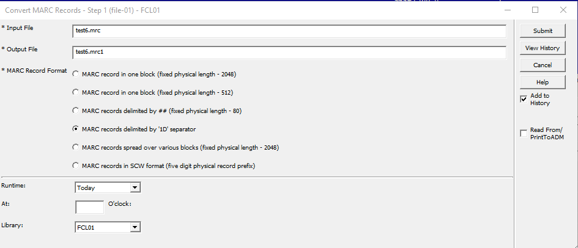

1. (Step 2) Click on Services/Load Catalog Records and Convert step 2 (file -02)
   1. Input file: name of output file from step 1
   2. Output file: new name
   3. MARC Record Form: Marc Record
   4. Library: FCL01

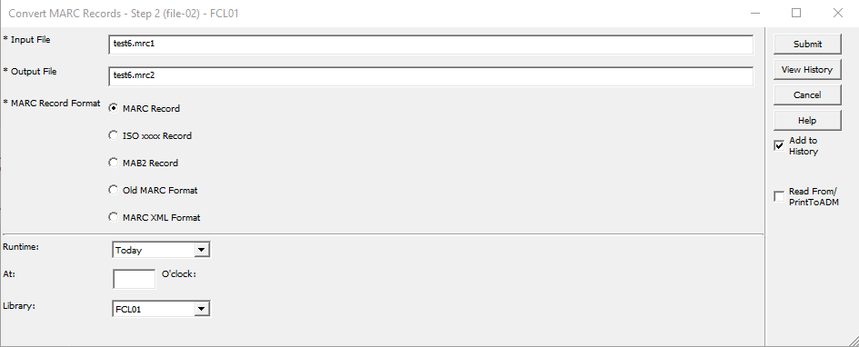

1. (FIX) Services/Load Catalog Records and select Fix Catalog Records (manage-37)
   1. Input File: Name of output file from step 2
   2. Output file: New name
   3. Input File Type: ALEPH Sequential
   4. Fix Routine: DPKNU
   5. Update Database: No

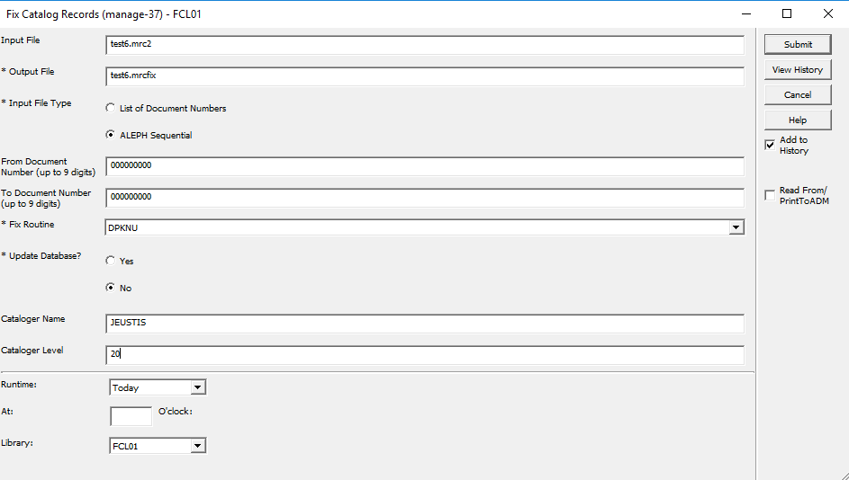

1. (Check Database) Services/Load Catalog Records and select Check Input File Against Database (manage-36)
   1. Input file: Name of output file from manage-37
   2. Output file 1, 2 & 3: give numbers 0 (new or no matches), 1 (update or single match), 2 (multimatches)
   3. Match Selection: 0359A
   4. Tag for Multiple Record Numbers: 989 or some other field never used
   5. Library: FCL01

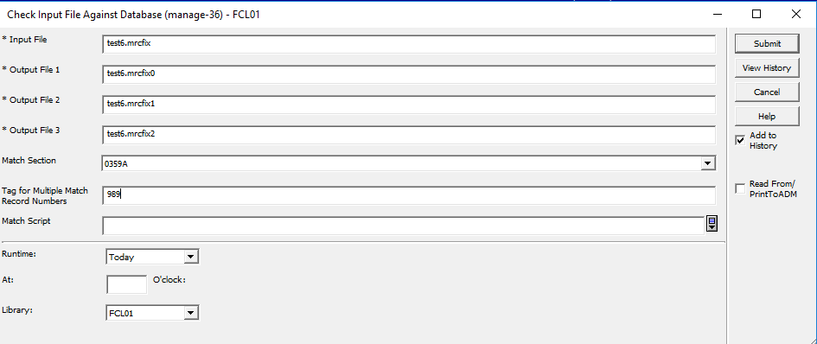

1. (**NEW & Updated RECORDS LOAD**): There is data in the file with the 0 at the end. Load that file under Services/Load Catalog Records and select Load Catalog Records (manage-18)
   1. Input file: File name with 0 at the end from manage-36
   2. Output file for Rejected Records: Add new file name
   3. Output file for Logging System Numbers: Add new file name
   4. Procedure to Rune: Add new records to the database
   5. If Updating Current Records: Replace fields within a record
   6. Indexing: Full
   7. Fix Routine: None
   8. Merge/Preferred Routine: None
   9. Character Conversion: OCLC_UTF_TO_UTF
   10. No. of Catalogers Currently Working: Multi-users
   11. Library: FCL01

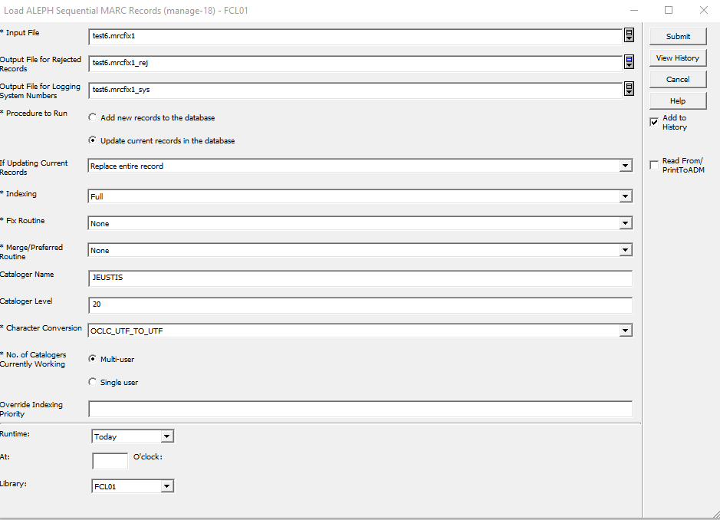

1. **(Add Inventory for Records)** Add Items/Holdings for New Records Loaded. Go to Serves/Load Catalog Records and select Create Holdings and Item records based on Bibliographic Data (manage-50)
   1. Input file: File name for the list of bib sys numbers created in last step manage-18
   2. ADM Library: DEP50
   3. HOL Library: FCL60
   4. Expand Procedure: None
   5. Main Field: 949#1
   6. Item/Holdings Creation Table: tab_hol_item_create_fcku
   7. Mapping table: tab_hol_item_map_fc_ku
   8. Holdings Record Creation Mode: Replace existing holdings records
   9. Item Record Creation Mode: Replace existing item records
   10. Holdings/Item Creation Interaction: Create holdings records based only on new items
   11. ADM Cataloger: Your login username to Aleph
   12. ADM Cataloging Level: 20
   13. HOL Cataloger: Your login username to Aleph
   14. HOL Cataloging Level: 20
   15. Update Database: Yes
   16. Check Item records: Yes
   17. Library: FCL01

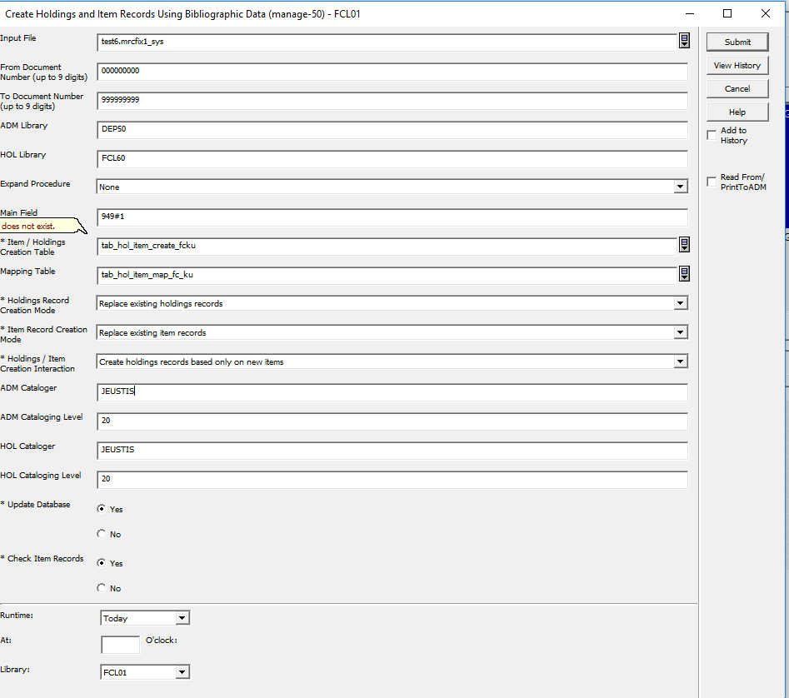

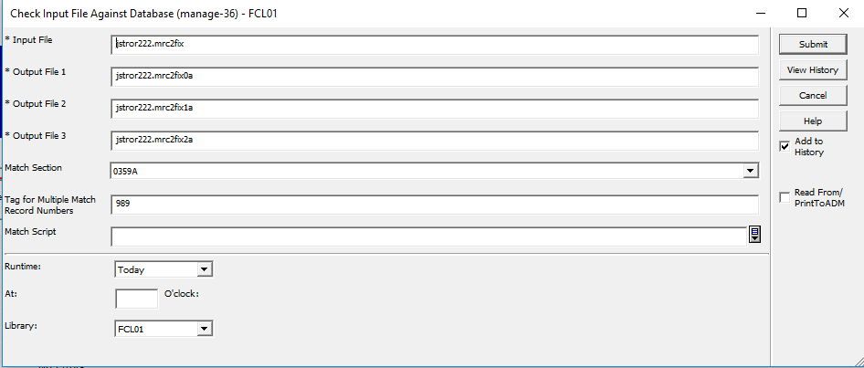

1. **(Remove URLs from New Record Bibs)** Remove URLs from Bib records: Go to Services/Catalog Maintenance Procedures and select Global Changes (manage-21)
   1. Input File: File name with the Bib sys numbers from manage-18
   2. Output file: File name for log
   3. Update database: Yes
   4. Line in Record
      1. Tag: 856
      2. First Indicator: #
      3. Second Indicator: #
   5. Delete Field: Yes

