jb

2020

Table of Contents

## Native-brome density water pulsing competition trials

### Purpose

To explore the importance of brome invasion and drought on annual plant species germination, mortality and biomass in the San Joaquin Desert.

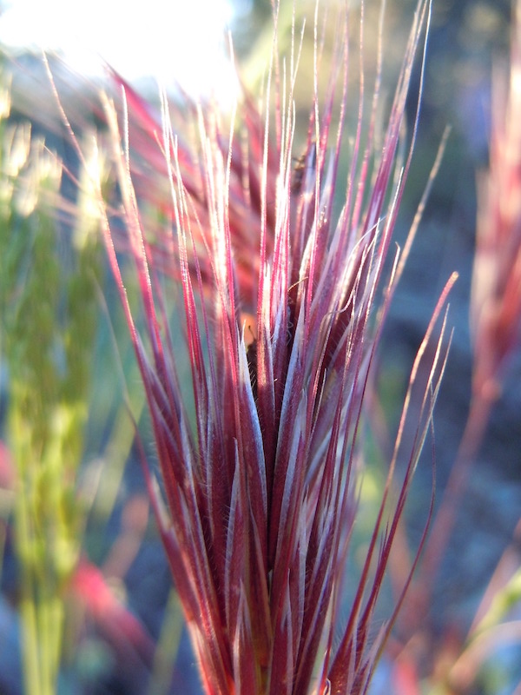

knitr::opts_chunk$set(echo = TRUE)

library(dplyr)

##   
## Attaching package: 'dplyr'

## The following objects are masked from 'package:stats':  
##   
## filter, lag

## The following objects are masked from 'package:base':  
##   
## intersect, setdiff, setequal, union

library(tidyr)  
library(ggplot2)  
library(readr)  
library(performance)  
library(emmeans)  
library(gridExtra)

##   
## Attaching package: 'gridExtra'

## The following object is masked from 'package:dplyr':  
##   
## combine

data <- read_csv("data/data.csv")

##   
## -- Column specification --------------------------------------------------------  
## cols(  
## pot.label = col_double(),  
## census = col_double(),  
## calendar = col_character(),  
## rep = col_double(),  
## native.species = col_character(),  
## native.density = col_double(),  
## brome.density = col_double(),  
## water.treatment = col_double(),  
## plantago = col_double(),  
## phacelia = col_double(),  
## salvia = col_double(),  
## brome = col_double()  
## )

data <- data %>% rename(native.seed = native.density, brome.seed = brome.density, brome.plant = brome)  
data <- mutate(data, native.plant = ifelse(native.species == "Plantago insularis", plantago, ifelse(native.species == "Salvia columbariae", salvia, phacelia)))  
data <- mutate(data, mixture = ifelse(brome.seed == 0, "nobrome", "brome"))

## Germination

germ <- data %>%  
 filter(census == 1)  
  
germ <- mutate(germ, prop.germ = native.plant/native.seed*100)  
  
ggplot(germ, aes(native.species, prop.germ, color = mixture, fill = as.factor(water.treatment))) + geom_boxplot()

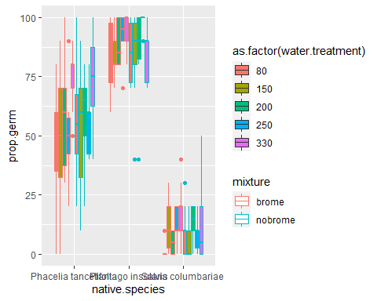

ggplot(germ, aes(water.treatment, prop.germ, color = mixture)) + geom_smooth(method = "lm") + facet_grid(~native.species)

## `geom_smooth()` using formula 'y ~ x'

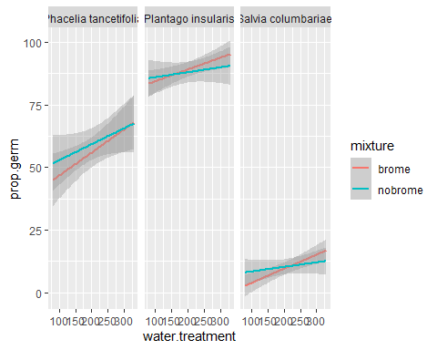

ggplot(germ, aes(brome.plant, prop.germ, color = as.factor(water.treatment))) + geom_smooth(method = "lm") + facet_grid(~native.species)

## `geom_smooth()` using formula 'y ~ x'

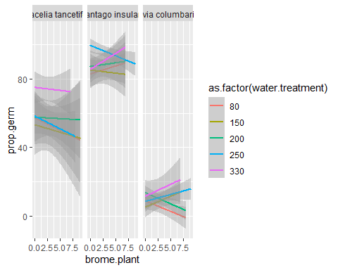

m0 <- glm(native.plant ~ water.treatment * native.species * brome.plant, data = germ, family = "poisson")  
summary(m0)

##   
## Call:  
## glm(formula = native.plant ~ water.treatment * native.species *   
## brome.plant, family = "poisson", data = germ)  
##   
## Deviance Residuals:   
## Min 1Q Median 3Q Max   
## -3.1692 -0.5555 0.0504 0.4026 2.6605   
##   
## Coefficients:  
## Estimate  
## (Intercept) 1.550e+00  
## water.treatment 1.190e-03  
## native.speciesPlantago insularis 5.589e-01  
## native.speciesSalvia columbariae -1.886e+00  
## brome.plant -2.764e-02  
## water.treatment:native.speciesPlantago insularis -8.672e-04  
## water.treatment:native.speciesSalvia columbariae 2.184e-04  
## water.treatment:brome.plant 5.649e-05  
## native.speciesPlantago insularis:brome.plant 2.592e-02  
## native.speciesSalvia columbariae:brome.plant -1.528e-01  
## water.treatment:native.speciesPlantago insularis:brome.plant -3.510e-05  
## water.treatment:native.speciesSalvia columbariae:brome.plant 7.992e-04  
## Std. Error z value  
## (Intercept) 1.452e-01 10.680  
## water.treatment 6.368e-04 1.869  
## native.speciesPlantago insularis 1.878e-01 2.976  
## native.speciesSalvia columbariae 4.069e-01 -4.635  
## brome.plant 3.684e-02 -0.750  
## water.treatment:native.speciesPlantago insularis 8.327e-04 -1.041  
## water.treatment:native.speciesSalvia columbariae 1.756e-03 0.124  
## water.treatment:brome.plant 1.643e-04 0.344  
## native.speciesPlantago insularis:brome.plant 4.905e-02 0.529  
## native.speciesSalvia columbariae:brome.plant 1.044e-01 -1.463  
## water.treatment:native.speciesPlantago insularis:brome.plant 2.192e-04 -0.160  
## water.treatment:native.speciesSalvia columbariae:brome.plant 4.397e-04 1.818  
## Pr(>|z|)   
## (Intercept) < 2e-16 ***  
## water.treatment 0.06155 .   
## native.speciesPlantago insularis 0.00292 **   
## native.speciesSalvia columbariae 3.57e-06 ***  
## brome.plant 0.45311   
## water.treatment:native.speciesPlantago insularis 0.29767   
## water.treatment:native.speciesSalvia columbariae 0.90103   
## water.treatment:brome.plant 0.73104   
## native.speciesPlantago insularis:brome.plant 0.59714   
## native.speciesSalvia columbariae:brome.plant 0.14336   
## water.treatment:native.speciesPlantago insularis:brome.plant 0.87280   
## water.treatment:native.speciesSalvia columbariae:brome.plant 0.06911 .   
## ---  
## Signif. codes: 0 '***' 0.001 '**' 0.01 '*' 0.05 '.' 0.1 ' ' 1  
##   
## (Dispersion parameter for poisson family taken to be 1)  
##   
## Null deviance: 975.54 on 299 degrees of freedom  
## Residual deviance: 218.63 on 288 degrees of freedom  
## AIC: 1137.2  
##   
## Number of Fisher Scoring iterations: 5

anova(m0, test = "Chisq")

## Analysis of Deviance Table  
##   
## Model: poisson, link: log  
##   
## Response: native.plant  
##   
## Terms added sequentially (first to last)  
##   
##   
## Df Deviance Resid. Df Resid. Dev  
## NULL 299 975.54  
## water.treatment 1 10.26 298 965.28  
## native.species 2 732.09 296 233.19  
## brome.plant 1 0.27 295 232.92  
## water.treatment:native.species 2 8.41 293 224.51  
## water.treatment:brome.plant 1 0.82 292 223.69  
## native.species:brome.plant 2 1.22 290 222.48  
## water.treatment:native.species:brome.plant 2 3.85 288 218.63  
## Pr(>Chi)   
## NULL   
## water.treatment 0.001362 **   
## native.species < 2.2e-16 ***  
## brome.plant 0.601210   
## water.treatment:native.species 0.014939 *   
## water.treatment:brome.plant 0.366633   
## native.species:brome.plant 0.544020   
## water.treatment:native.species:brome.plant 0.146061   
## ---  
## Signif. codes: 0 '***' 0.001 '**' 0.01 '*' 0.05 '.' 0.1 ' ' 1

check_overdispersion(m0)

## # Overdispersion test  
##   
## dispersion ratio = 0.666  
## Pearson's Chi-Squared = 191.937  
## p-value = 1

## No overdispersion detected.

## Establishment

est <- data %>%  
 filter(census == 2)  
  
#est <- mutate(est, prop.est = native.plant/native.seed*100)  
#est <- mutate(est, fail = native.seed - native.plant)  
#y2 <- cbind(est$native.plant, est$fail)  
#est <- filter(est, !(mixture == "brome" & brome.plant == 0))  
#est <- filter(est, prop.est > 0)  
  
ggplot(est, aes(native.species, native.plant, color = mixture, fill = as.factor(water.treatment))) + geom_boxplot()

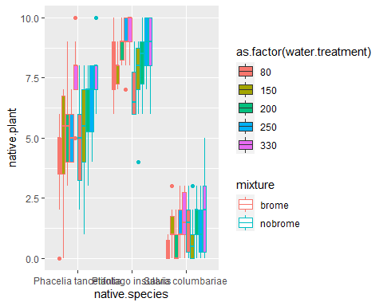

ggplot(est, aes(water.treatment, native.plant, color = mixture)) + geom_smooth(method = "lm") + facet_grid(~native.species)

## `geom_smooth()` using formula 'y ~ x'

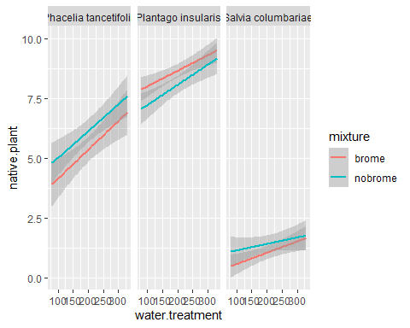

ggplot(est, aes(brome.plant, native.plant, color = as.factor(water.treatment))) + geom_smooth(method = "lm") + facet_grid(~native.species)

## `geom_smooth()` using formula 'y ~ x'

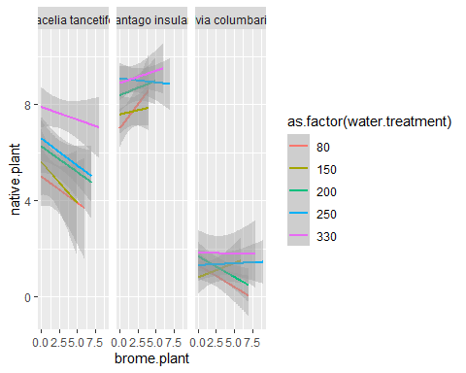

m4 <- glm(native.plant ~ native.species * water.treatment*mixture, data = est, family = poisson)  
summary(m4)

##   
## Call:  
## glm(formula = native.plant ~ native.species * water.treatment *   
## mixture, family = poisson, data = est)  
##   
## Deviance Residuals:   
## Min 1Q Median 3Q Max   
## -3.0668 -0.5072 0.0440 0.4702 1.9661   
##   
## Coefficients:  
## Estimate  
## (Intercept) 1.2125099  
## native.speciesPlantago insularis 0.7931055  
## native.speciesSalvia columbariae -2.1383936  
## water.treatment 0.0022375  
## mixturenobrome 0.2288802  
## native.speciesPlantago insularis:water.treatment -0.0014897  
## native.speciesSalvia columbariae:water.treatment 0.0022706  
## native.speciesPlantago insularis:mixturenobrome -0.3588808  
## native.speciesSalvia columbariae:mixturenobrome 0.6518108  
## water.treatment:mixturenobrome -0.0004314  
## native.speciesPlantago insularis:water.treatment:mixturenobrome 0.0007225  
## native.speciesSalvia columbariae:water.treatment:mixturenobrome -0.0021817  
## Std. Error  
## (Intercept) 0.1680306  
## native.speciesPlantago insularis 0.2102361  
## native.speciesSalvia columbariae 0.4441098  
## water.treatment 0.0007174  
## mixturenobrome 0.2284767  
## native.speciesPlantago insularis:water.treatment 0.0009122  
## native.speciesSalvia columbariae:water.treatment 0.0018024  
## native.speciesPlantago insularis:mixturenobrome 0.2925386  
## native.speciesSalvia columbariae:mixturenobrome 0.5707670  
## water.treatment:mixturenobrome 0.0009810  
## native.speciesPlantago insularis:water.treatment:mixturenobrome 0.0012728  
## native.speciesSalvia columbariae:water.treatment:mixturenobrome 0.0023748  
## z value  
## (Intercept) 7.216  
## native.speciesPlantago insularis 3.772  
## native.speciesSalvia columbariae -4.815  
## water.treatment 3.119  
## mixturenobrome 1.002  
## native.speciesPlantago insularis:water.treatment -1.633  
## native.speciesSalvia columbariae:water.treatment 1.260  
## native.speciesPlantago insularis:mixturenobrome -1.227  
## native.speciesSalvia columbariae:mixturenobrome 1.142  
## water.treatment:mixturenobrome -0.440  
## native.speciesPlantago insularis:water.treatment:mixturenobrome 0.568  
## native.speciesSalvia columbariae:water.treatment:mixturenobrome -0.919  
## Pr(>|z|)   
## (Intercept) 5.35e-13 ***  
## native.speciesPlantago insularis 0.000162 ***  
## native.speciesSalvia columbariae 1.47e-06 ***  
## water.treatment 0.001815 **   
## mixturenobrome 0.316457   
## native.speciesPlantago insularis:water.treatment 0.102442   
## native.speciesSalvia columbariae:water.treatment 0.207744   
## native.speciesPlantago insularis:mixturenobrome 0.219905   
## native.speciesSalvia columbariae:mixturenobrome 0.253458   
## water.treatment:mixturenobrome 0.660085   
## native.speciesPlantago insularis:water.treatment:mixturenobrome 0.570274   
## native.speciesSalvia columbariae:water.treatment:mixturenobrome 0.358269   
## ---  
## Signif. codes: 0 '***' 0.001 '**' 0.01 '*' 0.05 '.' 0.1 ' ' 1  
##   
## (Dispersion parameter for poisson family taken to be 1)  
##   
## Null deviance: 842.53 on 299 degrees of freedom  
## Residual deviance: 199.72 on 288 degrees of freedom  
## AIC: 1135.2  
##   
## Number of Fisher Scoring iterations: 5

anova(m4, test = "Chisq")

## Analysis of Deviance Table  
##   
## Model: poisson, link: log  
##   
## Response: native.plant  
##   
## Terms added sequentially (first to last)  
##   
##   
## Df Deviance Resid. Df Resid. Dev  
## NULL 299 842.53  
## native.species 2 605.02 297 237.52  
## water.treatment 1 24.39 296 213.13  
## mixture 1 0.51 295 212.62  
## native.species:water.treatment 2 5.35 293 207.27  
## native.species:mixture 2 5.76 291 201.52  
## water.treatment:mixture 1 0.12 290 201.40  
## native.species:water.treatment:mixture 2 1.67 288 199.72  
## Pr(>Chi)   
## NULL   
## native.species < 2.2e-16 ***  
## water.treatment 7.87e-07 ***  
## mixture 0.47523   
## native.species:water.treatment 0.06902 .   
## native.species:mixture 0.05626 .   
## water.treatment:mixture 0.73271   
## native.species:water.treatment:mixture 0.43293   
## ---  
## Signif. codes: 0 '***' 0.001 '**' 0.01 '*' 0.05 '.' 0.1 ' ' 1

car::Anova(m4, type = 2, test.statistic="LR")

## Analysis of Deviance Table (Type II tests)  
##   
## Response: native.plant  
## LR Chisq Df Pr(>Chisq)   
## native.species 605.02 2 < 2.2e-16 ***  
## water.treatment 24.39 1 7.87e-07 ***  
## mixture 0.51 1 0.47523   
## native.species:water.treatment 5.42 2 0.06641 .   
## native.species:mixture 5.83 2 0.05414 .   
## water.treatment:mixture 0.12 1 0.73271   
## native.species:water.treatment:mixture 1.67 2 0.43293   
## ---  
## Signif. codes: 0 '***' 0.001 '**' 0.01 '*' 0.05 '.' 0.1 ' ' 1

check_overdispersion(m4)

## # Overdispersion test  
##   
## dispersion ratio = 0.579  
## Pearson's Chi-Squared = 166.719  
## p-value = 1

## No overdispersion detected.

est.mod <- m4  
  
#m4.int <- glm(native.plant ~ water.treatment * brome.plant * native.species, data = est, family = poisson)  
  
#AIC(m4.int, m4)  
#anova(m4, m4.int, test = "Chisq")  
  
#no significant difference in models  
  
#check_overdispersion(m4)  
#anova(m4, test = "Chisq")  
  
  
a <- emmeans(est.mod, list(pairwise ~ native.species*mixture), adjust = "tukey")

## NOTE: Results may be misleading due to involvement in interactions

a <- summary(a)  
b <- a$`pairwise differences of native.species, mixture`  
b

## 1 estimate SE  
## Phacelia tancetifolia brome - Plantago insularis brome -0.4922 0.0786  
## Phacelia tancetifolia brome - Salvia columbariae brome 1.6797 0.1599  
## Phacelia tancetifolia brome - Phacelia tancetifolia nobrome -0.1417 0.0847  
## Phacelia tancetifolia brome - Plantago insularis nobrome -0.4210 0.0797  
## Phacelia tancetifolia brome - Salvia columbariae nobrome 1.3269 0.1353  
## Plantago insularis brome - Salvia columbariae brome 2.1719 0.1551  
## Plantago insularis brome - Phacelia tancetifolia nobrome 0.3505 0.0751  
## Plantago insularis brome - Plantago insularis nobrome 0.0712 0.0694  
## Plantago insularis brome - Salvia columbariae nobrome 1.8191 0.1295  
## Salvia columbariae brome - Phacelia tancetifolia nobrome -1.8215 0.1583  
## Salvia columbariae brome - Plantago insularis nobrome -2.1007 0.1556  
## Salvia columbariae brome - Salvia columbariae nobrome -0.3528 0.1902  
## Phacelia tancetifolia nobrome - Plantago insularis nobrome -0.2793 0.0763  
## Phacelia tancetifolia nobrome - Salvia columbariae nobrome 1.4686 0.1333  
## Plantago insularis nobrome - Salvia columbariae nobrome 1.7479 0.1302  
## df z.ratio p.value  
## Inf -6.265 <.0001   
## Inf 10.502 <.0001   
## Inf -1.673 0.5498   
## Inf -5.284 <.0001   
## Inf 9.807 <.0001   
## Inf 14.006 <.0001   
## Inf 4.665 <.0001   
## Inf 1.026 0.9092   
## Inf 14.046 <.0001   
## Inf -11.508 <.0001   
## Inf -13.498 <.0001   
## Inf -1.855 0.4303   
## Inf -3.661 0.0034   
## Inf 11.015 <.0001   
## Inf 13.426 <.0001   
##   
## Results are given on the log (not the response) scale.   
## P value adjustment: tukey method for comparing a family of 6 estimates

lstrends(est.mod, ~native.species, var = "water.treatment")

## NOTE: Results may be misleading due to involvement in interactions

## native.species water.treatment.trend SE df asymp.LCL asymp.UCL  
## Phacelia tancetifolia 0.002022 0.000491 Inf 1.06e-03 0.00298  
## Plantago insularis 0.000893 0.000405 Inf 9.87e-05 0.00169  
## Salvia columbariae 0.003202 0.001081 Inf 1.08e-03 0.00532  
##   
## Results are averaged over the levels of: mixture   
## Confidence level used: 0.95

#m5 <- glm(native.plant ~ water.treatment * native.species + brome.plant, data = est, family = poisson)  
#summary(m5)  
#anova(m5, test = "Chisq")  
  
  
#m6 <- glm(native.plant ~ brome.plant * native.species+water.treatment, data = est, family = poisson)  
#summary(m6)  
# car::Anova(m6, type = 3)  
#   
# AIC(m4, m4.int, m5, m6)  
#   
# anova(m4, m5, test = "Chisq")  
# #close but still now difference  
#ok looks like brome doesn't matter, but water does & species ID does  
  
#I'm curious about brome  
  
# brome <- filter(est, mixture == "brome")  
#   
#   
# b1 <- glm(brome.plant ~ native.plant + native.species + water.treatment, data = brome, family = poisson)  
# summary(b1)

## Survivorship

sur <- data %>%  
 filter(census == 3)  
  
ggplot(sur, aes(water.treatment, native.plant, color = mixture)) + geom_smooth(method = "lm") + facet_grid(~native.species)

## `geom_smooth()` using formula 'y ~ x'

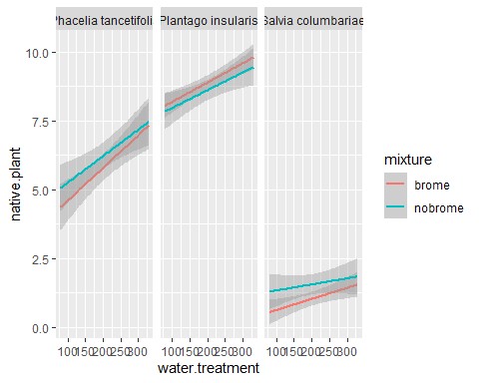

msur.int <- glm(native.plant ~ water.treatment * native.species * mixture, data = sur, family = poisson)  
summary(msur.int)

##   
## Call:  
## glm(formula = native.plant ~ water.treatment * native.species *   
## mixture, family = poisson, data = sur)  
##   
## Deviance Residuals:   
## Min 1Q Median 3Q Max   
## -1.98677 -0.46869 0.05194 0.35592 2.40957   
##   
## Coefficients:  
## Estimate  
## (Intercept) 1.3347054  
## water.treatment 0.0020372  
## native.speciesPlantago insularis 0.6905062  
## native.speciesSalvia columbariae -2.1348825  
## mixturenobrome 0.1773199  
## water.treatment:native.speciesPlantago insularis -0.0012520  
## water.treatment:native.speciesSalvia columbariae 0.0018475  
## water.treatment:mixturenobrome -0.0005007  
## native.speciesPlantago insularis:mixturenobrome -0.2012067  
## native.speciesSalvia columbariae:mixturenobrome 0.7776662  
## water.treatment:native.speciesPlantago insularis:mixturenobrome 0.0004618  
## water.treatment:native.speciesSalvia columbariae:mixturenobrome -0.0019842  
## Std. Error  
## (Intercept) 0.1604806  
## water.treatment 0.0006891  
## native.speciesPlantago insularis 0.2032802  
## native.speciesSalvia columbariae 0.4358610  
## mixturenobrome 0.2213786  
## water.treatment:native.speciesPlantago insularis 0.0008852  
## water.treatment:native.speciesSalvia columbariae 0.0017932  
## water.treatment:mixturenobrome 0.0009571  
## native.speciesPlantago insularis:mixturenobrome 0.2839273  
## native.speciesSalvia columbariae:mixturenobrome 0.5526738  
## water.treatment:native.speciesPlantago insularis:mixturenobrome 0.0012424  
## water.treatment:native.speciesSalvia columbariae:mixturenobrome 0.0023282  
## z value  
## (Intercept) 8.317  
## water.treatment 2.956  
## native.speciesPlantago insularis 3.397  
## native.speciesSalvia columbariae -4.898  
## mixturenobrome 0.801  
## water.treatment:native.speciesPlantago insularis -1.414  
## water.treatment:native.speciesSalvia columbariae 1.030  
## water.treatment:mixturenobrome -0.523  
## native.speciesPlantago insularis:mixturenobrome -0.709  
## native.speciesSalvia columbariae:mixturenobrome 1.407  
## water.treatment:native.speciesPlantago insularis:mixturenobrome 0.372  
## water.treatment:native.speciesSalvia columbariae:mixturenobrome -0.852  
## Pr(>|z|)   
## (Intercept) < 2e-16 ***  
## water.treatment 0.003112 **   
## native.speciesPlantago insularis 0.000682 ***  
## native.speciesSalvia columbariae 9.68e-07 ***  
## mixturenobrome 0.423143   
## water.treatment:native.speciesPlantago insularis 0.157246   
## water.treatment:native.speciesSalvia columbariae 0.302879   
## water.treatment:mixturenobrome 0.600885   
## native.speciesPlantago insularis:mixturenobrome 0.478538   
## native.speciesSalvia columbariae:mixturenobrome 0.159398   
## water.treatment:native.speciesPlantago insularis:mixturenobrome 0.710150   
## water.treatment:native.speciesSalvia columbariae:mixturenobrome 0.394065   
## ---  
## Signif. codes: 0 '***' 0.001 '**' 0.01 '*' 0.05 '.' 0.1 ' ' 1  
##   
## (Dispersion parameter for poisson family taken to be 1)  
##   
## Null deviance: 838.85 on 299 degrees of freedom  
## Residual deviance: 175.68 on 288 degrees of freedom  
## AIC: 1133.4  
##   
## Number of Fisher Scoring iterations: 5

anova(msur.int, test = "Chisq")

## Analysis of Deviance Table  
##   
## Model: poisson, link: log  
##   
## Response: native.plant  
##   
## Terms added sequentially (first to last)  
##   
##   
## Df Deviance Resid. Df Resid. Dev  
## NULL 299 838.85  
## water.treatment 1 19.04 298 819.81  
## native.species 2 632.37 296 187.44  
## mixture 1 0.68 295 186.77  
## water.treatment:native.species 2 3.92 293 182.85  
## water.treatment:mixture 1 0.34 292 182.51  
## native.species:mixture 2 5.64 290 176.87  
## water.treatment:native.species:mixture 2 1.19 288 175.68  
## Pr(>Chi)   
## NULL   
## water.treatment 1.282e-05 ***  
## native.species < 2.2e-16 ***  
## mixture 0.41067   
## water.treatment:native.species 0.14118   
## water.treatment:mixture 0.56047   
## native.species:mixture 0.05958 .   
## water.treatment:native.species:mixture 0.55197   
## ---  
## Signif. codes: 0 '***' 0.001 '**' 0.01 '*' 0.05 '.' 0.1 ' ' 1

sur.em <- emmeans(msur.int, list(pairwise ~ native.species*mixture), adjust = "tukey")

## NOTE: Results may be misleading due to involvement in interactions

sur.em <- summary(sur.em)  
  
b <- sur.em$`pairwise differences of native.species, mixture`  
  
lstrends(msur.int, ~native.species, var = "water.treatment")

## NOTE: Results may be misleading due to involvement in interactions

## native.species water.treatment.trend SE df asymp.LCL asymp.UCL  
## Phacelia tancetifolia 0.001787 0.000479 Inf 8.49e-04 0.00272  
## Plantago insularis 0.000766 0.000396 Inf -1.07e-05 0.00154  
## Salvia columbariae 0.002642 0.001061 Inf 5.62e-04 0.00472  
##   
## Results are averaged over the levels of: mixture   
## Confidence level used: 0.95

#   
# msur <- glm(native.plant ~ water.treatment +native.species + brome.plant, data = sur, family = poisson)  
#   
# msur1 <- glm(native.plant ~ water.treatment * native.species + brome.plant, data = sur, family = poisson)  
# summary(msur1)  
# msur2 <- glm(native.plant ~ water.treatment + native.species * brome.plant, data = sur, family = poisson)  
#   
# AIC(msur, msur.int, msur1, msur2)  
#   
# anova(msur, msur1, msur2, test = "Chisq")  
  
#same almost water by native but doesn't actually improve fit and is not significant  
  
# brome <- filter(sur, mixture == "brome")  
# brom1 <- glm(brome.plant ~ water.treatment + native.plant + native.species, data = brome, family = poisson)  
#   
# summary(brom1)  
#   
# phac <- filter(sur, native.species == "Phacelia tancetifolia")  
# m4 <- glm(native.plant ~ water.treatment + mixture, data = phac, family = poisson)  
# summary(m4)  
# car::Anova(m4, type = 2)  
#   
# plan <- filter(sur, native.species == "Plantago insularis")  
# m4 <- glm(native.plant ~ water.treatment + mixture, data = plan, family = poisson)  
# summary(m4)  
# car::Anova(m4, type = 2)  
#   
#   
# sal <- filter(sur, native.species == "Salvia columbariae")  
# m4 <- glm(native.plant ~ water.treatment + mixture, data = sal, family = poisson)  
# summary(m4)  
# car::Anova(m4, type = 2)  
#   
# ```  
#   
#   
# ## Mortality  
#   
# ```{r, mortality}  
# mort <- est %>% select(pot.label, native.plant) %>% right_join(.,sur, by = "pot.label")  
# mort$alive <- mort$native.plant.y  
# mort <- mutate(mort, dead = native.plant.x - alive)  
# y <- cbind(mort$alive, mort$dead)  
# #replace negatives with zeros?  
#   
# #meh  
# m7 <- glm(dead ~ brome.plant * water.treatment * native.species, data = mort, family = gaussian)  
# summary(m7)  
# car::Anova(m7, type = 2)

## Biomass

prod <- read_csv("data/productivity.csv")

##   
## -- Column specification --------------------------------------------------------  
## cols(  
## pot.label = col_double(),  
## census = col_double(),  
## rep = col_double(),  
## native.species = col_character(),  
## brome.treatment = col_double(),  
## water.treatment = col_double(),  
## `5.wk.percent.cover` = col_double(),  
## `10.wk.percent.cover` = col_double(),  
## leaf.count = col_double(),  
## invasive.plant.height = col_double(),  
## native.plant.height = col_double(),  
## final.native.aboveground.biomass = col_double(),  
## final.brome.aboveground.biomass = col_double(),  
## soil.moisture = col_double()  
## )

prod <- prod %>% rename(native.biomass = final.native.aboveground.biomass)  
prod <- select(prod,1, 7:14)  
sur <- left_join(sur, prod, by = "pot.label")  
prod <- filter(sur, native.biomass > 0)  
prod <- mutate(prod, per.capita = native.biomass/native.plant)  
  
ggplot(prod, aes(water.treatment, per.capita, color = mixture)) + geom_smooth(method = "lm") + facet_grid(~native.species)

## `geom_smooth()` using formula 'y ~ x'

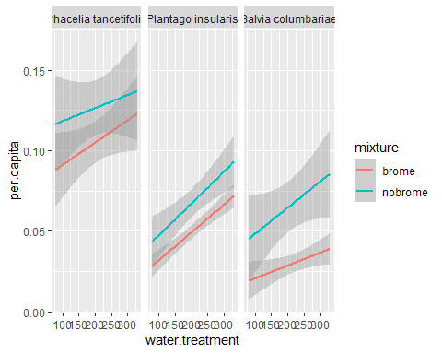

m1 <- glm(per.capita ~ native.species * water.treatment * mixture, data = prod, family = gaussian)  
  
summary(m1)

##   
## Call:  
## glm(formula = per.capita ~ native.species * water.treatment *   
## mixture, family = gaussian, data = prod)  
##   
## Deviance Residuals:   
## Min 1Q Median 3Q Max   
## -0.084049 -0.021798 -0.002973 0.014355 0.212163   
##   
## Coefficients:  
## Estimate  
## (Intercept) 7.725e-02  
## native.speciesPlantago insularis -6.237e-02  
## native.speciesSalvia columbariae -6.456e-02  
## water.treatment 1.393e-04  
## mixturenobrome 3.288e-02  
## native.speciesPlantago insularis:water.treatment 3.320e-05  
## native.speciesSalvia columbariae:water.treatment -5.957e-05  
## native.speciesPlantago insularis:mixturenobrome -1.998e-02  
## native.speciesSalvia columbariae:mixturenobrome -1.334e-02  
## water.treatment:mixturenobrome -5.788e-05  
## native.speciesPlantago insularis:water.treatment:mixturenobrome 8.312e-05  
## native.speciesSalvia columbariae:water.treatment:mixturenobrome 1.408e-04  
## Std. Error  
## (Intercept) 1.461e-02  
## native.speciesPlantago insularis 2.066e-02  
## native.speciesSalvia columbariae 2.550e-02  
## water.treatment 6.662e-05  
## mixturenobrome 2.066e-02  
## native.speciesPlantago insularis:water.treatment 9.422e-05  
## native.speciesSalvia columbariae:water.treatment 1.109e-04  
## native.speciesPlantago insularis:mixturenobrome 2.921e-02  
## native.speciesSalvia columbariae:mixturenobrome 3.368e-02  
## water.treatment:mixturenobrome 9.422e-05  
## native.speciesPlantago insularis:water.treatment:mixturenobrome 1.333e-04  
## native.speciesSalvia columbariae:water.treatment:mixturenobrome 1.492e-04  
## t value  
## (Intercept) 5.289  
## native.speciesPlantago insularis -3.020  
## native.speciesSalvia columbariae -2.532  
## water.treatment 2.091  
## mixturenobrome 1.592  
## native.speciesPlantago insularis:water.treatment 0.352  
## native.speciesSalvia columbariae:water.treatment -0.537  
## native.speciesPlantago insularis:mixturenobrome -0.684  
## native.speciesSalvia columbariae:mixturenobrome -0.396  
## water.treatment:mixturenobrome -0.614  
## native.speciesPlantago insularis:water.treatment:mixturenobrome 0.624  
## native.speciesSalvia columbariae:water.treatment:mixturenobrome 0.944  
## Pr(>|t|)   
## (Intercept) 2.62e-07 ***  
## native.speciesPlantago insularis 0.00278 **   
## native.speciesSalvia columbariae 0.01194 *   
## water.treatment 0.03753 *   
## mixturenobrome 0.11265   
## native.speciesPlantago insularis:water.treatment 0.72485   
## native.speciesSalvia columbariae:water.treatment 0.59172   
## native.speciesPlantago insularis:mixturenobrome 0.49458   
## native.speciesSalvia columbariae:mixturenobrome 0.69245   
## water.treatment:mixturenobrome 0.53957   
## native.speciesPlantago insularis:water.treatment:mixturenobrome 0.53330   
## native.speciesSalvia columbariae:water.treatment:mixturenobrome 0.34612   
## ---  
## Signif. codes: 0 '***' 0.001 '**' 0.01 '*' 0.05 '.' 0.1 ' ' 1  
##   
## (Dispersion parameter for gaussian family taken to be 0.001610323)  
##   
## Null deviance: 0.74034 on 269 degrees of freedom  
## Residual deviance: 0.41546 on 258 degrees of freedom  
## AIC: -956.5  
##   
## Number of Fisher Scoring iterations: 2

anova(m1, test = "Chisq")

## Analysis of Deviance Table  
##   
## Model: gaussian, link: identity  
##   
## Response: per.capita  
##   
## Terms added sequentially (first to last)  
##   
##   
## Df Deviance Resid. Df Resid. Dev  
## NULL 269 0.74034  
## native.species 2 0.240923 267 0.49942  
## water.treatment 1 0.036361 266 0.46306  
## mixture 1 0.039579 265 0.42348  
## native.species:water.treatment 2 0.002320 263 0.42116  
## native.species:mixture 2 0.004149 261 0.41701  
## water.treatment:mixture 1 0.000034 260 0.41698  
## native.species:water.treatment:mixture 2 0.001517 258 0.41546  
## Pr(>Chi)   
## NULL   
## native.species < 2.2e-16 ***  
## water.treatment 2.016e-06 ***  
## mixture 7.136e-07 ***  
## native.species:water.treatment 0.4866   
## native.species:mixture 0.2758   
## water.treatment:mixture 0.8842   
## native.species:water.treatment:mixture 0.6244   
## ---  
## Signif. codes: 0 '***' 0.001 '**' 0.01 '*' 0.05 '.' 0.1 ' ' 1

#   
# m1 <- glm(per.capita ~ water.treatment + native.species + native.plant + brome.plant, data = prod, family = gaussian)  
#   
#   
# m1.ad <- glm(native.biomass ~ native.species * water.treatment +mixture+ native.plant , data = prod, family = gaussian)  
#   
# summary(m1.ad)  
#   
# shapiro.test(resid(m1.ad))  
#   
# plot(m1.ad)  
# AIC(m1, m1.ad)  
#   
#   
# anova(m1, m1.ad, test = "Chisq")  
#   
#   
# shapiro.test(resid(m1))  
# summary(m1)  
# car::Anova(m1, type = 2)  
# anova(m1, test = "Chisq")  
#   
#   
# library(sjPlot)  
# plot_model(m1.ad, type = "int", terms = "brome.plant")  
#   
#   
# emtrends(m1.ad, pairwise ~ mixture, var = "native.plant")  
#   
# emmip(m1.ad, mixture ~ native.plant, cov.reduce = range)  
  
#brome.lst <- lstrends(m1, ~native.plant, var = "brome.plant")  
#pairs(brome.lst)

prod <- rename(prod, final.brome = final.brome.aboveground.biomass)  
  
prod <- mutate(prod, brome.per.capita = final.brome/brome.plant)  
  
m1.ad <- glm(final.brome ~ water.treatment + native.species + brome.plant, data = prod, family = gaussian)  
summary(m1.ad)

##   
## Call:  
## glm(formula = final.brome ~ water.treatment + native.species +   
## brome.plant, family = gaussian, data = prod)  
##   
## Deviance Residuals:   
## Min 1Q Median 3Q Max   
## -0.48583 -0.12447 0.01955 0.08193 1.72795   
##   
## Coefficients:  
## Estimate Std. Error t value Pr(>|t|)   
## (Intercept) -0.0681959 0.0394100 -1.730 0.0847 .   
## water.treatment -0.0001717 0.0001599 -1.074 0.2840   
## native.speciesPlantago insularis 0.0623840 0.0313448 1.990 0.0476 *   
## native.speciesSalvia columbariae 0.2270048 0.0347402 6.534 3.26e-10 ***  
## brome.plant 0.0876967 0.0043971 19.944 < 2e-16 ***  
## ---  
## Signif. codes: 0 '***' 0.001 '**' 0.01 '*' 0.05 '.' 0.1 ' ' 1  
##   
## (Dispersion parameter for gaussian family taken to be 0.04903778)  
##   
## Null deviance: 36.499 on 269 degrees of freedom  
## Residual deviance: 12.995 on 265 degrees of freedom  
## AIC: -40.914  
##   
## Number of Fisher Scoring iterations: 2

ggplot(prod, aes(water.treatment, brome.per.capita)) + geom_smooth(method = "lm")

## `geom_smooth()` using formula 'y ~ x'

## Warning: Removed 137 rows containing non-finite values (stat_smooth).

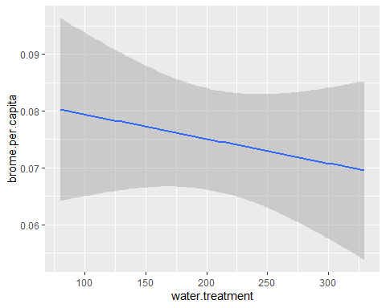

ggplot(prod, aes(water.treatment, final.brome)) + geom_smooth(method = "lm")

## `geom_smooth()` using formula 'y ~ x'

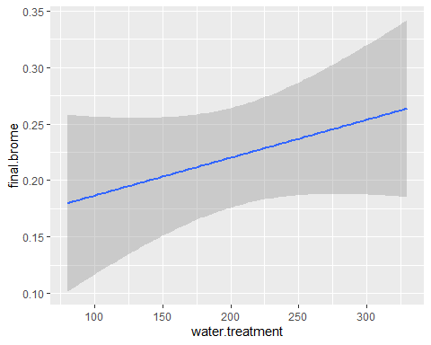

mprod <- glm(native.plant ~ water.treatment + native.species + final.brome, data = prod, family = poisson)  
summary(mprod)

##   
## Call:  
## glm(formula = native.plant ~ water.treatment + native.species +   
## final.brome, family = poisson, data = prod)  
##   
## Deviance Residuals:   
## Min 1Q Median 3Q Max   
## -2.27201 -0.39835 -0.01783 0.36016 2.08305   
##   
## Coefficients:  
## Estimate Std. Error z value Pr(>|z|)   
## (Intercept) 1.5659011 0.0741550 21.117 < 2e-16 ***  
## water.treatment 0.0011828 0.0002924 4.045 5.22e-05 ***  
## native.speciesPlantago insularis 0.3840371 0.0535436 7.172 7.37e-13 ***  
## native.speciesSalvia columbariae -1.1544736 0.1001571 -11.527 < 2e-16 ***  
## final.brome -0.1207535 0.0958636 -1.260 0.208   
## ---  
## Signif. codes: 0 '***' 0.001 '**' 0.01 '*' 0.05 '.' 0.1 ' ' 1  
##   
## (Dispersion parameter for poisson family taken to be 1)  
##   
## Null deviance: 499.798 on 269 degrees of freedom  
## Residual deviance: 96.237 on 265 degrees of freedom  
## AIC: 1039.9  
##   
## Number of Fisher Scoring iterations: 4

w1 <- lm(soil.moisture ~ water.treatment, data = sur)  
  
summary(w1)

##   
## Call:  
## lm(formula = soil.moisture ~ water.treatment, data = sur)  
##   
## Residuals:  
## Min 1Q Median 3Q Max   
## -14.444 -5.199 -1.734 1.766 30.099   
##   
## Coefficients:  
## Estimate Std. Error t value Pr(>|t|)   
## (Intercept) 5.490407 1.288314 4.262 2.72e-05 ***  
## water.treatment 0.078043 0.005877 13.280 < 2e-16 ***  
## ---  
## Signif. codes: 0 '***' 0.001 '**' 0.01 '*' 0.05 '.' 0.1 ' ' 1  
##   
## Residual standard error: 8.67 on 298 degrees of freedom  
## Multiple R-squared: 0.3718, Adjusted R-squared: 0.3697   
## F-statistic: 176.4 on 1 and 298 DF, p-value: < 2.2e-16

shapiro.test(resid(w1))

##   
## Shapiro-Wilk normality test  
##   
## data: resid(w1)  
## W = 0.858, p-value = 6.05e-16

cor.test(sur$soil.moisture, sur$water.treatment)

##   
## Pearson's product-moment correlation  
##   
## data: sur$soil.moisture and sur$water.treatment  
## t = 13.28, df = 298, p-value < 2.2e-16  
## alternative hypothesis: true correlation is not equal to 0  
## 95 percent confidence interval:  
## 0.5333276 0.6762879  
## sample estimates:  
## cor   
## 0.6097433

## RII

Let’s look at the relative effect of Brome

c1 <- filter(sur, mixture == "brome")  
  
  
rii <- function(data, y)  
{  
 # Parse out shrub and open  
 s1 <- subset(data, mixture == "brome", select=y)  
 o1 <- subset(data, mixture == "nobrome", select=y)  
 # Rii formula  
 return1 <- (s1 - o1) / (s1 + o1)  
}  
  
  
  
sur_rii <- rii(sur, "native.plant")  
sur_rii <- rename(sur_rii, sur.rii = native.plant)  
c1 <- cbind(c1, sur_rii)  
c1_noNA <- filter(c1, sur.rii != "NaN")  
  
  
t.test(c1_noNA$sur.rii)

##   
## One Sample t-test  
##   
## data: c1_noNA$sur.rii  
## t = -1.4493, df = 146, p-value = 0.1494  
## alternative hypothesis: true mean is not equal to 0  
## 95 percent confidence interval:  
## -0.12467097 0.01917997  
## sample estimates:  
## mean of x   
## -0.0527455

a1 <- lm(sur.rii ~ native.species+water.treatment, data = c1_noNA)  
summary(a1)

##   
## Call:  
## lm(formula = sur.rii ~ native.species + water.treatment, data = c1_noNA)  
##   
## Residuals:  
## Min 1Q Median 3Q Max   
## -0.94017 -0.13451 -0.01774 0.11573 1.21533   
##   
## Coefficients:  
## Estimate Std. Error t value Pr(>|t|)  
## (Intercept) -0.1676922 0.1055443 -1.589 0.114  
## native.speciesPlantago insularis 0.0610307 0.0875266 0.697 0.487  
## native.speciesSalvia columbariae -0.0973950 0.0889148 -1.095 0.275  
## water.treatment 0.0006220 0.0004232 1.470 0.144  
##   
## Residual standard error: 0.4376 on 143 degrees of freedom  
## Multiple R-squared: 0.03651, Adjusted R-squared: 0.0163   
## F-statistic: 1.806 on 3 and 143 DF, p-value: 0.1487

library(boot)  
bootmean <- function(d, i) mean(d[i])  
sal_rii <- filter(c1_noNA, native.species == "Salvia columbariae")  
  
SUR.rii <- boot(sal_rii$sur.rii, bootmean, R=10000, stype = "i")  
ci.SUR.rii <- boot.ci(SUR.rii)

## Warning in boot.ci(SUR.rii): bootstrap variances needed for studentized  
## intervals

bca.SUR <- ci.SUR.rii$bca  
  
est_rii <- rii(est, "native.plant")  
est_rii <- rename(est_rii, est.rii = native.plant)  
c1 <- cbind(c1, est_rii)  
#t.test(c1$sest.rii)  
a1 <- lm(est.rii ~ as.factor(water.treatment), data = c1)  
summary(a1)

##   
## Call:  
## lm(formula = est.rii ~ as.factor(water.treatment), data = c1)  
##   
## Residuals:  
## Min 1Q Median 3Q Max   
## -1.09329 -0.16839 -0.00221 0.22050 1.16007   
##   
## Coefficients:  
## Estimate Std. Error t value Pr(>|t|)   
## (Intercept) -0.16007 0.08553 -1.871 0.0633 .  
## as.factor(water.treatment)150 0.25336 0.12096 2.095 0.0380 *  
## as.factor(water.treatment)200 -0.06043 0.12096 -0.500 0.6181   
## as.factor(water.treatment)250 0.19802 0.11995 1.651 0.1010   
## as.factor(water.treatment)330 0.16228 0.12096 1.342 0.1819   
## ---  
## Signif. codes: 0 '***' 0.001 '**' 0.01 '*' 0.05 '.' 0.1 ' ' 1  
##   
## Residual standard error: 0.4606 on 141 degrees of freedom  
## (4 observations deleted due to missingness)  
## Multiple R-squared: 0.06562, Adjusted R-squared: 0.03911   
## F-statistic: 2.475 on 4 and 141 DF, p-value: 0.04701

ggplot(c1, aes(est.rii, as.factor(water.treatment))) + geom_boxplot()

## Warning: Removed 4 rows containing non-finite values (stat_boxplot).

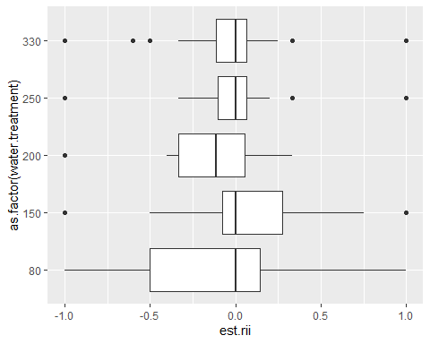

prod <- mutate(prod, per.capita = native.biomass/native.plant)  
sur <- mutate(sur, per.capita = native.biomass/native.plant)  
  
  
bio_rii <- rii(sur, "per.capita")  
bio_rii <- rename(bio_rii, bio.rii = per.capita)  
c1 <- cbind(c1, bio_rii)  
#t.test(c1$bio.rii)  
a1 <- aov(bio.rii ~ native.species, data = c1)  
TukeyHSD(a1)

## Tukey multiple comparisons of means  
## 95% family-wise confidence level  
##   
## Fit: aov(formula = bio.rii ~ native.species, data = c1)  
##   
## $native.species  
## diff lwr upr  
## Plantago insularis-Phacelia tancetifolia -0.02577081 -0.1734235 0.121881893  
## Salvia columbariae-Phacelia tancetifolia -0.19596749 -0.3819722 -0.009962796  
## Salvia columbariae-Plantago insularis -0.17019668 -0.3562014 0.015808011  
## p adj  
## Plantago insularis-Phacelia tancetifolia 0.9098474  
## Salvia columbariae-Phacelia tancetifolia 0.0364078  
## Salvia columbariae-Plantago insularis 0.0802876

summary(a1)

## Df Sum Sq Mean Sq F value Pr(>F)   
## native.species 2 0.643 0.3217 3.324 0.0394 *  
## Residuals 120 11.613 0.0968   
## ---  
## Signif. codes: 0 '***' 0.001 '**' 0.01 '*' 0.05 '.' 0.1 ' ' 1  
## 27 observations deleted due to missingness

nat <- emmeans(a1, "native.species")  
pairs(nat)

## contrast estimate SE df t.ratio p.value  
## Phacelia tancetifolia - Plantago insularis 0.0258 0.0622 120 0.414 0.9098   
## Phacelia tancetifolia - Salvia columbariae 0.1960 0.0784 120 2.500 0.0364   
## Plantago insularis - Salvia columbariae 0.1702 0.0784 120 2.171 0.0803   
##   
## P value adjustment: tukey method for comparing a family of 3 estimates

ggplot(c1, aes(bio.rii, water.treatment)) + geom_smooth(method = "lm")

## `geom_smooth()` using formula 'y ~ x'

## Warning: Removed 27 rows containing non-finite values (stat_smooth).

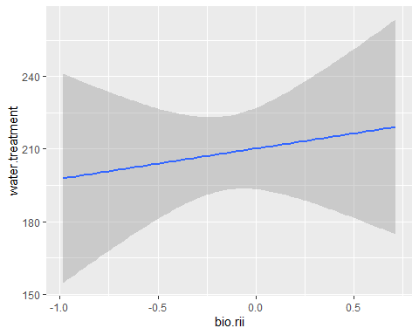

sal_rii <- filter(c1, native.species == "Salvia columbariae")  
  
  
  
#BIO.rii <- boot(sal_rii$bio.rii, bootmean, R=10000, stype = "i")  
#ci.SUR.rii <- boot.ci(SUR.rii)  
#bca.SUR <- ci.SUR.rii$bca  
  
  
  
#Figure 1  
  
#establishment - plant count at census 2  
a <- ggplot(est, aes(water.treatment, native.plant, color = mixture)) + geom_smooth(method = "lm") + facet_grid(~native.species) + ylab("Establishment") +xlab("") + theme(panel.grid.major = element_blank(), panel.grid.minor = element_blank(),  
panel.background = element_blank(), axis.line = element_line(colour = "black")) + theme(legend.title = element_blank()) + scale_color_discrete(labels = c("No Brome", "With Brome")) + theme(legend.box = "horizontal", legend.position = c(0.9, 0.7), legend.title = element_blank()) + theme(  
 strip.background = element_rect(  
 color="black", fill="white", size=.75, linetype="solid"  
 ))  
   
a

## `geom_smooth()` using formula 'y ~ x'

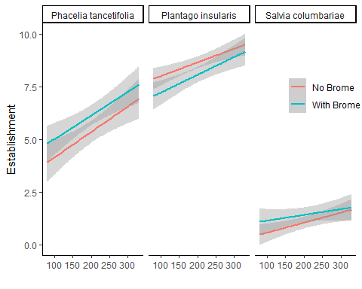

#survival - plant count at census 3  
b <- ggplot(sur, aes(water.treatment, native.plant, color = mixture)) + geom_smooth(method = "lm") + facet_grid(~native.species) + ylab("Survival") +xlab("") + theme(panel.grid.major = element_blank(), panel.grid.minor = element_blank(),  
panel.background = element_blank(), axis.line = element_line(colour = "black")) + theme(legend.position = "none", legend.title = element_blank()) + scale_color_discrete(labels = c("No Brome", "With Brome")) +   
theme(strip.background = element_blank(), strip.text = element_blank())  
b

## `geom_smooth()` using formula 'y ~ x'

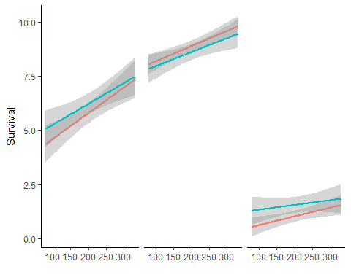

#biomass  
c <- ggplot(prod, aes(water.treatment, native.biomass, color = mixture)) + geom_smooth(method = "lm") + facet_grid(~native.species) + ylab("Per capita biomass (g)") +xlab("Water Treatment (ml)") + theme(panel.grid.major = element_blank(), panel.grid.minor = element_blank(),  
panel.background = element_blank(), axis.line = element_line(colour = "black")) + theme(legend.position = "none", legend.title = element_blank()) + scale_color_discrete(labels = c("No Brome", "With Brome")) +   
theme(strip.background = element_blank(), strip.text = element_blank())  
c

## `geom_smooth()` using formula 'y ~ x'

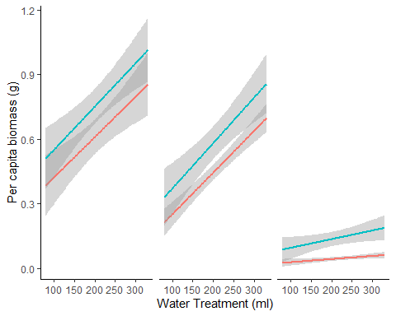

#l1 <- get_legend(c)  
  
grid.arrange(a, b, c, ncol = 1)

## `geom_smooth()` using formula 'y ~ x'  
## `geom_smooth()` using formula 'y ~ x'  
## `geom_smooth()` using formula 'y ~ x'

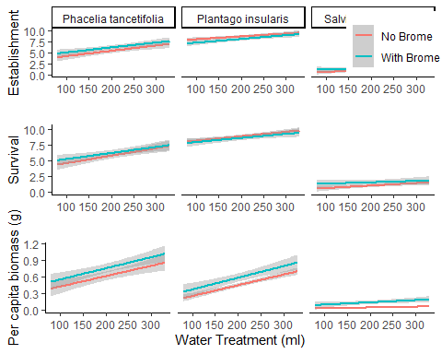

plots <- list(a,b,c)  
grobs <- list()  
widths <- list()  
  
for (i in 1:length(plots)){  
 grobs[[i]] <- ggplotGrob(plots[[i]])  
 widths[[i]] <- grobs[[i]]$widths[2:5]  
}

## `geom_smooth()` using formula 'y ~ x'  
## `geom_smooth()` using formula 'y ~ x'  
## `geom_smooth()` using formula 'y ~ x'

maxwidth <- do.call(grid::unit.pmax, widths)  
for (i in 1:length(grobs)){  
 grobs[[i]]$widths[2:5] <- as.list(maxwidth)  
}  
  
p <- do.call("grid.arrange", c(grobs, ncol = 1))

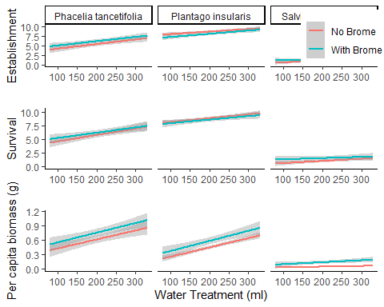

p

## TableGrob (3 x 1) "arrange": 3 grobs  
## z cells name grob  
## 1 1 (1-1,1-1) arrange gtable[layout]  
## 2 2 (2-2,1-1) arrange gtable[layout]  
## 3 3 (3-3,1-1) arrange gtable[layout]

#establishment  
options(scipen = 999)  
#est.tab <- car::Anova(est.mod, type = 1, test.statistic="F")  
anova(est.mod, test = "Chisq")

## Analysis of Deviance Table  
##   
## Model: poisson, link: log  
##   
## Response: native.plant  
##   
## Terms added sequentially (first to last)  
##   
##   
## Df Deviance Resid. Df Resid. Dev  
## NULL 299 842.53  
## native.species 2 605.02 297 237.52  
## water.treatment 1 24.39 296 213.13  
## mixture 1 0.51 295 212.62  
## native.species:water.treatment 2 5.35 293 207.27  
## native.species:mixture 2 5.76 291 201.52  
## water.treatment:mixture 1 0.12 290 201.40  
## native.species:water.treatment:mixture 2 1.67 288 199.72  
## Pr(>Chi)   
## NULL   
## native.species < 0.00000000000000022 ***  
## water.treatment 0.000000787 ***  
## mixture 0.47523   
## native.species:water.treatment 0.06902 .   
## native.species:mixture 0.05626 .   
## water.treatment:mixture 0.73271   
## native.species:water.treatment:mixture 0.43293   
## ---  
## Signif. codes: 0 '***' 0.001 '**' 0.01 '*' 0.05 '.' 0.1 ' ' 1

est.tab <- anova(est.mod, test = "Chisq")  
est.tab <- signif(est.tab, digits = 2)  
est.tab <- rename(est.tab, p = "Pr(>Chi)", Chisq = "Deviance")  
est.tab <- mutate(est.tab, p = ifelse(p < 0.001, "< 0.001", signif(p, digits = 2)))  
#est.tab <- est.tab %>% select(-"Sum Sq")   
#est.tab <- est.tab[, c(2,1,3)]  
#est.tab  
  
  
#save objects for knitr for export to word  
#save(an, file = "out.rda")