The small-scale floral neighbourhood but not phenotypic traits predict the structure of an individual-based pollinator visitation network. title good - can we simplify a bit though?

Neighborhood not phenotype predict individual-based pollinator visitation network.

Abstract (<300 words)

A central focus of ecology is understanding the mechanisms underlying interaction patterns in natural communities. Network analysis has become a valuable tool for plant pollinator interactions, but these networks are primarily built by aggregating interactions within species. Interactions are made between individuals however, and an advantage of individual-based networks is the ability to integrate individual traits. This approach provides a mechanistic assessment of the drivers of network structure. In all plant communities, focusing only on the drivers of pairwise interactions limits our capacity to describe and predict community resilience, structure, and composition. We used a desert shrub and cactus community as a model system to study the underlying drivers of network topology. We hypothesized that the traits that alter attractiveness of plants to pollinators can predict an individual plant’s role within the visitation network and contribute to the structure of network. We found that floral display size increased pollinator visitation early in the study but contrary to our predctions did not directly influence the centrality measures for individual plants or for the formation of any other measures of network structure. Neighbourhood shrub density positively influenced pollinator visitation rates indicating diffuse facilitation was prevalent in this system. In addition, plants growing in relatively higher densities of shrubs had roles?? more central? important to connecting the network. The individual-based network resembled the aggregated-species network suggesting that individual-level analyses can predict interaction patterns at larger scales?. This study shows that immediate neighbours can influence the structure of plant-pollinator interactions at the community level. GREAT - I agree with your comments - GOOD fit for Oikos and matches style - still a bit tangled here with concepts - if my edits are on the right track?

**Keywords: arid, desert, pollination, facilitation, centrality, positive interactions, non-trophic, network**

**Introduction**

Interactions between species structure plant communities and contribute to biodiversity maintenance globally. Interacting populations can be seen as aggregations of interacting individuals?? thus the outcome of interactions between species (i.e. plant fitness) can be influenced by both intraspecific and interspecific variation in attractiveness to pollinators. bit clunky Attractiveness to pollinators is influenced by phenotypic variation in plant traits such as floral display size (Ohashi and Yahara 1998, Thomson 1981) and plant height (Donnelly*, et al.* 1998, Toräng*, et al.* 2006). The floral composition of the surrounding area can also influence attractiveness due to density-dependent interactions between the local co-blooming floral neighbourhood and the focal plant (Rathcke 1983, Seifan*, et al.* 2014). Spatial association with co-blooming heterospecifics can alter the attractiveness of an individual plant leading to increases (facilitation) or decreases (competition) in pollinator visitation rates (Braun and Lortie 2018, Mitchell*, et al.* 2009, Rathcke 1983). Consequently, both individual phenotypic traits and neighbourhood context impact interactions with pollinators that in turn influence plant fitness. further to your comment, I like local floral neighbourhood - sounds sweet - like the local flower shop. lol - little shop of horrors. oh wait. skip. haha.

Network analysis has emerged as a valuable tool for studying plant-pollinator interactions (Bascompte and Jordano 2013). Most pollinator visitation networks are species-based. Each node represents a population of plants or pollinators, and links are the sum of interactions between the populations. The recognition that patterns between interacting individuals drive the patterns between interacting species has lead to examinations of downscaling interaction networks from populations to individuals (Dupont*, et al.* 2011, Dupont*, et al.* 2014, Gómez and Perfectti 2011, Rumeu*, et al.* 2018, Tur*, et al.* 2014, Valverde*, et al.* 2016). An advantage of individual-based networks is the ability to integrate individual variation to the study of structure and pattern of relations within ecological networks (Losapio*, et al.* 2019, Olesen*, et al.* 2010). Individual-based networks have been used to explore specialization of pollen use (Tur*, et al.* 2014) and interaction rewiring with phenology (Valverde*, et al.* 2016). Species and individual-based approaches are complementary, and for instance, these coupled approaches have been used to study changes in specialization across a gradient of elevation in hummingbird-plant networks (Maglianesi*, et al.* 2015). Downscaling to individuals is a fundamental step to illuminate the underlying drivers of community functioning.

topic sentence first to set stage for what this paragraph is about. Relative differences in attractiveness can contribute to the role of an individual plant in the network if pollinator foraging preferences introduce differences in the number or distribution of links connecting nodes. Centrality describes the node’s topological position within the network i.e. its functional role within a community (González*, et al.* 2010). Centrality measures are estimates of relative influence and can be used to identify keystone species (Estrada 2007, Jordán*, et al.* 2006). Within populations, links between nodes act as mating probabilities, and centrality has been shown to increase plant fitness due to relative differences in attractiveness between conspecifics (Gómez and Perfectti 2011). More attractive plants are more central in the network and also have higher relative fitness. Within a community, being more attractive is only a benefit if the pollinators also visit other members of the same plant species. For example, if pollinator-mediated facilitation increases joint attractiveness than a plant will be more central, but it will be mostly connected to heterospecifics. Thus, using an individual-network approach can provide novel approach to the mechanisms that underlie how plants influence the interactions with? other plants through pollinators?. The purpose of this paragraph is a bit hazy to me - is it about centrality mostly and what it means in an individual-network? if so, state that and then frame clearly and logically.

topic sentence - short one - is the purpose to articulate benefits of individual-networks? Using a trait-based, individual approach can provide a more mechanistic understanding of network structures that arise from pollinator sharing (Woodward*, et al.* 2010). Modules are network structures consisting of densely connected nodes that interact more strongly with each other than the rest of the network. Within species-based interaction networks, modules can be considered biologically significant co-evolutionary units (Donatti*, et al.* 2011, Olesen*, et al.* 2007). These structures can arise even in very short flowering seasons (Morente-López*, et al.* 2018), and their membership is constrained by phenology (Tur*, et al.* 2015, Valverde*, et al.* 2016) and spatial location (Dupont*, et al.* 2014). Previous individual-based approaches have demonstrated the importance of inter-individual variation as conspecifics can belong to different modules (Tur*, et al.* 2015). Individual-based modularity can shed light on how pollinator preferences structure plants into groups that interact more strongly with each other. Nestedness is a quantitative measure describing the functional redundancy of a network i.e., resilience (Bascompte and Jordano 2013). In nested networks, specialized nodes i.e. those with fewer interactions are linked with generalized nodes i.e. well connected nodes. Differences in attractiveness can alter quantity and breadth of floral visitors, thus these trait-mediated influences of generalization can contribute to overall network hierarchy and provide information on traits that contribute to network stability. ok.... how cow batwoman - I get it you are working through all network ideas - ok. flow a bit more?

In all plant communities, focusing only on the drivers of pairwise interactions limits our capacity to describe and predict community resilience, structure, and composition. We used a spring-blooming, desert shrub and cactus community as a model system to study the underlying drivers of interaction network topology to examine the influence of pollinator preferences on interactions between plants. Specifically, we tested the hypothesis that there are two primary sets of factors that influence network structures - the local floral neighbourhood density and the plant traits including floral display size and height. The predictions examined were that a. the species level and individual level networks respond to these drivers through nestedness, modularity, and specialization, b. individual interactions scale up into species-level patterns, and c. traits and ecological context jointly influence network structures. Synthetically, this study advances novel theory because it explores whether network-level attributes are emergent properties of individual interactions.

is that it? so clear eco-hypothesis and preds BUT linked back to network theory?

Methods

Field data collection

Plant-pollinator interactions were studied at Sunset Cove at the Sweeney Granite Mountains Desert Research Station within the Mojave National Preserve in California (1280 MASL, 34°46'26.5"N 115°39'31.3"W). Data were collected between April 20th and May 9th, 2018 encompassing the flowering period of most spring blooming shrubs and cacti at the site. The experiment ended when it was not possible to locate additional blooming shrubs. Focal plants were chosen by walking in a line starting in a different quadrant of the study site each day to avoid confounding area by time of day. To avoid oversampling the most abundant species, up to six individuals of a single species were sampled per observer per day. We georeferenced all focal plants using a Garmin 64st handheld GPS.

We recorded flower-visitor interactions for each focal plant within 10-minute *in situ* observation periods between 9:00 AM and 5:30 PM in the absence of strong winds. Observations were focused on seven species of shrub and three species of cactus for a total of 66 hours of observation (Table 1). This approach to creating a pollinator visitation network allows visitation rates to be compared between individual plants in contrast to the frequently used method of transect walks in which the most abundant interactors are observed for longer (Westphal*, et al.* 2008).

Only potential pollinators that made direct contact with plant reproductive organs were considered in this study. Taxonomic groups previously documented as non-pollinating visitors were excluded such as Coccinellidae ladybird beetles, *Carpophilus* sp. pollen beetles and spiders. Soft-winged flower beetles (Melyridae) in the subfamily Dasytinae were also excluded because they were observed but were stationary deep within flowers and could not be effectively counted. Finally, pollinators < 2 mm in size such as micro-beeflys (Mythicomyiidae) were excluded from analyses because it was not viable to accurately track visitation to large shrubs such as *Larrea tridentata*. Most floral visitors were identified to genus or species on the wing to minimize any artefacts of destructive sampling. We collected voucher specimens to verify the on-the-wing identifications, and samples are archived at York University. Some groups such as Tachinidae and Sarcophagidae were resolved to family due to the difficulty of identifying them on the wing (Figure A1). Some visitors were also morphotyped within these categories. Morphotyping and RTU (recognizable taxonomic unit) are useful methods for characterizing and quantifying pollinator communities (Oliver and Beattie 1993). This method provides information about the linkages between different genera and functional groups.

We recorded the number of open flowers and the height of each focal plant directly before the observation period as individual-level traits. As a measure of the immediate floral neighbourhood, we recorded the abundance and identity of all blooming shrubs and cacti within a 3 m radius around the focal plant. We tracked shrub phenology daily and estimated site-level floral density by counting the number of blooming shrubs of each species in four 10 m by 50 m band transects for the study period. This was used as a proxy for net floral abundance at the site level.

**Data analysis**

All statistical analyses were performed using R Version 3.4.2 (R Core Team, 2017), and all code is available on GitHub at https://github.com/jennabraun/foundation-pollination. Site-level density values for non-density-sampling days (~3) were imputed for each species separately using linear interpolation because there was no expectation for seasonality using the R package imputeTS, (Moritz and Bartz-Beielstein 2017). The species-specific values were summed to complete missing date observations.

Influence of individual traits and floral neighbourhood on pollinator visitation

To test for between-plant variation in pollinator visitation rates, we fit generalized linear mixed models (GLMM) with the number of visits as the response variable and individual floral display size, floral neighbourhood density, site density, and study day - new spot each day so no nested right? as predictors. The shrub species was included in the models as a random effect. To account for over dispersion in the model, we used a negative binomial error distribution (Zuur*, et al.* 2009) - nice citation!. Height and floral display size were positively correlated (Figure A2), Pearson’s = 0.537, p < 0.0001, df = 392), and thus, only floral display size was included in finals models. We assessed model fit by comparing candidate models to each other and to the intercept only model using AIC and likelihood ratio tests. In cases when AIC < 2 and there were no differences in likelihood ratio test, we chose the simpler of the models. We tested the final chosen predictors for multicollinearity using the vif function from the R package car (Fox*, et al.* 2012). perfect. you are the stats master.

To test for pollination hotspots that can arise from habitat preferences or spatial heterogeneity locally rather than floral preferences, we used Moran’s I and Geary’s C (k = 4) to test for spatial autocorrelation of visitation rates using the R package spdep (Bivand*, et al.* 2011). if there were hotspots, how did you use those data in the network analyses? or do you have to? can you load as weighting factor or does not make sense to do that?

Network analyses

Pollinators were classified into 17 distinct functional groups (Table S1) to facilitate the detection of general trends. Bipartite networks test... We built a quantitative, bipartite network using visitation frequencies to each individual plant as the measure of interaction strength. As a measure of individual generalization, we calculated the effective number of interaction partners, eH, where H is the Shannon Diversity of functional groups visiting the individual plant (Dormann 2011). We also calculated the extent that each plant’s interaction contributes to network nestedness in comparison to a random null model that controls for degree differences (Saavedra and Stouffer 2013). All bipartite network indices were calculated using functions within the bipartite R package (Dormann*, et al.* 2008).

Unipartite networks tests.. then In unipartite networks, each link is a shared pollinator functional group connecting potentially interacting individual plants. We projected the quantitative bipartite network into an individual based unipartite network to estimate centrality measuresthat social network analyses use to estimate influence using igraph (Csardi and Nepusz 2006). In species networks, these measures describe the importance of species (Gonzalez 2010, Jordano 2006). Degree is the number of links per individual. In plant-plant networks, degree centrality quantifies the number of potential interactions between plants mediated through pollinators. Two measure were calculated. 1. Eigancentrality was calculated to estimate degree centrality but takes into the account of the importance i.e. degree of the interactors (citation). Individuals that interact frequently with other highly connected individuals are more likely to influence the full network because they can interact with dense substructures within the network. 2. Betweenness was calculated as the number of times a node lies on the shortest path between other nodes, and this estimate describes the importance of a node on connecting the parts of the network (Freeman 1978, Martín-González*, et al.* 2010). We tested for difference in these? centrality measures? between species using Kruskal-Wallis tests.

We fit GLMMs with the R package glmmTMB (Brooks*, et al.* 2017) using the bipartite and unipartite network indices as response variables and the individual plant traits, local floral neighbourhood, and study day as predictors. Plant species was included in all models as a random effect, and the link function depended on the distribution of the indice variable (Table A2). Models were compared to intercept only models using AIC and likelihood ratio tests with χ2 approximations.

Betweenness values were continuous and zero-inflated (n = 141, Figure A2). Consequently, we first modeled the likelihood of an individual having a betweenness value > 0 using a binomial mixed effect model. A high number of ultra-peripheral nodes is typical in pollination networks (Dupont*, et al.* 2011, Guimera and Amaral 2005). We then log-transformed the continuous part to meet the assumptions of normality and modeled it using a Gaussian error distribution (residuals: W = 0.98854, p-value = 0.5491).

We created unweighted, unipartite networks for each plant species and used these networks to count the number of linked conspecifics and heterospecific plants. The number of linked and unlinked conspecific or heterospecific plants were used as a binomial response variable. Quasibinomial family GLMM (MASS) (Venables and Ripley 2013) was used to account for overdispersion and plant species was included as a random effect. Degree, eiganvector, and closeness centrality measures were strongly and positively correlated with each other (Table A3). Hence, only degree centrality was included in these models. Betweenness centrality, study day, visitation rates, shrub density and floral display size were used as predictors. Models were compared to random intercept only models using AIC and likelihood ratio tests to identify the most parsimonious models.

Overall network structure

Modularity describes how plant communities are structured into clusters or modules of densely interacting individuals by pollinator sharing. Modularity was calculated for the plant-plant interaction network using simulated annealing in the R package rnetcarto, (Doulcier and Stouffer 2015). This value was compared to the modularity of 1000 random networks generated holding the totals of rows and columns fixed based on Patefields’ (1981) algorithm (Oksanen and Blanchet). Z-scores were calculated to assess significance of results and facilitate comparison between the different networks. Z-scores were calculated using: Z:Score = (Observed value - mean (null)/sd*null). Positive values denote the observed value is higher than the mean of the null distribution. To explore the role of individual traits and neighbourhood on modularity, and therefore ecological dynamics, we built multinomial models using the nnet package (Venables and Ripley 2013) with the module as the response, and plant species, individual floral display size, visitation rate, study day and local floral neighbourhood as the predictors. ok this is great.

Down-scaling effects on whole network measures

To complement these individual measures and facilitate comparison of this network to other visitation networks, we calculated several common indices for the individual and species bipartite network. The metric H2` is the degree of complementary specialization of the whole network of interacting species and measures the deviation of observed interactions from those expected given the marginal totals of the species (citation). This quantitative measure ranges from 0 and 1; the higher the selectivity of the species, the higher H2` for the network. H2` does not vary significantly with network size (Blüthgen*, et al.* 2006). Weighted nestedness (WNODF) is a quantitative measure that ranges between 0 and 100 and describes the hierarchy of the interactions of the network. In nested networks, specialized nodes i.e. those with fewer interactions are linked with well-connected nodes (Almeida-Neto and Ulrich 2011). Weighted connectance is the linkage density divided by the total number of interactors (species or individuals) (Tylianakis*, et al.* 2007). It is a central network property that drives other network properties such as nestedness (Poisot and Gravel 2014). It measures of the complexity of the network. The modularity of each network was assessed using DirtLPA algorithm implemented in bipartite (Beckett 2016). Indices were compared to the indices from 1000 random networks generated holding the totals of rows and columns fixed based on Patefields’ (1981) algorithm using Z-scores. We used the Z-scores as effect size measures of the deviation from random as a method to compare the networks.

Results

General patterns

A total of 635 foraging instances were recorded over 394 observation periods, and 163 periods had zero visits. A total of 430 visits were to shrubs and 205 were to cactus. The pollinators made up 17 functional groups spanning 62 RTUs of visitors (Table 1). With the exception of hummingbirds (*Calypte* sp.), all floral visitors were insects. There was no spatial autocorrelation detected for visitation rates - so no hotspots? (Moran’s: -0.055108, p = 0.953, Geary: 1.0442, p = 0.8145), and there was no significant correlation between site-level floral density and local neighbourhood floral density (Pearson’s = 0.11, p = 0.1187, df = 178).

There was a consistent, positive influence of neighbourhood shrub density on pollinator visitation rates throughout the study period (n = 395, Table 2), but floral display size became unimportant later in the study period (Table 2). Site-level density of blooming plants decreased over the duration of study (Pearson’s = -0.4978227, df = 18, p-value = 0.02551). Site-level density interacted with floral display size similarly to day effects, but these models had higher AIC scores (Table Ax), and only study day was used for all subsequent models.

Floral display size and neighbourhood effects on centrality, effective partners and module membership

Individual plants that received more pollinator visits were more central within the network. Pollinator visitation rate was a significant predictor of degree centrality (GLMM: Est: 0.20863, χ2:80.891, P < 0.0001), eigancentrality (Est: 0.055032, χ2: 97.755, p < 0.0001) and betweenness centrality (GLMM: Est: 0.18868, χ2: 26.336, p < 0.0001, logistic part: Est: 0.83234, chi, p <0.001). The probability of an individual plant having a betweenness > 0 increased with local shrub density (GLMM, Est: 0.20559, chi, p = 0.018). The number of effective partners (eH) increased with pollinator visitation rate (GLMM, Est: 0.08167, χ2: 20.2173, p < 0.001) and shrub density (Est: 0.05054, χ2: 4.0376, p = 0.0445). The size of an individual plant’s floral display and study day were unimportant to a plant’s centrality (Table A3).

Foundation plant species differed in their degree centrality (Kruskal-Wallis: 44.913, df = 9, p < 0.0001, Figure 1) and eigancentrality (Kruskal-Wallis: 84.285, df = 9, p < 0.0001, Figure 1). However, betweenness did not differ between plant species (Kruskal-Wallis: 6.7085, df = 9, p-value = 0.6674) nor did the number of effective partners (Kruskal-Wallis: 15.056, df = 9, p-value = 0.08941). this paragraph and last one, tempted to put all stats in a table?

Individual plants that were more central to the network had a greater probability of interacting with both conspecific and heterospecific plant individuals (Figure 2, Table 3). Neighbourhood shrub density increased linkage to conspecifics but not heterospecifics (Table 4). We believe that the interaction between degree and visitation rate is an artefact rather than an ecological trend (cause?). At a high degree, increased visitation results in links to individuals that a plant is already linked to rather than increasing the proportion of potential interactors. Again, there was no influence of floral display size nor a day effect (Table A4).

The individual-based, unipartite interaction network was significantly modular (0.335, Z = 17.57, p < 0.001). It was made up of five modules (Figure 3). Species identity was the strongest predictor of module membership (266.689, df = 36, < 0.0001), however conspecifics belonged to different modules. Visitation rate (20.085, df = 4, p = 0.0004805), study day (20.085, df = 4, 0.0025540) and neighbourhood shrub density were also important (9.397, df = 4, 0.0518980). The modules had unequal numbers of individuals. The module 0 had only three members, and the last module with only nine individuals.

The individual-based and species-based bipartite networks were both significantly different than random in connectance, specialization, nestedness, and modularity (Table 4). Both bipartite networks were less cohesive and less nested than random networks, and more specialized and modular than random networks. When downscaled from species to individual, the pollinator visitation network became more nested, more generalized, more cohesive, and less modular relative to the species network (Table 4). NOTE Chris could you please check if I am interpreting the Z-scores correctly? I am trying to use them as effect sizes i.e. distance from random network it’s a bit complicated because the +/- aspect of them and maybe I am confused - ok reviewed table 4 - seems like a reasonable assumption to me too. z-scores are not like effect sizes measure though and cannot be used as such. Larger values do mean more different though but do not convey strength of effects.

**Discussion**

This study highlights the complexities that arise when moving from pairwise interactions to interactions between many individuals to describe and predict community structure. We hypothesized that individual traits that are associated with attractiveness to pollinators and neighbourhood will influence an the role of an individual plant within an interaction network. We found no direct influence of floral display size on network roles or structures despite its strong direct influence on pollinator visitation rates. The competitive advantage of a large floral display size was lost in the later time period suggesting that even the relative importance of individual traits to attractiveness has a temporal component within this system. The neighbourhood estimated by net flowering shrub density did however influence network topology in addition to also directly increasing visitation rates. The effects included betweenness centrality and modularity suggesting that that the floral attributes of neighbourhood significantly contributes to the role of that plant within the whole network. This is a profoundly interesting finding because while plant traits are important to individual visitations from pollinators its role within the network is not driven by these traits but by the neighbourhood. The structure of the network as a whole is shaped by spatial contiguity of individuals not their traits. LIKE OK _ I really do think this a wow Jenna. The implication of these findings is that theory for plant-pollinator interactions

Diffuse pollinator-mediated facilitation between co-blooming plants was prevalent in this system and network analyses revealed additional, potential mechanisms that plants can benefit from their neighbours. Facilitation between co-blooming plants through increases in local, interspecific density is a frequently studied mechanism within many ecosystems but has not been reported previously for desert ecosystems (Braun and Lortie 2018) but has been detected in??. This indicates that?? these two systems share similar plant-pollinator interactions mechanistically and that facilitation through co-blooming is an important ecological process. Intraspecific density is also important and has been reported to benefit the pollination of desert mustard *Lesquerella fendleri* (Roll*, et al.* 1997). Interestingly, shrub, but not cactus density elicited this positive effect here. Shrubs were taller than cacti, with larger floral displays, and this attractiveness can bring in pollinators via the magnet species effect leading to improved visitation to neighbouring plants (sensu Laverty 1992). This suggests that species specificity (citation to Callaway paper in Oikos - How specific are plant interactions) in benefactors is relevant to network analyses of plant interactions. good paragraph - expand a bit as proposed above please.

Diversity in addition to interaction frequencies also varied in this system. Foundation plants growing in relatively higher densities of flowering shrubs were visited by a higher diversity of pollinator functional groups i.e. were more generalized. Pollinator abundance-richness relationships are commonly reported for plant-pollinator interactions (Steffan-Dewenter*, et al.* 2002, Steffan‐Dewenter 2003). Increases in pollinator diversity can increase plant fitness (Gómez*, et al.* 2007, Klein*, et al.* 2003, Perfectti*, et al.* 2009) through several mechanisms. Pollinator-pollinator interactions can lead to increases in pollen deposition by displacing pollinators to other plants and decreasing geitonogamy (Greenleaf and Kremen 2006, Heinrich 1979). Alternatively, the likelihood of attracting more effective pollinators increases with pollinator diversity through sampling effort (Ives 2005). The positive relationship between pollinator diversity and pollination success is likely important in desert ecosystems because that relationship is strongest when floral resources are heterogeneously distributed (Tylianakis*, et al.* 2008). Plants growing in relatively higher density areas were linked to a higher proportion of the conspecific population. This is a novel pathway of pollination facilitation as improved pollen diversity can also increase fitness through increases in genetic diversity (Desrocher and Rieseberg 1998). Desert foundation plants have multiple flowers, and there is strong potential to increase genetic diversity of seed set from a single foundation plant within a single flowering season. OK so gene flow and diversity also benefit from this approach - highlight this more clearly - ie Oikos is all about novel synthesis and so this study supports that theory development too.

topic sentence? then restate result = Plant species did not differ in betweenness centrality suggesting this network role is contextual in this system. Low differences between plant species have also been reported among hedgerow perennials in agricultural systems (Russo*, et al.* 2013). Species with high betweenness centrality are hypothesized to mediate co-evolutionary cascades moving through mutualistic networks (Martín-González*, et al.* 2010) and keep communities from being fragmented (Newman 2004, Jeong 2000). A meta-analysis confirmed the importance of central, generalized species and demonstrated their similarity of roles across geographical regions and ecosystems (Martín-González*, et al.* 2010). In this system, shrub facilitation contributes to the cohesiveness of the network because plants with betweenness > 0 connect areas of the network that would otherwise be fragmented (Newman 2004). An intriguing possibility raised by these results is that density promotes betweenness because pollinators attracted by mixed patches of flowers are more gregarious. The next step here is to determine how the co-blooming neighbourhood influences centrality measures in the absence of facilitation.

A network module is a relevant measure ecologically because it describes?? a complex if interacting species. However, this study supports the findings of previous work that modules are not temporally stable structures (Stanoev*, et al.* 2011). Modules can shift over short time periods due to phenology (Morente-López*, et al.* 2018, Valverde*, et al.* 2016). Temporal variations in plant-pollinator interactions are not well documented at the community level and the causes of short-term visitation network dynamics are critically understudied (Bascompte and Jordano 2013, CaraDonna*, et al.* 2017, Poisot*, et al.* 2015). In addition to potential short-term phenological variation, the decreases in net site-level floral density may have contributed to day dependent modularity because changes in resource availability can alter pollinator foraging behaviour (Jha and Vandermeer 2009). The species-based network was more modular than the individual-based network suggesting that aggregating to species overestimates compartmentalization of individual interactions.

Overall, the structure of the bipartite individual-based network resembled the species-based network indicating that this was a reasonable approach to explaining the aggregated patterns of species networks. However, in this system the species network was more specialized than the individual-based network. A similar increase in specialization has also been reported within a population of *Sinapis arvenis (*Kuppler, *et al*. 2016)*.* Rumeu (2018) found that a multi-species network built with traits to be less specialized than species and suggests that species networks may overestimate specialization. The degree of specialization of species in desert ecosystems is a subject of ongoing debate (Chesson et al, 2004). Desert organisms are hypothesized to adapt to high environmental variability by generalizing resource use (Chesson et al., 2004). This study suggests this adaptation can occur at the individual level. Connectance i.e. the density of interactions, and nestedness were lower than an equivalent random network indicating this system may be particularly sensitive to perturbation. Only visitation rates contributed to the individual network’s nestedness highlighting the importance of generalist plants in this system for stability.

topic sentence - now going to discuss individual networks etc. Modularity and the correlation between degree and other centrality measures are considered universal features of ecological networks (Martín-González*, et al.* 2010) and were present at the individual level as well showing the importance of intraspecific interactions to overall community structure. Those that aggregate individuals to species dominate the study of pollination networks - reword?. For species networks, traits are increasingly being recognized as driving forces of network structure (Dupont*, et al.* 2014, Eklöf*, et al.* 2013, Olesen*, et al.* 2010, Olito and Fox 2015). The floral neighbourhood an individual is embedded in also contributes to network structure. I do not love papers that end with more research needed - can you find another way to end. plus this paragraph is kind of hanging on - can you work into previous or frame differently? not sure what the point of it is.

Tables & Figures

do tables first, then figures.

put all fig legends on a single page then have figures after that.

expand figure legends a bit

move table 1 to app

cut or revise fig 1 - does not clearly show specificity at the moment.

Table 1: List of foundation species, number of observation periods, phenotypic traits and visitation rate. I would move this table to Appendix

|  |  |  |  |  |  |
| --- | --- | --- | --- | --- | --- |
| Foundation plant species | Observation periods | Mean height (cm) | | Mean floral number | Mean visitation rate (per 10 min) |
| *Acamptopappus sphaerocephalus* | 96 | | 51.08 | 45.16 | 0.88 |
| *Eriogonum fasciculatum* | 31 | | 44.03 | 16.71 | 2.39 |
| *Ericameria cooperi* | 55 | | 49.35 | 124.36 | 1.69 |
| *Ericameria linearifolia* | 4 | | 69.25 | 46.50 | 0.25 |
| *Larrea tridentata* | 80 | | 189.88 | 127.14 | 1.91 |
| *Scutellaria mexicana* | 12 | | 72.93 | 24.14 | 0.86 |
| *Salvia dorri* | 13 | | 55.83 | 27.00 | 1.08 |
| *Echinocereus engelmannii* | 5 | | 27.80 | 2.40 | 1.60 |
| *Opuntia basilaris* | 28 | | 25.14 | 4.71 | 1.64 |
| *Cylindropuntia echinocarpa* | 69 | | 56.01 | 8.03 | 2.19 |

Table 2: Summary of the GLMM showing the influence of floral display size, floral neighbourhood and time on pollinator visitation rates to desert foundation plants (n = 395 plants). Species was included as a random effect in the models. ok

|  |  |  |  |  |
| --- | --- | --- | --- | --- |
|  | Estimate | χ2 | Df | p |
| Intercept | -0.61 | 4.15 | 1 | 0.042 |
| Shrub Density | 0.074 | 4.12 | 1 | 0.042 |
| Day | 0.046 | 5.17 | 1 | 0.023 |
| Floral Display Size | 0.012 | 14.85 | 1 | 0.00012 |
| Floral Display:Day | -0.00053 | 4.15 | 1 | 0.042 |

on the x-axis, species is the foundation species right? I do not think this figure shows much at all? do you? it 'kind' of species specificity but it does not really pop. Any other options? cut, sort in ascending order instead of alphabetically, were some species really different or low in one more that one measure? what does the facet by species then all 4 measure in a single plot look like instead? is that more informative?

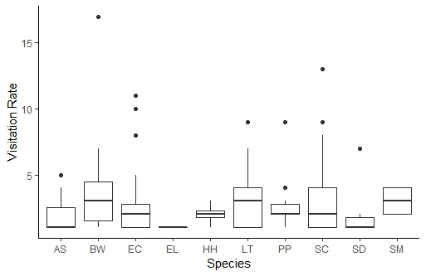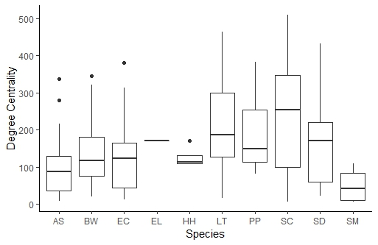

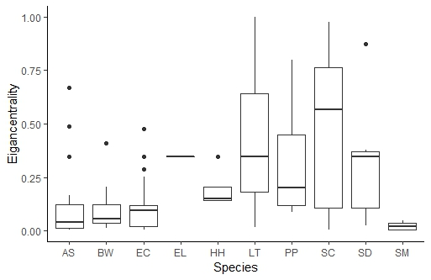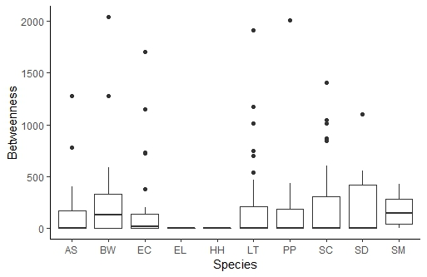

Figure 1: Species differed in their degree centrality and eiganvector centrality - cannot tell from plot - maybe just plot mean as dot with se error bar like we do rii plots?, but not betweenness. need way better figure legend please

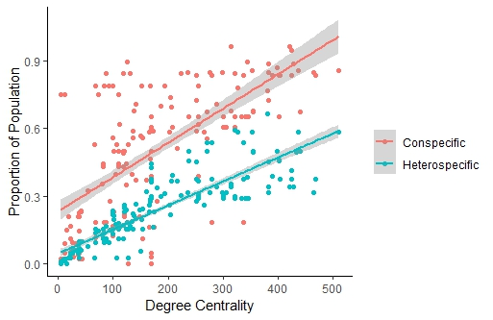

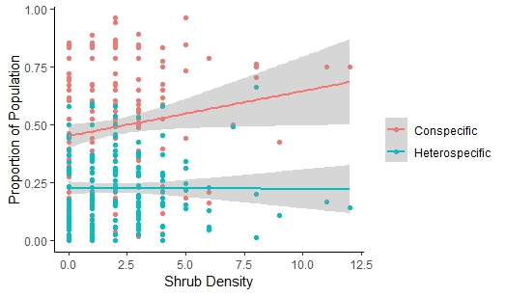

Figure 2: Foundation plants interact with a greater proportion of conspecifics than heterospecifics. Values are the number of interactors standardized by the number of potentially interacting plants within the network. Degree centrality increased both the proportion of conspecifics and heterospecifics. Shrub density increased the proportion of conspecifics only.

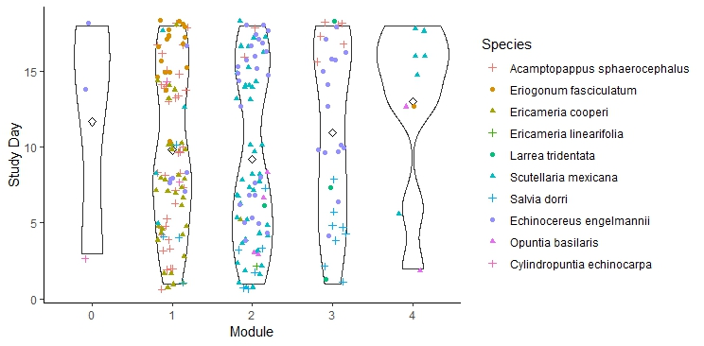

Figure 3: Plant-plant modules were structured by species identity and day. Conspecifics can be found in multiple modules.

Table 3: Results from GLMM showing predictors of proportion of conspecific and heterospecific interactors

|  |  |  |  |  |  |  |
| --- | --- | --- | --- | --- | --- | --- |
|  | Proportion of Conspecifics | | | Proportion of heterospecifics | | |
|  | Estimate | χ2 | p | Estimate | χ2 | p |
| Shrub density | 0.066 | 5.93 | 0.015 | NA | NA | NA |
| Degree | 0.0086 | 181.59 | <0.0001 | 0.01 | 424.35 | <0.0001 |
| Visitation Rate | 0.072 | 3.05 | 0.08 | 0.044 | 1.44 | 0.23 |
| Degree: Visitation rate | -0.000423 | 6.09 | 0.016 | -0.00055 | 24.95 | <0.0001 |

Table 4: Comparison of common quantitive network indices between the species network and the downscaled individual-based network. Indices were calculated for random networks of the same size and compared to the observed networks using Z-scores.

|  |  |  |
| --- | --- | --- |
| Indice | Species-based network | Individual-based network |
| Weighted Connectance | Observed: 0.15 (Z: -40.9***)  Random: 0.27 | 0.08 (Z: -16.1)  Random 0.13 |
| H2 | 0.43 (Z: 57.16)  Random 0.05 | 0.57 (Z: 26.1)  Random: 0.2004796 |
| WNODF | 32.83 (Z: -8.39)  Random: 63.15 | 4.65 (Z: -6.40)  Random: 8.13 |
| Modularity | Obs :0.44 (Z: 36.4)  Random: 0.09 | 0.59 (Z: 24.35)  Random: 0.38 |

**Appendix**

Table A.1: Functional groups

|  |  |  |
| --- | --- | --- |
| Functional group | Key | Taxons |
| Long-tongued very large bees | LtLbee | Anthophora |
| Short-tongued very large bees | StVLbee | Centris |
| Short-tongued large | StLBee | Diadasia, Mellisodes |
| Short-tongued medium | StMbee | Megachile, Colletes, Ashmeadiella, Hoplitis, Osmia, Lasioglossum |
| Short-tongued small | StSmbee | Lasioglossum (Lasioglossum), Hesperapis, Hylaeus |
| Short-tongued very small | StVSbee | Perdita, Lasioglossum |
| Honeybees | Honeybee | Apis mellifera |
| Small flies | SmDi | Agromyzidae, Richaardiae, Tephritidae |
| Large flies | LgDi | Muscidae, Sarcophagidae, Tachinidae |
| Nectar-seeking wasps | Nwasp | Ammophila, Bembecini, Eumeninae, Pompilidae |
| Long proboscis bee-fly | LpBeefly | Bombylinae |
| Short proboscis bee-fly | SpBeefly | Anthracinae etc |
| Syrphid fly | Syrphid | Allograpta exotica, Eupeodes volucris, Eristalis sp., Pseudodoros clavatus |
| Humming bird | hummingbird | Calypte sp. |
| Beetles | beetle | Elaterinae, Chrysomelidae |
| Small Day flying moths | MicroLep | Coleophora, Lithariapteryx |
| Butterfly | butterfly | Desert swallowtail (Papilio polyxenes coloro), Mojave blue (Euphilotes mojave Mojave) |

Table A2

List of model types used throughout paper. Will maybe integrate into text.

|  |  |  |
| --- | --- | --- |
| Response | Error distribution | Log link |
| Visitation | Negative binomial | default |
| Degree | Negative binomial |  |
| Eigancentrality | Gaussian |  |
| Betweenness | Logistic binomial, log transformed Gaussian |  |
| Proportion conspecifics | Quasibinomial |  |
| Proportion heterospecifics | Quasibinomial |  |
| EH | Poisson |  |
| Contribution to nestedness | Gaussian |  |

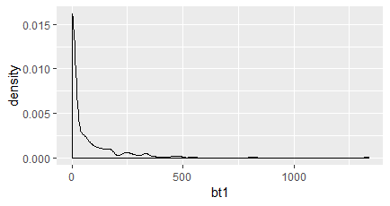

Figure A1: Betweenness values were very zero-inflated. Most models for zero-inflation are for count data, not continuous data.

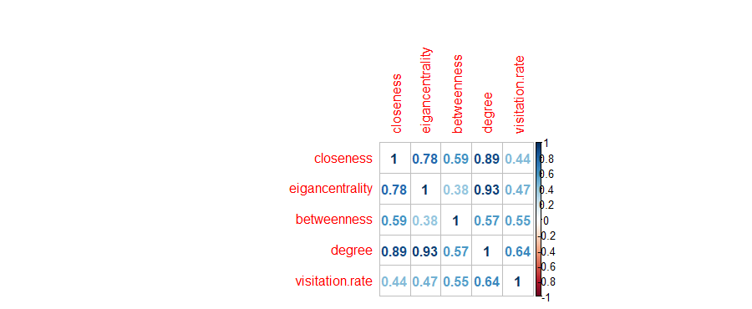

Figure A2: Correlation coefficients between centrality measures and visitation rates.

Comparing best model to null (Visitation rates) using car::Anova = Chi square: 40.687, df=4,p <0.00

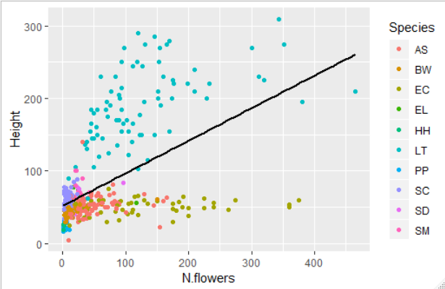

Figure A3: Correlation between the number of flowers and height, split by foundation plant species.

**Full Models for centrality**

Table A4

|  |  |  |  |  |  |  |
| --- | --- | --- | --- | --- | --- | --- |
|  | Degree | | | Eiganvector | | |
|  | Estimate | χ2 | p | Estimate | χ2 | p |
| Visitation rate | 0.2042996 | 75.5616 | < 0.0001 | 0.0543331 | 91.4049 | < 0.001 |
| Shrub density | 0.0034335 | 0.0184 | 0.8921 | -0.0028750 | 0.1577 | 0.6913 |
| Study day | -0.0076894 | 0.8207 | 0.3650 | 0.0001981 | 0.8769 | 0.3490 |
| Floral display size | 0.0007984 | 1.2705 | 0.2597 | -0.0026972 | 1.1406 | 0.2855 |

(Intercept) 4.326e+00 2.522e-01 17.154 <2e-16 ***

Quantity 2.025e-01 2.356e-02 8.598 <2e-16 ***

shrub.density 3.445e-03 2.724e-02 0.126 0.899

day -6.199e-04 1.753e-02 -0.035 0.972

N.flowers 1.739e-03 2.221e-03 0.783 0.434

day:N.flowers -9.339e-05 2.020e-04 -0.462 0.644

Table A5

|  |  |  |  |  |  |  |  |
| --- | --- | --- | --- | --- | --- | --- | --- |
|  | | Betweenness (binomial) | | | Betweenness > 0, gaussian | | |
|  | Estimate | χ2 | p | Estimate | χ2 | p |
| Visitation rate | 0.835882 | 41.864 | < 0.0001 | 0.1906119 | 26.5317 | < 0.0001 |
| Shrub density | 0.256831 | 7.6533 | 0.00567 | 0.0033480 | 0.0065 | 0.9357 |
| Study day | -0.008943 | 0.0926 | 0.76089 | 0.0066236 | 0.1842 | 0.6678 |
| Floral display size | 0.003956 | 3.5005 | 0.06135 | -0.0012015 | 1.5460 | 0.2137 |

|  |  |  |  |  |  |  |  |
| --- | --- | --- | --- | --- | --- | --- | --- |
|  | | Effective partners | | | Nestedness contribution | | |
|  | Estimate | χ2 | p | Estimate | χ2 | p |
| Visitation rate | 0.0795522 | 18.2781 | <0.0001 | 0.1015193 | 29.5833 | <0.0001 |
| Shrub density | 0.0484860 | 3.6568 | 0.0558 | -0.0106382 | 0.1963 | 0.658 |
| Study day | 0.0013102 | 0.0188 | 0.8908 | -0.0126016 | 2.3509 | 0.125 |
| Floral display size | 0.0006251 | 1.1940 | 0.2745 | 0.0007321 | 1.1543 | 0.283 |

|  |  |  |  |  |  |  |  |
| --- | --- | --- | --- | --- | --- | --- | --- |
|  | | Proportion of Conspecifics | | | Proportion of Heterospecifics | | |
|  | Estimate | χ2 | p | Estimate | χ2 | p |
| Visitation rate |  |  |  | -0.1233885 |  | 0.0000 |
| Shrub density |  |  |  | 0.0162254 |  | 0.3509 |
| Degree |  |  |  | 0.0084822 |  | 0.0000 |
| Study day |  |  |  | -0.0009280 |  | 0.8828 |
| Floral display size |  |  |  | -0.0004064 |  | 0.4406 |

AIC table for nnet models

|  |  |  |
| --- | --- | --- |
| Candidate model | Df | AIC |
| Intercept only |  | 555.3168 |
| Species + shrub.density + Quantity + N.flowers*day | 60 | 364.1505 |
| Species + shrub.density + Quantity +day + N.flowers | 56 | 365.7156 |
| Species + shrub.density + Quantity + day | 52 | 360.2055 |
| Species + shrub.density + Quantity + site level density |  | 368.5406 |

Literature Cited

Almeida-Neto, M. and Ulrich, W. 2011. A straightforward computational approach for measuring nestedness using quantitative matrices. - Environmental Modelling & Software 26: 173-178.

Bascompte, J. and Jordano, P. 2013. Mutualistic networks. - Princeton University Press.

Beckett, S. J. 2016. Improved community detection in weighted bipartite networks. - Royal Society open science 3: 140536.

Bivand, R., et al. 2011. spdep: Spatial dependence: weighting schemes, statistics and models. - R package version 0.5-31, URL <http://CRAN>. R-project. org/package= spdep.

Blüthgen, N., et al. 2006. Measuring specialization in species interaction networks. - BMC ecology 6: 9.

Braun, J. and Lortie, C. 2018. Finding the bees knees: a conceptual framework and systematic review of the mechanisms of pollinator-mediated facilitation. - Perspectives in Plant Ecology, Evolution and Systematics.

Brooks, M. E., et al. 2017. glmmTMB balances speed and flexibility among packages for zero-inflated generalized linear mixed modeling. - The R journal 9: 378-400.

CaraDonna, P. J., et al. 2017. Interaction rewiring and the rapid turnover of plant–pollinator networks. - Ecology letters 20: 385-394.

Csardi, G. and Nepusz, T. 2006. The igraph software package for complex network research. - InterJournal, Complex Systems 1695: 1-9.

Donatti, C. I., et al. 2011. Analysis of a hyper‐diverse seed dispersal network: modularity and underlying mechanisms. - Ecology letters 14: 773-781.

Donnelly, S. E., et al. 1998. Pollination in Verbascum thapsus (Scrophulariaceae): the advantage of being tall. - American Journal of Botany 85: 1618-1625.

Dormann, C. F. 2011. How to be a specialist? Quantifying specialisation in pollination networks. - Network Biology 1: 1-20.

Dormann, C. F., et al. 2008. Introducing the bipartite package: analysing ecological networks. - interaction 1.

Doulcier, G. and Stouffer, D. 2015. Rnetcarto: Fast network modularity and roles computation by simulated annealing. - R package version 0.2 4.

Dupont, Y., et al. 2011. Scaling down from species to individuals: a flower–visitation network between individual honeybees and thistle plants. - Oikos 120: 170-177.

Dupont, Y. L., et al. 2014. Spatial structure of an individual‐based plant–pollinator network. - Oikos 123: 1301-1310.

Eklöf, A., et al. 2013. The dimensionality of ecological networks. - Ecology letters 16: 577-583.

Estrada, E. 2007. Characterization of topological keystone species: local, global and “meso-scale” centralities in food webs. - Ecological Complexity 4: 48-57.

Fox, J., et al. 2012. Package ‘car’. - Vienna: R Foundation for Statistical Computing.

Freeman, L. C. 1978. Centrality in social networks conceptual clarification. - Social networks 1: 215-239.

Gómez, J. M., et al. 2007. Pollinator diversity affects plant reproduction and recruitment: the tradeoffs of generalization. - Oecologia 153: 597-605.

Gómez, J. M. and Perfectti, F. 2011. Fitness consequences of centrality in mutualistic individual-based networks. - Proceedings of the Royal Society B: Biological Sciences 279: 1754-1760.

González, A. M. M., et al. 2010. Centrality measures and the importance of generalist species in pollination networks. - Ecological Complexity 7: 36-43.

Greenleaf, S. S. and Kremen, C. 2006. Wild bees enhance honey bees’ pollination of hybrid sunflower. - Proceedings of the National Academy of Sciences 103: 13890-13895.

Guimera, R. and Amaral, L. A. N. 2005. Functional cartography of complex metabolic networks. - nature 433: 895.

Heinrich, B. 1979. Resource heterogeneity and patterns of movement in foraging bumblebees. - Oecologia 40: 235-245.

Jha, S. and Vandermeer, J. H. 2009. Contrasting bee foraging in response to resource scale and local habitat management. - Oikos 118: 1174-1180.

Jordán, F., et al. 2006. Topological keystone species: measures of positional importance in food webs. - Oikos 112: 535-546.

Klein, A. M., et al. 2003. Fruit set of highland coffee increases with the diversity of pollinating bees. - Proceedings of the Royal Society of London. Series B: Biological Sciences 270: 955-961.

Kuppler, J., et al. 2016. Time‐invariant differences between plant individuals in interactions with arthropods correlate with intraspecific variation in plant phenology, morphology and floral scent. - New Phytologist 210: 1357-1368.

Losapio, G., et al. 2019. Plant interactions shape pollination networks via nonadditive effects. - Ecology 100: e02619.

Maglianesi, M. A., et al. 2015. Functional structure and specialization in three tropical plant–hummingbird interaction networks across an elevational gradient in Costa Rica. - Ecography 38: 1119-1128.

Martín-González, A., et al. 2010. Centrality measures and the importance of generalist species in pollination networks. - Ecological Complexity 7: 36-43.

Mitchell, R. J., et al. 2009. New frontiers in competition for pollination. - Annals of Botany 103: 1403-1413.

Morente-López, J., et al. 2018. Phenology drives species interactions and modularity in a plant-flower visitor network. - Scientific reports 8: 9386.

Moritz, S. and Bartz-Beielstein, T. 2017. imputeTS: time series missing value imputation in R. - The R Journal 9: 207-218.

Ohashi, K. and Yahara, T. 1998. Effects of variation in flower number on pollinator visits in Cirsium purpuratum (Asteraceae). - American Journal of Botany 85: 219-224.

Oksanen, J. and Blanchet, F. G. Package ‘vegan’. -.

Olesen, J. M., et al. 2007. The modularity of pollination networks. - Proceedings of the National Academy of Sciences 104: 19891-19896.

Olesen, J. M., et al. 2010. From Broadstone to Zackenberg: space, time and hierarchies in ecological networks. Advances in ecological research. Elsevier, pp. 1-69.

Olito, C. and Fox, J. W. 2015. Species traits and abundances predict metrics of plant–pollinator network structure, but not pairwise interactions. - Oikos 124: 428-436.

Oliver, I. and Beattie, A. J. 1993. A possible method for the rapid assessment of biodiversity. - Conservation biology 7: 562-568.

Perfectti, F., et al. 2009. The functional consequences of diversity in plant–pollinator interactions. - Oikos 118: 1430-1440.

Poisot, T. and Gravel, D. 2014. When is an ecological network complex? Connectance drives degree distribution and emerging network properties. - PeerJ 2: e251.

Poisot, T., et al. 2015. Beyond species: why ecological interaction networks vary through space and time. - Oikos 124: 243-251.

Rathcke, B. 1983. Competition and facilitation among plants for pollination. - Pollination biology: 305-329.

Roll, J., et al. 1997. Reproductive Success Increases with Local Density of Conspecif ics in a Desert Mustard (Lesquerella fendleri) El Exito Reproductivo Incrementa con la Densidad Local de Coespecificos en la Mostaza del Desierto (Lesquerella fendleri). - Conservation biology 11: 738-746.

Rumeu, B., et al. 2018. Zooming into plant-flower visitor networks: an individual trait-based approach. - PeerJ 6: e5618.

Russo, L., et al. 2013. Supporting crop pollinators with floral resources: network‐based phenological matching. - Ecology and Evolution 3: 3125-3140.

Seifan, M., et al. 2014. The outcome of shared pollination services is affected by the density and spatial pattern of an attractive neighbour. - Journal of Ecology 102: 953-962.

Stanoev, A., et al. 2011. Identifying communities by influence dynamics in social networks. - Physical Review E 84: 046102.

Steffan-Dewenter, I., et al. 2002. Scale‐dependent effects of landscape context on three pollinator guilds. - Ecology 83: 1421-1432.

Steffan‐Dewenter, I. 2003. Importance of habitat area and landscape context for species richness of bees and wasps in fragmented orchard meadows. - Conservation biology 17: 1036-1044.

Thomson, J. D. 1981. Spatial and temporal components of resource assessment by flower-feeding insects. - The Journal of Animal Ecology 50: 49-59.

Toräng, P., et al. 2006. Facilitation in an Insect-Pollinated Herb with a Floral Display Dimorphism. - Ecology 87: 2113-2117.

Tur, C., et al. 2015. Increasing modularity when downscaling networks from species to individuals. - Oikos 124: 581-592.

Tur, C., et al. 2014. Downscaling pollen–transport networks to the level of individuals. - Journal of Animal Ecology 83: 306-317.

Tylianakis, J. M., et al. 2008. Resource heterogeneity moderates the biodiversity-function relationship in real world ecosystems. - PLoS Biology 6: e122.

Tylianakis, J. M., et al. 2007. Habitat modification alters the structure of tropical host–parasitoid food webs. - Nature 445: 202.

Valverde, J., et al. 2016. The temporal dimension in individual‐based plant pollination networks. - Oikos 125: 468-479.

Venables, W. N. and Ripley, B. D. 2013. Modern applied statistics with S-PLUS. - Springer Science & Business Media.

Westphal, C., et al. 2008. Measuring bee diversity in different European habitats and biogeographical regions. - Ecological monographs 78: 653-671.

Woodward, G., et al. 2010. Individual-based food webs: species identity, body size and sampling effects. Advances in ecological research. Elsevier, pp. 211-266.

Zuur, A., et al. 2009. Mixed effects models and extensions in ecology with R. - Springer Science & Business Media.