Neighbours and networks: An individual-based, community level pollinator-visitation network.

**Can skip until rule on second page ☺**

P1: Interactions between species structure plant community and contribute to biodiversity maintenance. Most plant species rely on animal-pollinator (Ollerton) and plant fitness is tightly linked to pollinator sharing. Interacting populations are aggregations of interacting individuals, thus the outcome of interactions between species can be influenced by both intraspecific and interspecific variation in attractiveness to pollinators. Attractiveness to pollinators varies not only with individual traits such as floral display size and height (Lortie, that morphotype facilitation paper), but the density and identity of neighbours, and the overall density of the area at larger scale. Pollinator-mediated interactions are hypothesized to fall on a continuum from facilitation to competition depending on the density (Rathcke). This hypothesis has some empirical support, however it is often not the case.

Interactions for pollination are scale-dependent and occur at the whole-community level. However, most studies focus one pairwise interactions between plants. This is inadequate to describe higher-level patterns of interactions. Network analysis has been increasingly used to study…. More recently, networks have been successfully downscaled (Gomez etc). These have explored specialization (Tur), phenology (Valverde). A few papers have explored how individual plant traits influence network topology (Dupont). However, these papers are not exploring patterns at the community level. Maglienesi uses both species and individual networks to explore changes in specialization across a gradient of elevation.

Community’s shaped by competition are characterized by…Resource partitioning, specialization, nestedness, connectivity etc. Pauw (2018) writes that negative-frequency dependence requires the partitioning of visits between plants. Positive density-dependence has been reported… Negative has been reported. Under interspecific competition, pollinators are expected to become more specialized by increasing resource partitioning (Schoener 1974, Inouye 1978). When niche partitioning is occurring by flexible foragers in response to interspecific competition, network modularity is expected to increase (Spiesman and Gratton). They also predict that specialization should increase with plant resource availability because it supports pollinators within their niches, and prevents them from having to be more general. Nestedness has been demonstrated in several studies to reduce competition through…. Both specialization and complementarity are expected to reduce inter-species competition and promote coexistence ((MacArthur 1955; Elton 1958; Levine & HilleRisLambers2009). In nested networks, both specialists and generalists tend to interact with generalists, specialist-specialist relationships are rarer.

Network topology is just the pattern of relations. Thus, plant traits should show influence on network topology and because these attractiveness is density-dependent then the influence should also vary with density. Some interactions are better analyzed by projecting to a unipartite network. Each link is a shared pollinator group leading to potentially interactions individuals. We used several metrics from social network analysis to describe the traits or contexts that lead to an individual plant being more influential. Degree centrality is an importance score based on the number of links held by a node. Species that have a disproportionate effect on a community can be identified by looking at degrees of the many nodes (Dale and Fortin). Here, individuals with the highest degree have the highest number of potential mates, and the highest number of potential competitors/facilitators, and therefore the largest capacity to influence the surrounding community. Eigancentrality takes this one step further, taking into account how well-connected their associated nodes are. Similarly, to bipartite networks, plants sharing similar pollinators can be structured into modules. Modules tend to mate within themselves more often.

In this study we address how the interplay between individual floral display size, the local floral neighbourhood and within-season phenology (i.e. density shifts) *alters pollination services* and shapes the topology of pollinator-visitation networks. We quantified pollinator visitation to all foundational plant species within a shrub and cactus dominated desert community moving through natural spring phenology and built quantitative visitation networks to describe shifts in community interactions during one season. We began sampling at the very beginning of shrub flowering and ended when it was no longer possible to locate flowering shrubs that had not yet been sampled.

We hypothesize that decreases in floral availability will precede decreases in pollinator availability leading to altered foraging decisions by pollinators that change interactions between plants.

Predictions:

1. Pollinator visitation to individual plants will depend on floral display size, local floral neighbour density and time period/site level density level.
2. There will be network level evidence for resource partitioning: Increased specialization and modularity, decreased nestedness and connectance (bipartite networks).
3. Floral display size, neighbour density and time period/site density influence the structure of plant-plant modules (one-mode networks)
4. Floral display size and neighbour density contribute to the individual plants’ influence including degree centrality, eigancentrality and betweenness, but varies with time period/site density (one-mode network)

Methods

Field data collection

Plant-pollinator interactions were studied at Sunset Cove on the property of the Sweeney Granite Mountains Desert Research Station within the Mojave National Preserve in California (34°46'26.5"N 115°39'31.3"W). Data collection was carried out between April 20th and May 9th, 2018 which included the flowering period of most spring blooming shrubs and cacti at the site. The experiment ended when it was not possible to located blooming shrubs that had not yet been observed. Focal plants were chosen by walking in a line starting in a different quadrant of the study site each day to avoid confounding area by time of day. To avoid oversampling the most abundant species, up to six individuals of a single species was sampled per observer per day. All focal plants were georeferenced using a Garmin 64st handheld GPS.

Flower-visitor interactions for each focal plant were recorded within 10-minute in-situ observation periods between 9:00 AM and 5:30 PM in the absence of strong winds. Observations were focused on seven species of shrub and three species of cactus for a total of 66 hours of observation (Table 1). This approach to creating a pollinator visitation network allows visitation rates to be compared between individual plants, in comparison to the frequently used method of transect walks in which the most frequent interactions are that which are most frequently observed.

Only visitors that made contact with the reproductive organs of the flowers were recorded. Visitors from taxonomic groups known not be pollinators were excluded (i.e. ladybird beetles, Carpophilus sp. pollen beetles and spiders). Soft-winged flower beetles in the subfamily Dasytinae were excluded because while abundant, were generally stationary deep within flowers and it would not be realistic count them without disturbing the flower. Very small pollinators, i.e. micro-beeflys (Mythicomyiidae) were excluded from analyses as it was not realistic to accurately track visitation to large shrubs such as *L. tridentata*.

Most floral visitors were identified to genus or species, however some groups (Tachinidae, Sarcophagidae) were left as family due to the difficulty of identifying them on the wing. Some visitors were morphotyped within these categories. We collected x number of voucher specimens to verify the identification. We wanted to minimize any artefacts of destructive sampling. Morphotyping and RTU are useful methods for characterizing and quantifying pollinator communities (Memmott & Godfray 1993; Oliver et al). This method provides information about the linkages between different genera and functional groups.

Floral display size and height are known to influence attractiveness of plants to pollinators, sowe counted the number of open flowers and measured the height of each focal plant directly before the observation period. As a measure of the immediate floral neighbourhood, we recorded the abundance and identity of all blooming shrubs and cactus within a 3 m radius around the focal plant. *We also measured the distance to and identity of the focal shrub’s nearest blooming neighbour.* We tracked shrub phenology and estimated site level floral density by counting the number of blooming shrubs of each species in three x by x band transects on x number of days over the study period. It is not realistic to count the number flowers on each shrub so this measurement forms a proxy for floral abundance.

To track pollinator population changes throughout the study period, I placed yellow, white, and blue coloured six-inch diameter plastic bowls filled with water with a few drops of dish detergent added. These were placed in arrays of three at six locations in open areas, every other day. I quantified the number of ‘large bodied’ pollinators to reflect the sizes of those observed during the experiments (hereafter just ‘pollinators’).

**Data analysis**

All statistical analyses were performed using R Version 3.4.2 (R Core Team, 2017), and all code is available on GitHub.

Time periods, density and miscellany

Site level density values for non-density-sampling days (~3) were imputed for each species separately using linear interpolation as there was no expectation for seasonality (imputeTS, Appendix). The species-specific values were summed together to fill in the missing dates.

We split the dataset into three time periods: the first five days, the final five days, and the middle (nine days but six sampling days). To test for site level density differences between time periods, we used a GLM with gaussian error distribution (glm).

Pollinators were assigned to 1 of 17 functional groups. Functional groups provided insight into general trends. See Appendix for full list of visitors and the functional group they were assigned to.

Influence of neighbours etc on pollinator visitation

To test for between-plant variation in pollinator visitation rates, we fit generalized linear mixed models (GLMM) with the number of visits as the response variable and individual floral display size, floral neighbourhood, site density and time period as predictor variables. The shrub species was included in the models as a random effect. To account for over dispersion in the model, we used a negative binomial error distribution. Height and floral display size were positively correlated (Pearson’s = 0.537, p < 0.0001, df = 392) and thus only floral display size was included in finals models. We assessed model fit by comparing candidate models to each other and to the intercept only model using AIC and likelihood ratio tests. In cases when AIC < 2 and there were no differences in likelihood ratio test, we chose the simpler of the models.

To test for pollination hotspots that may arise from habitat preferences rather than floral preferences, we used Moran’s I and Geary’s C (k = 4) to test for spatial autocorrelation of visitation rates using spdep (vignette citation).

Network differences in topology

To measure changes in the whole community pollinator visitation network over the study period, we built quantitative visitation networks. For each time period, I built a species level network, an individual network and a trait-based network. The trait-based network was built by clustering floral display sizes using vegdist and hclust in vegan (vignette). The tree was cut at five clusters to maximize the differences between the clusters while maintaining ease of interpretation (see Appendix for dendrogram). Only plants that were part of the network were clustered (ie plants with 0 visits were excluded).

For each of the nine networks, several frequently used network descriptors were calculated using bipartite (vignette). H2` characterizes the degree of specialization of the network, is quantitative and it does not vary much with network size (Bluthgen and Menzel, 2006). Weighted nestedness (WNODF) ranges from 0 to 100. In nested networks, specialized nodes are linked with generalized nodes (Almeida-Neto & Ulrich, 2011). Interaction evenness ranges from 0 to 1 (1 is perfectly even). Connectance is..The modularity of each network was assessed using QB algorithm (Dormann and Strauss). Modularity describe how the network is split into modules of species or individuals that are more likely to interact with other than outside the module. In a bipartite network, modules consist of both plants and pollinators.

For each of the 9 observed networks, 1000 random networks were generated holding the totals of rows and columns fixed, based on Patefields’ (1981) algorithm (permatfull, vegan). Each of the four indices and modularity were calculated for each random network. Z-scores were calculated to assess significance of results and facilitate comparison between the different networks. Z-scores were calculated using: Z:Score = (Observed value - mean (null)/sd*null). Positive value denote the observed value is higher than the mean of the null distribution.

Influence of traits and neighbours on the individual plant-plant network topology

To explore the contribution of floral display size and local floral neighbourhood on an individual plant’s influence on the whole network, we projected each time period’s individual-based network bipartite network into a one-mode networks (bipartite). These are plant-plant interaction network where each link is a shared pollinator functional group between individuals.

For each time period we calculated degree centrality, the number of links per individual. In a plant-plant network it describes the number of interacting conspecifics ie mating pool and the number of heterospecifics ie the number of potential competitors/facilitators. In social network analysis it is a frequently used influence metric.

We also calculated eigancentrality, which extends the concept of degree centrality but takes into the account of the importance (degree) of the interactors. Individuals that interact frequently with other highly influential individuals are more poised to influence the full network.

We calculated betweenness, number of times a node lies on the shortest path between other nodes. Important to the cohesiveness of a network and describes the importance of a node on connect the parts of the network. The data was zero-inflated, so we first modelled the likelihood of an individual having a betweenness value > 0 using a binomial mixed effect model. I then log-transformed the continuous part and modelled it using a Gaussian error distribution.

We were unable to calculate closeness centrality because our graphs were disconnected (there might be a way around this tho). All plant-plant centrality measures were calculated using igraph.

We then fit GLMM using the network indices as response variables, and the individual plant traits and the time period as predictors and the plant species as a random effect.

Plant-plant network modularity.

Modularity is a measure of the extent to which a network is subdivided into modules. Modular networks are those whose modules are comprised of members than interact strongly within the module and weakly between modules. We projected the individual-based bipartite interaction network of each time period into a one-mode plant-plant interaction network. Modularity was calculated for each network using simulated annealing (netcarto, vignette) and compared to 1000 random networks created using Patefield’s to assess significance (permatful, vegan). Modularity describes how plant communities are structured into groups by pollinator sharing, and how this structure changes with phenology.

To explore the role of phenology, individual traits and neighbourhood on modularity, and therefore ecological dynamics, we built multinomial models (nnet) using the module as the response, and individual floral display size and local floral neighbourhood as the predictors. Plant species was included as a covariate in all models to account for species-specific responses.

Results

A total of 635 foraging bouts were recorded over 394 observation periods. 430 visits were to shrubs and 205 were to cactus. The pollinators made up 17 functional groups spanning 62 RTU of visitors. With the exception of hummingbirds (*Calypte sp*)., all floral visitors were insects.

Site level site density (n = 19) differed between the time periods (GLM, χ2 = 8.08, p = 0.01754). The late time period was significantly less dense than middle (p = 0.0133), but only marginally, significantly so from the early period (0.0567). (Table 1) (Figure 1)

There was no significant correlation between site level density and local neighbourhood density (Pearsons = 0.11, p = 0.1187, df = 178).

Overall, visitation rates don’t differ between the three time periods (GLMM, χ2 = 5.542, Df = 2, p = 0.06316). However, visitation rates were significantly higher in the later period relative to the middle period (p = 0.294) and there was a marginally significant increase of the later time period relative to the early (Est = 0.33589, p = 0.05639 (Table 2).

There was a consistent, positive influence of neighbourhood shrub density on pollinator visitation rates throughout the study period (Table 3). There was a significant interaction between individual floral display size and time period. During the early time period, visitation increases sharply with individual floral display size. However, display size becomes unimportant in the later time period (Figure 3, Table 3). There was no spatial autocorrelation detected for visitation rates (Moran’s: -0.055108, p = 0.953, Geary: 1.0442, p = 0.8145).

Network level differences over time

At the level of the community, specialization of the species interaction network increases over the study period (all networks in Table 4) and the network is significantly specialized at all time periods. The network is significantly modular and the modularity increases over the study period.

The network is less nested than expected, and nested is lowest in the middle time period but doesn’t shift greatly. The network is significantly less nested than expected. Both connectance and interaction evenness are much less than expected and both decrease over the study period.

For the individual-based networks, specialization is lower than the species network, and also increases over the study period but much more quickly. Nestedness is lower than species and somewhat decreases. The networks are less modular overall, and this modularity is lowest at the beginning and higher in the mid and later.

For the floral cluster network, less specialized than species and individual, but increase for the later time period. Changes in the floral cluster network are less pronounced except evenness which decreases a fair bit.

Influence metrics

The traits that make an individual plant influential depended on the time period (Table 6, Table 7). There was no contribution of the floral neighbourhood to degree centrality or eigancentrality. In the early and mid-time periods, eigancentrality increases with floral display size, however it decreases with floral display size in the later time periods. A similar trend occurs with degree centrality; however, the slope is less steep.

The probability of an individual plant having a betweenness measure greater than one increased with floral number and shrub density, even when the number of visits was included in the model. There’s an interaction of shrub density and time for betweeness – this model is barely different than the non-interactive model. (Table and Figure 8). According to the interactive model, individual plants growing is denser neighbourhoods, later in the study time (ie at declining densities) are more important for connecting the parts of the network.

Plant-plant modules

At all three time periods, the plant-plant networks were modular. (early: 0.305, mid: 0.379, later: 0.362). Z-scores (50.09, 78.77, 66.4). The traits that influence modularity differ between the time period. Both levels of floral density differed. (Table 8). Shrub density was important early on to modularity, whereas floral display size was important in the middle, and neither were important later on.

**Discussion:**

* The competitive advantage of a large floral display size was lost in the later time period
* Higher visitation rates with decreasing densities is what we expect if there are more pollinators than shrubs (spill-over or temporal facilitation effect)
* Overall modularity of the bipartite networks had the tendency to increase over study period. Results consistent with resource partitioning by pollinators. Same for increases in specialization and decreases in nestedness.
* All of the plant-plant interaction networks were significantly modular, and the structure of these modules was influenced by the various levels of density at different times. Modularity is supposed to be important for biodiversity and stability but at these zoomed-in scales it is influenced by the composition etc of the communities themselves
* All networks show similar trends but can discuss a few differences
* Individual traits and neighbours influence network topology.
* Networks can change a lot even in a very short season.

Still to do: Better integrate floral cluster network into hypothesis

Can include beta-diversity? See last page: Network differences as in Poisot 2012. Unfamiliar territory for me but some measure of interaction turnover could be helpful.

Tables & Figures

Table 1: **Test for site-level density differences between the time periods**. Values are shrubs per m2. Site density results from GLM (n days = 19). Reference level is later time period. Used Gaussian, residuals are *almost* normal, p = 0.03

(Intercept) 0.028600 0.002835 10.090 2.43e-08 ***

timeearly 0.008233 0.004009 2.054 0.0567 .

timemid 0.009844 0.003535 2.785 0.0133 *

Response: sum

LR Chisq Df Pr(>Chisq)

time 8.0867 2 0.01754 *

Pairwise contrasts (using multcomp)

Linear Hypotheses:

Estimate Std. Error z value Pr(>|z|)

early - later == 0 0.008233 0.004009 2.054 0.0991 .

mid - later == 0 0.009844 0.003535 2.785 0.0147 *

mid - early == 0 0.001611 0.003535 0.456 0.8914

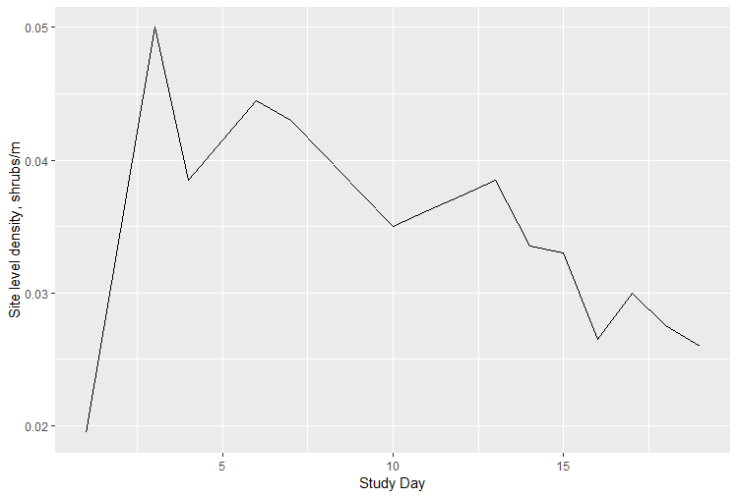

Table 2: **Pollinator visitation between time periods.** Later period is reference level. Negative binomial GLM.

Conditional model:

Estimate Std. Error z value Pr(>|z|)

(Intercept) 0.7158 0.1238 5.783 7.32e-09 ***

timeearly -0.3359 0.1760 -1.908 0.0564 .

timemid -0.3555 0.1632 -2.178 0.0294 *

Chisq

time 5.5242 2 0.06316 .

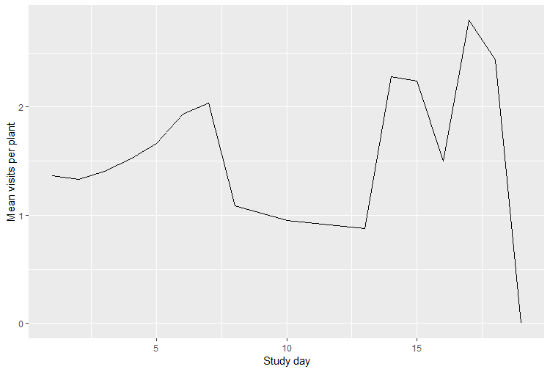

Table 3: Results of GLMM of density-dependence. P-values from type 3 wald’s chisq test . Response is pollinator visitation, species as random effect.

|  |  |  |  |
| --- | --- | --- | --- |
| Variable | Chisq | Df | p |
| Intercepts | 1.4756 | 1 | 0.224465 |
| Shrub.density | 4.4213 | 1 | 0.035492 * |
| N.flowers.scaled | 15.3996 | 1 | 8.701e-05 *** |
| Time | 10.2441 | 2 | 0.005964 ** |
| Nflowers:Time | 11.6674 | 2 | 0.002927 ** |

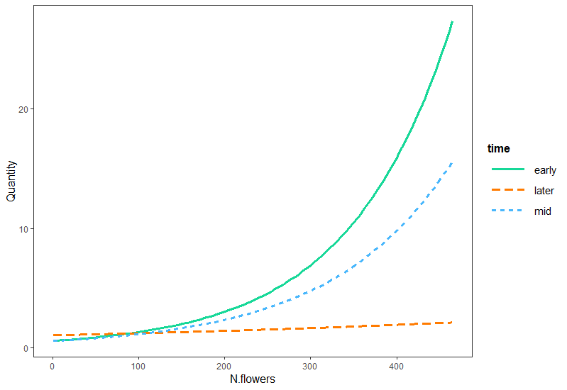

Figure 3: Interaction diagram from previous module predicting pollinator visitation.

Table 4: Network indices for plant-pollinator bipartite networks. We can also use ΔH2 to compare.

|  |  |  |  |  |  |  |  |  |  |
| --- | --- | --- | --- | --- | --- | --- | --- | --- | --- |
|  |  | early |  |  | mid |  |  | later |  |
|  | species | indiv | Floral cluster | Species | indiv | Floral cluster | Species | indiv | Floral cluster |
| H2 | 0.441 | 0.490 | 0.252 | 0.483 | 0.622 | 0.216 | 0.587 | 0.555 | 0.362 |
| Null | 0.12  ± 0.018 | 0.21  ± 0.027 | 0.090  ± 0.018 | 0.085  ± 0.013 | 0.209 ± 0.028 | 0.062  ± 0.014 | 0.073  ± 0.017 | 0.218  ± 0.022 | 0.076  ± 0.017 |
| Delta H | **0.321** | **0.28** | **0.162** | **0.398** | **0.413** | **0.154** | **0.514** | **0.337** | **0.286** |
| Z-score | **18.15** | **10.52** | **8.94** | **29.77** | **14.5** | **11.39** | **30.81** | **15.70** | **16.46** |
| WNODF | 19.999 | 5.86 | 37.72 | 22.23 | 3.97 | 50.17 | 24.21 | 4.68 | 30.93 |
| Null | 44.61  ± 4.12 | 7.79 ± 1.08 | 47.3  ± 4.43 | 54.71  ± 4.96 | 7.54  ± 0.75 | 50.47  ± 4.26 | 55.8  ± 5.51 | 11.43  ± 1.31 | 57.49  ± 6.00 |
| Z-score | **-5.976** | **-1.8** | **-2.17** | **-6.56** | **-4.75** | **-0.07** | **-5.74** | **-5.17** | **-4.43** |
| Modularity | 0.42 | 0.58 | 0.32 | 0.47 | 0.63 | 0.28 | 0.49 | 0.58 | 0.33 |
| Null (mean, sd) | 0.17  ± 0.02 | 0.42  ± 0.02 | 0.15  ± 0.02 | 0.14  ± 0.02 | 0.42  ± 0.01 | 0.12  ± 0.02 | 0.12  ± 0.02 | 0.36  ± 0.015 | 0.11  ± 0.02 |
| Z-score | **13.83** | **9.47** | **8.902** | **19.75** | **15.76** | **9.931** | **21.35** | **14.61** | **12.78** |
| Connectance | 0.294 | 0.099 | 0.5411 | 0.32 | 0.093 | 0.575 | 0.33 | 0.11 | 0.5 |
| Null | 0.3935 ±  0.017 | 0.12  ± 0.003 | 0.573  ± 0.024 | 0.455  ± 0.018 | 0.13  ± 0.003 | 0.67  ± 0.02 | 0.52  ± 0.017 | 0.153  ± 0.003 | 0.595  ± 0.030 |
| Z-score | **-5.840** | **-8.287** | **-8.29** | **-7.654** | **-11.99** | **-11.99** | **-10.79** | **-12.39** | **-12.39** |
| Evenness | 0.636 | 0.648 | 0.726 | 0.62 | 0.646 | 0.765 | 0.598 | 0.649 | 0.673 |
| Null (mean, sd) | 0.736  ± 0.006 | 0.69  ± 0.004 | 0.776  ± 0.006 | 0.75  ± 0.004 | 0.71  ± 0.004 | 0.818  ± 0.005 | 0.746  ± 0.005 | 0.715  ± 0.004 | 0.749  ± 0.005 |
| Z-score | **-18.15** | **-10.52** | **-8.94** | **-29.768** | **-14.50** | **-11.41** | **-30.81** | **-15.701** | **-16.460** |
|  |

Mean specialization for plants and pollinators.

|  |  |  |  |
| --- | --- | --- | --- |
| D’ | Early | Mid | later |
| Plants | 0.4198684 | 0.4621463 | 0.5716662 |
| Pollinators | 0.3160467 | 0.306564 | 0.3111274 |
| Ind: Plants | 0.2891871 | 0.3142522 | 0.3091529 |
| Ind: Pol | 0.5716828 | 0.7522722 | 0.6438295 |

Table 6: **Degree centrality model** results – shrub.density was not significant and can be excluded? Species is included as random effect.

Estimate Std. Error z value Pr(>|z|)

(Intercept) 4.126296 0.175896 23.459 < 2e-16 ***

N.flowers -0.001923 0.001238 -1.553 0.120311

timeearly -0.321560 0.197421 -1.629 0.103354

timemid -0.466697 0.168709 -2.766 0.005670 **

N.flowers:timeearly 0.003354 0.001750 1.917 0.055287 .

N.flowers:timemid 0.005621 0.001481 3.796 0.000147 ***

Analysis of Deviance Table (Type III Wald chisquare tests)

Response: dg1

Chisq Df Pr(>Chisq)

(Intercept) 550.3095 1 < 2.2e-16 ***

N.flowers 2.4133 1 0.1203110

time 7.6803 2 0.0214901 *

N.flowers:time 14.4462 2 0.0007295 ***

(Intercept) 4.130084 0.189813 21.759 < 2e-16 ***

N.flowers -0.001918 0.001241 -1.545 0.122422

timeearly -0.321922 0.197505 -1.630 0.103114

timemid -0.466827 0.168708 -2.767 0.005656 **

shrub.density -0.001548 0.029484 -0.052 0.958136

N.flowers:timeearly 0.003355 0.001750 1.917 0.055191 .

N.flowers:timemid 0.005619 0.001481 3.793 0.000149 ***

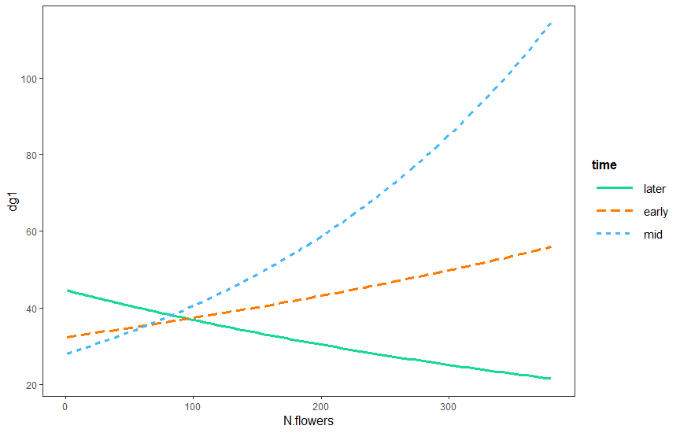

Interaction plot for degree centrality.

Table 7: **Eigancentrality.** GLMM, species is included as a random effect.

(Intercept) 0.2640413 0.0635292 4.156 3.24e-05 ***

N.flowers -0.0009081 0.0003717 -2.443 0.01456 *

timeearly 0.0418065 0.0578402 0.723 0.46981

timemid -0.1269570 0.0473340 -2.682 0.00732 **

N.flowers:timeearly 0.0012132 0.0005163 2.350 0.01880 *

N.flowers:timemid 0.0021765 0.0004207 5.173 2.30e-07 ***

Response: V2

Chisq Df Pr(>Chisq)

(Intercept) 22.8764 1 1.728e-06 ***

N.flowers 0.5545 1 0.456475

time 13.8785 2 0.000969 ***

N.flowers:time 27.3034 2 1.178e-06 ***

Model with shrub.density:

(Intercept) 0.2623040 0.0663917 3.951 7.79e-05 ***

N.flowers -0.0009116 0.0003736 -2.440 0.01470 *

timeearly 0.0420332 0.0578903 0.726 0.46779

timemid -0.1270894 0.0473518 -2.684 0.00728 **

shrub.density 0.0007737 0.0084078 0.092 0.92668

N.flowers:timeearly 0.0012112 0.0005167 2.344 0.01909 *

N.flowers:timemid 0.0021775 0.0004208 5.175 2.28e-07 ***

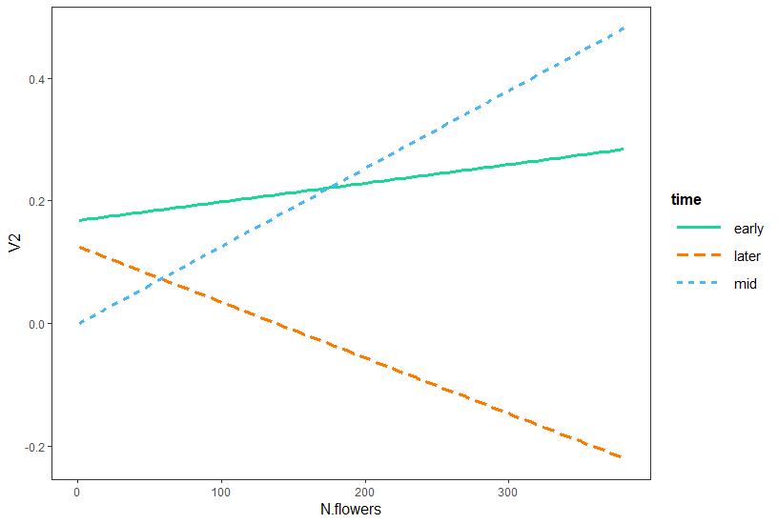

Figure 7: Interaction plot for eigancentrality model.

Table 8: **Betweenness modelling**

Logistic regression for a value of betweeness > 0

N.flowers 0.004291 0.002179 1.969 0.04899 *

timeearly 1.563605 0.758136 2.062 0.03917 *

timemid 0.720244 0.718139 1.003 0.31589

shrub.density 0.803654 0.282852 2.841 0.00449 **

Quantity 0.861167 0.132465 6.501 7.97e-11 ***

timeearly:shrub.density -0.749146 0.326856 -2.292 0.02191 *

timemid:shrub.density -0.655377 0.302413 -2.167 0.03022 *

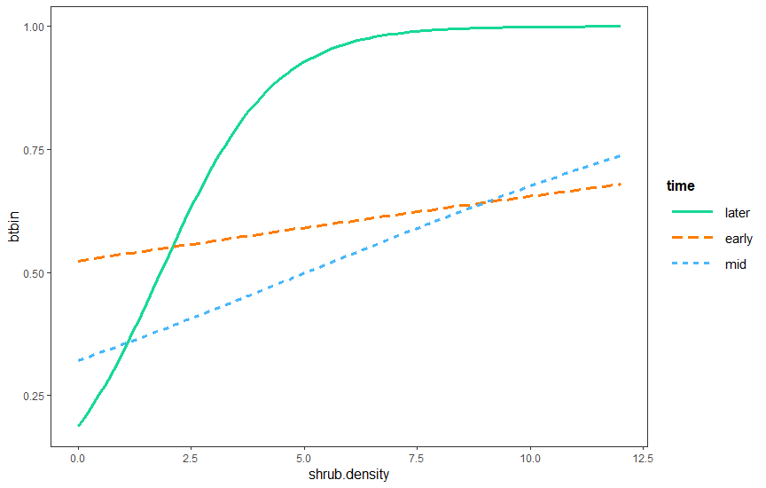

Figure 8: Interaction plot for the logistic model.

Table 9: **Multinomial models predicting structure of modules.**

Early:

Response: module

LR Chisq Df Pr(>Chisq)

Species 85.920 27 4.643e-08 ***

N.flowers 2.882 3 0.41020

shrub.density 8.230 3 0.04148 *

Mid:

Species 95.318 36 2.91e-07 ***

N.flowers 10.332 4 0.03519 *

shrub.density 8.093 4 0.08824 .

Late

Species 69.820 27 1.19e-05 ***

N.flowers 1.350 3 0.7172

shrub.density 1.823 3 0.6100

Early season: Higher number is floral cluster with more flowers

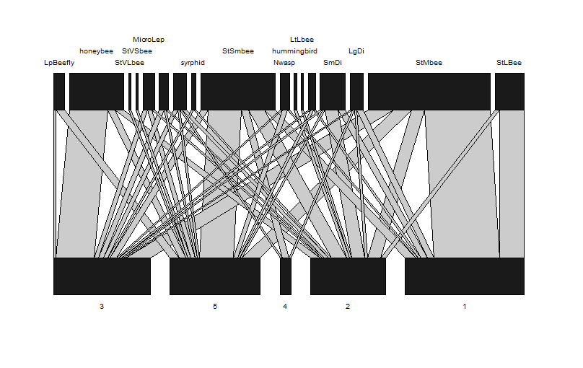

Middle:

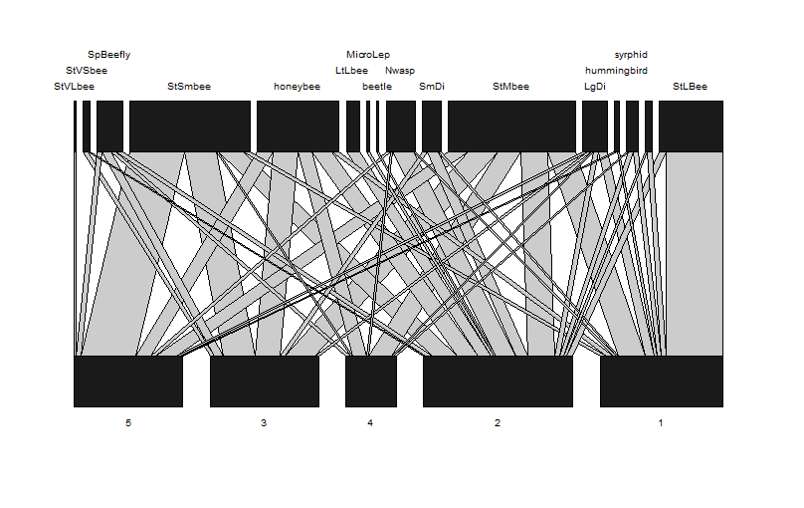

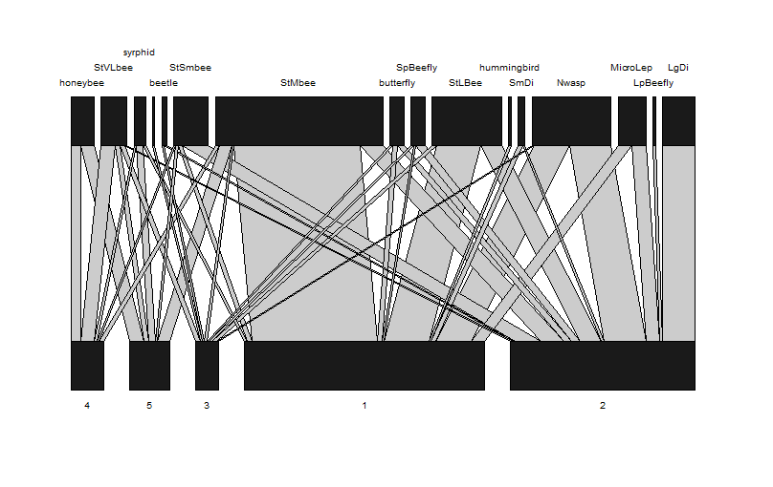

Later

Appendix

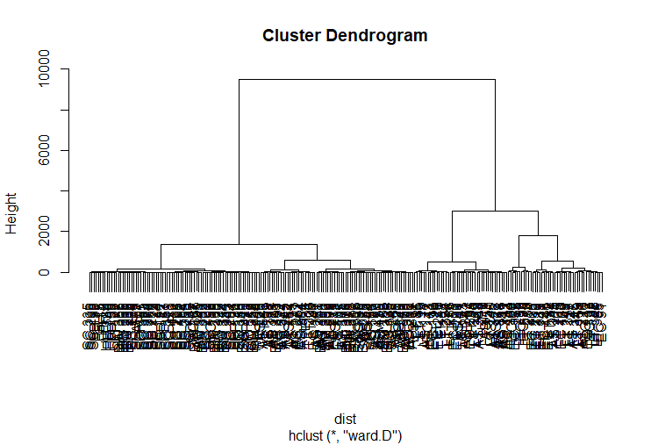

Figure: Floral display size dendrogram. The tree was cut at a height of 1200 creating 5 clusters. The red line is the approximate cutting height.

level dissimilarity/interaction turnover for species network

|  |  |  |  |  |  |
| --- | --- | --- | --- | --- | --- |
| **S** | | **OS** | **WN** | **ST** | |
| **Early vs Mid** | 0.05882353 | 0.2705882 | 0.3186813 | | 0.04809308 |
| **Early vs later** | 0.12500000 | 0.4230769 | 0.6103896 | | 0.18731269 |
| **Mid vs. Later** | 0.10638298 | 0.4328358 | 0.5128205 | | 0.07998469 |

WN: dissimilarity of interactions

ST: Dissimilarity of interactions due to species turnover

OS: Dissimilarity of interactions established between species common to both realisations

S: Dissimilarity in the species composition of communities

ST/ WN Contribution of species dissimilarity to network dissimilarity

While interpreting the output, it is important to considerthat ST is strongly constrained by the values of S (the species composition dissimilarity). ST is only really meaningful when the values of S are "intermediate"; a good example is when the net-works have been sampled along a gradient, and a more or less equal proportion of the species showturnover from one step to the next. In the situations where S is either really high or really low, the values of ST are constrained and should no be given importance. The values of OS and WN, and how they relate to S, have more informative value