Results

Visitation

Visits per hour are not normally distributed (shapiro.test, p < 0.00001)

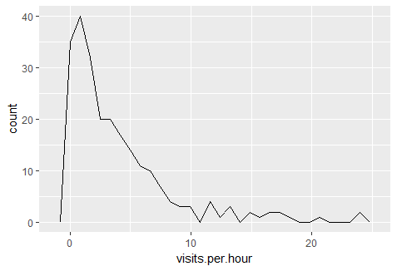

Super left skewed distribution.

Coefficients:

Estimate Std. Error t value Pr(>|t|)

(Intercept) 0.713290 0.221711 3.217 0.00149 \*\*

treatmentshrub -0.325539 0.138123 -2.357 0.01929 \*

floweringpre 0.765107 0.151378 5.054 8.94e-07 \*\*\*

understory.richness 0.136619 0.079526 1.718 0.08719 .

het.annual.floral.density 0.001568 0.018570 0.084 0.93279

So far looks like negative effect of shrubs, negative effect of no blooming, positive understorey richness. So significant interaction term.